Report
Section A
a)
Inputs: [1.2, 0.8, 2.0]
Targets: [3.0, 2.5, 4.0]
Learning rate: 0.01
Layers of network =3 (one hidden layer)
Size of layers=[ 1(input layer) , 2(hidden layer), 1(output layer)]
Bias=0
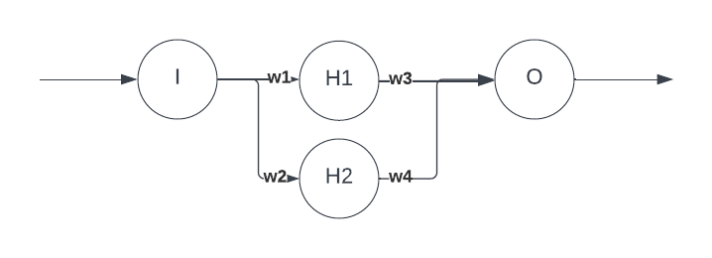

Forward pass:
Input=1.2
Hidden layer output = ReLU($\left[\begin{aligned}y_{1} \\ y_{2}\end{aligned}\right]$) = ReLU($\left[\begin{aligned}0.6 \\ 0.6\end{aligned}\right]$)= $\left[\begin{aligned}0.6 \\ 0.6\end{aligned}\right]$
Ouput layer output= 0.6*0.5+0.6*0.5=0.6

Input=0.8
Hidden layer output = ReLU($\left[\begin{aligned}y_{1} \\ y_{2}\end{aligned}\right]$) = ReLU($\left[\begin{aligned}0.4 \\ 0.4\end{aligned}\right]$)= $\left[\begin{aligned}0.4 \\ 0.4\end{aligned}\right]$
Ouput layer output= 0.4*0.5+0.4*0.5=0.4

Input=2
Hidden layer output = ReLU($\left[\begin{aligned}y_{1} \\ y_{2}\end{aligned}\right]$) = ReLU($\left[\begin{aligned}1 \\ 1\end{aligned}\right]$)= $\left[\begin{aligned}1 \\ 1\end{aligned}\right]$
Ouput layer output= 1*0.5+1*0.5=1

MSE = 1/3(1.2-0.6 +2-1+0.8-0.4)=0.67
Backward pass
Output layer
Dz(output)=[0.6-1.2,0.4-0.8,1-2]=[-0.6,-0.4,-1]
Delta(output)=1/3([-0.6,-0.4,-1].[[0.6,0.4,1],[0.6,0.4,1])=1/3[-1.52,-1.52]=[-0.5,-0.5]
W_new(output layer)=[0.5,0.5]+0.01[0.5,0.5]=[0.55,0.55]
Hidden layer
Dz=([0.5,0.5].[-0.6,-0.4,-1])*relu_der([0.6,0.4,1]=( [-0.6,-0.4,-1]. [0.5,0.5])=([[-0.3,-0.3],[-0.2,-0.2],[-0.5,-0.5]])
Dw=1/3([-0.6,-0.4,-1]. ([[-0.3,-0.3],[-0.2,-0.2],[-0.5,-0.5]])= 1/3([0.18+0.08+0.5,0.18+0.08+0.5]=[0.253,0.253]
db=[-1/3,-1/3]
w_new=[0.5,0.5]-[0.253,0.253]=[0.247,0.247]
b) For test sample we use the following expression:
$w^{T}x+b= {\left(\sum_{i=1}^{m}{α_{i}y^{\left(i\right)}x^{\left(i\right)}}\right)}^{T}x+b$$$=\sum_{i=1}^{m}{α_{i}y^{\left(i\right)}〈x^{\left(i\right)},x〉}+b \\ =\sum_{i=1}^{m}{α_{i}y^{\left(i\right)}K(x_{test},x_{i})}+b$$
For gaussian kernel:
$$K\left(x,z\right)=exp⁡(-\frac{{\left|\left|x-z\right|\right|}^{2}}{2σ^{2}})$$final classification expression:
$f\left(x_{test}\right)=sign\left(\sum_{i=1}^{n}{α_{i}y^{\left(i\right)}}\exp\left(-\frac{{\left|\left|x_{test}-x_{i}\right|\right|}^{2}}{2σ^{2}}\right) +γ\right) where γ=bias term$

c)
-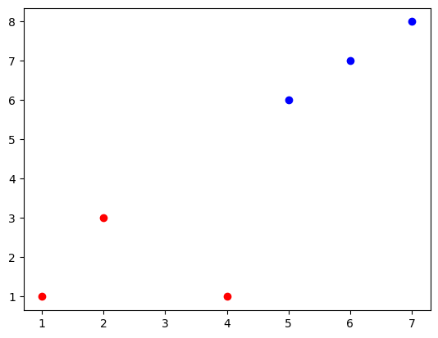
- Yes the points are linearly seperable as seen from the above picture
- For the equation of the decision boundary we solve the following equations:
By inspection we have 3 support vectors:
$\left(\begin{aligned}4 \\ 1\end{aligned}\right) \left(\begin{aligned}5 \\ 6\end{aligned}\right)\left(\begin{aligned}2 \\ 3\end{aligned}\right)$
Inserting a bias into the vectors
$\left(\begin{aligned}4 \\ 1 \\ 1\end{aligned}\right) \left(\begin{aligned}5 \\ 6 \\ 1\end{aligned}\right)\left(\begin{aligned}2 \\ 3 \\ 1\end{aligned}\right)$

And now solving the following equations:
$$α_{1}\left(\begin{aligned}4 \\ 1 \\ 1\end{aligned}\right)\left(\begin{aligned}4 \\ 1 \\ 1\end{aligned}\right) +α_{2}\left(\begin{aligned}5 \\ 6 \\ 1\end{aligned}\right)\left(\begin{aligned}4 \\ 1 \\ 1\end{aligned}\right)+α_{3}\left(\begin{aligned}2 \\ 3 \\ 1\end{aligned}\right)\left(\begin{aligned}4 \\ 1 \\ 1\end{aligned}\right)=+1 \\ α_{1}\left(\begin{aligned}4 \\ 1 \\ 1\end{aligned}\right)\left(\begin{aligned}5 \\ 6 \\ 1\end{aligned}\right)+α_{2}\left(\begin{aligned}5 \\ 6 \\ 1\end{aligned}\right)\left(\begin{aligned}5 \\ 6 \\ 1\end{aligned}\right)+α_{3}\left(\begin{aligned}2 \\ 3 \\ 1\end{aligned}\right)\left(\begin{aligned}5 \\ 6 \\ 1\end{aligned}\right)=-1 \\ α_{1}\left(\begin{aligned}4 \\ 1 \\ 1\end{aligned}\right)\left(\begin{aligned}2 \\ 3 \\ 1\end{aligned}\right) +α_{2}\left(\begin{aligned}5 \\ 6 \\ 1\end{aligned}\right)\left(\begin{aligned}2 \\ 3 \\ 1\end{aligned}\right)+α_{3}\left(\begin{aligned}2 \\ 3 \\ 1\end{aligned}\right)\left(\begin{aligned}2 \\ 3 \\ 1\end{aligned}\right)=+1$$
$$18α_{1}+27α_{2}+12α_{3}=1$$
$$27α_{1}+62α_{2}+29α_{3}=-1 \\ 12α_{1}+29α_{2}+{14α}_{3}=1$$
On solving these questions:
$$α_{1}=\frac{2}{3} α_{2}=-\frac{7}{3} α_{3}=\frac{13}{3} \\ w=∑α_{i}s_{i} \\ =\frac{2}{3}\left(\begin{aligned}4 \\ 1 \\ 1\end{aligned}\right)-\frac{7}{3}\left(\begin{aligned}5 \\ 6 \\ 1\end{aligned}\right)+\frac{13}{3}\left(\begin{aligned}5 \\ 6 \\ 1\end{aligned}\right)$$
$$=\left(\begin{aligned}-1/3 \\ -1/3 \\ 8/3\end{aligned}\right)$$
Equation of hyperplane-> y+x=8
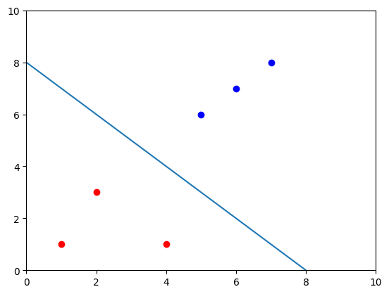
c)
support vectors
distance from planes
$$\left(2,3\right)→\frac{3}{\sqrt{2}} \\ \left(6,7\right)→\frac{7}{\sqrt{2}} \\ \left(5,6\right)→\frac{3}{\sqrt{2}} \\ \left(4,1\right)→\frac{3}{\sqrt{2}} \\ \left(1,1\right)→\frac{6}{\sqrt{2}} \\ \left(7,8\right)→\frac{7}{\sqrt{2}}$$
Since nearest distances are (2,3) (4,1) (5,6) they are the support vectors

$$margin=\frac{1}{\left|\left|w\right|\right|} \\ =\frac{1}{\sqrt{1^{2}+1^{2}}}=\frac{1}{\sqrt{2}}=0.707$$

- If we remove any of the support vectors the decision boundary would either shift or rotate.
If we remove (4,1) or (5,6) the boundary would shift but if we remove (2,3) it will rotate.
Section B
Graphs and code ipynb
Section C
1)
iii) 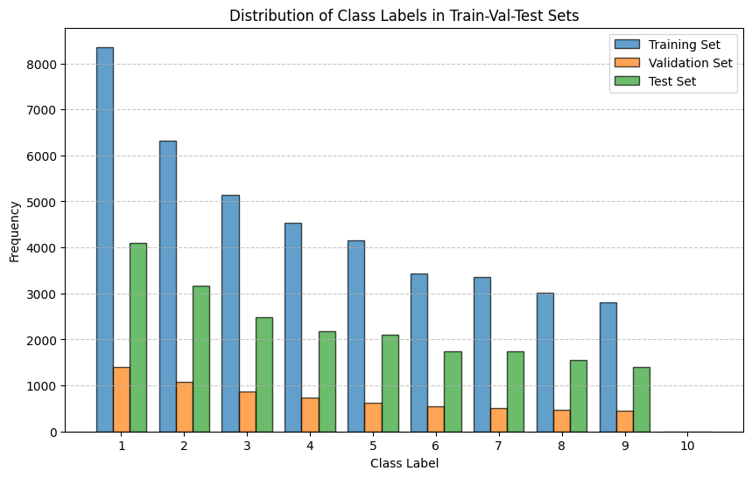
iv) 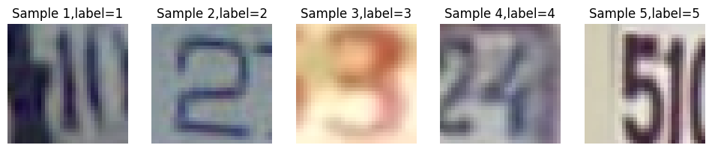
2)
ii) optimal parameters: batch size=150, hidden layer=(300,300) epoch=15
iii) losses in ipynb
iv)
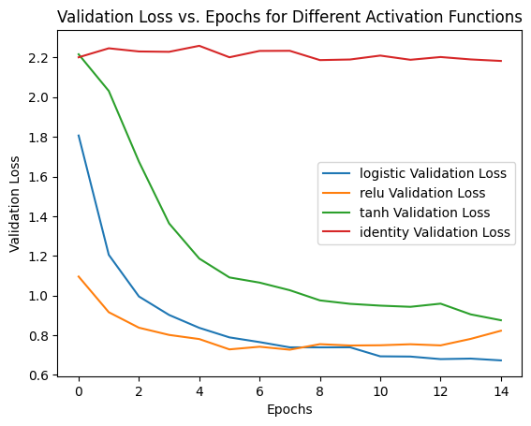
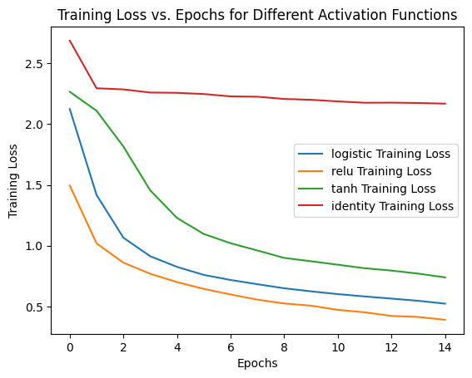
v) The model can effectively learn with sigmoid, relu, and tanh activation function with the best learning with relu activation. This is because non linear functions enable the network to approximate complex functions and incorporate non linear relationship between data.
The model performs poorely with linear activation because then they act as linear models like linear regression or classification. The image data is not linearly separable which causes the linear activation to perform poorely.
vi)
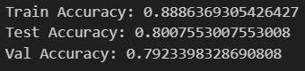
This is the best accuracy with batch size=150,hidden layer=(300,300), activation=relu and iterations=15.
These accuracy was obtained by using multiple gridsearch cv on various parameters and trying the activation functions.
3)
i) Images in ipynb
ii) Possible reasons for misclassification:
Distrations present in image: More than one number is present
Blurry image: The image is too blurry
Insufficient training data for proper classification

