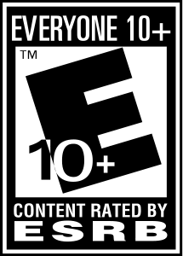Game Title: HOOPS!

ESRB Rating: E10+

Platforms: PS4, Xbox One, Nintendo Switch, and Windows PC

Intended Audience: Kids, Teens and Up.

Background Information:

The Worldwide Hoops Corporation is hosting a 2-on-2 Global Tournament with a cash prize of $1,000,000. Strong teams from all across the world are expected to compete in this upcoming tournament. Choose one of many players, form a team, and face off against other teams in order to reach the top.

Gameplay:

The game is a platform fighter where players can choose from 14 different characters with their own unique skillsets. Hoops is a sport that plays very much like basketball but with no foul contact restrictions. Because of this freedom, team members tend to bring in unique powers and abilities, designed to harm and knockout others.

Competitors:

* Super Smash Bros.
* Rivals of Aether
* Slap City
* Indie Pogo
* Brawlhalla

Differences from Other Competitors:

* It’s the first platform fighter that has a focus with a
* Unique and memorable characters