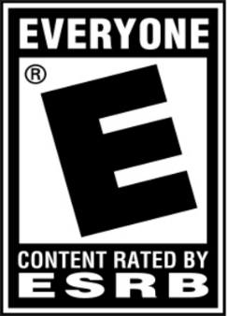

Game Title: Spelling Bee, The Competition

ESRB Rating: Everyone

Platforms: Windows PC, Mac OS, Linux

Intended Audience: Kids and Up.

Background Information:

You have entered into a Spelling Bee competition. It is your goal to reach the top ranks in order to qualify for the Worldwide Spelling Bee Tournament! As you enter into more tournaments and progress through the game, you will climb the leaderboard and finally take part in the tournament one day!

Gameplay:

Each competition you enter will follow the standard Spelling Bee format. Each round your character will walk onto the stage and be given a word from an audio cue, type in the wrong answer and you will be eliminated from the tournament. In your downtime there is a practice mode that opens up in which you can train with your coach or do a practice match against other players.

Competitors:

* Typing of the Dead: Overkill
* Epistory: Typing Chronicles

Differences from Other Competitors:

* The first typing, Spelling Bee video game
* The most recent typing games released have usually all been in the puzzle genre and have not branched out.