INTRODUCTION TO CYBERSECURITY

INTRODUCTION TO OFFENSIVE SECURITY

offensive security is the process of breaking into computer systems, exploiting software bugs, and finding loopholes in applications to gain unauthorized access to them.

Q & A



Now in the next task I was supposed to hack into a bank and do some transfer. Now I was presented with a web page called fakebank.com.

I checked for hidden directories by bruteforcing for hidden directories using the gobuster tool and luckily enough, there was a hidden directory.

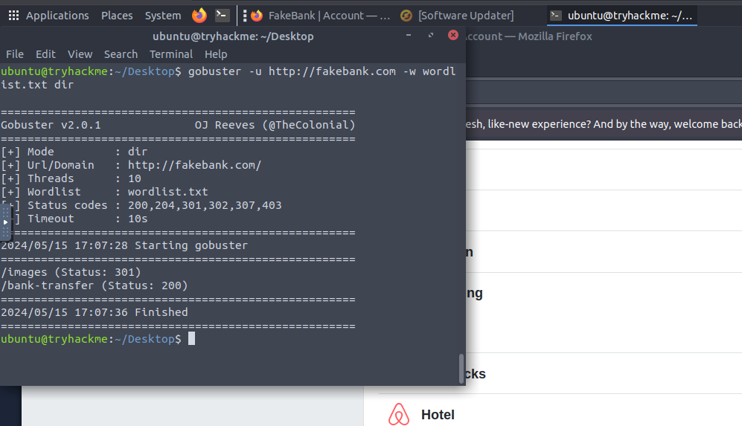

Visiting the url path having /bank-transfer, I am presented with a transaction webpage.

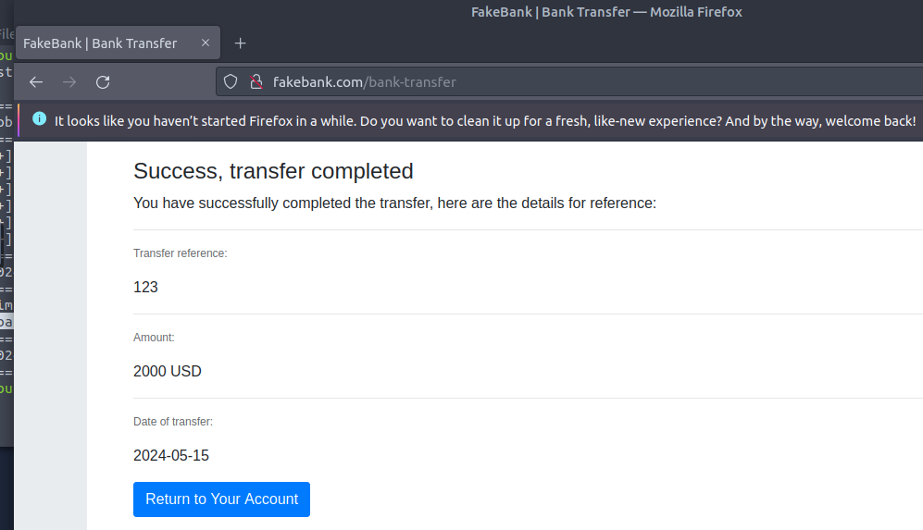

And as you can see I successfully transferred money to my account.



X

NOTE: This website had a INFORMATION DISCLOSURE or SENSITIVE DATA EXPOSURE vulnerability that an attacker can abuse to gain access to sensitive information that are not ment for normal users.

I exploited this vulnerability and boom! Managed to transact.



WEB APPLICATION SECURITY

INTRODUCTION

In todays interconnected world, 90% of programs run on web applications and for that reason here comes the need for security of the data and informations that are exchanged.

Q & A





q

since we are dealing with data over the internet, there is a great need for encryption of this data so that it might be of no sense to any one who tempts to intercept. And here cryptography come to play a handy job.



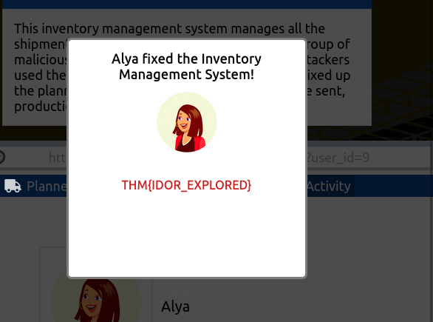

IDOR occurs when an application exposes a reference to an internal object, such as a file, database record, or URL, and relies solely on user input to determine access to the object without verifying if the user is authorized to access it, of which it should not be the case.

Fh

INTRODUCTION TO DIGITAL FORENSICS

INTRODUCTION

With the use and spread of digital systems, such as computers and smartphones, a new branch of forensics was born to investigate related crimes: computer forensics, which later evolved into, digital forensics.

Q & A





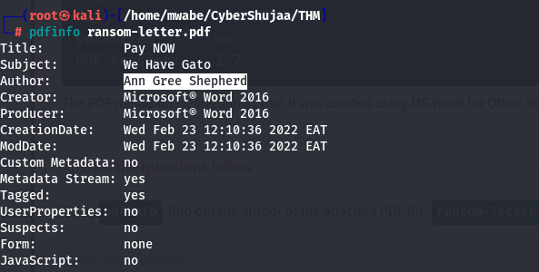



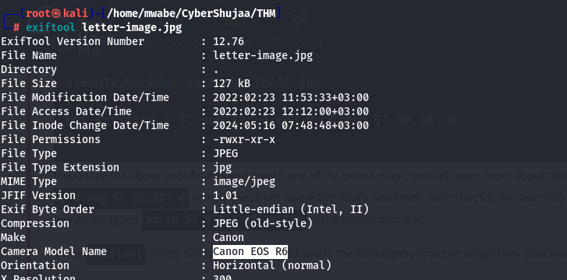





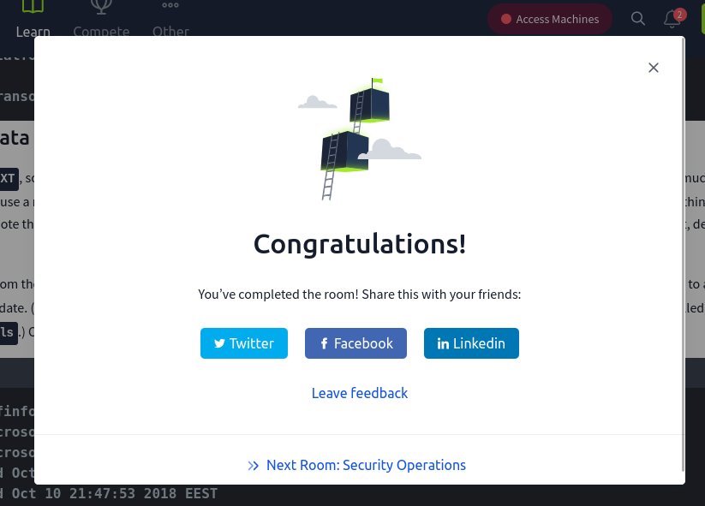d

CONCLUSION

This room has given hands-on and general introduction to:

* careers in cybersecurity
* Offensive Security; hacking your first application
* Defensive Security; defending against a live cyber attack
* Exploring security topics in the industry