User Manual

Haptic Learning Center
Version 1.0 Beta

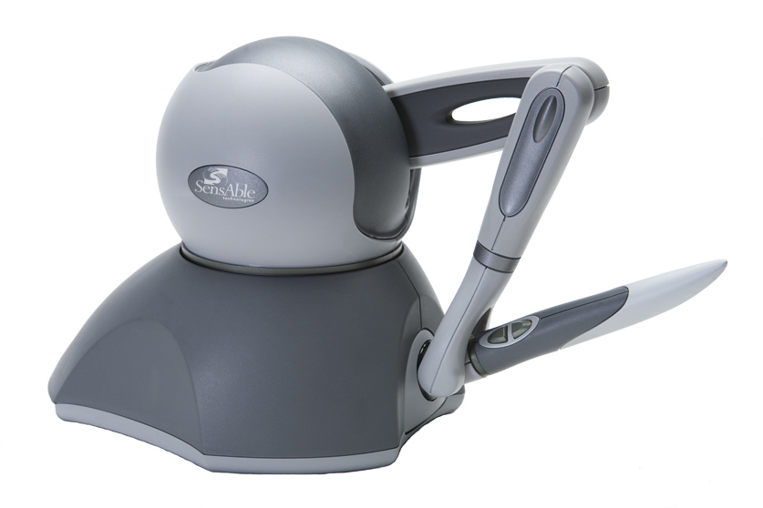

Electronics and Computer Engineering Technology
California State Polytechnic University, Pomona

Introduction
The applicaion will help users with disabilities acquiring the writing and drawing skills by using a haptic device. It uses a robotic mapping from a haptic user interface to a virtual environment. For the tasks, the application consists of a force reflecting haptic interface drive, PHANToM Omni with OpenHaptics Toolkit (version 3.0) and OpenGL (Open Graphics Library).

A detailed analysis of patters (e.g., labyrinths, letters and angles) was conducted in order to select three very distinguishable levels of difficulty that could be included in the system, and which would yield the greatest benefit in terms of assessment of coordination and strength issues as well as in training. Support algorithms (position, force, velocity, inertia and viscosity) were also developed and incorporated into the tasks in order to introduce general computer assistance to the mapping of the user’s movements to the computer screen without overriding the user’s commands to the robotic device.

We discussed the possibility of improving eye-hand coordination in children diagnosed with this problem, using a robotic mapping from a haptic user interface to a virtual environment. Our goal is to develop, implement and refine a system that will assess and improve the eye-hand coordination and grip strength in children diagnosed with poor graphomotor skills.

Getting Started
The Application is a Microsoft® Visual C++ Win32 console application. When the user enters the application, he/she will be asked what test mode he/she would like to run. After loading the test environment, he/she can choose a level for inertia effect, start recording, or quit the application by using the right-click menu.

System Requirements

Hardware
Intel Pentium 4 or higher
512 MB free disk space
1 GB RAM
FireWire 1394a*
Laptop Computers
PHANToM Omni

Software
Windows® XP-32 (SP3), XP-64 (SP2), Vista-32 (SP2), Vista-64 (SP2) or Windows 7, win
Microsoft® Visual C++ 2005 (SP2) 32 or x64
OpenHaptics Toolkit version 3.0
PHANToM Device Driver v4.2.B131 or above

Design of Tasks
There are three patterns shown in Fig. 1: Maze, LeLe hand writing pattern, and Complex Labyrinth. The subject is required to move the stylus along and follow the specified trajectory while holding the stylus on the X-Y plane (in the air). A mapping was also designed for the children to follow the trajectories on a piece of paper X-Z plane (on the desk) follow these four simple steps to use the application:
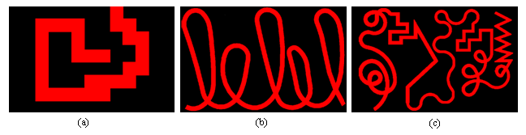
Figure 1: (a) Maze; (b) LeLe hand Writing Pattern; (c) Complex Labyrinth.

Regulation of Positions
The application is built with an X-Y plane workspace and set the Z-coordinate position to zero throughout the task execution in order to keep the slave position (virtual representation of the stylus position) within the workspace. The application created a virtual wall model which is applied to the Z-plane in order to prevent the user from penetrating through the surface.

Force Assistance Functions
This application assists the user by applying the force in the direction of the task to be completed, or attracting the user to the desired path if he/she diverts from it. Force feedback can be used to guide the subjects’ hand in a predetermined trajectory when he/she is unable to move in response to visual feedback.

Inertia Effect
The inertia effect is mainly used to reduce tremor in the hands of the user having problems with eye-hand coordination and, at the same time, improve their grip strength as this test is conducted both with power and precision grasps. The effect is implemented by increasing the mass, damping coefficient and spring stiffness. Table 2 lists the values tested for this function.
- The Values Chosen to Apply the Inertia Effect
Effect Level | Mass  (kg) | Damping Coefficient  (kg/[1000 * sec]) | Spring Stiffness  (kg/[1000 *sec2])
None | 0.0 | 0.0 | 0.0
Low | 0.01 | 0.001 | 0.1
Median | 0.03 | 0.003 | 0.2
High | 0.05 | 0.005 | 0.4

Viscosity Effect
The Viscosity effect is developed to provide a smooth execution of the task for the user by eliminating the fast and irregular movements of the master (stylus) that is added by the user. It provides the effect of moving the drive in a denser medium by a small force to the user’s hand at the same time, which in turn, activates the hand muscles while executing the task.

Design of Tasks
The training procedure is separated into two parts. The first part is the user’s training environment and the second part is the evaluation module to analyze the user's training result. There are 12 options in the main menu (see Figure 3-2):
[1] Maze: Loading Maze pattern.
[2] Maze (Viscosity Effect Mode): Loading Maze pattern with viscosity effect.
[3] Maze (Force Assistance Mode): Loading Maze pattern with force assistance.
[4] LeLe: Loading LeLe pattern.
[5] Labyrinth: Loading Complex Labyrinth pattern.
[6] Labyrinth (Force Assisance Mode): Loading Complex Labyrinth pattern with force
assistance.
[7] Maze (Drawing on the Desk): Loading Maze pattern.
[8] LeLe (Drawing on the Desk): Loading LeLe pattern.
[9] Labyrinth (Drawing on the Desk): Loading Complex Labyrinth pattern.
[A] Calibrate Ratio (Drawing in the Air): Calibrate Coordinator.
[D] Calibrate Ratio (Drawing on the Desk): Calibrate Coordinator.
[E] Exit Application: Exit the Application.

Calibrate Ratio
Due to the fact that the units for the evaluation function and haptic device’s coordinate system are different from each other, a ratio adjustment is required to get a more accurate evaluating score.
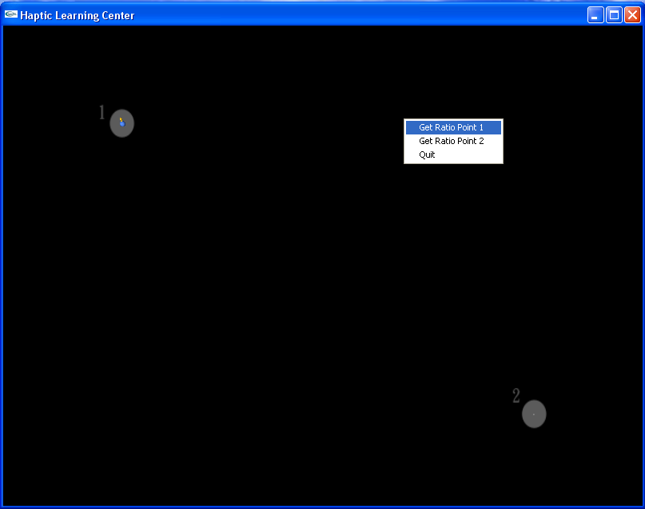
Figure 2: The environment for calibrate ratio.

Choose a Level to Test
In the first part, the instructor needs to choose an appropriate level of the task for user and press "Enter" key to start user’s training. A popup window is displayed for the user’s training environment.
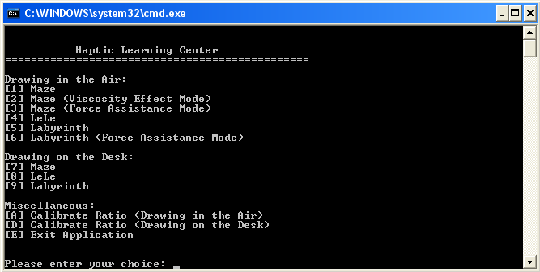
Figure 3: The prompt main menu.

Choose an Inertia Effect (Right-Click Menu)
There are four levels of inertia effect which is None, Low, Median and High for each test case.
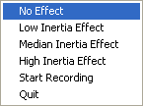
Figure 4: The right-click menu.

Start Record the Coordinates
Before starting the training, instructor informs the user to move the cursor of the haptic device to the start position. To start the training, the instructor is to select “Start Recording” from the drop down menu by right-clicking on the training environment. The Handwriting Training Application will now record every movement the user makes through the haptic device.
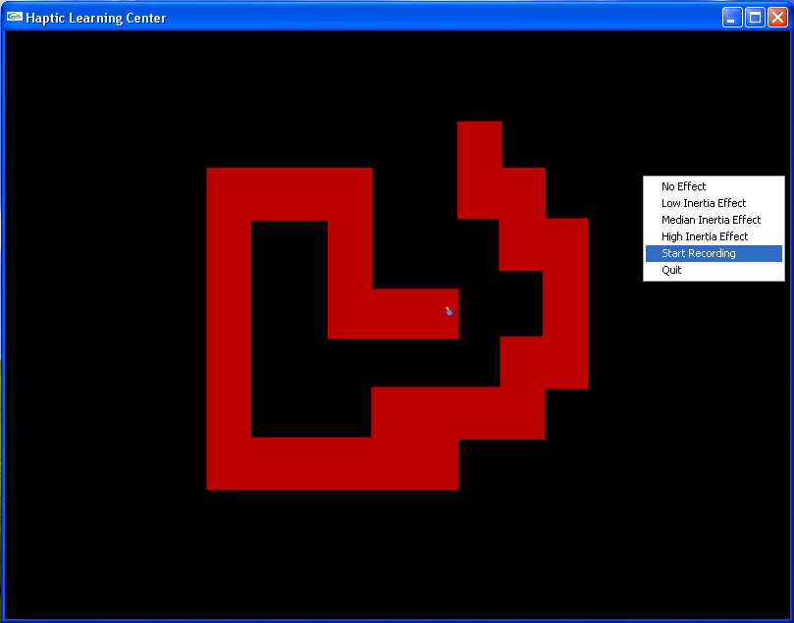
Figure 5: The right-click menu - Start Recording in Maze pattern.

Start Recording (Right-Click Menu)
The proxy position is obtained using the workspace mapping method provided by the OpenHaptics toolkit. It can be recorded manually from right-click menu, Start Recording. The position data in X, Y, Z coordinates were recorded for futher analysis. The user now starts following the trajectory of the task pattern.

Quit (Right-Click Menu)
When the user reaches the end position of the task pattern, the instructor will stop the recording by selecting "Quit" from the drop down menu by right-clicking on the training environment. Once the training is completed, the system will output a result file of this training for the next evaluation process. The first part of the training process is now complete.
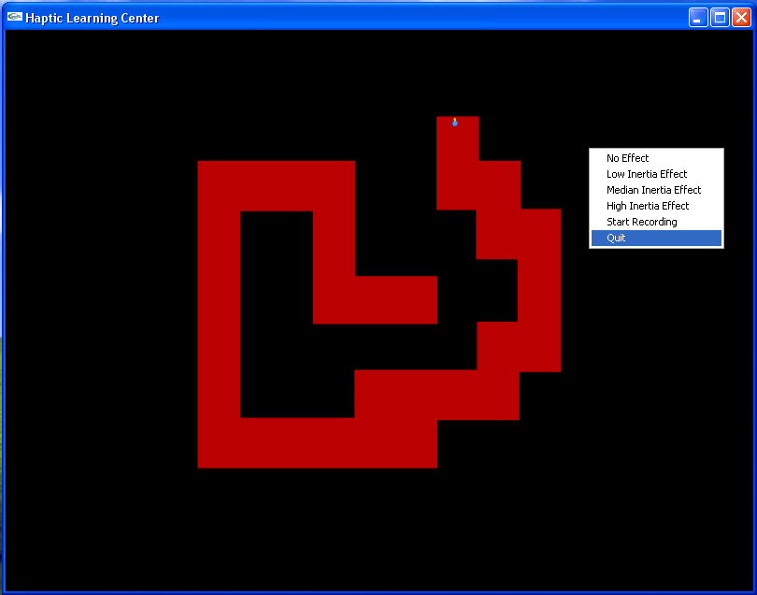
Figure 5: The right-click menu - Quit in Maze pattern.

