# Kickstarting with Excel

## Overview of Project

### Purpose

*The Purpose of this analysis is to find the best time to launch the Kickstarter campaign, and best goal(Cash) range that can be achieved for this purpose.

## Analysis and Challenges

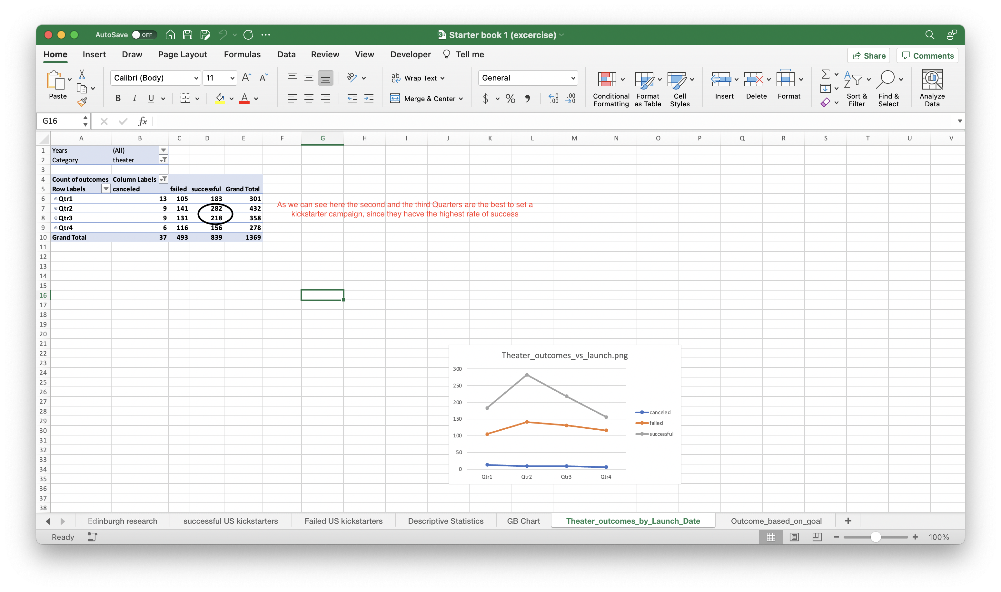

Caption

### Analysis of Outcomes Based on Launch Date

*So the best time to launch the campaign , is from March till September, and that is because it is the time with the highest success campaigns.

### Analysis of Outcomes Based on Goals

*In the range of $1000, to $4999, is the best range to set as a goal, because it has the highest success

From 5000 to 9999 is there second best, as it is the second highest rate of success

### Challenges and Difficulties Encountered

*The chanlleges that can be encountered

Lack of data

Inaccurate data

Bias data

## Results

- What are two conclusions you can draw about the Outcomes based on Launch Date?

*1) make the campaign in the second Quarter of the year

2) Avoid the last 3 months of the year specially, and the first 2 of the year, that is because those are the lowest months, Maybe due to Christmas and new year, people don't have money to kickstart something.

- What can you conclude about the Outcomes based on Goals?

*In the range of $1000, to $4999, is the best range to set as a goal, because it has the highest success

From 5000 to 9999 is there second best, as it is the second highest rate of success

- What are some limitations of this dataset?

*1) complexity and bias

2) Missing info, eg. marketing expenses.

3) Campaign team, how many people and functions, on both successful and failed campaigns.

- What are some other possible tables and/or graphs that we could create?

* Pie Chart

Column chart

Statistical

Pivot table

Combo chart