A REPORT

**ON**

**DESIGN AND SIMULATION OF A NOVEL FLEXIBLE SENSOR**

BY

Name(s) of the ID. No(s) Discipline(s)

Student(s)

NAREN VILVA 2019AAPS0236H ECE

TEJAS DNYANESHWAR 2019A3PS0409G EEE

MUSALE

AT

CSIR-CEERI, Pilani

A Practice School-I Station of

**BIRLA INSTITUTE OF TECHNOLOGY & SCIENCE, PILANI**

**June, 2021**

A REPORT

**ON**

**DESIGN AND SIMULATION OF A NOVEL FLEXIBLE SENSOR**

BY

Name(s) of the ID. No(s) Discipline(s)

Student(s)

NAREN VILVA 2019AAPS0236H ECE

TEJAS DNYANESHWAR 2019A3PS0409G EEE

MUSALE

Prepared in partial fulfilment of the Practice School-I Course No. BITS F221

AT

CSIR-CEERI, Pilani

A Practice School-I Station of

**BIRLA INSTITUTE OF TECHNOLOGY & SCIENCE, PILANI**

**June, 2021**

**ACKNOWLEDGEMENTS**

I’m extremely grateful toBITS Pilani to have given me this opportunity to work with such a prestigious station to broaden my views and enhance my knowledge. I’d like to acknowledge the assistance and support of my mentor Dr. Sumitra Singh and faculty advisor Dr. Pankaj Arora.

Lastly, I would like to express my deepest appreciation to my parents, without whom none of this would be possible.

**BIRLA INSTITUTE OF TECHNOLOGY AND SCIENCE PILANI**

**(RAJASTHAN)**

**Practice School Division**

**Station**: CSIR-CEERI………………………**Centre** ...PILANI.............…………………..

**Duration** .........2 months……………**Date of Start**.......31st May..........…………………

**Date of Submission**....25thJune............……………………………………………………

**Title of the Project**: DESIGN AND SIMULATION OF A NOVEL FLEXIBLE SENSOR

**Name(s)/ID(s)/Discipline(s):** NAREN VILVA – 2019AAPS0236H - ECE

**Name(s) and designation(s) of the expert(s):** Dr.Sumitra Singh

**Name(s) of the PS Faculty:** Dr. Pankaj Arora

**Key Words:** Flexible sensor, wearable devices, sensitivity, COMSOL simulation

**Project Areas:** Material Science, Electronics

**Abstract:**

Flexible sensors have gained interest in recent years for their application in wearable devices, healthcare and E-Skin. Using the piezoresistive properties of certain materials, flexible strain sensors can be developed. The objective is to design and simulate a novel flexible sensor. Previously published works on flexible sensors were analysed for potential designs and materials. The sensors were then designed and simulated using COMSOL, and assessed for viability in pulse detection and touch sensing. Finally, a novel flexible sensor was designed and simulated in COMSOL, and its results were analysed.

Signature(s) of Student(s) Signature of PS Faculty

22nd June 2021

**TABLE OF CONTENTS**

|  |  |  |
| --- | --- | --- |
| **Sr. No.** | **Content** | **Page No.** |
|  | Cover | 1 |
|  | Title Page | 2 |
|  | Acknowledgements | 3 |
|  | Abstract Sheet | 4 |
|  | Table of contents | 5 |
|  | Introduction | 6 |
|  | Literature review | 6, 7 |
|  | Introduction to design and simulation in COMSOL | 8,9 |
|  | Novel Sensor design and simulation | 10,11,12 |
|  | Conclusion | 12 |
|  | References | 13 |

**INTRODUCTION**

Flexible electronics are electronic devices which are built on flexible or bendable substrates. Flexible sensors have gained importance in recent years due to the rising popularity and importance of wearable electronics, healthcare monitoring and IoT integration. Conventional electronics, typically those which are silicon-based are rigid and inflexible making them impractical for wearable electronics, especially for health applications.

Flexible sensors consist of a flexible substrate, an interface layer and the active layer. The active layer is usually made from metallic nanowires, carbon nanotubes, graphene and amorphous oxide conductors. Carbon-based materials have gained popularity in recent years due to their excellent physical and electrical properties for use in piezoresistive strain sensors. The substrate layer must be flexible enough to conform to curved and irregular surfaces. Chemical stability and bio-compatibility are also desired properties for substrates. Common choices for substrates are PET, PDMS, Ecoflex, PEN, etc. Of these, PDMS is widely used due to its bio-compatibility making it suitable for wearable healthcare devices.

In this project, we will attempt to design and simulate a novel flexible sensor using COMSOL. Previously published works were analysed and select materials for substrate and active layer. The sensor will then be designed keeping in mind practicability for applications such as pulse monitoring and touchscreen sensors.

**LITERATURE REVIEW**

Multiple papers on flexible sensor design were read and analysed. Details regarding their fabrication, physical characteristics and applications were considered for use in our novel flexible sensor design.

The first paper was *Development and Analysis of Graphene Nanoplatelets (GNPs)-Based Flexible Strain Sensor for Health Monitoring Applications*. The sensor consisted of GNP active layer mounted on a PDMS substrate, both of which were fabricated on-site.

Most flexible strain sensors operate on the principle of piezoresistivity – change in the material’s resistance upon applying mechanical stress. Under mechanical stress, the electrical resistance increases due to the opening / closing of micro-cracks in the PDMS. Larger crack size means longer pathway for the electron flow resulting in increased resistance. Some sensors also make use of change in capacitance to detect stress. The sensor fabricated in this study was piezoresistive in nature. To test its sensitivity, its Gauge Factor (GF) is measured. Higher the GF, more sensitive the sensor.

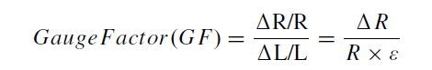

Formula of Gauge Factor. R, ΔR, L, ΔL and ε represents the resistance, resistance variation, length, change in length and applied strain respectively.

For the above GNP sensor, its GF was found to be 62.5, higher than previously published works on GNP sensors. The sensor was then tested for its application as a pulse sensor, touch sensor, and its responsiveness under bending.

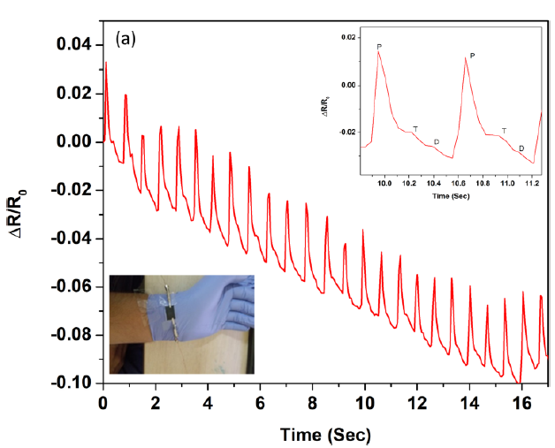 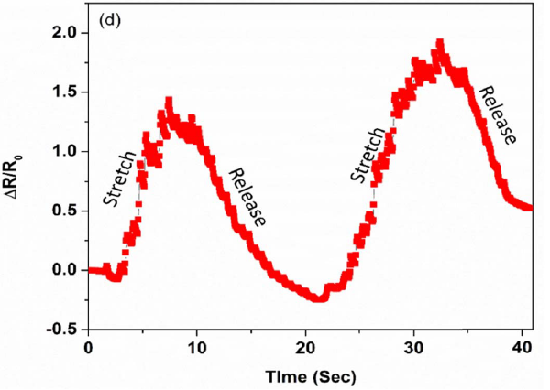

Response of the sensor with multiple stretch-release cycles

As a pulse sensor, it was able to distinctly detect the 3 pulse peaks (Percussion, Tidal, Dicrotic)

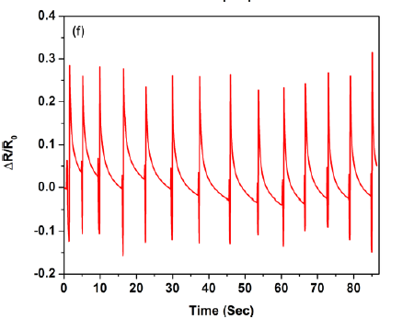

Response of the sensor under repeated touch-release cycles. Note The sharp peaks and fast response times

Based on the above tests, the GNP sensor showed promise as a potential candidate for wearable pulse monitoring devices and touchscreen sensors.

Similar papers using various active layers such as AgNW (silver nanowires), Carbon nanotubes and liquid metal were analysed, and their use in pulse monitoring and touch sensing was understood.

**Introduction to design and simulation in COMSOL**

**Piezoresistive pressure sensor:**

For the first COMSOL simulation, the paper *Simulation of carbon nanotubes polymer based piezoresistive flexible pressure sensor for ultra-sensitive electronic skin* was chosen. The sensor consisted of a 1.5 x 1 cm, 125 um thick PET (polyethylene terephthalate) substrate, with a 1.5 x 1 cm, 5 um thick SWCNT (single-walled carbon nanotube) active layer mounted on top. The PET and SWCNT layers were fabricated from scratch, and hence their material properties had to be manually added to the COMSOL material database for simulation.

The sides of the substrate were fixed and pressure was applied on the sensing layer in increments of 10 Pa from 0 to 130 Pa. The change in pressure is sensed by the change in resistance due to the piezoresistive nature of the device. This change is then plotted on a graph against the applied pressure. The sensitivity of the pressure sensor is defined as: Sensitivity = ((R-Rₒ)/Rₒ)/P=(ΔR/Rₒ)/P where R is the resistance after deformation, Rₒ is the initial resistance and P is the applied pressure.

Design of the piezoresistive sensor in COMSOL

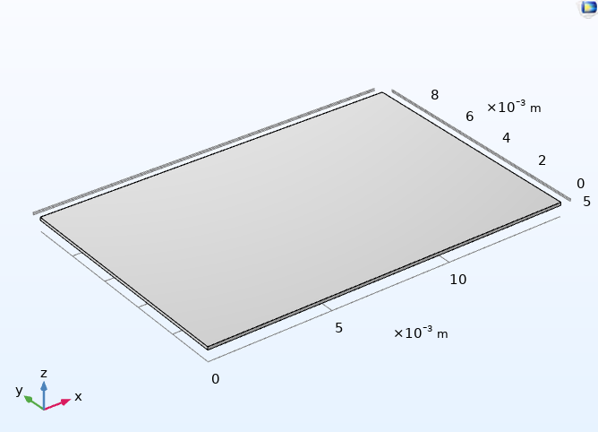 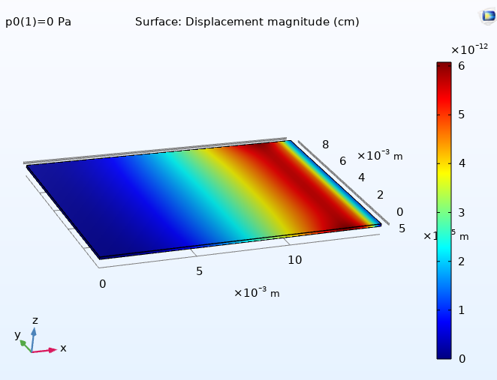

Graph of surface displacement on applying incremental pressure

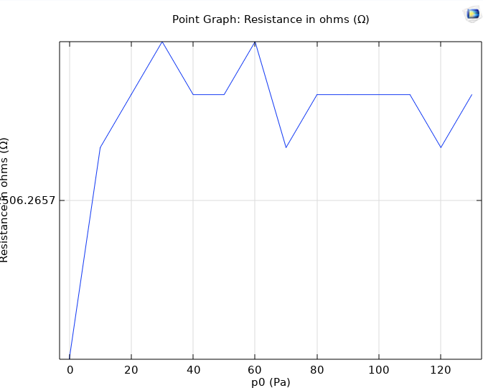

Graph of resistance vs applied pressure

We could not accurately replicate the resistance vs applied pressure graph due to the lack of information regarding specific material properties. Specifically, the piezoresistive coupling matrix values for the SWCNT layer were not provided. In future simulations, we will have to thoroughly analyse material properties and confirm if an accurate simulation is possible.

**Capacitive pressure sensor:**

The second paper which we simulated was a capacitive pressure sensor. In *Tunable flexible capacitive pressure sensors using arrangement of polydimethylsiloxane micro-pyramids for bio-signal monitoring*, the sensor consisted of 16 x 16 um, 11 um tall PDMS micro-pyramids mounted on a 130 um thick PDMS base. This acted as the dielectric material, and 2 gold electrodes were placed above and below. Pressure was then applied in increments, and the change in capacitance was plotted.

The principle behind the capacitive pressure sensor is the change in capacitance due to the decrease in spacing between the 2 electrodes due to applied pressure. Since capacitance is inversely proportional to the distance between the 2 electrodes, the capacitance increases as the spacing decreases with increased pressure.

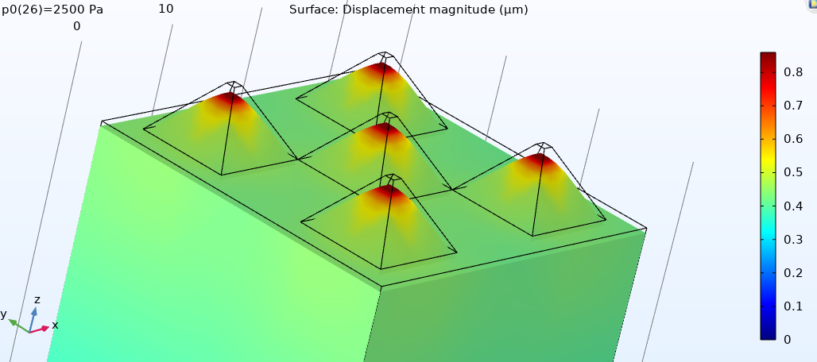

Surface displacement graph of Capacitive pressure sensor

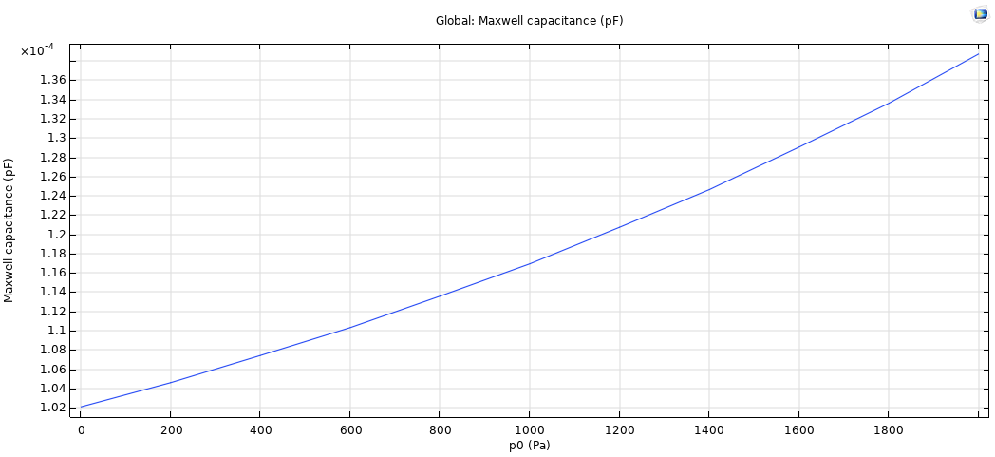

Capacitance vs Applied Pressure graph

**NOVEL SENSOR DESIGN AND SIMULATION**

After analysing and simulating previous works on flexible sensors, we designed a novel flexible sensor and simulated it in COMSOL. This sensor was a capacitive pressure sensor consisting of a 12 x 12 array of PDMS tetrahedral pyramids on a 0.1 x 0.1 cm, 15 um thick PDMS block. Each tetrahedral pyramid had a 25 um base and height , with a separation distance of 70 um. Gold electrode layers were then attached to the top and bottom of the PDMS structure.

The Capacitance of the sensor is given by:



Where, εr is relative permittivity, εo is permittivity of free space, ‘A’ is overlapping area of electrodes, ‘d’ is spacing between electrodes. For the given sensor, A is a constant. Upon applying pressure, d decreases and effective permittivity increases and hence capacitance increases. Effective permittivity increases with applied pressure because the deformation due to the pressure reduces the air volume between the pyramids, making it PDMS rich.

Pyramidal dielectric structure was chosen as it exhibits greater deformation under small applied pressures compared to planar dielectric structures. Hence, it exhibits greater sensitivity and is also comparatively lightweight.

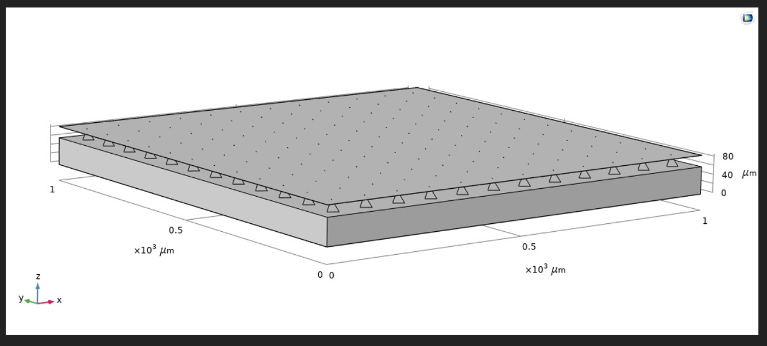

Geometry of the novel sensor

Pressure was then applied in increments from 0 to 1000 Pascal, and the change in capacitance was plotted.

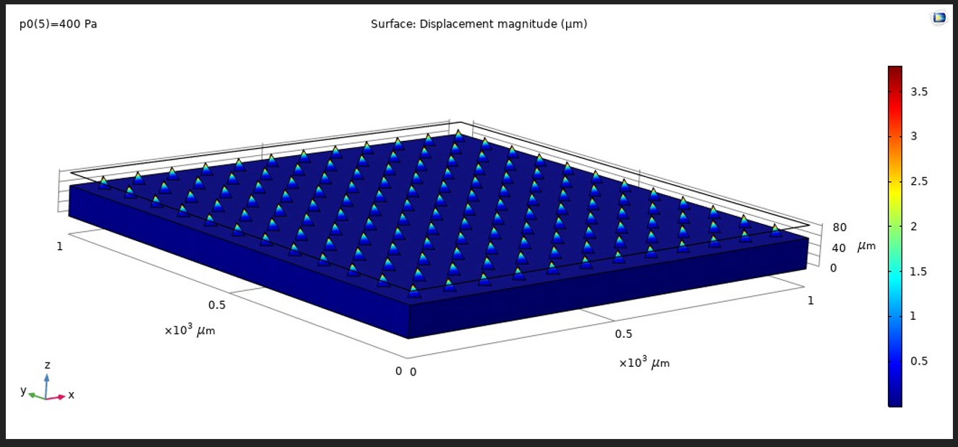

Displacement Graph





Capacitance Versus Pressure

The sensor showed high change in capacitance on applied pressure, and is thus highly sensitive.

The thickness of the PDMS base was also varied to check its impact on the sensor’s sensitivity. However, as shown in the graph above there was little to no effect on the sensitivity with variation in the dielectric thickness.

Overall, this sensor showed excellent sensitivity owing to the array of tetrahedral pyramids. Its thinness and light weight make it a possible candidate for health monitoring applications and wearable devices.

**CONCLUSION:**

After analysing multiple papers and simulations, we now have a basic understanding of the materials and designs for various types of flexible sensors. Flexible sensors have tremendous potential for applications such as healthcare and wearable devices, and future research in this area can help extend the scope of electronics as a whole.

**REFERENCES**

1. Flexible Electronics: Status, Challenges and Opportunities. <https://www.frontiersin.org/articles/10.3389/felec.2020.594003/full>
2. Lee, J. H.; Yang, D.; Kim, S.; Park, I. (2013). *Stretchable strain sensor based on metal nanoparticle thin film for human motion detection & flexible pressure sensing devices. , (), 2624–2627.*doi:10.1109/transducers.2013.6627344
3. Tingting Yang, Xin Jiang, Yujia Zhong, Xuanliang Zhao, Shuyuan Lin, Jing Li, Xinming Li, Jian-Long Xu, Zhihong Li, and Hongwei Zhu (2017), *A Wearable and Highly Sensitive Graphene Strain Sensor for Precise Home-Based Pulse Wave Monitoring.* • DOI: 10.1021/acssensors.7b00230 •
4. Suraj Baloda, Zeeshan Alam Ansari, Sumitra Singh, and Navneet Gupta (2020), *Development and Analysis of Graphene Nanoplatelets (GNPs)-Based Flexible Strain Sensor for Health Monitoring Applications.*
5. Roopa Hegde, K. Ramji, P. Swapna (2018), *Simulation of carbon nanotubes polymer based piezoresistive flexible pressure sensor for ultra-sensitive electronic skin.*
6. Thouti, Eshwar; Nagaraju, Atmakuru; Chandran, Achu; Prakash, P.V.B.S.S; Shivanarayanamurthy, P; Lal, Banwari; Kumar, Prem; Kothari, Prateek; Panwar, Deepak (2020). *Tunable flexible capacitive pressure sensors using arrangement of polydimethylsiloxane micro-pyramids for bio-signal monitoring.*