Marketing Environment Analysis for a Mental Health Clinic
Field-ready formulations for therapeutic sessions and counselling programs.

I. Internal Environment (Operational Formulation)
1) Therapeutic Identity
The clinic provides evidence-based psychological and counselling services within a modern scientific framework. It prioritizes a safe, confidential environment that respects client privacy. The clinic adopts an integrative approach—combining individual psychotherapy, family therapy, and preventive guidance training—to treat psychological disorders and enhance overall mental health and quality of life.
2) Professional Staff
The team consists of licensed psychiatrists and psychologists experienced in managing anxiety, depression, stress, and familial issues, alongside specialized coaches for educational and awareness programs. The human element is the most critical factor in service quality, as therapeutic success relies heavily on the professional alliance between the therapist and the client.
3) Service Offerings
- A. Clinical Services:
  - Individual psychotherapy for adults.
  - Child and adolescent therapy.
  - Family and marital counselling.
  - Treatment for anxiety, depression, and trauma (PTSD).
  - Standardized psychological assessments and testing.
- B. Counselling and Training Services:
  - Stress management workshops.
  - Positive parenting programs.
  - Pre-marital counselling courses.
  - Life skills and Emotional Intelligence (EQ) development.
  - Occupational burnout prevention workshops for employees.
4) Pricing Strategy
The clinic employs a pricing policy that considers the purchasing power of target segments. This includes discounted packages for consecutive sessions and more affordable online services to expand accessibility.
5) Location and User Experience (UX)
The location was selected for its ease of access combined with high levels of privacy and tranquillity to ensure the client’s psychological safety. Furthermore, the reception staff is trained in clinical sensitivity when handling mental health cases.
6) Digital Presence
The clinic provides online booking and teletherapy consultations. It also maintains an active social media presence, publishing educational content aimed at raising mental health awareness and reducing the stigma associated with seeking psychological help.

II. The Micro-Environment (Immediate External Factors)
1) Target Audience
The clinic serves diverse demographic segments, including:
- Individuals struggling with anxiety, depression, or life stressors.
- Couples and families facing interpersonal conflicts.
- Children with behavioural or academic difficulties.
- University students and young adults.
- Employees in high-pressure work environments.
- Engaged couples (pre-marital stage).
- Individuals seeking self-development and improved quality of life.
2) Competitors
- Direct Competitors: Private psychiatric clinics, specialized therapy centres, and independent practitioners.
- Indirect Competitors: Life coaches, religious counsellors, free online psychological content, and mental health mobile applications.
3) Referral Sources
The clinic builds professional networks with entities that refer cases, such as:
- Schools and universities.
- General practitioners and medical specialists.
- Corporations and institutions.
- Rehabilitation and addiction recovery centers.
- Non-profit organizations (NGOs).

III. The Macro-Environment (General Social Factors)
- Socio-Cultural Factors: Demand is influenced by social awareness and the prevailing stigma. Some individuals may hesitate to seek help due to societal perceptions.
- Economic Factors: Utilization of services is linked to disposable income; mental health services are often viewed as "deferrable" during economic downturns.
- Technological Factors: The rise of Tele-therapy has expanded the service scope, reaching clients in remote areas or those who prioritize maximum anonymity.
- Legal Factors: Practice is governed by strict regulations regarding professional licensing, data protection, and patient rights.

IV. The Marketing Mix (7Ps for Mental Health Services)
- Product: Evidence-based psychotherapy and scientific counselling.
- Price: Tiered pricing based on service type and session duration.
- Place: Physical facility + online digital platforms.
- Promotion: Awareness content, seminars, and targeted digital campaigns.
- People: Highly specialized professional team.
- Process: Clear, streamlined, and confidential booking systems.
- Physical Evidence: A professional, calming, and comfortable therapeutic environment.

Concluding Statement (For Business Plans)
"The clinic operates within a marketing environment characterized by high sensitivity and a need for extreme privacy. Success depends more on building trust and delivering high-quality professional care than on traditional advertising. Consequently, raising community awareness remains a primary driver for increasing demand for treatment and counselling services."

Strategic Marketing Framework: STP Analysis
Field-ready formulations for Mental Health Clinics and Counselling Centers.

I. Market Segmentation
The clinic segments the market into homogenous groups based on demographic, psychographic, and behavioural variables to address the diverse therapeutic and developmental needs of the community.
1) Demographic Segmentation
- Children (6–12 years): Behavioural issues and developmental guidance.
- Adolescents: Anxiety, depression, and identity transitions.
- Young Adults: Academic stress, career pressure, and relationship dynamics.
- Couples: Marital conflicts and communication enhancement.
- Parents: Parenting skills and child psychology.
- Professionals: Occupational burnout and workplace stress management.
- Elderly: Isolation, grief, and geriatric depression.
2) Psychographic Segmentation
- Individuals diagnosed with clinical psychological disorders.
- Individuals facing life stressors without a formal clinical diagnosis.
- Self-actualizers seeking personal growth and improved quality of life.
- Highly motivated clients actively seeking therapeutic intervention.
- Hesitant individuals concerned about social stigma.
3) Behavioural Segmentation
- Previous Users: Individuals with prior experience in psychotherapy.
- Crisis-Driven: Clients who seek help only during acute life crises.
- Digital-First: Those who prefer the anonymity and convenience of tele-therapy.
- Workshop Seekers: Individuals preferring short-term courses over long-term clinical sessions.
- Referral-Based: Clients directed by schools, doctors, or corporate partners.
4) Geographic Segmentation
- Residents in the immediate vicinity of the clinic.
- Commuters from neighbouring cities.
- Regional/International clients via remote online consultation platforms.

II. Targeting Strategy
After evaluating the segments, the clinic focuses on the groups with the highest need and readiness for professional intervention.
- Primary Target Market:
  - Adults aged 20–45 residing in urban areas.
  - Middle-to-high income brackets.
  - Individuals struggling with anxiety, depression, or chronic stress.
  - Those with relative awareness of mental health benefits and a commitment to regular sessions.
- Secondary Target Market:
  - Couples and those seeking pre-marital counselling.
  - Parents looking for educational and behavioural guidance for children.
  - Employees in high-pressure corporate environments.
  - University students.
- Counselling & Training Market:
  - Individuals seeking group learning rather than individual therapy.
  - Corporate entities investing in employee wellness programs.
  - Personal development enthusiasts seeking life-skills training.

III. Market Positioning
Positioning defines the specific image the clinic aims to cultivate in the minds of its clients.
Professional Positioning Statement:
"The clinic positions itself as a specialized centre providing evidence-based psychological treatment and scientific counselling within a safe and confidential environment. It distinguishes itself by integrating professional clinical therapy with preventive and developmental programs that respect cultural privacy."
Key Differentiating Elements:
- High Confidentiality: A strict commitment to client privacy and data protection.
- Licensed Expertise: A team of certified practitioners with proven clinical track records.
- Modern Methodology: Utilization of contemporary, evidence-based therapeutic modalities.
- Hybrid Delivery: Seamless integration of in-person and online sessions.
- Non-Judgmental Atmosphere: A supportive environment focused on empathy and unconditional positive regard.
Example Marketing Slogan/Tagline:
"A specialized canter for psychotherapy and family counselling, offering professional scientific care in a secure environment that respects your privacy and restores your life’s balance."

Integrated Summary (Ready for Research or Business Plans)
The clinic employs a marketing strategy based on meticulous market segmentation across demographic, psychographic, and behavioural lines. It primarily targets urban adults dealing with common psychological disorders and life stressors, while capturing secondary markets through preventive counselling for parents and professionals.
By positioning itself as a professional, culturally-sensitive institution that balances clinical intervention with developmental training, the clinic effectively mitigates the social stigma associated with mental health while delivering high-value, evidence-based care.

Strategic Diagnostic: PESTEL & SWOT Analysis
Field-ready professional formulations for Mental Health Clinics.

I. PESTEL Analysis (Macro-External Environment)
1) Political Factors
- Increased state focus on mental health within the national healthcare framework.
- Government-led public awareness initiatives regarding psychological well-being.
- Impact of health and tax policies on private clinical investments.
- Strategic Impact: Provides a supportive regulatory umbrella for expansion, though influenced by broader economic policies.
2) Economic Factors
- Rising cost of living may limit out-of-pocket spending on private therapy.
- Perception of mental health as a "non-essential" service that families may defer during inflation.
- Rising unemployment and workplace stress levels drive up the incidence of anxiety and depression, increasing the underlying demand.
- The Paradox: Economic pressure simultaneously decreases the ability to pay while increasing the clinical need for services.
3) Socio-Cultural Factors
- Persistence of social stigma surrounding psychiatric treatment in certain demographics.
- Significant growth in mental health literacy among the youth and urban populations.
- Role of social media in normalizing psychological discourse.
- Preference for non-professional interventions (family advice or religious counselling) over clinical help.
- Strategic Impact: This is the most critical factor for a clinic's success; marketing must focus on "de-stigmatization."
4) Technological Factors
- Rapid adoption of Tele-therapy and remote video consultations.
- Utilization of digital booking systems and secure electronic payment gateways.
- Growth of mental health apps and localized digital content.
- Strategic Impact: Technology lowers geographical barriers but intensifies competition with digital platforms.
5) Environmental Factors
- Impact of urban stressors (noise, overcrowding, pollution) on chronic stress levels.
- Influence of global crises or local environmental events on collective mental health.
- The requirement for a physical therapeutic space that offers a "healing environment" (calm, quiet, and secluded).
6) Legal Factors
- Strict adherence to professional licensing and medical practice regulations.
- Rigorous data protection laws regarding patient confidentiality and health records.
- Compliance with advertising ethics for medical and psychological services.
- Legal liability in high-risk cases (e.g., self-harm or emergency interventions).

II. SWOT Analysis (Internal & Immediate Environment)

Strengths
- Qualified Human Capital: A team of licensed, highly trained practitioners.
- Service Diversity: Integrated model of clinical therapy, counseling, and training.
- Hybrid Delivery: Capability to offer both in-person and online sessions.
- Trust & Privacy: A secure environment that fosters high client retention.
- Niche Expertise: Specialization in high-demand areas (Anxiety, Depression, Family Dynamics).

Weaknesses
- Stigma Barriers: High effort required to overcome societal resistance to the service.
- Personal Branding Reliance: Success often tied to individual therapists rather than the institutional brand.
- High Overhead: Significant costs related to prime location, salaries, and specialized equipment.
- Scalability Limits: The one-on-one nature of the service makes rapid expansion challenging.
- Price Sensitivity: High elasticity of demand among middle-income segments.

Opportunities
- Rising Awareness: Growing cultural shift toward prioritizing mental well-being.
- Corporate Wellness: Increasing demand for Employee Assistance Programs (EAPs) in the private sector.
- Market Gaps: A significant shortage of qualified specialists relative to the total population's needs.
- Digital Expansion: Ability to reach the wider Arab diaspora through online platforms.
- Educational Demand: High interest in parenting and life-skills workshops.

Threats
- Fragmented Competition: Growth of independent practitioners and competing centers.
- Non-Professional Substitutes: Proliferation of "life coaches" or influencers offering unqualified advice.
- Economic Volatility: Fluctuations in purchasing power affecting long-term treatment adherence.
- Reputational Risk: A single negative experience can disproportionately damage the clinic’s credibility due to the sensitive nature of the field.

Integrated Strategic Summary
"The clinic operates in an environment characterized by high latent demand, set against persistent socio-economic barriers. While growth opportunities are abundant—driven by rising awareness and modern stressors—success hinges on the clinic's ability to institutionalize trust, adhere to rigorous legal/ethical standards, and offer a tiered pricing model that accommodates various economic segments."

Strategic Marketing Plan: The SOSTAC® Model
A Comprehensive Framework for Mental Health Clinical Services.

I. Situation Analysis (Where are we now?)
1) Market Overview:
The mental health sector is witnessing significant growth due to increasing life stressors and rising psychological awareness, particularly among youth and urban populations. However, actual demand remains lower than latent demand due to social stigma and the fear of seeking help.
2) Customer Profile:
- Adults facing anxiety, depression, and stress.
- Couples and families in conflict.
- University students and corporate professionals.
- Parents seeking educational/behavioural guidance.
3) Competition:
Private clinics, specialized therapy centers, independent psychiatrists, life coaches, and digital mental health apps.
4) Internal Audit:
- Strengths: Licensed professional services, hybrid delivery (in-person & online), and integrated preventive programs.
- Challenges: The high barrier of "trust-building," marketing sensitivity in medical fields, and heavy reliance on word-of-mouth.
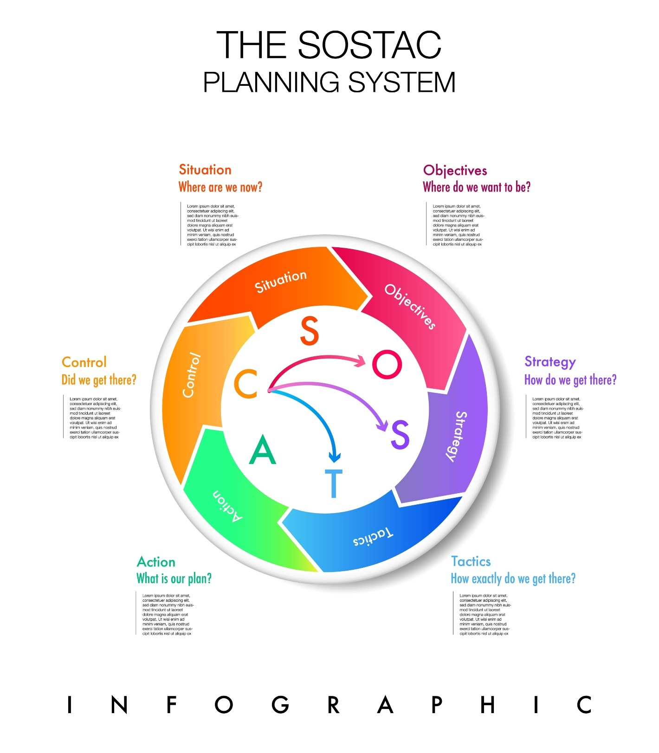

II. Objectives (Where do we want to be?)
Measured over a 12-month operational cycle.
- Short-Term (6–12 Months):
  - Increase the new client acquisition rate by 30%.
  - Maintain a session occupancy rate of at least 70%.
  - Build a strong digital presence with targeted follower growth.
  - Launch 3–5 group counselling programs.
- Long-Term:
  - Establish the clinic as the primary trusted mental health reference in the region.
  - Build an institutional brand identity independent of individual practitioner names.

III. Strategy (How do we get there?)
1) Targeting Strategy: Focus on middle-to-high-income urban adults with existing mental health awareness.
2) Value Proposition: Providing evidence-based clinical and counselling services in a secure, confidential environment that blends individual therapy with preventive development.
3) Trust-Building Strategy (Education Before Sales):
- Publishing credible scientific content.
- Highlighting professional credentials and clinical success.
- Utilizing non-stigmatizing, empathetic language.
4) Differentiation: Integrating therapy with training, ensuring high-level privacy, and offering hybrid accessibility.

IV. Tactics (The details of strategy)
1) Digital Marketing:
- Consistent educational content on mental health.
- Short-form videos simplifying psychological concepts.
- SEO (Search Engine Optimization) for local mental health queries.
2) Community Engagement:
- Workshops in schools, universities, and corporate offices.
- Partnerships with HR departments for employee wellness.
3) Lead Generation:
- Brief introductory "Discovery Sessions."
- Low-cost or free public webinars.
- Discounted therapeutic packages for long-term commitment.
4) Specialized Training: Programs focused on Positive Parenting, Pre-marital Counselling, Stress Management, and Burnout Prevention.

V. Action (The execution phase)
1) Operational Structure:
- Assigning a Marketing Coordinator.
- Training front-desk staff on "Patient Experience" and clinical sensitivity.
- Implementing a secure CRM (Client Relationship Management) system.
2) Roadmap:
- Monthly content calendars.
- Quarterly launches of group programs.
- Monthly performance reviews.
3) Required Resources: Marketing budget, content management tools, and online booking platforms.

VI. Control (How do we monitor performance?)
Key Performance Indicators (KPIs):
- Volume: Number of new clients per month.
- Efficiency: Session occupancy rate and inquiry-to-booking conversion rate.
- Satisfaction: Client satisfaction scores (CSAT) and retention rates.
- Financial: Customer Acquisition Cost (CAC) vs. Lifetime Value (LTV).
Monitoring Mechanisms:
- Monthly marketing performance reports.
- Post-service satisfaction surveys.
- Regular strategy adjustments based on data-driven insights.

Concluding Summary
"The clinic utilizes the SOSTAC® model to systematically plan its marketing activities. By starting with a thorough situational analysis and setting measurable goals, the clinic implements a trust-based strategy. This ensures that marketing tactics remain sensitive to the psychological nature of the field while maintaining rigorous performance monitoring to ensure sustainable growth and high-quality care."

Marketing Communication Framework: The AIDA Model
Strategic Messaging for Mental Health Clinics and Counseling Services.

I. Attention (Breaking the Silence)
Objective: To capture the attention of individuals suffering in silence by reflecting their lived experience.
- Strategies: Use relatable, non-clinical language; normalize the struggle; avoid fear-mongering or stigmatization.
- Effective Hooks:
  - "Do you feel constant tension for no apparent reason?"
  - "Is daily stress starting to affect your sleep and relationships?"
  - "You are not alone... many suffer in silence."
  - "When anxiety becomes a part of your daily routine, it's time to ask for help."

II. Interest (Building Resonance)
Objective: To make the individual feel that the clinic truly understands their specific condition.
- Strategies: Briefly explain the psychological mechanisms at play; provide useful insights; showcase specialized expertise.
- Effective Messaging:
  - "Anxiety and depression are among the most common disorders, and they can be treated effectively."
  - "Ignoring psychological pressure for long periods can lead to escalating physical and mental symptoms."
  - "Early psychological support helps restore balance before issues worsen."
  - "Therapeutic sessions help you understand yourself and acquire healthy coping skills."

III. Desire (Creating the Intent)
Objective: To transform interest into a genuine desire to seek professional help.
- Strategies: Highlight tangible benefits; emphasize absolute confidentiality; provide realistic hope without over-promising.
- Effective Messaging:
  - "Individual sessions in a safe environment with complete confidentiality."
  - "A specialized team experienced in treating anxiety, depression, and family conflicts."
  - "Counselling programs designed to help you manage stress and improve your quality of life."
  - "Flexible options: Attend sessions in person at the clinic or via secure online platforms."

IV. Action (Lowering the Barrier to Entry)
Objective: To convert desire into an actual booking or inquiry.
- Effective Calls to Action (CTAs):
  - "Book your appointment now."
  - "Start your journey toward recovery."
  - "Contact us in complete confidence."
  - "Schedule your initial consultation."
  - "Register for the upcoming counselling program."

Integrated Advertising Templates

Example 1: Psychotherapy Sessions (Facebook/Instagram)
- Attention: Feeling like the weight of the world is on your shoulders?
- Interest: Constant stress doesn't just stay in your head—it affects your sleep, your focus, and your loved ones.
- Desire: We offer individual therapy sessions with licensed experts in a safe, judgment-free space that respects your privacy.
- Action: Book your session today and take a real step toward peace of mind.

Example 2: Pre-Marital Counselling Workshop
- Attention: Getting married soon but feeling anxious about the future?
- Interest: Psychological and cognitive preparation for marriage significantly reduces conflicts down the road.
- Desire: Our Pre-Marital Program equips you with communication skills and tools to manage differences healthily.
- Action: Register now for the upcoming cycle—limited seats available.

Example 3: Short Social Media "Quick-Hit"
- Attention: Emotionally exhausted most of the time?
- Interest: Professional support can help you understand your feelings and handle them healthily.
- Desire: Confidential sessions with qualified specialists—available in-person or online.
- Action: Book now and start the change.

Academic Summary (For Research or Reports)
"The clinic utilizes the AIDA model in its marketing campaigns to systematically engage the public. It captures Attention by addressing common psychological challenges, builds Interest through educational insights, fosters Desire by highlighting service benefits and confidentiality, and concludes with a clear Action through simplified booking and registration processes."

