

**CS251 – Software Engineering I**

|  |  |
| --- | --- |
| **Staff Memebers** | **Email** |
| **Dr Mohamed El Ramly** | **m.elramly@fci-cu.edu.eg** |
| Eng Catherine Bedrossian | c.bedrossian@fci-cu.edu.eg |
| Eng Sara Tarek Ali Othman | s.tarek@fci-cu.edu.eg |
| Eng Mohamed Samir | m.samir@fci-cu.edu.eg |
| Eng Marwa Nabil | m.nabil@fci-cu.edu.eg |
| Eng Yomna Magdy Mohamed | yomna@fci-cu.edu.eg |
| Eng Desoky Abd El-qawy | d.abdelqawy@fci-cu.edu.eg |
| Eng Omar Khaled Ali Ragab | o.khaled@fci-cu.edu.eg |
| Eng Mohamed Elarnaoty | m.elarnaoty@fci-cu.edu.eg |
| Eng Mostafa Saad | m.saad@fci-cu.edu.eg |

Contents

Team 3

Document Purpose and Audience 3

System Models 3

System Decomposition 4

Class diagrams 5

Sequence diagrams 6

Class - Sequence Usage 6

Physical Entity-Relationship Diagram 7

User Interface Design 8

Screen 1 – Sign in 8

Screen 2 – Account infotmation 9

Screen 3 – Home Page 10

Ownership Report 10

# Team

|  |  |  |  |
| --- | --- | --- | --- |
| **ID** | **Name** | **Email** | **Mobile** |
| 20120202 | Shady Shalaby Aly | [shady.shalaby1994@gmail.com](mailto:shady.shalaby1994@gmail.com) | 01281538099 |
| 20120205 | Sheref Mohammed Shokry | [sheref_shokry@yahoo.com](mailto:sheref_shokry@yahoo.com) | 01140229395 |
| 20120206 | Sherif Mohammed Abdul-Latif | [sherif.mohammed2016@gmail.com](mailto:sherif.mohammed2016@gmail.com) | 01112597719 |
| 20120214 | Sabry Ragab Darwish | [mypatience94@hotmail.com](mailto:mypatience94@hotmail.com) | 01118314788 |

# Document Purpose and Audience

# This document explains an easily buy, sell and exchange products online system. It describes the features that are provided by this system, system decomposition, class diagram, sequence diagram, physical entity (ERD) and system interface.

# Audience of this document system administrator, stockholder, testers and developers.

# System Models

## System Decomposition

## Class diagrams

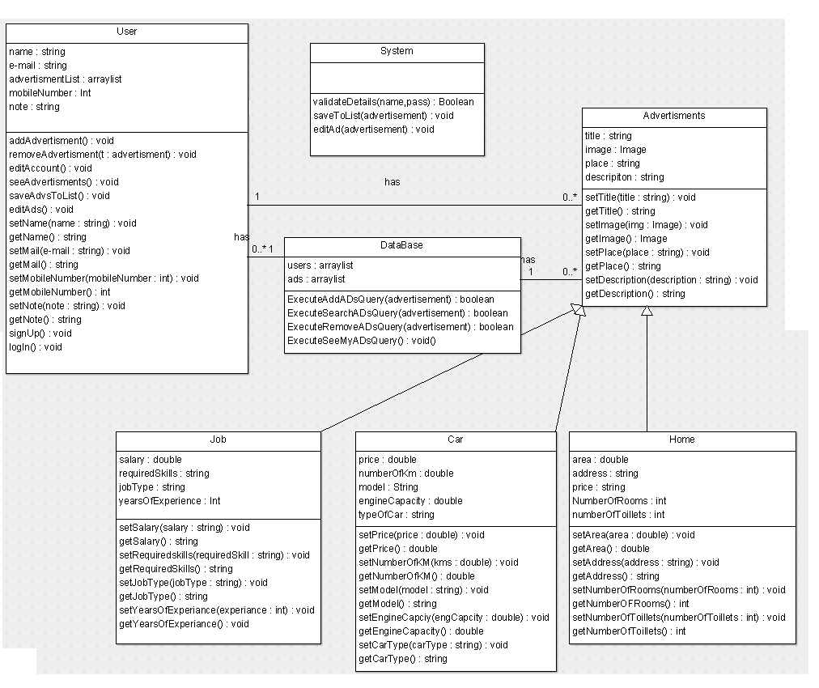

## Sequence diagrams

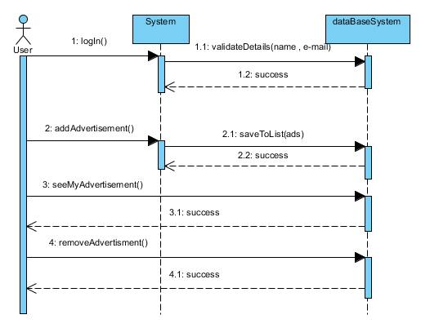

### Class - Sequence Usage

| **Class Name** | **Sequence Diagrams** | **Overall used methods** |
| --- | --- | --- |
| User | 1 , 1.2 , 2 , 2.2 | Login() , addAdvertisments() |
| System | 1.1 , 2.1 3 ,4 | validateDetails() ,savaToList() seeMyAdvertisment() ,removeAdvertisment() |

## Physical Entity-Relationship Diagram

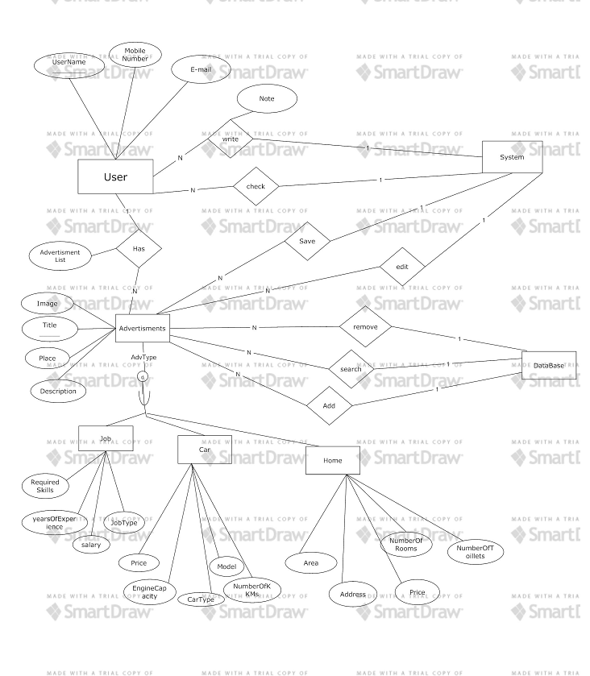

## User Interface Design

### Screen 1 – Sign in

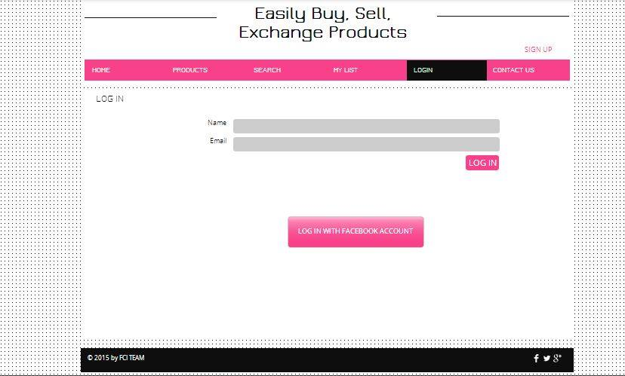

### Screen 2 – Account infotmation

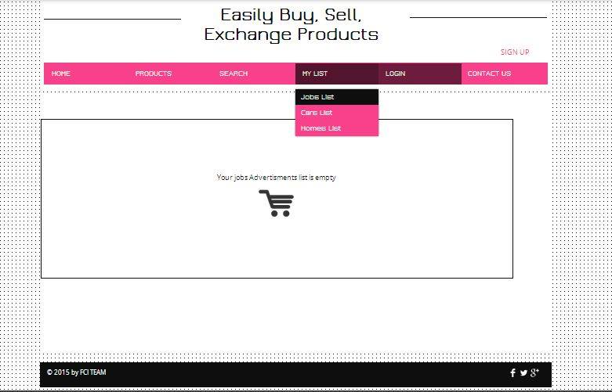

### Screen 3 – Home Page



# Ownership Report

|  |  |
| --- | --- |
| **Item** | **Owners** |
| System Decomposition | Sherif Abdul Latif |
| Class Diagrams | Shady Shalaby, Sherif Shokry, Sherif Abdel-Latif , Sabry Rageb |
| Sequence Diagrams | Sherif Abdel-Latif |
| Physical Entity-Relationship Diagram | Sabry Ragab |
| Interface | Sheref Shokry |