**Arab Academy for Science and Technology**

**College of Language and Communication**

**Object Oriented Programming**

Electronics Store

(Report)

**Submitted by:**

Loay Mohamed Gaber

Shady Mohamed Tarek

Ahmed Sobhy Metawea

**Department:** computer engineering

**Reg #:** 19101664 /19100178/19103156

**Submitted to:** Dr. Noha Ghatwary

**Introduction:**

Our project is about an Electronics Store that can be managed by administrators adding

products to database, removing or editing products in database as well as customers can have an account stored in our database storing their needed details, which is used to access our system and explore our store.

**GUI:**

First of all, our first form asks the user to login as an Admin or a customer then when they choose, they are directed to login page in order to enter their ID/Username and Password.

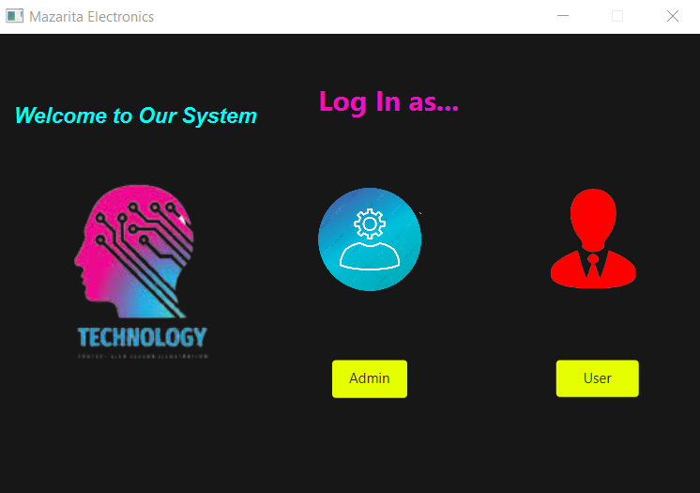

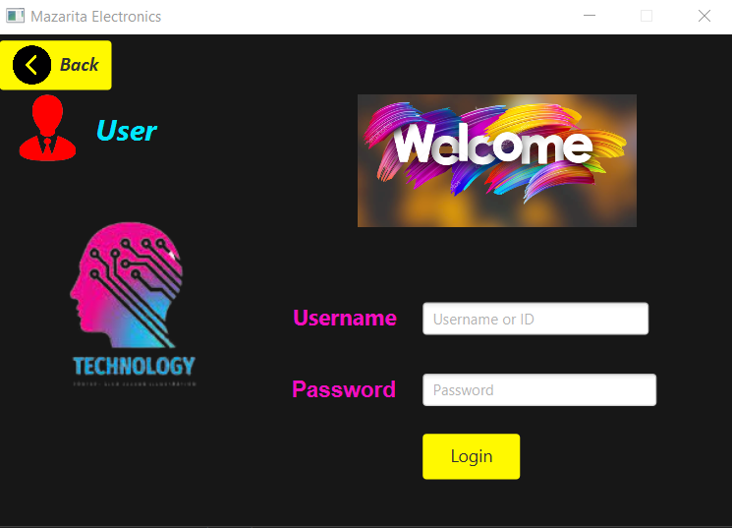

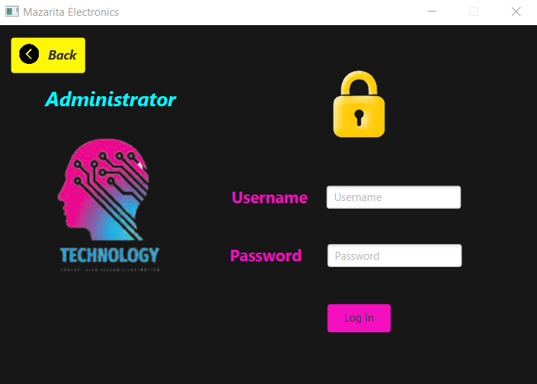

A verification check is done using the entered ID/Username and Password to see if this person is registered in our database or no.

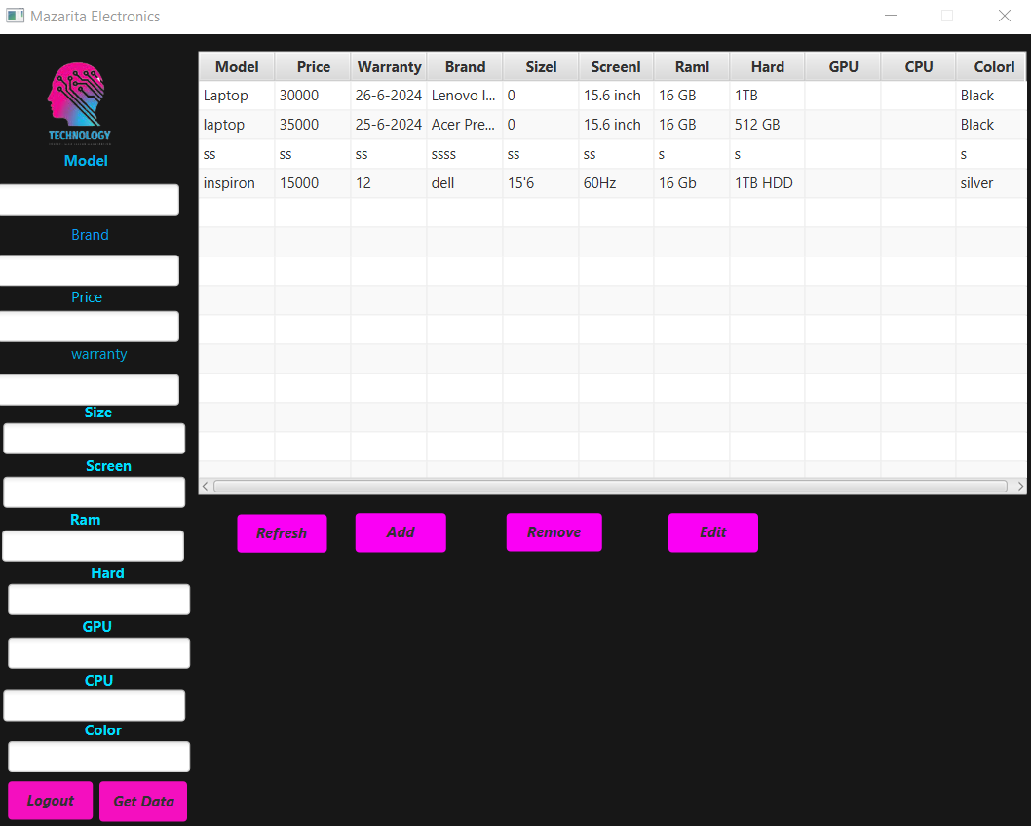

Using this table, admin can add products to database, remove or edit products as well as return his own stored data.

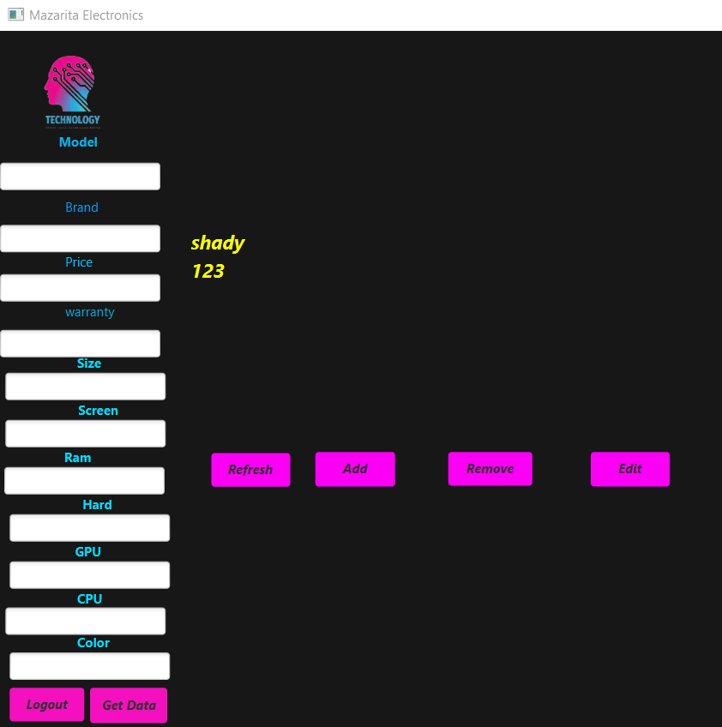

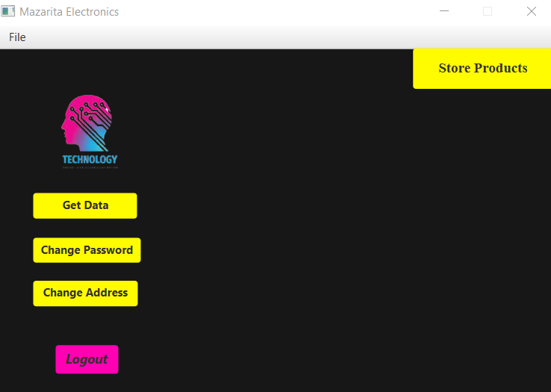

Here registered customer can get his own data as well as change his password or address and can also view our store products.

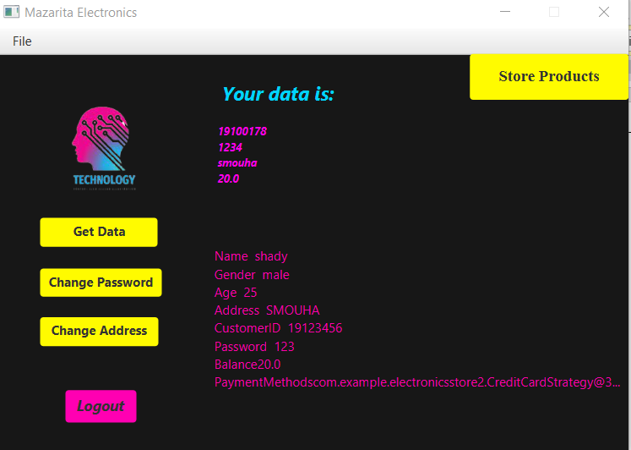

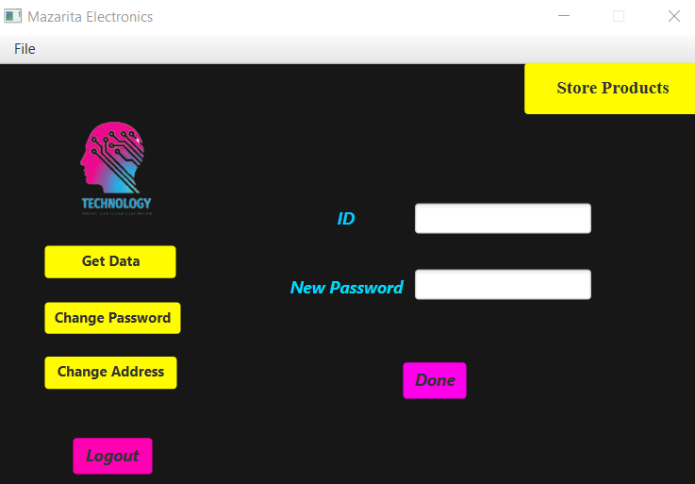

In order to change password, the customer must enter his ID as a verification in oreder to change his data in the database.

* Here the user enters his old address to update his address with the new address.

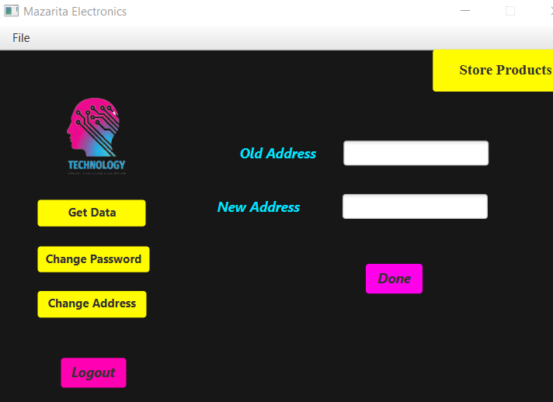

* Mobiles

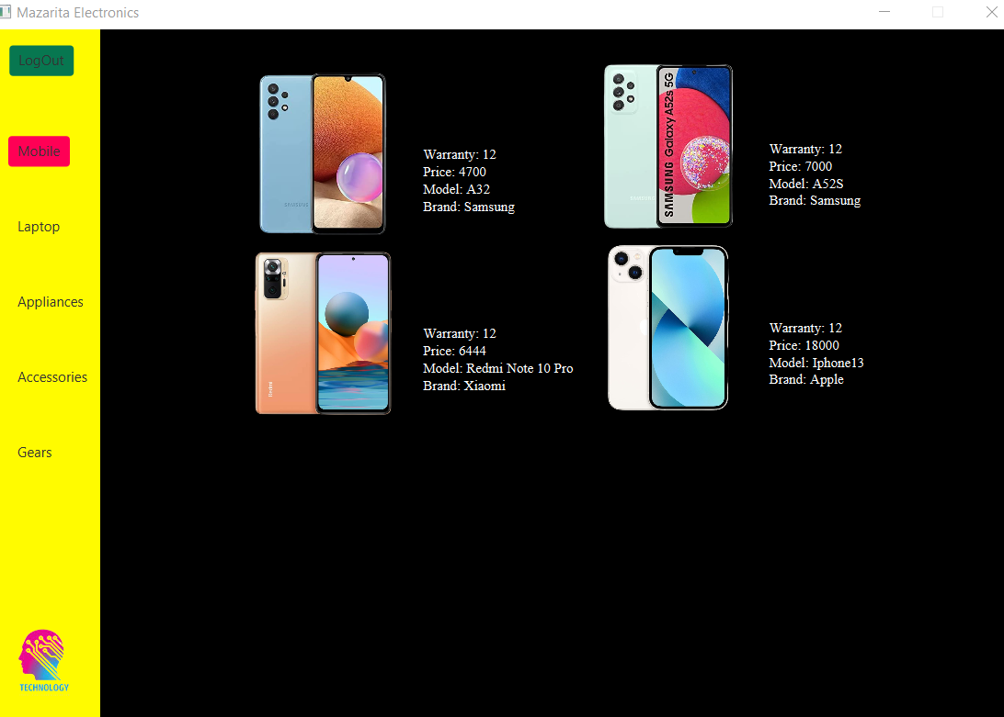

* Laptops

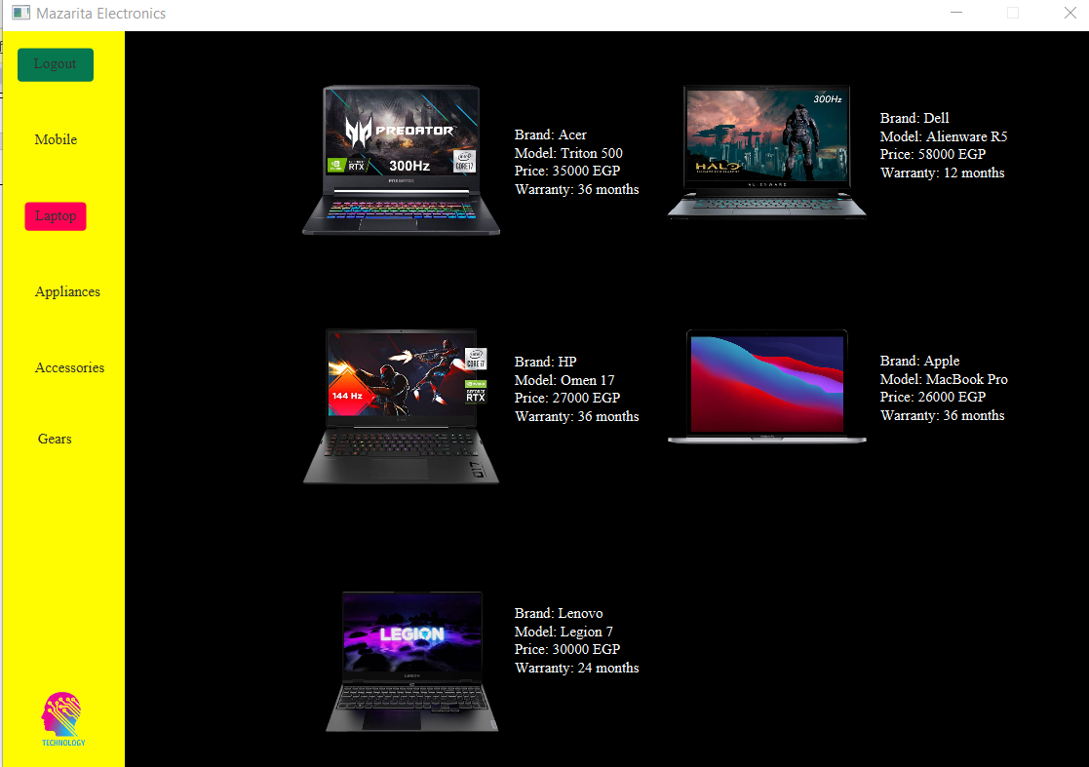

* Appliances

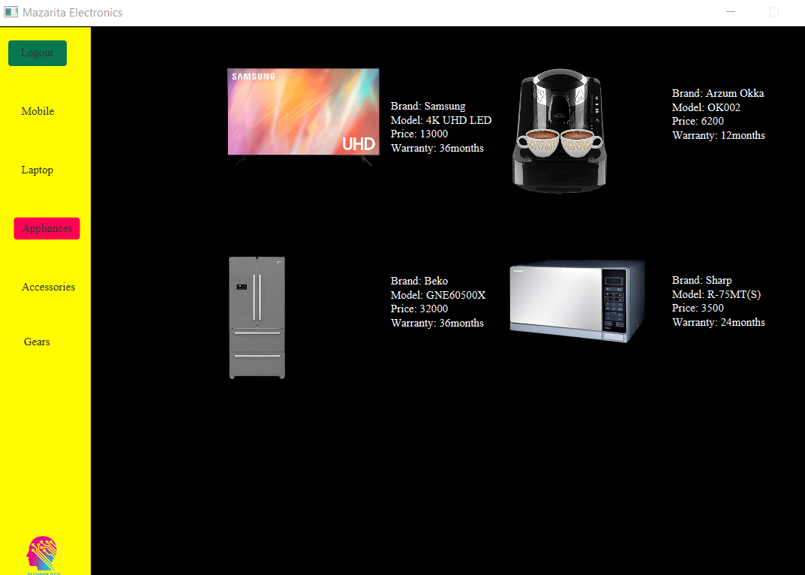

* Accessories

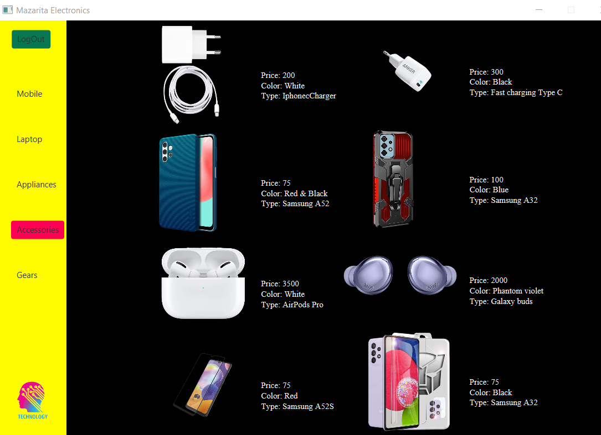

* Gears

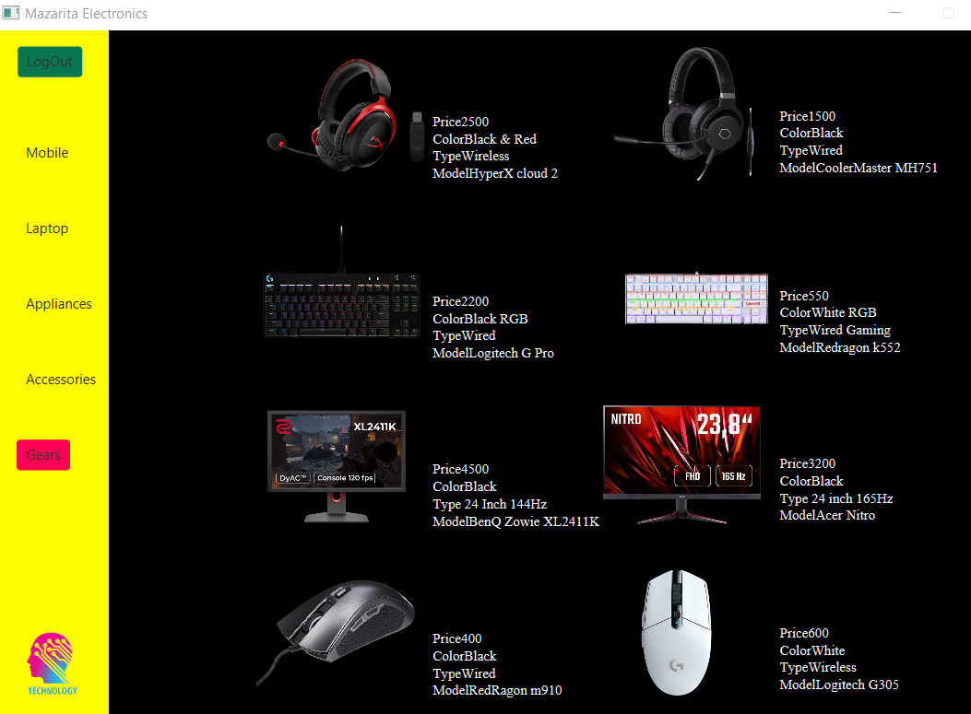

We can add to cart by pressing on any product a pop up will appear asking you to enter the name of the product and adding it to cart or removing a certain product from the cart.

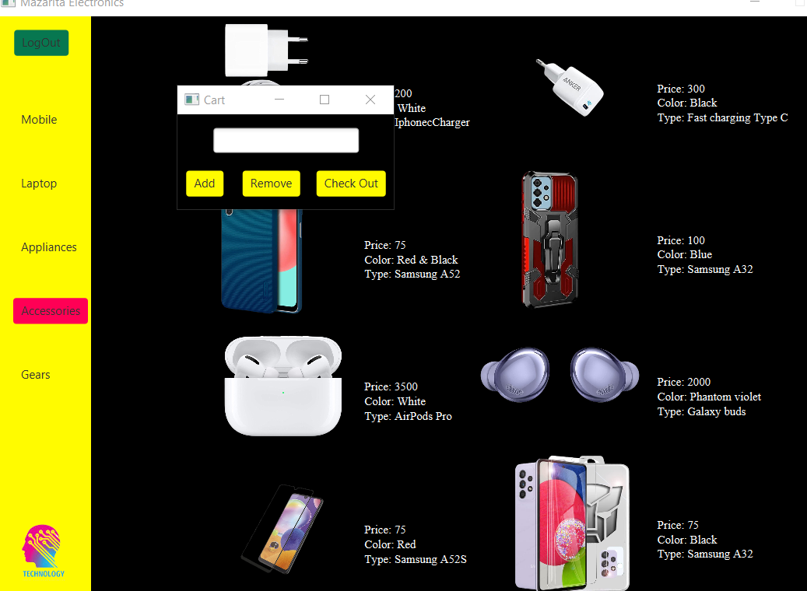

* Database:

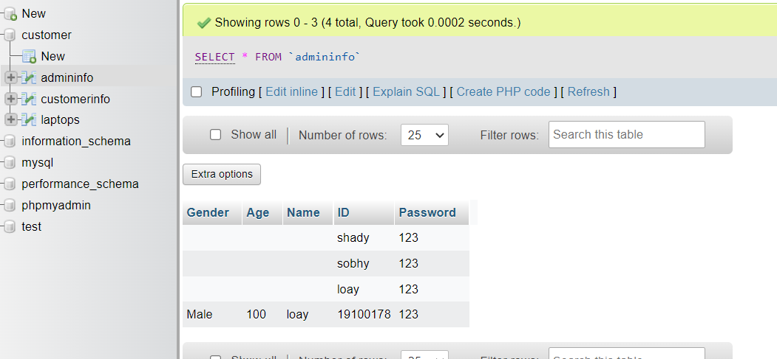

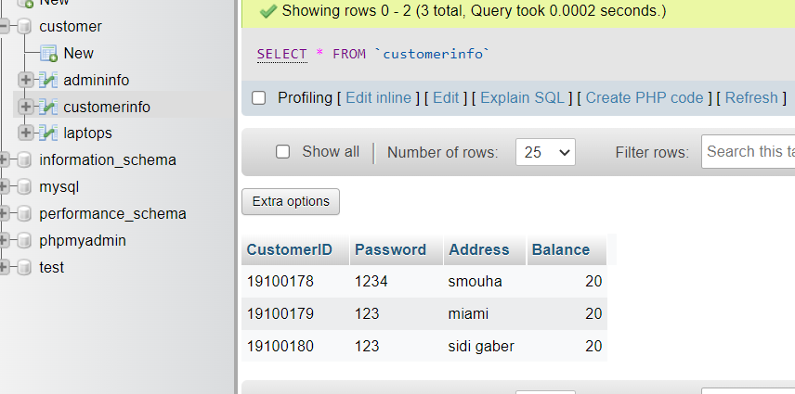

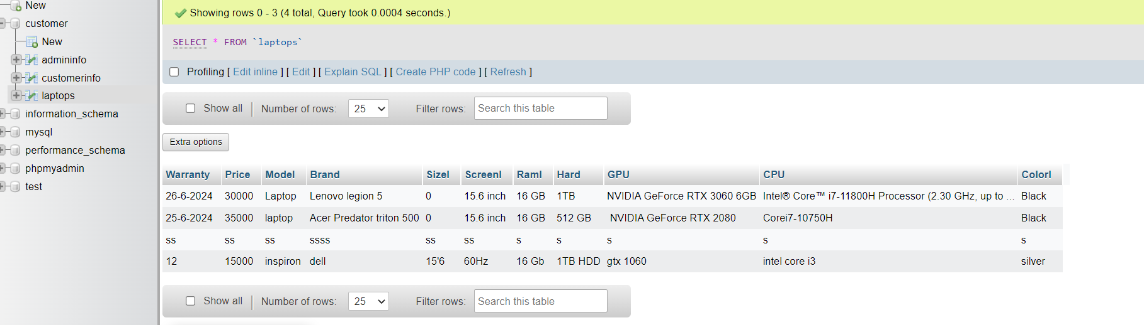

* UML

