**Absolute Loader**

**BY:**

Shady Mohamed Tarek 19100178

Loay Mohamed Gaber 19101664

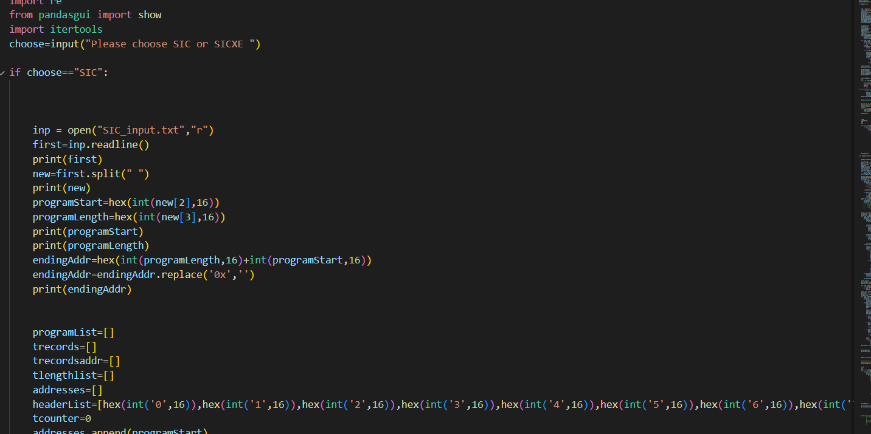Our main program asks the user to choose which program to run (SIC/ SICXE),for this case we are going to enter SIC to run our absolute program.

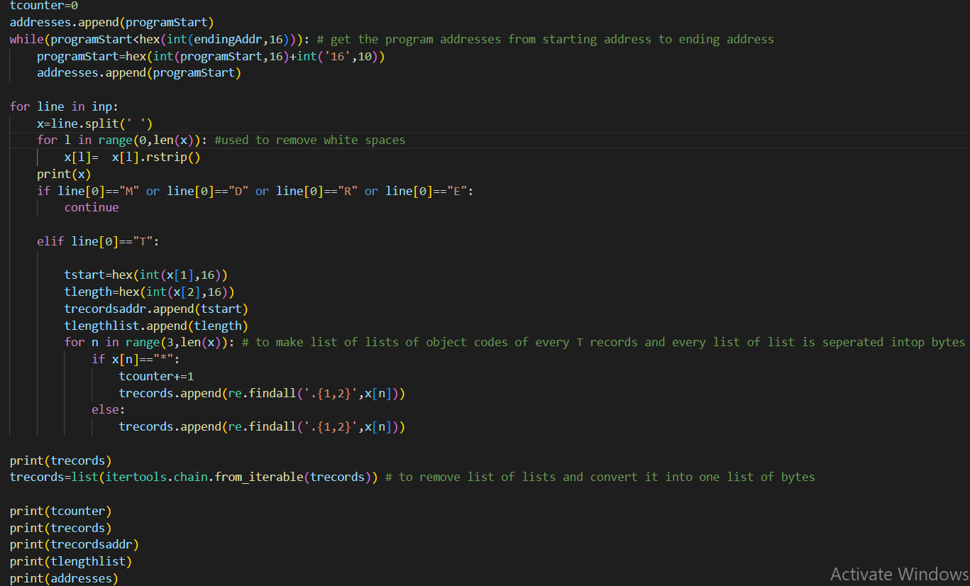

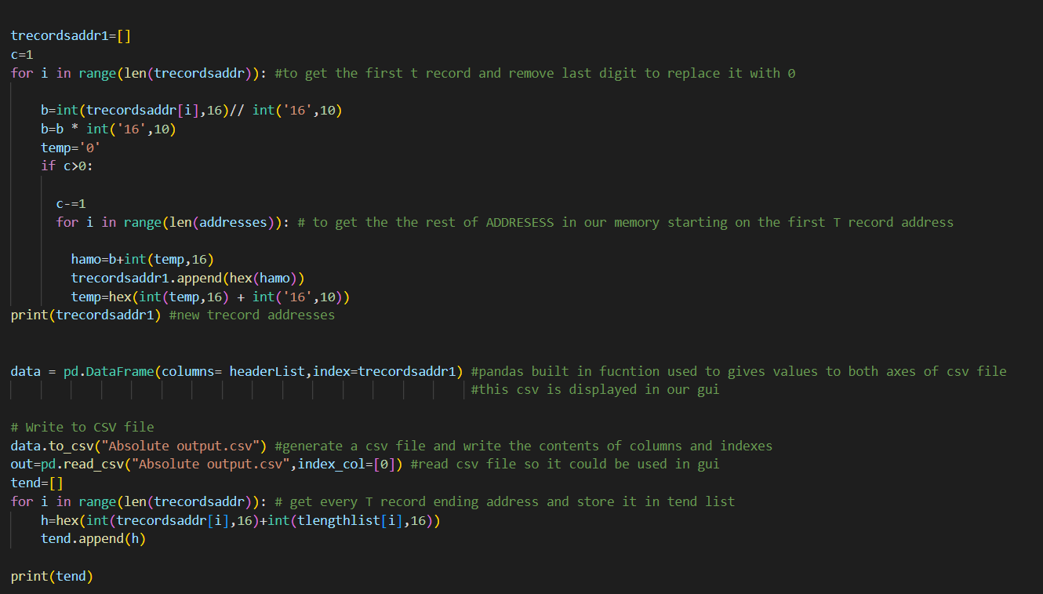

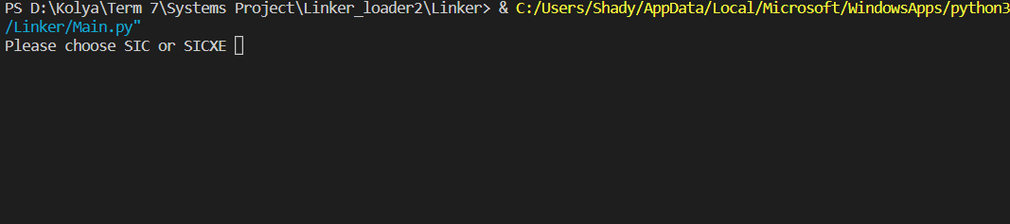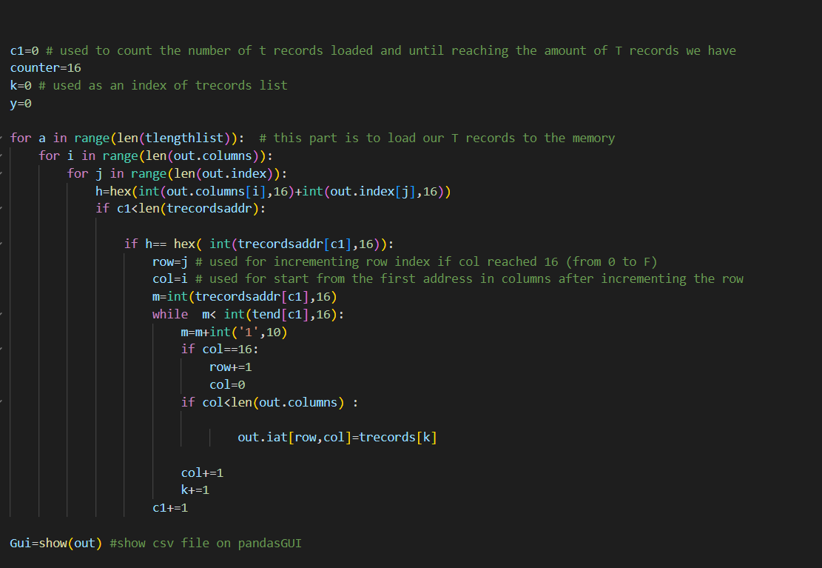

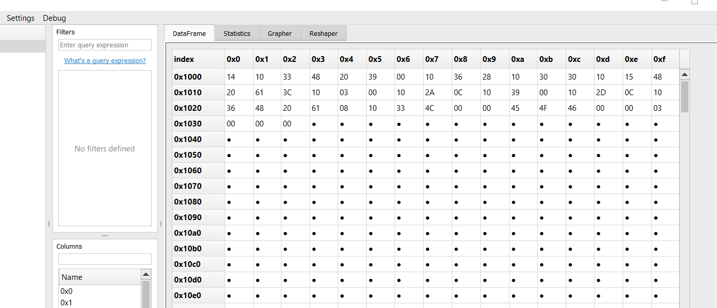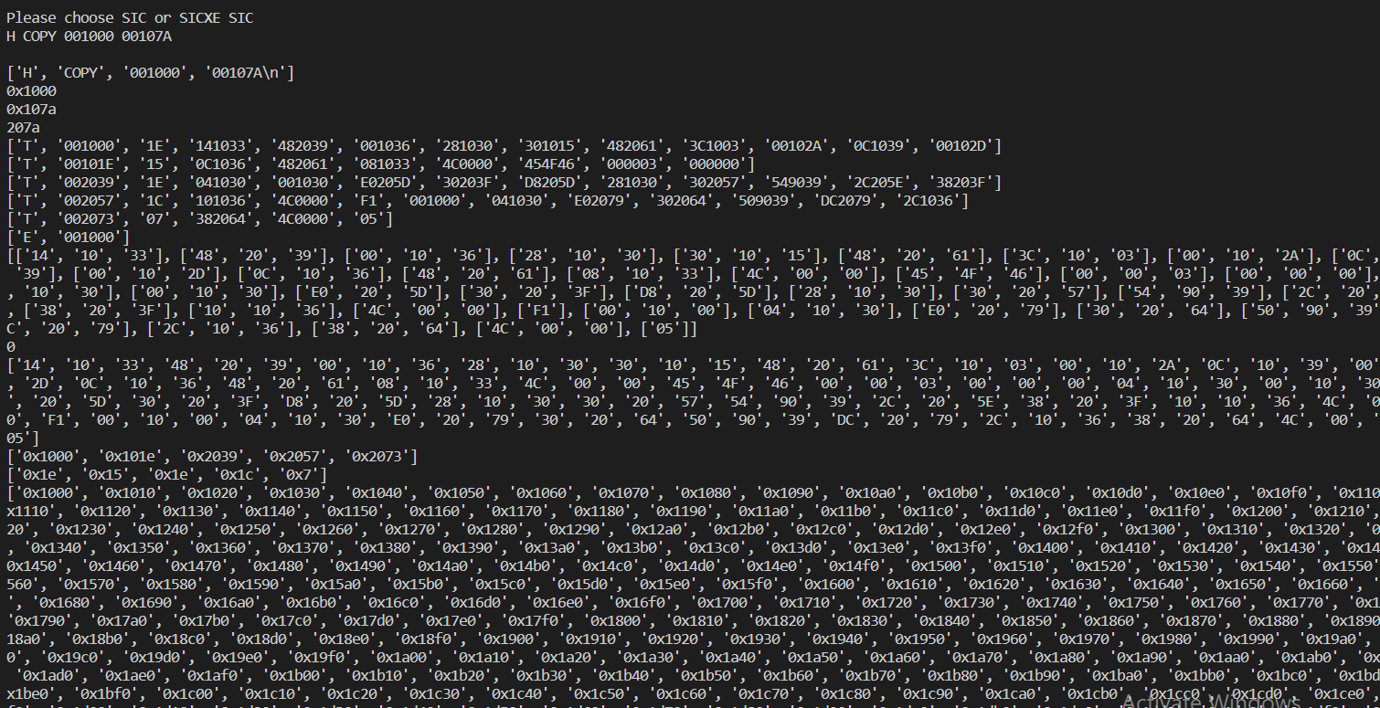

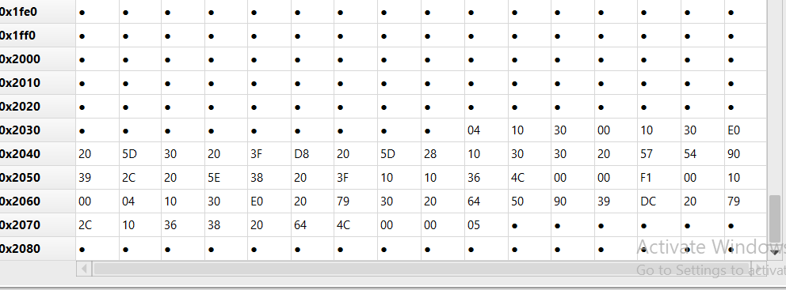

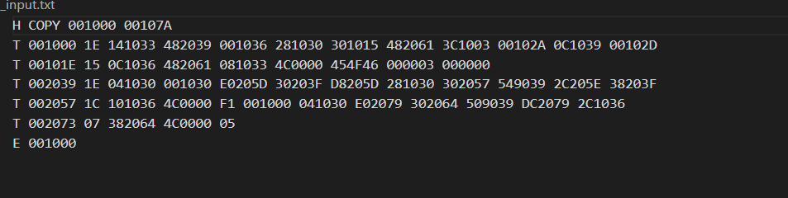

**Design issues:**

* We made a list of lists for trecords in order to load them in the memory but we had to access this list using a nested loop as when we did that we ecountered a index out of bound error so we converted the list of lists in to one list and we accessed this new list using an index counter (k).
* When loading trecords in the gui we had to handle incrementing the row when we reach column = 16 and when column<16 we keep the row value and increment column.