**Arab Academy for Science and Technology**

**College of Language and Communication**

Systems Programming

(Report)

**Submitted by:**

Shady Mohamed Tarek

Loay Mohamed Gaber

**Department:** computer engineering

**Reg #:** 19100178 / 19101664

**Submitted to:** Dr. Noha Seddik

1. **Statements on how to use our program:**

-python intermediate.py --data in.txt (input file)

- python pass_one.py --data intermediate.txt (input file)

- python pass_two.py --data out_pass1.txt (input file)

1. **Design issues:**

-white spaces in 3rd column and label column if it wasn’t replaced by a specific symbol an out of list index error will appear so any white spaces in columns must be replaced by symbols.

**Pass One:**

* Input File:

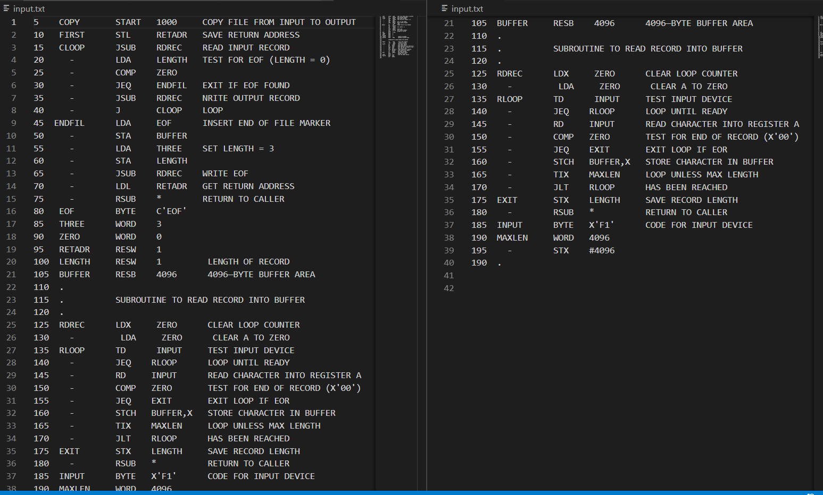

* 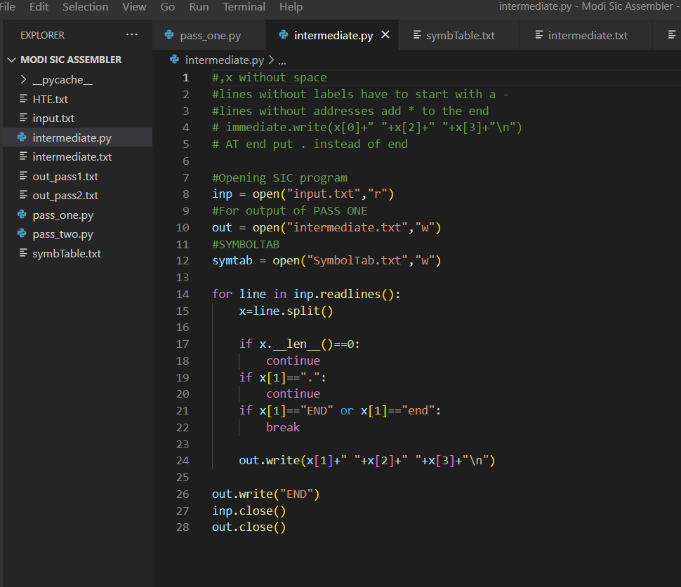Generating intermediate file Code:
* intermediate file:

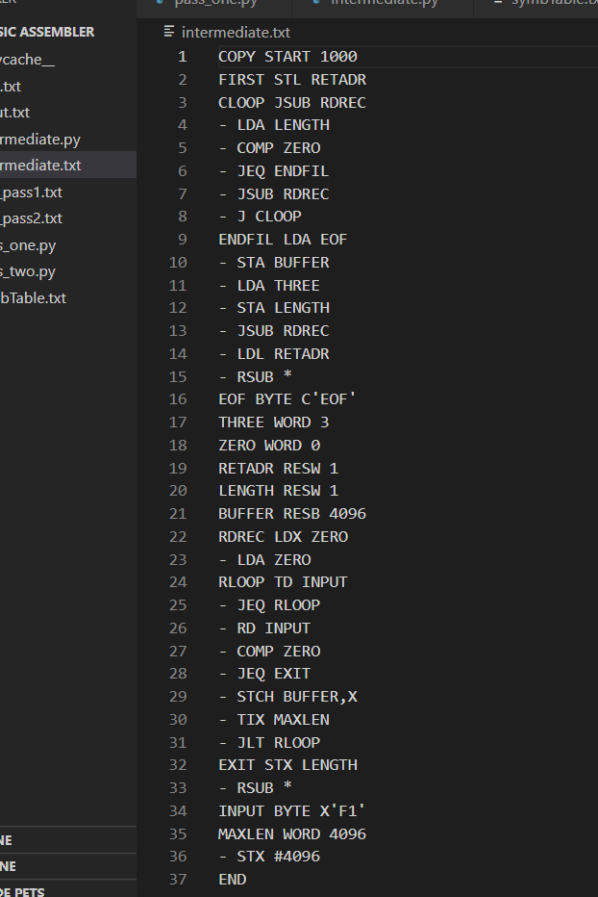

* Pass one code to generate the corresponding location counter of the input Program: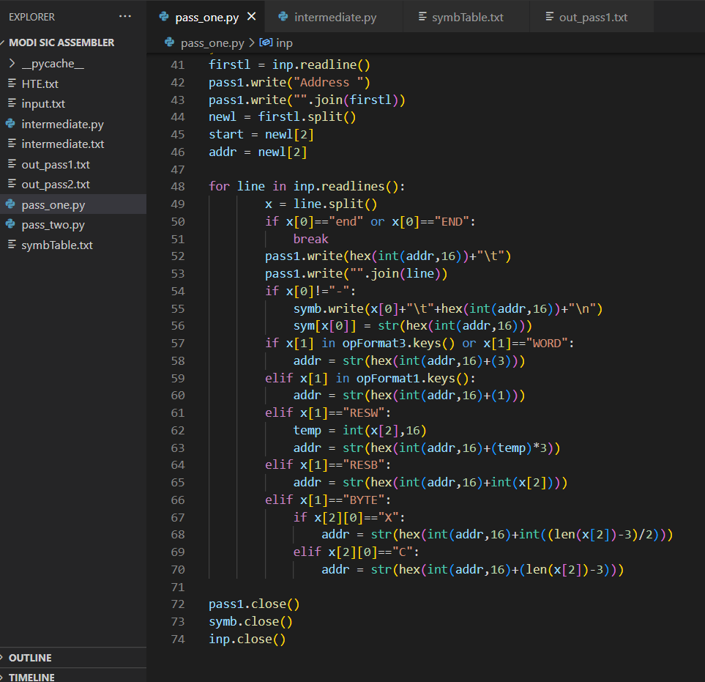
* Pass one output:

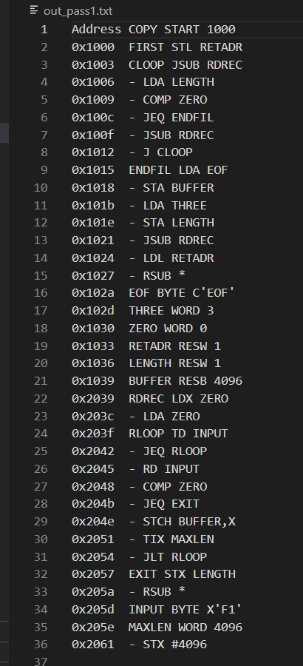

* Symbol table:

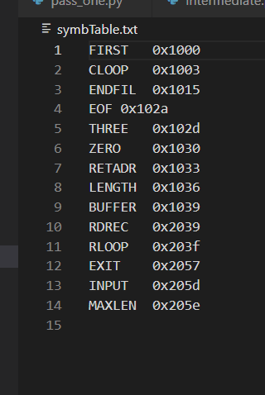

* Pass Two:

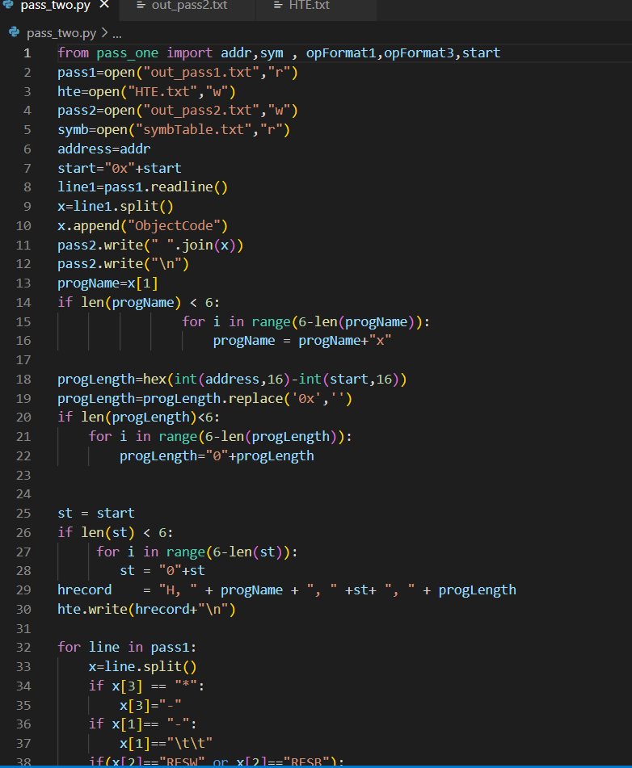

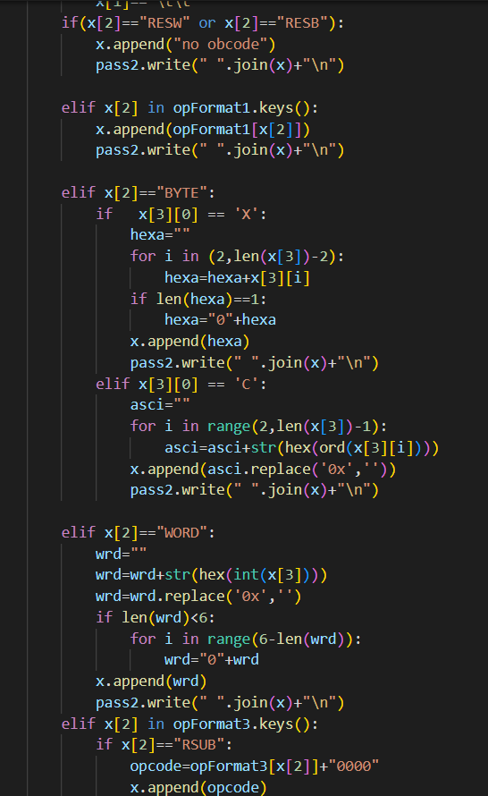

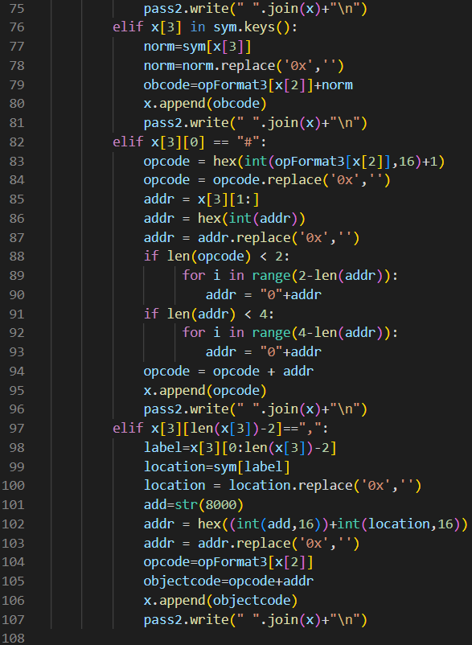

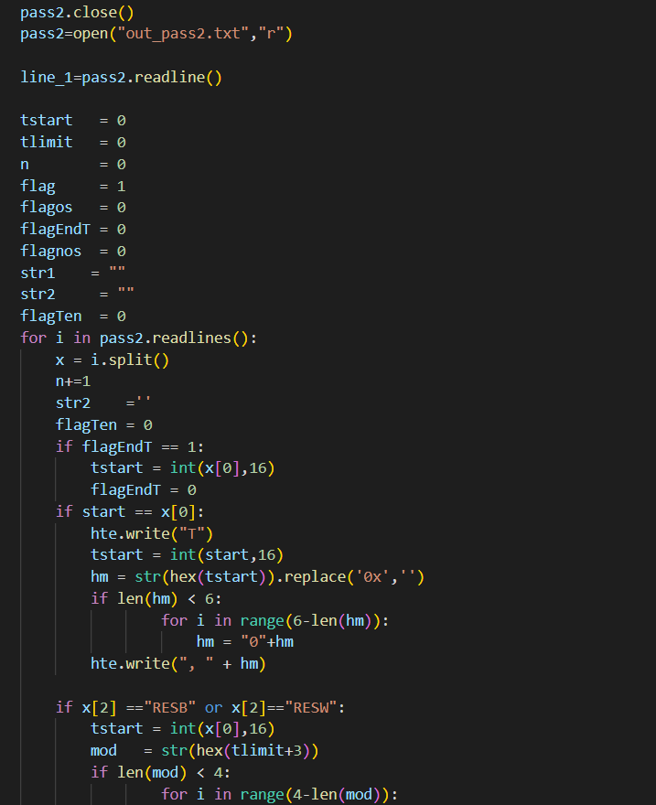

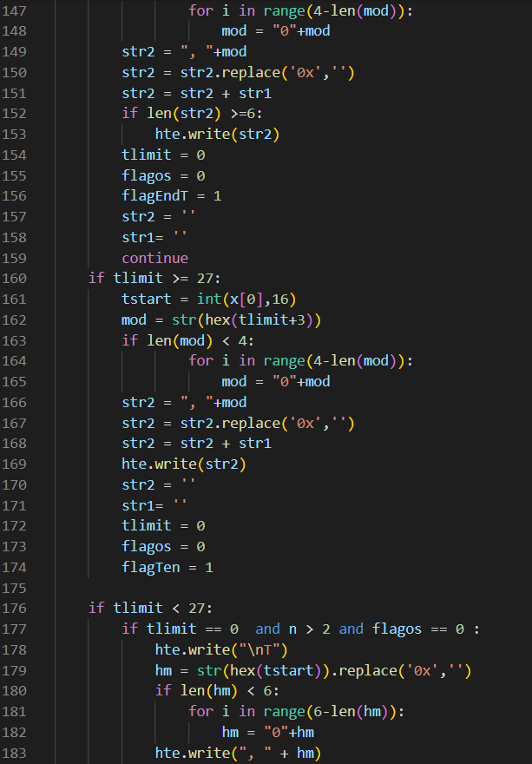

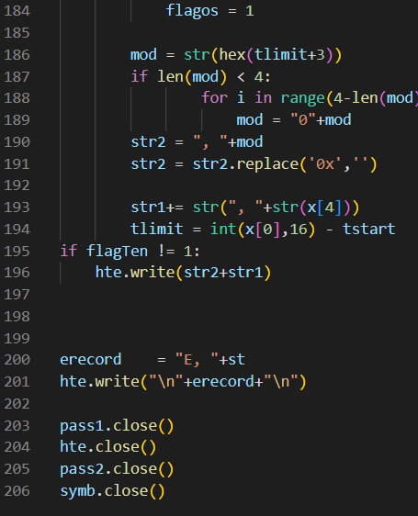

* Pass Two Output:

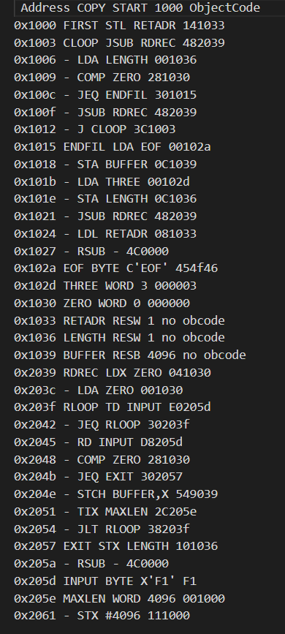

* HTE

