**What is Wireless LAN Controller (WLC) ?**

A Wireless LAN Controller (WLC) is a device that is used to manage and control a wireless local area network (WLAN) infrastructure. It is responsible for managing the wireless access points (APs) that provide wireless connectivity to devices such as laptops, smartphones, and tablets. The WLC performs tasks such as authentication, security, and quality of service (QoS) for the wireless network. It also provides centralized management of the APS, allowing administrators to configure and manage the WLAN from a single location.

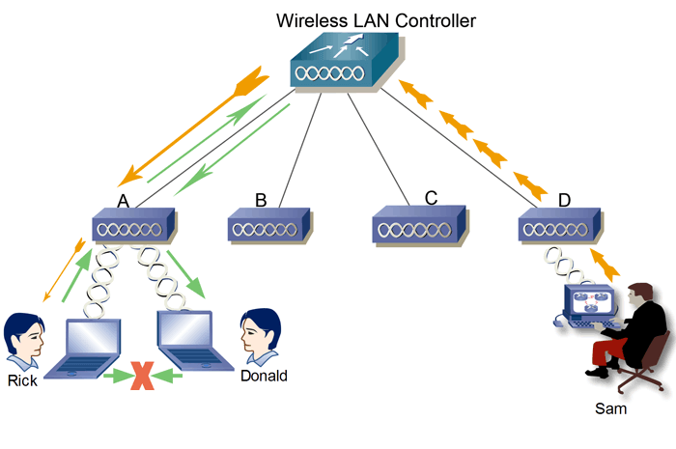

**References**

*Cisco. (2022, September 27). What is a WLAN controller? (WLC). Cisco. Retrieved December 23, 2022, from [cisco.com](https://www.cisco.com/c/en/us/products/wireless/wireless-lan-controller/what-is-wlan-controller.html)*

**Cisco Secure Access Control Server (ACS) ?**

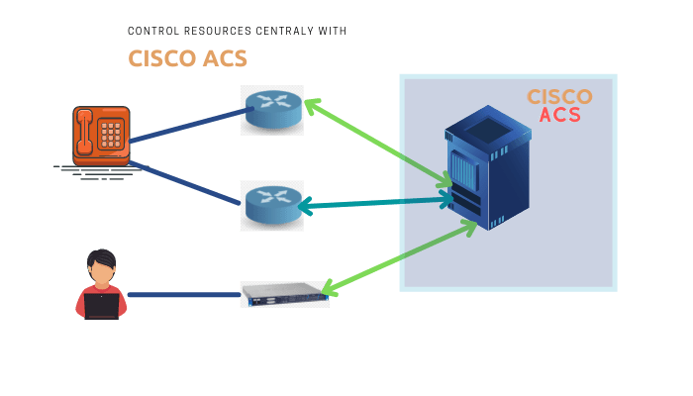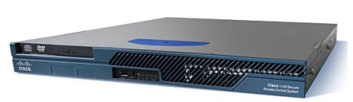Cisco Secure Access Control Server (ACS) is a network security solution that provides centralized authentication, authorization, and accounting (AAA) for networks. It is designed to help organizations manage user access to network resources, enforce security policies, and monitor network activity. ACS can be used to authenticate users on a variety of network devices, including routers, switches, and wireless access points. It supports a variety of authentication protocols, including RADIUS, TACACS+, and LDAP, and can be integrated with other security solutions such as firewalls and intrusion prevention systems.

**References**

*Introducing ACS. Cisco Content Hub - Introducing ACS. (n.d.). Retrieved December 23, 2022, from [cisco.com](https://content.cisco.com/chapter.sjs?uri=%2Fsearchable%2Fchapter%2Fwww.cisco.com%2Fcontent%2Fen%2Fus%2Ftd%2Fdocs%2Fnet_mgmt%2Fcisco_secure_access_control_system%2F5-3%2Fuser%2Fguide%2Facsuserguide%2Fintrod.html.xml)*

**What is User Awareness ?**

User awareness refers to the knowledge and understanding that individuals have about security practices and procedures within an organization. Users need to be aware of the potential risks and vulnerabilities associated with using networked systems and devices, as well as the policies and procedures in place to protect against these risks.

Having a high level of user awareness can help to prevent security breaches and other types of cyber incidents. This can be achieved through various means, such as providing user training and education, communicating security policies and procedures, and promoting a culture of security within the organization.

User awareness can also involve actively encouraging users to report suspicious activity or potential security threats, as well as providing resources and support to help them identify and mitigate potential risks. Overall, user awareness is an essential component of a comprehensive security program and can help to protect both the organization and its users from potential threats.

**References**

*User awareness*. User Awareness - an overview | ScienceDirect Topics. (n.d.). Retrieved December 23, 2022, from [sciencedirect.com](https://www.sciencedirect.com/topics/computer-science/user-awareness#:~:text=User%20awareness%20is%20knowledge%20that,that%20they%20will%20do%20so.)

**What is 6LoWPAN ?**

6LoWPAN (IPv6 over Low-Power Wireless Personal Area Networks) is a network protocol that enables the use of Internet Protocol version 6 (IPv6) over low-power wireless personal area networks (WPANs). It is designed to allow small, low-power devices such as sensors, actuators, and other Internet of Things (IoT) devices to communicate over short-range wireless networks using IPv6. One of the key features of 6LoWPAN is its ability to compress IPv6 packets to fit within the limited transmission capabilities of low-power WPANs. This is achieved through the use of header compression techniques, which remove unnecessary information from the packet header and reduce its size. 6LoWPAN also supports the use of mesh networking, which allows devices to communicate with each other directly without the need for a central hub or access point. 6LoWPAN is based on the IEEE 802.15.4 standard for WPANs and is often used in conjunction with other protocols such as Zigbee or Thread to provide a complete networking solution for IoT devices. It is widely used in a variety of applications, including home automation, smart cities, industrial automation, and healthcare.

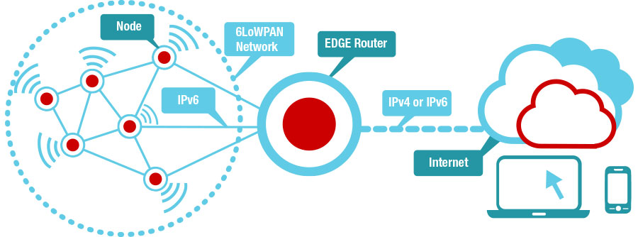

**References**

*What is 6lowpan?* GeeksforGeeks. (2022, July 21). Retrieved December 23, 2022, from [geeksforgeeks.org](https://www.geeksforgeeks.org/what-is-6lowpan/)