1. Interactive workbooks online

[The interactive map](https://public.tableau.com/app/profile/xiyu.zhang5851/viz/shared/PCJY75GBN) I created in Tableau

Could generate a portfolio online with multiple Tableau workbooks

1. Generate a dumbbell graph with dual axis 哑铃图

Tableau做双轴的图真的很方便！

Can see it on the same Tableau public account here.

Wrap up:

There exist other types of graphs – Alluvial graph, Sankey graph, among others – 不适合用Tableau做，还是可以寻找别的R包或者Power BI来做。

1. create an origin-and-destination map 出发-到达热线地图

数据处理可能比较麻烦- 可以用Trifacta 数据处理器，或者Tableau prep

Example: Trifacta wrangler

There are unique data set structure requirements for generating this type of map

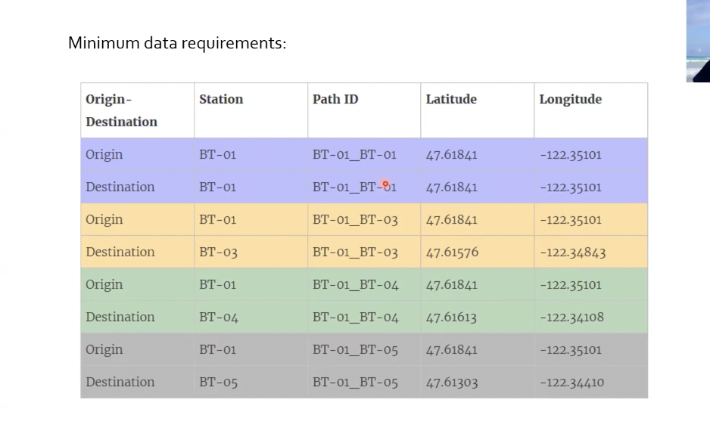Unique **path ID**

1. 第二个：去掉 far more，添加China，增加黑色波浪线
2. 第三个：副标题去掉US，mid point lighter green
3. 第四个 flip the axis，因为time，还有
4. 第五个 拉长整个chart，防止扁平的部分不知道有多少
5. Page 8 wider
6. 最后一个 number of ports – for clarification