**Image Recognition with IBM Cloud Visual Recognition**

# Emotion Recognition in Image Captioning Emotion recognition adds a new dimension to image captioning by detecting and expressing the emotions depicted in the image. With the help of advanced algorithms, images can be analyzed to identify emotions such as joy, sadness, surprise, and more.

**Project Update:**

We have created a website to upload and display Images

**Future Development of the Project:**

The website will be AI generated to caption the emotions in the uploaded image

**Source Code:**

**HTML Code**

<!DOCTYPE html>

<html lang="en">

<head>

<meta charset="UTF-8">

<title>Image Upload</title>

<link rel="stylesheet" href="style.css">

</head>

<body>

<div class="container">

<h1>Image Upload</h1>

<form id="upload-form" enctype="multipart/form-data">

<input type="file" name="file" id="file-input" accept="image/*">

<button type="submit">Upload</button>

</form>

<div id="preview">

<img id="image-preview" src="" alt="Image Preview">

</div>

</div>

<script src="script.js"></script>

</body>

</html>

**CSS Code**

body {

font-family: Arial, sans-serif;

}

.container {

max-width: 400px;

margin: 0 auto;

text-align: center;

}

h1 {

margin-top: 20px;

}

form {

margin: 20px 0;

}

input[type="file"] {

display: none;

}

button {

padding: 10px 20px;

background-color: #007BFF;

color: #fff;

border: none;

cursor: pointer;

}

button:hover {

background-color: #0056b3;

}

#preview {

display: none;

margin-top: 20px;

}

#image-preview {

max-width: 100%;

}

**Javascript Code**

const fileInput = document.getElementById('file-input');

const imagePreview = document.getElementById('image-preview');

fileInput.addEventListener('change', function () {

const file = fileInput.files[0];

if (file) {

const reader = new FileReader();

reader.onload = function (e) {

imagePreview.src = e.target.result;

document.getElementById('preview').style.display = 'block';

};

reader.readAsDataURL(file);

}

});

const uploadForm = document.getElementById('upload-form');

uploadForm.addEventListener('submit', function (e) {

e.preventDefault();

const formData = new FormData(uploadForm);

});

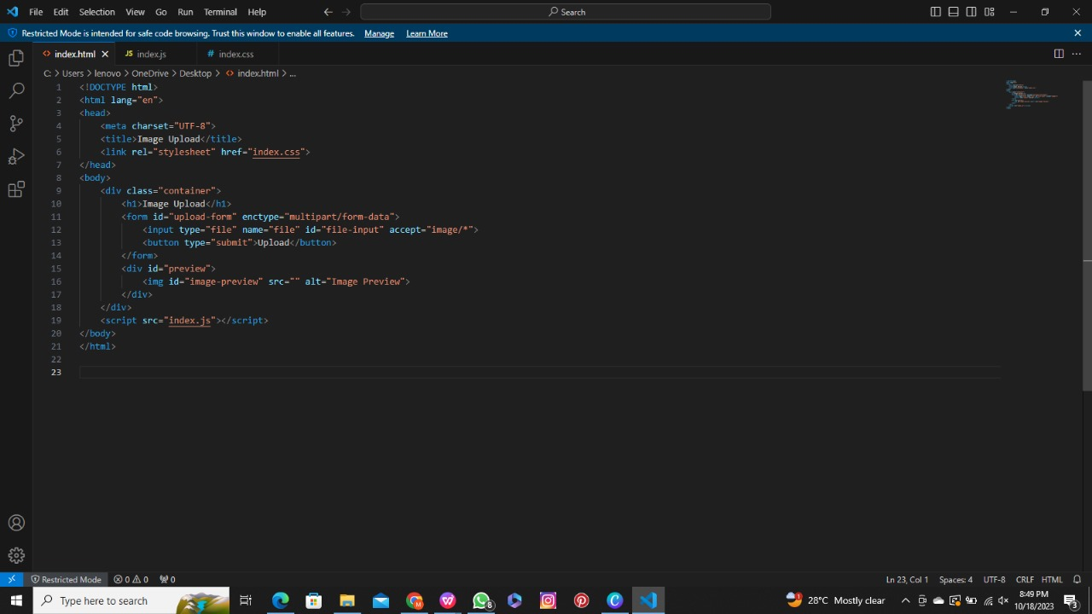

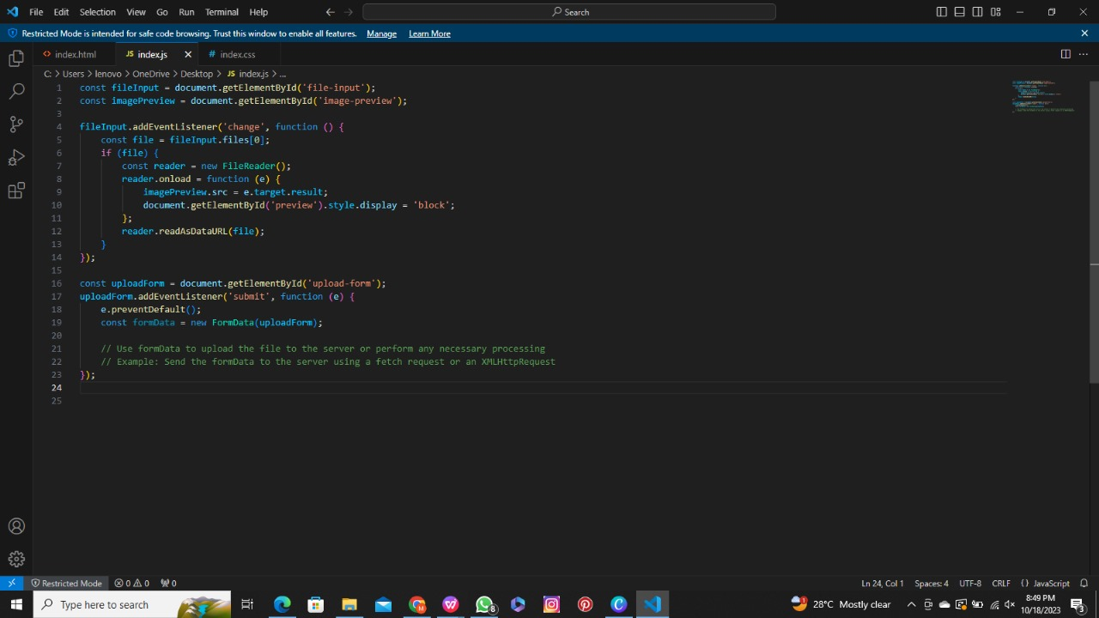

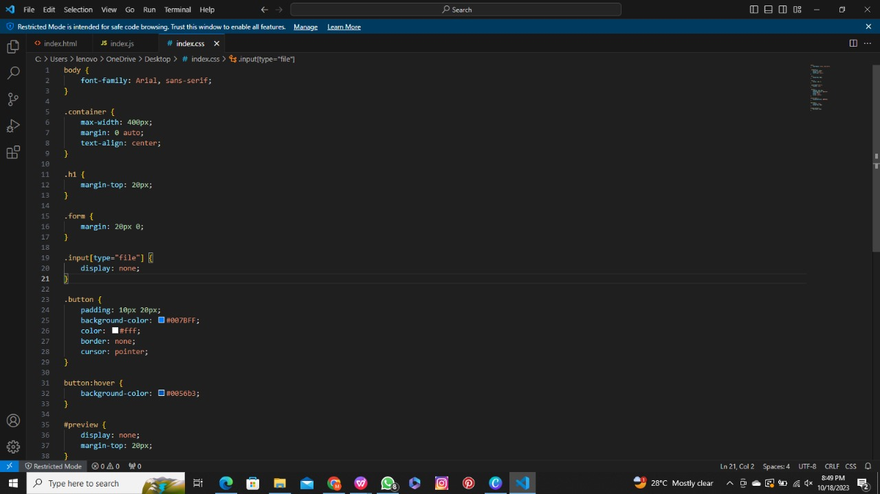

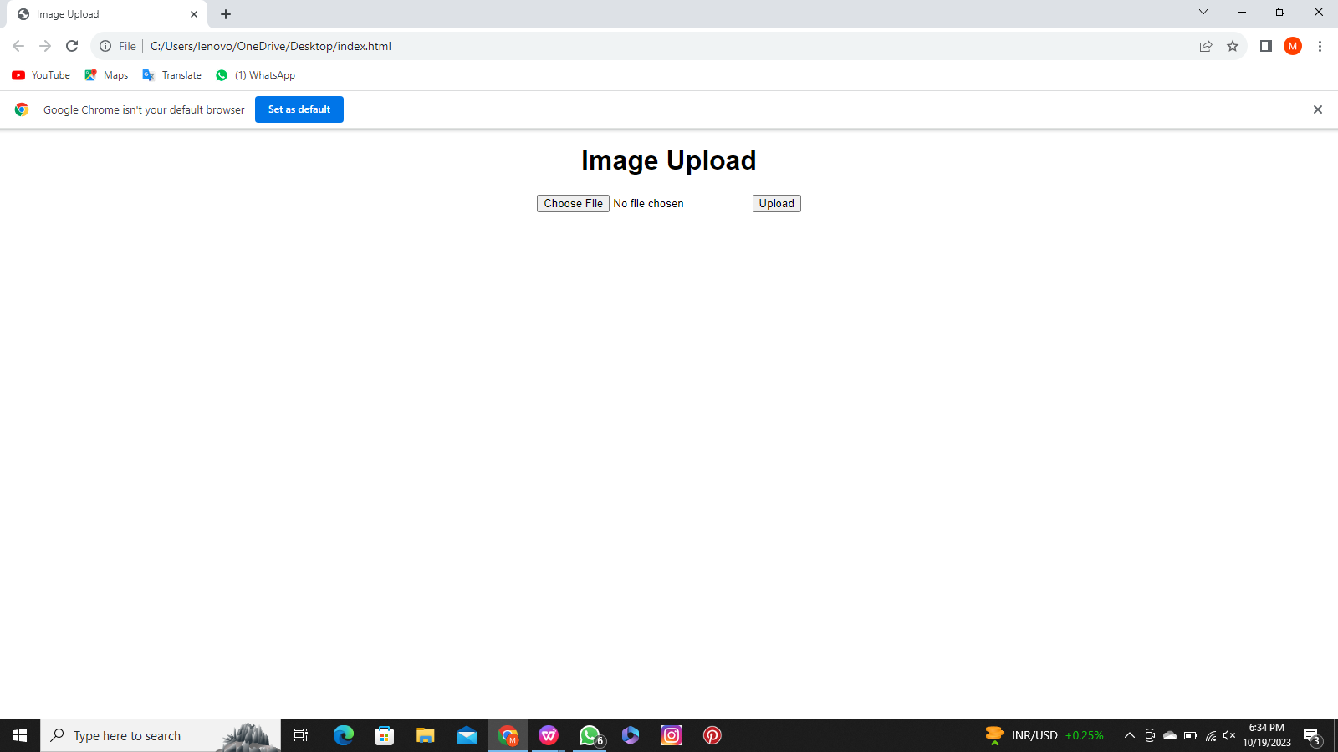

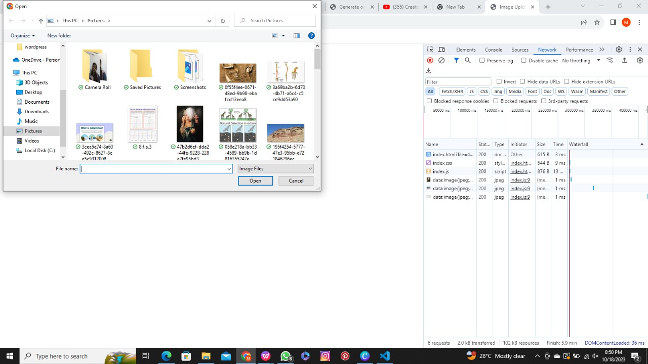

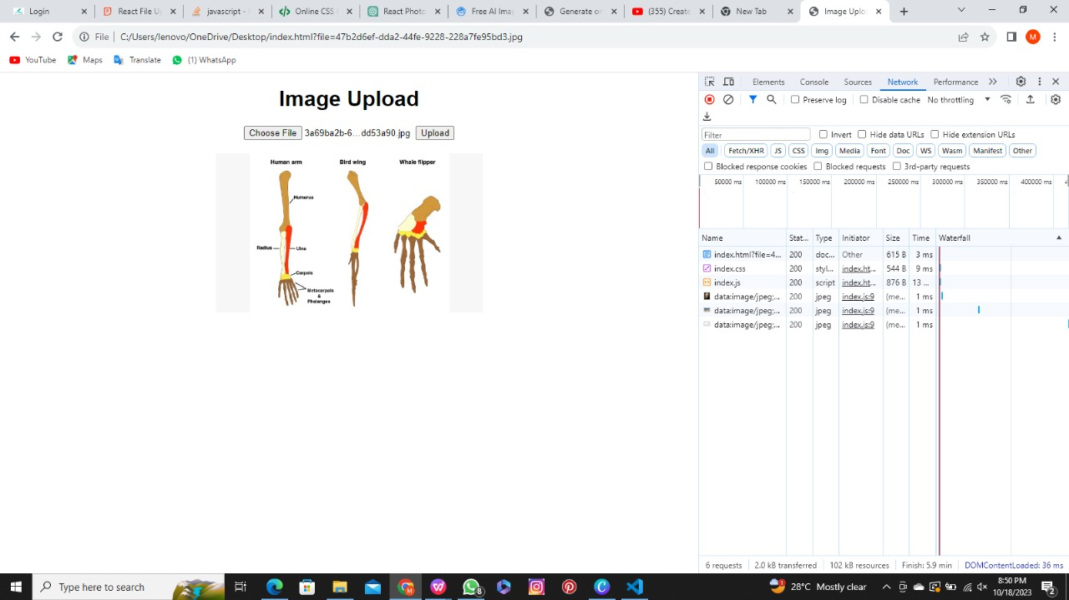

Link to website: https://1drv.ms/u/s!AuhxUHIC7GHOilx4arQ_SV9jfh3o?e=nRO7By