# Test Case 4:

1. The existing Video Learning project was trained with three small video data set know as Circle, Triangle and Rectangle. Now we have generated a new video dataset known as **Star**. Parameters were specified in the code and was used to run the **Run1()** function. By keeping all the parameters stagnant (HTM config) we have trained the HTM model with the SP + TM and **20** maxcycles. We have used **5 datasets** in this experiment **(Circle, Rectangle, Triangle, Pentagon and Star).** We have tried to run the model with 5 datasets several times. As we kept the **frameHeight = 18** and **frameWeight = 18**, the model was running for two days and kept generating the **Newborn cycles**. After two days we stopped the process as it was not showing any significant improvement. The following screenshot depicts the non-stop generation of Newborn cycles after two days.

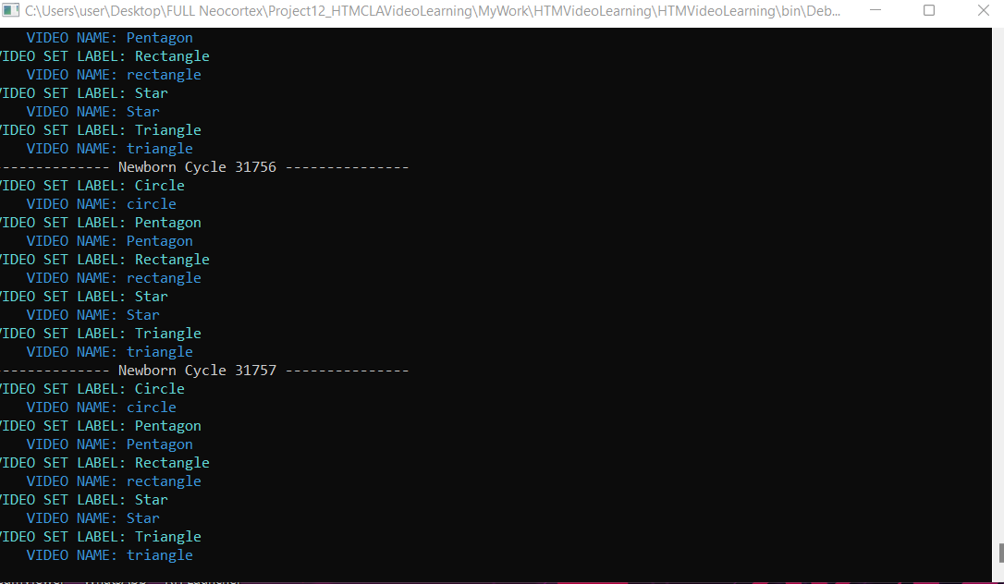

1. Then we changed the **frameHeight** and **frameWeight** parameters both to **20.** By keeping all other parameters stagnant (HTM config) we have trained the HTM model with the SP + TM and documented the accuracy after **20** cycles. We have noticed one thing that when we increased the size of frame height and weight, the runtime of the whole process significantly decreased.

Video Set of Label: **Circle reachs accuracy: 62.857142857142854%**

Video Set of Label: **Rectangle reachs accuracy: 45.714285714285715%**

Video Set of Label: **Pentagon reachs accuracy: 64.0625%**

Video Set of Label: **Star reachs accuracy: 63.74999999999999%**

Video Set of Label: **Triangle reachs accuracy: 88.57142857142857%**

**Accuracy in last Cycle (Cycle 19): 64.99107142857142%**

1. As we have trained the model with larger dataset **(5 videos**), we have increased the maxCycles parameter gradually to check the impact of this parameter on the average accuracy. So, we have changed the maxCycles parameter to 40 cycles and ran the experiment again. The following results were generated after **40** cycles. Here the **frameWeight** and **frameHeight** parameters are kept unchanged which is **20**.

Video Set of Label: **Circle reachs accuracy: 48.57142857142857%**

Video Set of Label: **Rectangle reachs accuracy: 51.42857142857142%**

Video Set of Label: **Pentagon reachs accuracy: 71.875%**

Video Set of Label: **Star reachs accuracy: 58.75%**

Video Set of Label: **Triangle reachs accuracy: 85.71428571428571%**

**Accuracy in last Cycle (Cycle 39): 63.26785714285714%**

1. Afterwards we have trained the model with maxCycles = 70. **We have noticed that if we train the model with 5 dataset it shows better training accuracy when the maxCycles is 20.** The following results were generated after 70 cycles.

Video Set of Label: **Circle reachs accuracy: 60%**

Video Set of Label: **Rectangle reachs accuracy: 45.714285714285715%**

Video Set of Label: **Pentagon reachs accuracy: 65.625%**

Video Set of Label: **Star reachs accuracy: 60%**

Video Set of Label: **Triangle reachs accuracy: 85.71428571428571%**

**Accuracy in last Cycle (Cycle 69): 63.410714285714285%**

1. Then we trained our model with **20** maxCycles and we have change the parameters **frameWidth** and **frameHeight** to **22**. The following results were generated after 20 cycles.

Video Set of Label: **Circle reachs accuracy: 54.285714285714285%**

Video Set of Label: **Rectangle reachs accuracy: 31.428571428571427%**

Video Set of Label: **Pentagon reachs accuracy: 62.5%**

Video Set of Label: **Star reachs accuracy: 70%**

Video Set of Label: **Triangle reachs accuracy: 77.14285714285715%**

**Accuracy in last Cycle (Cycle 19): 59.07142857142856%**

1. Then we trained our model with **20** maxCycles and we have change the parameters **frameWidth** and **frameHeight** to **24**. The following results were generated after 20 cycles.

Video Set of Label: **Circle reachs accuracy: 54.285714285714285%**

Video Set of Label: **Rectangle reachs accuracy: 31.428571428571427%**

Video Set of Label: **Pentagon reachs accuracy: 59.375%**

Video Set of Label: **Star reachs accuracy: 70%**

Video Set of Label: **Triangle reachs accuracy: 80%**

**Accuracy in last Cycle (Cycle 19): 59.01785714285713%**

1. So far, we have manipulated three parameters such as maxCycles, frameWeight and frameHeight. If the maxCycles is 20, frameWeight is 20 and frameHeight is 20 then the training accuracy is optimum for these 5 videosets. So, we trained our model with the specified parameters and checked the prediction process with 5 random frames taken from each of the five Converted video sets folder.
2. We took frame no 7 which is Circle_circle_7.png and found the result below. In the case of Circle, it did not successfully predict the next frame.

Predicted nextFrame: Circle_circle_18

Predicted nextFrame: Circle_circle_19

Predicted nextFrame: Pentagon_Pentagon_31

Predicted nextFrame: Pentagon_Pentagon_31

Predicted nextFrame: Pentagon_Pentagon_32

Predicted nextFrame: Pentagon_Pentagon_31

Predicted nextFrame: Pentagon_Pentagon_32

Predicted nextFrame: Pentagon_Pentagon_31

Predicted nextFrame: Pentagon_Pentagon_32

Predicted nextFrame: Pentagon_Pentagon_31

Predicted nextFrame: Pentagon_Pentagon_32

Predicted nextFrame: Pentagon_Pentagon_31

Predicted nextFrame: Pentagon_Pentagon_32

Predicted nextFrame: Pentagon_Pentagon_31

Predicted nextFrame: Pentagon_Pentagon_32

Predicted nextFrame: Pentagon_Pentagon_31

Predicted nextFrame: Pentagon_Pentagon_32

Predicted nextFrame: Pentagon_Pentagon_31

Predicted nextFrame: Pentagon_Pentagon_32

Predicted nextFrame: Pentagon_Pentagon_31

Predicted nextFrame: Pentagon_Pentagon_32

1. We took frame no 19 which is Rectangle_rectangle_19.png and found the result below. In the case of rectangle, it predicted the next frame successfully. (**Once**)

Predicted nextFrame: Circle_circle_12

Predicted nextFrame: Circle_circle_13

**Predicted nextFrame: Rectangle_rectangle_20**

Predicted nextFrame: Pentagon_Pentagon_49

Predicted nextFrame: Pentagon_Pentagon_47

Predicted nextFrame: Pentagon_Pentagon_48

Predicted nextFrame: Pentagon_Pentagon_49

Predicted nextFrame: Pentagon_Pentagon_48

Predicted nextFrame: Pentagon_Pentagon_49

Predicted nextFrame: Pentagon_Pentagon_48

1. We took frame no 13 which is Triangle_triangle_13.png and found the result below. In the case of Triangle, it predicted the next sequences of frames successfully.

**Predicted nextFrame: Triangle_triangle_14**

**Predicted nextFrame: Triangle_triangle_15**

**Predicted nextFrame: Triangle_triangle_16**

**Predicted nextFrame: Triangle_triangle_17**

**Predicted nextFrame: Triangle_triangle_18**

**Predicted nextFrame: Triangle_triangle_19**

**Predicted nextFrame: Triangle_triangle_20**

**Predicted nextFrame: Triangle_triangle_21**

**Predicted nextFrame: Triangle_triangle_22**

**Predicted nextFrame: Triangle_triangle_23**

**Predicted nextFrame: Triangle_triangle_24**

**Predicted nextFrame: Triangle_triangle_25**

**Predicted nextFrame: Triangle_triangle_26**

1. We took frame no 37 which is Pentagon_pentagon_37.png and found the result below. In the case of Pentagon, it predicted the next frame successfully. (**Multiple times**)

**Predicted nextFrame: Pentagon_Pentagon_37**

Predicted nextFrame: Pentagon_Pentagon_39

**Predicted nextFrame: Pentagon_Pentagon_37**

Predicted nextFrame: Pentagon_Pentagon_36

**Predicted nextFrame: Pentagon_Pentagon_37**

1. We took frame no 45 which is Star_star_45.png and found the result below. In the case of Pentagon, it predicted the next four frames successfully.

**Predicted nextFrame: Star_Star_46**

**Predicted nextFrame: Star_Star_47**

**Predicted nextFrame: Star_Star_48**

**Predicted nextFrame: Star_Star_49**

Predicted nextFrame: Star_Star_48

Predicted nextFrame: Star_Star_49

Predicted nextFrame: Star_Star_48

Predicted nextFrame: Star_Star_49

Predicted nextFrame: Star_Star_48

Predicted nextFrame: Star_Star_49

Predicted nextFrame: Star_Star_48

Predicted nextFrame: Star_Star_49