**KEY MILESTONE 1**

**Hospital Patient Management System**



**Database Management Systems Lab**

**Submitted By:**

SANA ZAHIR(22pwcse2151)

AYESHA AHMED(22pwcse2150)

SHAFAQ BUKHARI(22pwcse2154)

**Section:**

**C**

**Submitted to:**

Mam Sumayyea Salahudin

**Department of Computer Systems Engineering**

**University of engineering and technology, Peshawar**

**ENTITY DESCRIPTION**

|  |  |
| --- | --- |
| **Person** | Represents any individual in the system, including patients, doctors, and staff. It stores shared attributes such as name, contact, gender, and address. **Example:** A record of Mr. Ahmed, a 45-year-old residing in Lahore, with contact info stored. |
| **Patient** | An individual receiving medical services. Each patient may book appointments, receive prescriptions, and undergo tests. **Example:** Patient Maryam books an appointment and receives test results for a blood test. |
| **Doctor** | A licensed medical professional providing treatment. Each doctor belongs to a department and can issue prescriptions and order tests. **Example:** Dr. Imran from Cardiology department treats patients every Monday and Friday. |
| **Staff** | Non-medical employees such as clerks or receptionists who assist in hospital operations. **Example:** Receptionist Fatima manages patient check-ins and updates room availability. |
| **Nurse** | A specialized staff member who provides patient care and assists in appointments. **Example:** Nurse Rabia assists Dr. Waleed during surgical appointments. |
| **Department** | An organizational unit such as Pediatrics or Surgery headed by a doctor and comprising multiple staff and doctors. **Example:** The Orthopedics department is located on the second floor and headed by Dr. Sameer. |
| **Room** | A physical location where appointments take place, with properties such as type, availability, and floor. **Example:** ICU Room #302 is currently occupied and not available for new bookings. |
| **Appointment** | A scheduled interaction between a patient and doctor, optionally involving a nurse and a room. **Example:** Appointment #1203 between Patient Ayesha and Dr. Hina in Room 105 at 10 AM. |
| **Billing** | Tracks payment details linked to an appointment, including amount, status, and insurance claims. **Example:** Bill #B0093 shows Rs. 4000 paid via debit card and claimed under insurance. |
| **Prescription** | Details medication and treatment instructions provided by a doctor during an appointment. **Example:** Prescription for antibiotics issued by Dr. Yasir for Patient Kamran. |
| **Insurance Provider** | Stores data about external companies offering insurance coverage to patients. **Example:** Jubilee Insurance provides health coverage for patients like Saad. |

**Business Rules:**

* A Person can be either a Patient, Doctor, or Staff (ISA relationship).
* A Patient can make many Appointments; each Appointment is booked with one Doctor.
* A Patient can generate multiple Bills; each Bill is linked to one Patient and one Appointment.
* A Patient can have multiple Tests; each Test belongs to one Patient and is ordered by one Doctor.
* A Patient can receive multiple Prescriptions; each Prescription is issued by one Doctor during an Appointment.
* A Patient has one Primary Care Doctor; a Doctor can be primary care for many Patients.
* A Doctor can handle many Appointments; each Appointment is with one Patient.
* A Doctor has one Specialization and one Department.
* A Doctor can issue multiple Prescriptions; each Prescription is for a single Appointment.
* A Doctor can order multiple Tests; each Test is ordered for a single Patient.
* A Staff member has one Role and can belong to one or more Departments (M:N relationship).
* A Department has a unique ID, Name, and a Head Doctor; one Doctor can head only one Department.
* A Department can have many Doctors and many Staff Members.
* A Room has a unique ID, Block, Floor, Type, and Availability status.
* A Room can host multiple Appointments, but each Appointment is booked in only one Room.
* Appointments are of two types: Physical and Online.
* Physical Appointments must be linked to a Room; Online Appointments have no Room assigned.
* Each Appointment may optionally involve a Nurse (for preparation or assistance).
* A Nurse can assist in multiple Appointments; one Appointment may involve at most one Nurse.
* Insurance information is stored for each Patient; a Patient may have one Insurance Provider.
* Each Insurance Provider can be linked to multiple Patients.
* Billing is generated after each Appointment and reflects services and prescriptions involved.
* Only authorized Staff or Doctors can access sensitive Patient medical data.
* Room availability must be updated in real-time when linked to new or completed Appointments.

**Diagram:**

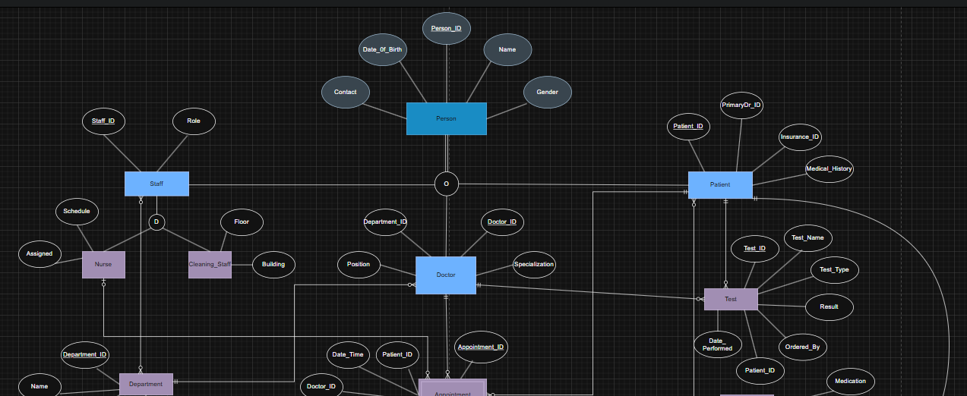

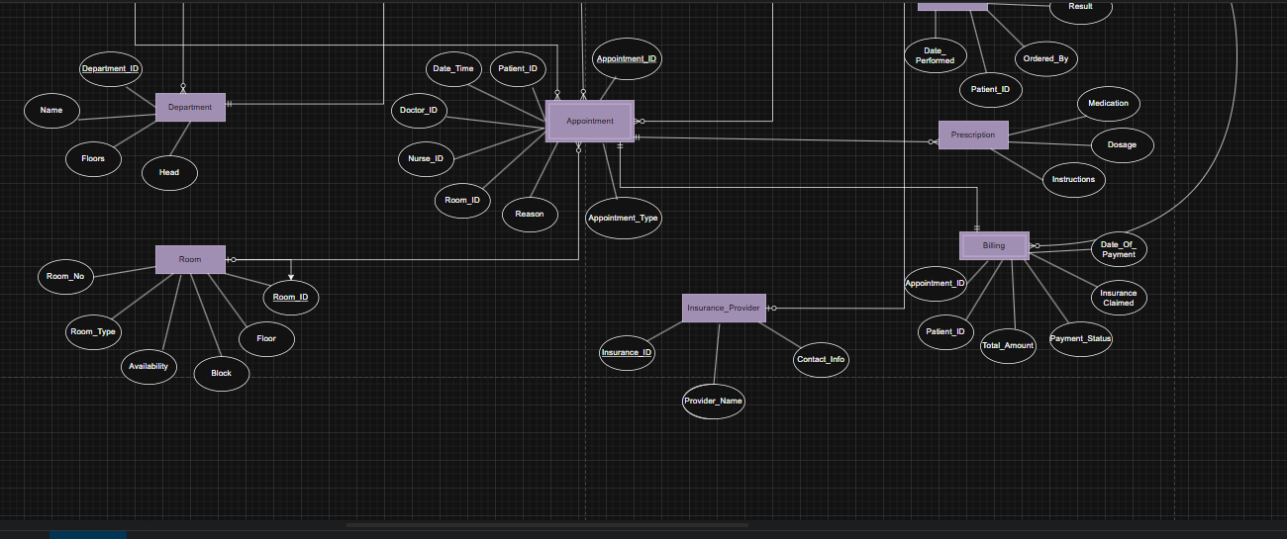

References:

* Elmasri, R., & Navathe, S. B.
* Coronel, C., & Morris, S.
* ChatGPT