**KEY MILESTONE :3**

**HOSPITAL MANAGEMENT SYSTEM**



**Database Management Systems Lab**

**Submitted By:**

Ayesha Ahmed (22pwcse2150)

Shafaq Bukhari (22pwcse2154)

Sana Zahir (22pwcse2151)

**Section:**

**C**

**Submitted to:**

Mam Sumayyea Salahudin

**Department of Computer Systems Engineering**

**University of engineering and technology, Peshawar**

The command mysql -u root is used to access the MariaDB monitor as the root user through the MySQL in XAMPP.

**DATABASE CREATION:**

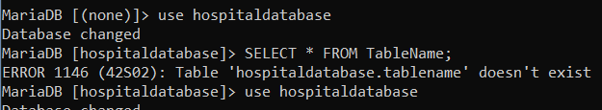

This command is use to show the database.

**PERSON TABLE**

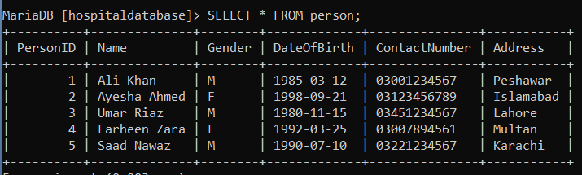

This table stores general information about all people in the hospital system. Every patient, doctor, or staff member is first entered here. It includes the person's ID, name, gender, date of birth, contact number, and address. This acts as a **superclass** for the other roles (Patient, Doctor, Staff) using ISA relationship.

**PATIENT TABLE**

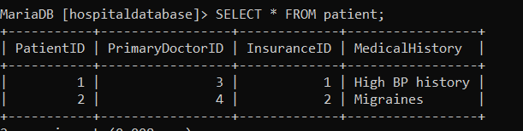

The patient table stores data specific to individuals who are receiving treatment. Each patient record is connected to a person from the person table and also linked to a primary doctor and an insurance provider. Additionally, medical history information is stored for each patient.

**DOCTOR TABLE**

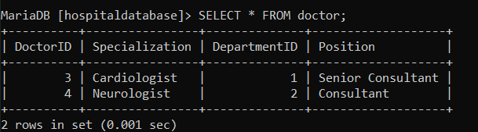

This table stores records of doctors in the hospital. Each doctor is also a person and belongs to a specific department. The table includes information like the doctor's specialization and job position. This helps in identifying the area of expertise and departmental role of the doctor.

**STAFF TABLE**

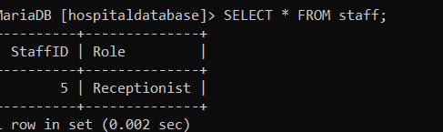

The staff table contains information about all non-doctor employees in the hospital such as receptionists, administrative staff, etc. Each staff member is also a person, and their specific role in the hospital is mentioned in this table.

**NURSE TABLE**

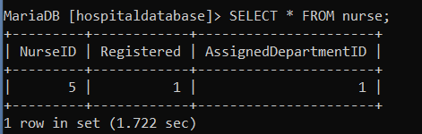

This table represents nurses who are a special category of staff. It stores whether the nurse is registered and to which department they are assigned. Each nurse is linked to a staff record..

**DEPARTMENT TABLE**

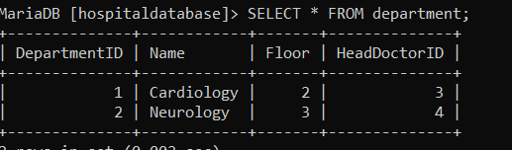

Departments are different units of the hospital like ICU, Surgery, etc. This table stores information such as department ID, name, floor, and the ID of the head doctor managing that department.

**ROOM TABLE**

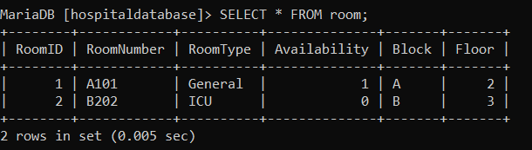

The room table tracks all rooms available in the hospital. It includes the room number, type (such as general or ICU), availability status, block name, and floor. This helps manage physical appointments and patient accommodations.

**APPOINTMENT TABLE**

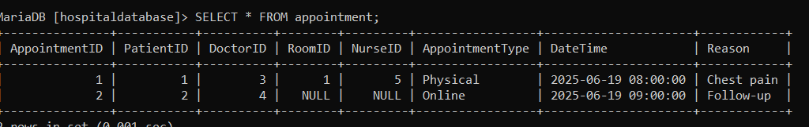

Appointments are scheduled interactions between patients and doctors. This table contains appointment ID, patient and doctor references, the type of appointment (physical or online), and date/time details. Physical appointments are linked to a room, and optionally a nurse can be assigned to assist.

**BILLING TABLE**

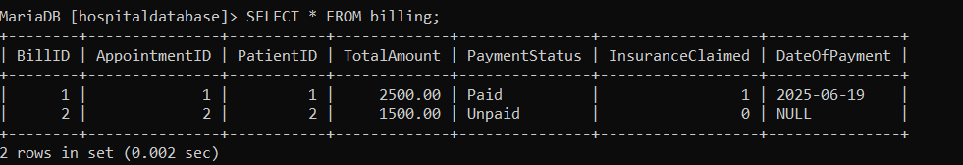

This table handles all billing information for patients after their appointments. It includes details like the total bill amount, whether insurance was claimed, the payment status, and the date of payment. Each billing record is linked to a patient and a specific appointment.

**TEST TABLE**

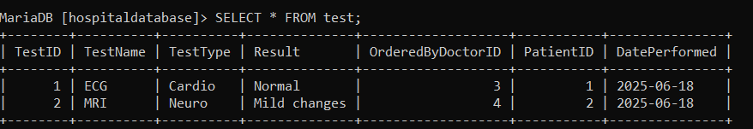

The test table stores all medical or lab tests ordered by doctors for patients. It includes the test name, type, result, and the date it was performed. Each test is linked to the doctor who ordered it and the patient who took it.

**PRESCRIPTION TABLE**

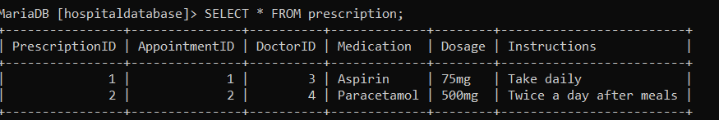

This table stores prescriptions written by doctors during appointments. It contains information about the prescribed medication, dosage, and usage instructions. Each prescription is associated with a specific appointment and doctor.

**INSURANCE PROVIDER TABLE**

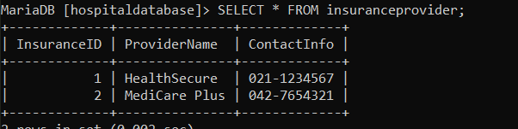

The insurance provider table stores details of medical insurance companies that patients are linked to. It contains the provider’s name and contact information, and is referenced in the patient records..