**HOSPITAL MANAGEMENT SYSTEM**

**PROJECT REPORT**



**Database Management Systems Lab**

**Submitted By:**

Ayesha Ahmed (22pwcse2150)

Shafaq Bukhari (22pwcse2154)

Sana Zahir (22pwcse2151)

**Section:**

**C**

**Submitted to:**

Mam Sumayyea Salahudin

**Department of Computer Systems Engineering**

**University of engineering and technology, Peshawar**

**Hospital Patient Management System**

***Objective***

The objective of this Hospital Patient Management System (HPMS) is to build a comprehensive, secure, and modular web-based application using **Laravel** to streamline key hospital operations. The system handles patient records, doctor and staff schedules, appointments, billing, test results, prescriptions, room assignments, and departmental organization. It aims to replace traditional manual processes with a unified digital platform, ensuring accuracy, efficiency, and accessibility.

**Key Goals Achieved:**

• Designed a modular architecture with clear separation of concerns  
• Developed 10+ interconnected modules for core hospital functions  
• Implemented relational data models with foreign key constraints  
• Designed consistent, responsive interfaces using Blade and Bootstrap  
• Deployed and tested the application live on Hostinger Shared Hosting

***Technologies Used:***

|  |  |
| --- | --- |
| Component | Technology |
| Frontend | Laravel Blade Templates, Bootstrap 5 |
| Backend | Laravel 10, PHP 8+ |
| Database | MySQL 8+ with foreign key constraints |
| Authentication | Laravel Auth (Login & Middleware) |
| Version Control | GitHub |
| Hosting | Hostinger Shared Hosting (cPanel, FTP) |
| Deployment Tools | File Manager, phpMyAdmin, .env config |
| Documentation | README.md, Manual.txt, UI Screenshots |

***System Architecture and component structure:***

***Frontend Structure*** (Blade Views)

• ***Layout:*** layouts/app.blade.php defines main layout and navbar  
• ***Pages/Views:***  
 patients/index.blade.php, doctors/index.blade.php, etc.  
 Common views include list, form, and detail pages  
• ***UI Components***: Bootstrap modals, alerts, cards, and tables  
• ***Forms***: Use CSRF tokens, validation messages, and reusable form components  
• ***Navigation:*** Sidebar with links to all modules  
• ***Responsive Design***: Optimized for mobile/tablet view using Bootstrap grid system

***Backend Structure*** (Laravel MVC)

• ***Routes:*** Defined in web.php and grouped by middleware (e.g., auth)  
• ***Controllers***: Handle business logic (e.g., PatientController.php)  
• ***Models:*** Map entities like Patient, Doctor, Appointment, etc.  
• ***Migrations***: Define database schema with relationships and constraints  
***• Middleware:*** Used to protect sensitive routes and sessions  
  
***Database Schema***  
• Normalized structure with defined foreign keys  
• Key Relationships:  
 appointments.patient_id → patients.id  
 appointments.doctor_id → doctors.id  
 schedules.entity_id → doctors.id/staff.id (unified schedule)  
 prescriptions.appointment_id → appointments.id  
 billings.patient_id → patients.id

***Authentication and Security:***

Laravel’s built-in Authentication system used  
• Secure login with session handling and route protection  
• Role-based access control planned for future upgrade

***Testing and Validation Strategy:***

***Local Testing:*** Laravel’s built-in test server (php artisan serve)  
• ***Form Validation:*** Server-side validation for required fields and correct formats  
• ***Database Checks:*** Foreign key enforcement and cascading deletes  
• ***Edge Cases:***  
 Double-booked appointments → Blocked  
 Empty patient forms → Error alert  
 Unique doctor email → Enforced in model rules  
• ***Deployment Testing***: Live system tested post-deployment on Hostinger

***Deployment Details:***

• ***Backend Upload:*** Laravel files uploaded via cPanel File Manager  
• ***Database Setup:*** Imported SQL dump via phpMyAdmin  
• ***Environment File:*** .env configured with production DB and APP_URL  
• ***Migrations:*** Executed on server using artisan or manual import  
• ***Routing:*** .htaccess configured for clean URLs  
• ***Live Testing:*** Verified routes, forms, DB integration on live server

***Screenshots of website:***

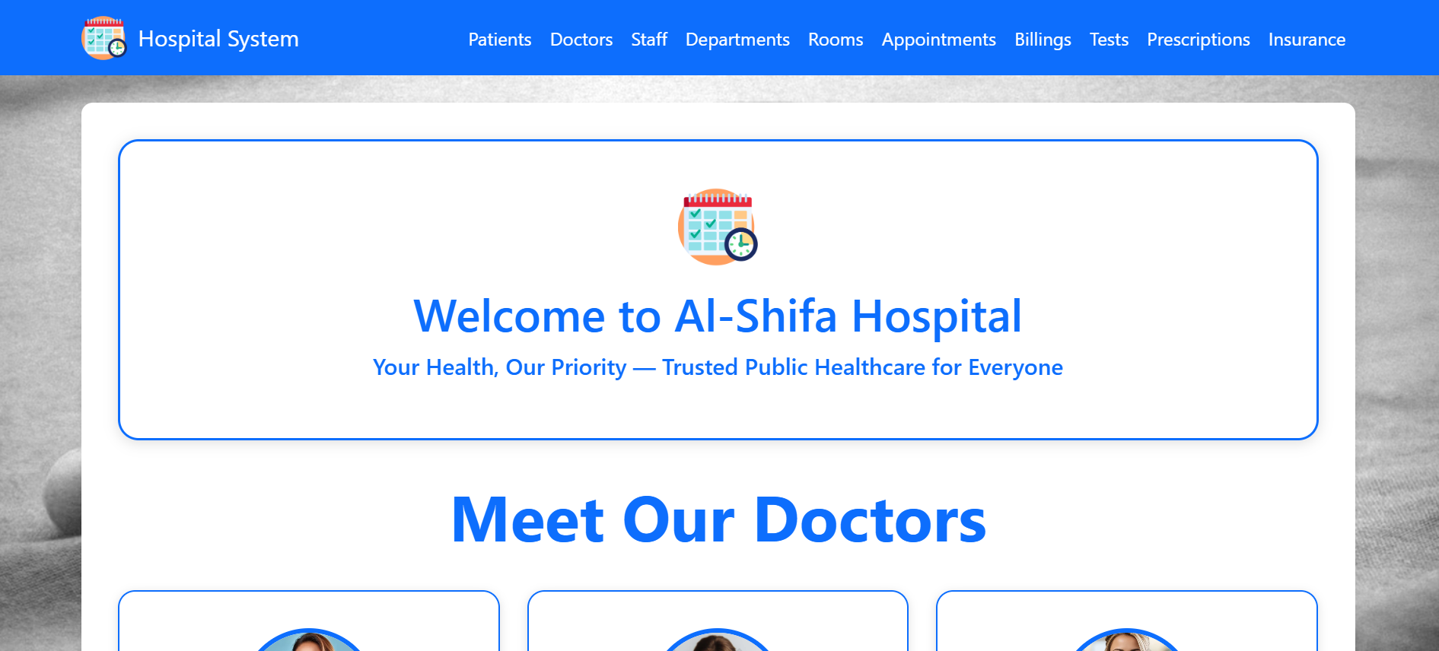

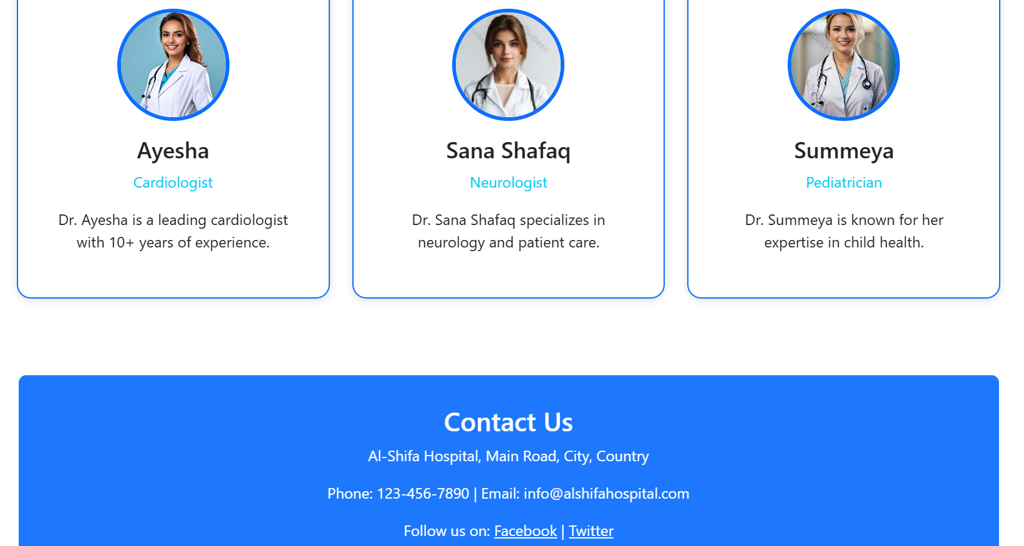

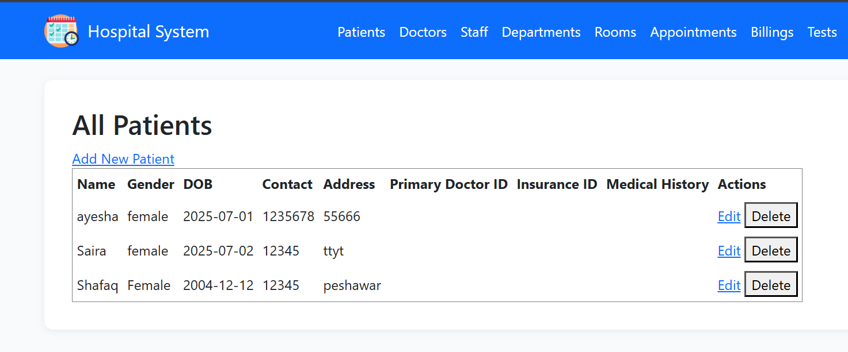

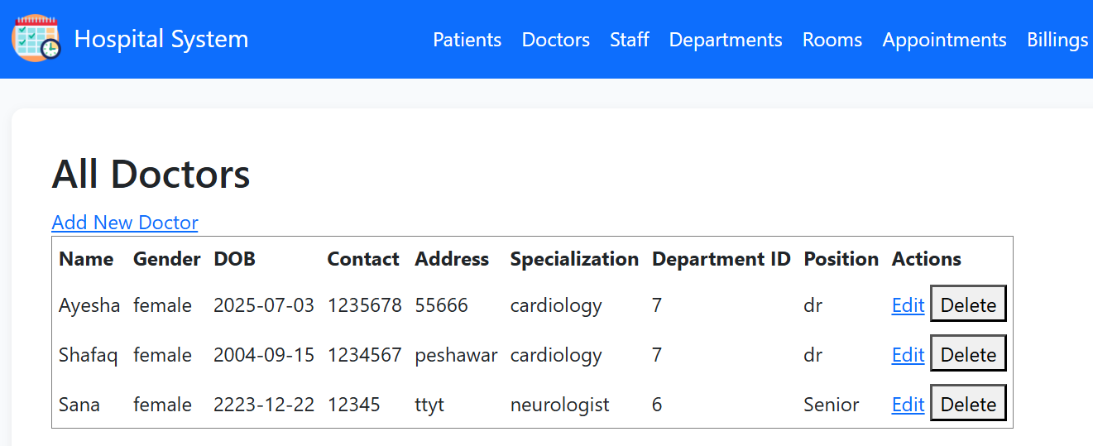

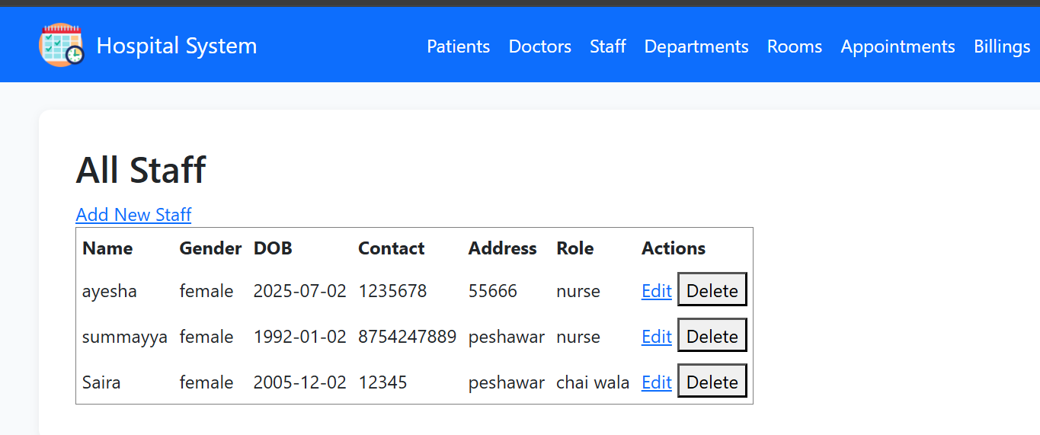

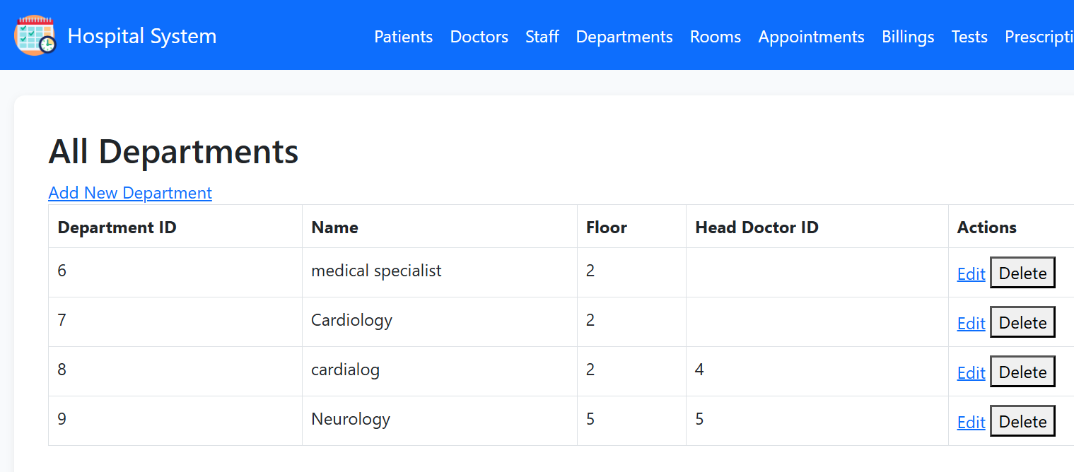

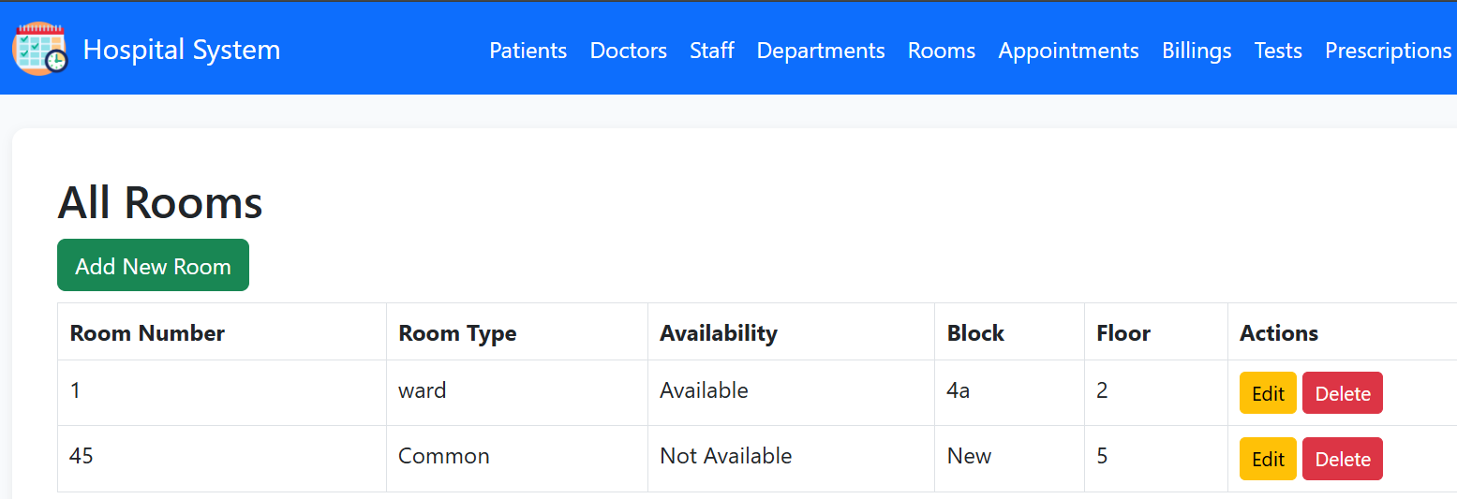

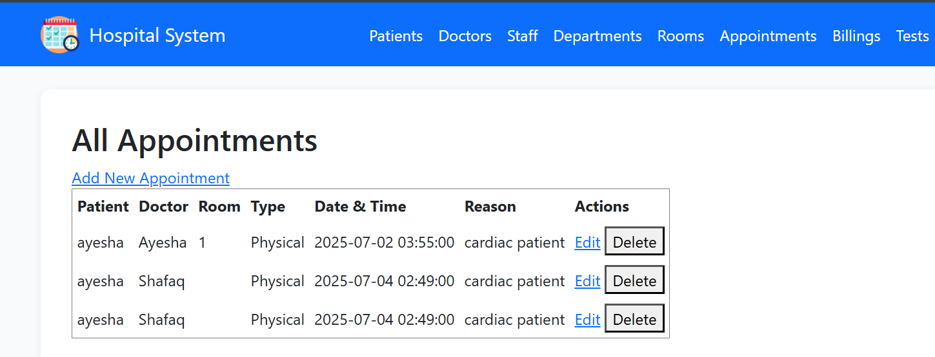

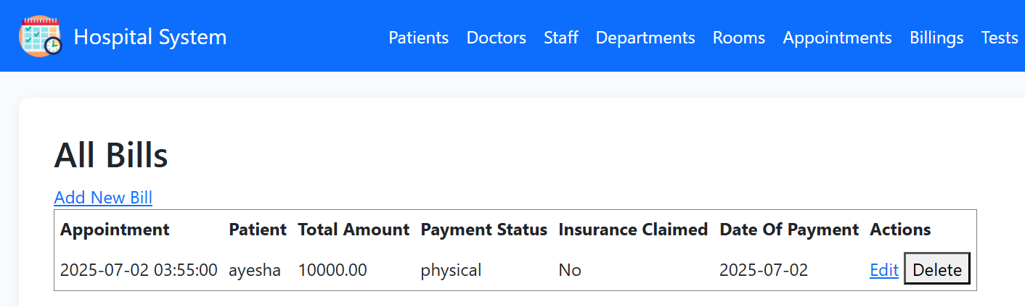

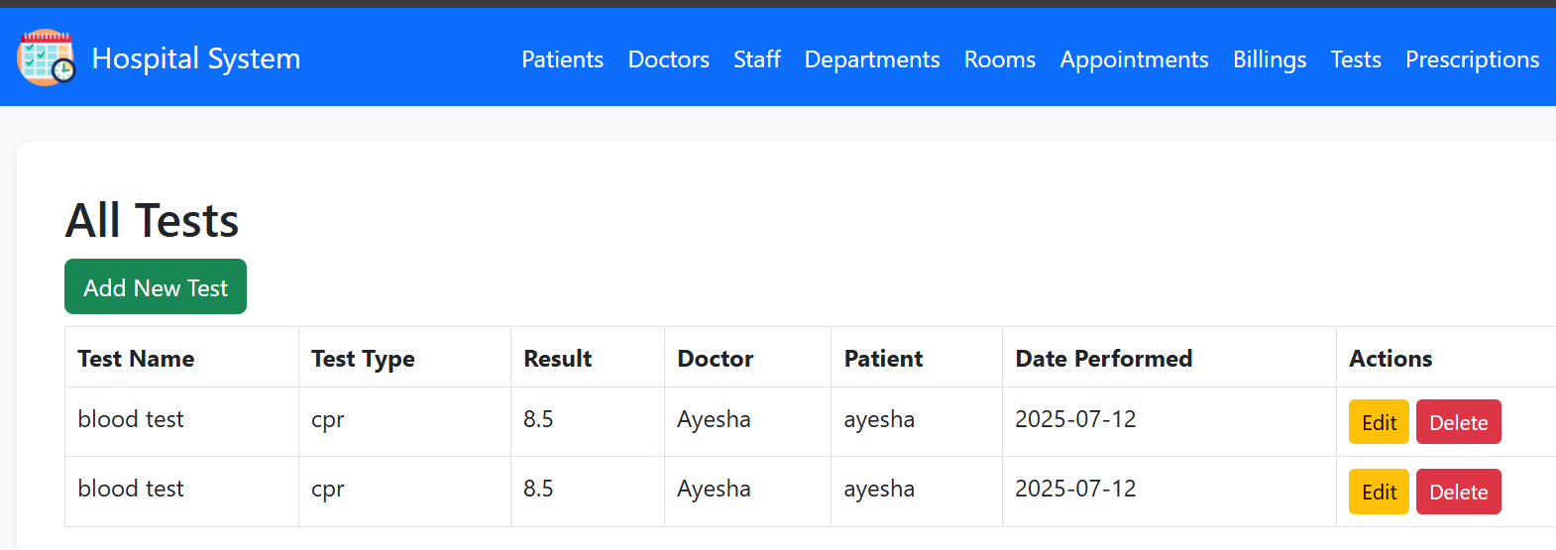

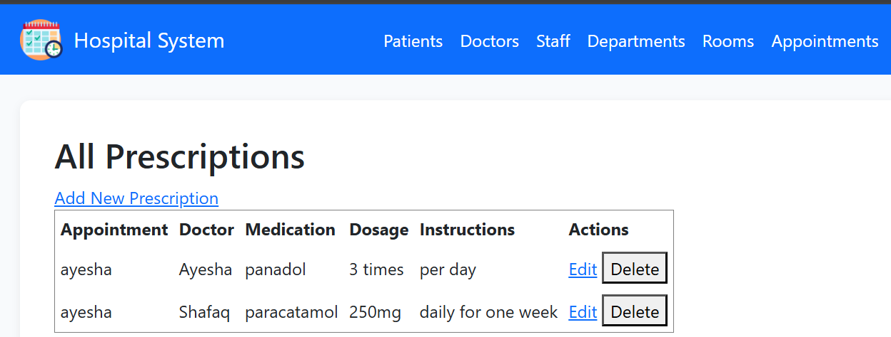

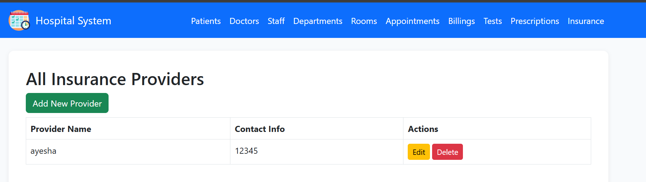

***Deployment link:***

[***https://saddlebrown-albatross-802686.hostingersite.com/***](https://saddlebrown-albatross-802686.hostingersite.com/)

***Conclusion:***

The Hospital Patient Management System successfully meets its objective of digitizing core hospital workflows. Built with Laravel and MySQL, the system integrates various hospital operations into a centralized web platform. Through real-world deployment and testing, the project demonstrates production readiness and full-stack web development capability. It also lays a solid foundation for future enhancements such as user roles, email/SMS notifications, and reporting modules.

***Project Group Detail:***

Group Members:  
[AYESHA AHMED] Reg No. 22PWCSE2150  
[SANA ZAHIR] Reg No. 22PWCSE2151  
[SHAFAQ BUKHARI] Reg No. 22PWCSE2154  
  
Supervisor: [Engr. Sumayyea Salahuddin]