NovaCart Management Report
Profitability, Marketing Return and Customer Retention
Period: January 2025 – June 2026 · Prepared by: Shafayat · Data: 1,718 customers, 2,460 orders, 40 products

Executive summary
Despite $492,000 of net revenue over 18 months, NovaCart made an operating loss of $1,960, because almost all of the $115,000 gross profit from selling products was spent on advertising ($108,000).
- Revenue more than doubled (+115% from January 2025 to June 2026), and the business has been profitable in most months since August 2025: +$13,290 in the first half of 2026.
- Facebook Ads lose money on every customer. They take 53% of the ad budget, cost $93 per customer and return a loss of $42 per customer after ad cost. Email and Referral customers earn $43–49 each.
- Electronics drives 60% of revenue at only a 12% gross margin. Beauty and Home & Kitchen earn 39–62%.
- 72% of customers buy only once, so growth depends on paying to acquire new customers.
- Black Friday 2025 sold at a loss (−4.7% gross margin) and brought in customers who rarely came back. November was the worst month of the period (−$7,579).

1. Is NovaCart profitable?
Gross profit covers product cost and refunds; operating profit also subtracts shipping and marketing.
Measure (18 months) | Amount | Share of net revenue
Net revenue | $492,163 | 100.0%
Gross profit | $115,196 | 23.4%
Shipping | $8,682 | 1.8%
Marketing | $108,474 | 22.0%
Operating profit | −$1,960 | −0.4%

Ten of 18 months made a loss: every month from January to July 2025, then October and November 2025 and February 2026. Profit has improved as revenue grew while marketing stayed near $5,800 a month, apart from November.
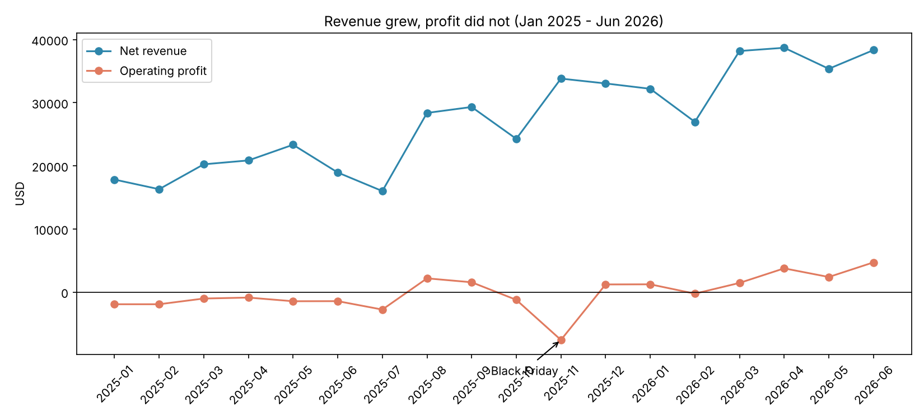
Figure 1. Net revenue vs operating profit by month

2. Which categories really make money?
Category | Net revenue | Refund rate | Gross profit | Gross margin
Electronics | $293,660 | 5.8% | $35,790 | 12.2%
Home & Kitchen | $79,574 | 4.7% | $30,909 | 38.8%
Fashion | $67,605 | 21.9% | $25,991 | 38.4%
Beauty | $20,610 | 2.6% | $12,773 | 62.0%
Sports | $30,714 | 6.1% | $9,732 | 31.7%
Total | $492,163 | 8.1% | $115,196 | 23.4%

- Electronics is high volume, low margin. Product cost is 72–82% of price, so any discount above about 12% sells it at a loss.
- Fashion refunds one dollar in every five. Half of Fashion returns (103 of 207) are "wrong size"; the rest are quality issues or "not as described".
- Beauty is small but the most profitable per dollar at a 62% margin, with the lowest refund rate (2.6%).

3. Which marketing channels bring valuable customers?
Channel | Customers | Ad spend | CAC | Repeat rate | Profit after ads per customer
Organic | 322 | $0 | – | 35.1% | $71.31
Email | 178 | $6,972 | $39.17 | 42.1% | $48.65
Referral | 166 | $6,115 | $36.84 | 42.2% | $42.98
Google Ads | 431 | $37,417 | $86.82 | 29.5% | −$13.49
Facebook Ads | 621 | $57,970 | $93.35 | 11.8% | −$42.44

Facebook Ads cost $57,970 and generated $31,615 of gross profit: a gap of $26,355. Its customers also return least often (11.8%). Email and Referral customers cost less than half as much to acquire and come back almost four times as often.
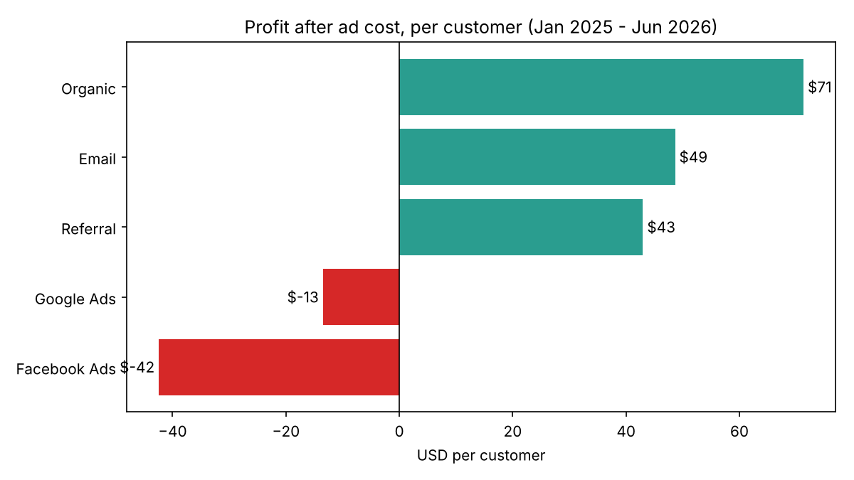
Figure 2. Profit after ad cost per customer, by channel

4. Do customers come back?
Mostly not. 71.9% of customers placed only one delivered order. On average about 12% of a cohort orders again in the month after their first order and about 14% in the second month, after which repeat buying fades quickly. Customers who return tend to do so 1–2 months after their first purchase, which is the window to target.
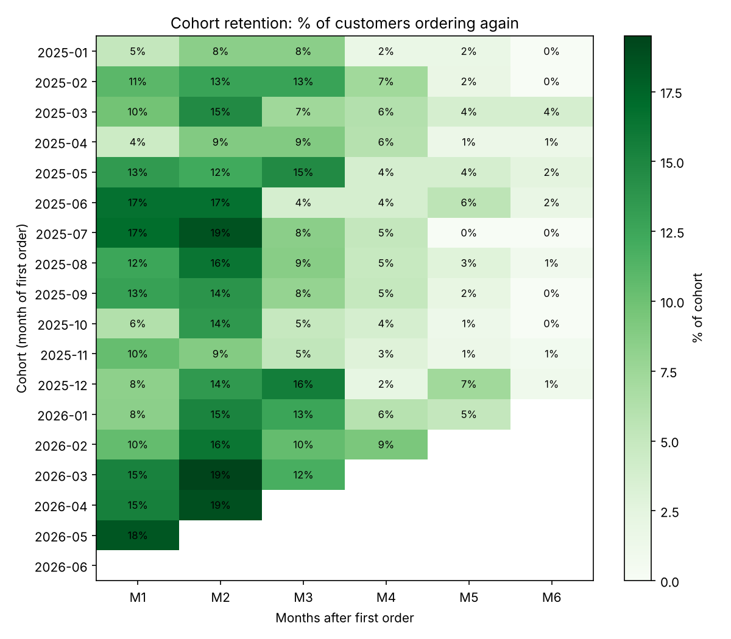
Figure 3. Cohort retention: % of each month’s new customers ordering again

5. Was Black Friday 2025 worth it?
No. The campaign (20–30 November) doubled daily orders but lost money on the sales themselves and attracted low-value customers.
Per day | Black Friday | Other days
Orders | 8.2 | 4.3
Net revenue | $1,262 | $918
Gross profit | −$59 | $222
Gross margin | −4.7% | 24.2%

Customers signed up | Black Friday | Same season, other days
Customers | 82 | 472
From Facebook Ads | 63.4% | 36.7%
Repeat rate | 12.2% | 29.9%
Gross profit per customer | $20.28 | $69.66

A flat 30% discount is larger than the margin on most products, especially Electronics. November marketing also rose to $10,260, about $4,500 above a normal month. Each Black Friday customer earned about $20 of gross profit against a Facebook acquisition cost of about $93.

Recommendations
Ordered by expected impact. Each is supported by the findings above.
- Cut Facebook Ads spend and move budget to Email and Referral. Facebook lost $26,355 over the period after ad cost. Start by reducing it by a third and test whether Email and Referral incentives can replace the lost customers at under $40 each.
- Never discount below a category’s margin. Cap Electronics discounts at about 10%; put larger promotions on Beauty and Home & Kitchen, which can absorb them. Judge campaigns on gross profit and 90-day repeat rate, not revenue.
- Build repeat purchase. Send a follow-up offer 30–45 days after the first order, when customers are most likely to return. Lifting repeat rate from 27% toward the 42% seen in Email customers reduces the need for paid acquisition.
- Reduce Fashion returns. Add a size guide and fit notes to product pages. Wrong size causes half of Fashion returns; halving them would save an estimated $4,700 in refunds over 18 months.
- Grow the high-margin categories. Beauty and Home & Kitchen earn three to five times the margin of Electronics. Feature them in recommendations and bundles alongside Electronics purchases.

Data and method notes
- Sources: products, customers, orders, order items, returns and monthly marketing spend, January 2025 – June 2026.
- Cleaning: 24 data quality issues fixed (duplicates, mixed date formats, inconsistent names, test accounts, impossible dates, price and refund typos). 56 of 8,834 rows (0.6%) were removed; every decision is listed in the data quality log.
- Definitions: only delivered orders count as sales. Net revenue = sales after discount minus refunds. Returned items are assumed not resellable, so their product cost is kept. CAC = channel ad spend ÷ customers acquired.
- Six orders from an unknown customer (C9999) are included in the P&L but excluded from channel and cohort analysis. Cohorts are based on the month of each customer’s first delivered order.
- Tools: SQL (SQLite) for cleaning and analysis, Excel for the formula model, Python (pandas, matplotlib) for the automated pipeline and charts, Power BI for the interactive dashboard.

