Quillio Legal Assistant — RND Bug Report
Environment retest of previously reported editor and multi-format issues, plus newly observed defects.
Application | Quillio Legal Assistant (RND)
URL | https://app.rnd.legalassistant.au
Test account | samuel+4@botprofits.co
Browser | Google Chrome, maximized (full desktop)
Retest date | 17 August 2026
Previous tests | 7 August 2026 (editor) and 12 August 2026 (multi-format)
Scope | Document editor, file-format open/convert, import/upload, insert features

Summary
Twelve defects are documented below. Critical/high items block core legal-document workflows: PDF/TXT/RTF fail to open, large/legacy DOC files cannot be upgraded, typed text paints late, and there is no way to insert links, images, or tables. CSV and XLSX conversion quality is poor. PowerPoint is unsupported. PNG no longer hangs on “Preparing editor…” but still does not render the image. Home-page “Content temporarily unavailable” was not reproduced on this retest.
Defect register
ID | Severity | Retest status | Title
BUG-01 | Critical | Still broken | Legacy DOC cannot be upgraded for the editor
BUG-02 | Critical | Still broken | PDF files fail with Editor error
BUG-03 | Critical | Still broken | TXT files fail with Editor error
BUG-04 | Critical | Still broken | RTF files fail with Editor error
BUG-05 | High | Still broken | Typed text appears after ~2 second delay
BUG-06 | High | Still broken | No Insert Link / Image / Table in editor
BUG-07 | High | Still broken | CSV dates render as ########; headers truncated
BUG-08 | High | Still broken | XLSX opens as blank Word page showing only Sheet1
BUG-09 | High | Partial | PNG does not hang, but image is a placeholder not the file
BUG-10 | Medium | Still missing | PPT / PPTX not supported in Import
BUG-11 | Medium | Partial | Uploads remain Queued and do not complete
BUG-12 | Medium | Still broken | Failed documents show Not saved status

BUG-01 · Legacy / large DOC files cannot be upgraded for the editor
Severity | Critical
Retest status | Still broken (17 Aug 2026 retest)
Area | Document editor / file formats
Environment | RND — app.rnd.legalassistant.au — Chrome maximized

Description
Opening some Microsoft Word 97–2003 (.doc) files fails with a document-upgrade error. Retrying does not recover the document; the editor remains empty. Behaviour is inconsistent: a smaller QA-FORMAT .doc opened successfully in this retest, but the original failing file 1-MB-DOC.doc still cannot be opened. Failed documents also show a “Not saved” warning in the header.
Steps to reproduce
1. Log in to https://app.rnd.legalassistant.au.
2. Open Search My Documents or browse to Test Folder.
3. Open the file 1-MB-DOC.doc.
4. If an upgrade error appears, click Try Again.
Actual result
The editor shows: “This document could not be upgraded for the editor. Try again to retry the upgrade.” After Try Again the error becomes permanent: “This document cannot be upgraded for the editor. Retrying will not help — please contact support.” Header status shows “Not saved”. No document content is displayed.

Expected result
The .doc file converts/upgrades and opens in the editor with readable, editable content. If conversion is impossible, the user should get a clear, actionable error without a Try Again control that cannot succeed.

Screenshot
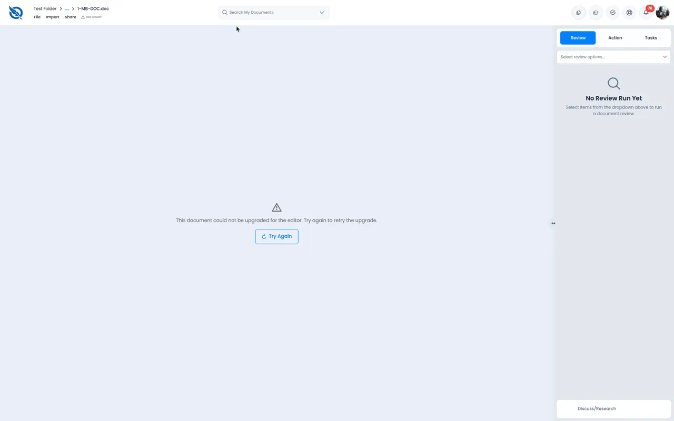
Figure 1. 1-MB-DOC.doc — upgrade failure and Not saved status

BUG-02 · PDF files fail to open with Editor error
Severity | Critical
Retest status | Still broken (17 Aug 2026 retest)
Area | Document editor / file formats
Environment | RND — app.rnd.legalassistant.au — Chrome maximized

Description
PDF documents listed as supported in Import fail to load in the editor. After loading spinners, the canvas shows a generic Editor error. PDFs are a core format for legal work, so this is a blocker.
Steps to reproduce
1. Log in to the RND app.
2. Search for or open QA-CLIO-PDF-20260716-194110.pdf (or any other PDF in the library).
3. Wait for the editor to finish loading.
4. If shown, click Try Again.
Actual result
The editor canvas displays “Editor error” with a Try Again button. Document content is not shown. Header shows “Not saved”.

Expected result
The PDF opens in the editor (or a dedicated viewer) with readable pages. Conversion/viewing failures should explain why and not leave the file in a Not saved state.

Screenshot
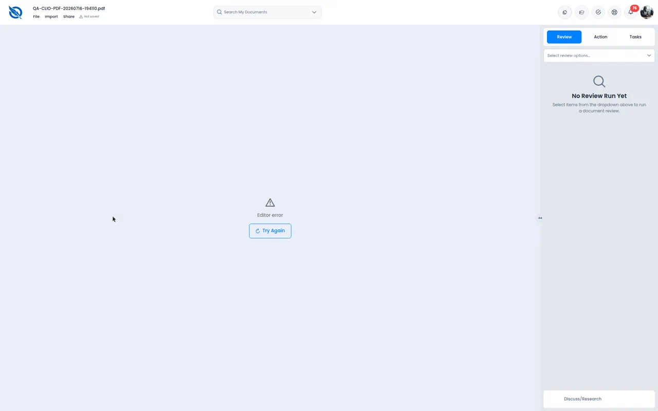
Figure 2. PDF QA-CLIO-PDF-20260716-194110.pdf — Editor error

BUG-03 · TXT files fail to open with Editor error
Severity | Critical
Retest status | Still broken (17 Aug 2026 retest)
Area | Document editor / file formats
Environment | RND — app.rnd.legalassistant.au — Chrome maximized

Description
Plain-text files are listed as supported (.txt) but existing library files such as sample.txt fail immediately with Editor error. Users cannot view or edit simple text documents.
Steps to reproduce
1. Log in to the RND app.
2. Open sample.txt from My Files / search.
3. Observe the editor canvas.
4. Click Try Again if present.
Actual result
Immediate “Editor error” with Try Again. No text content is shown. Header shows “Not saved”.

Expected result
The .txt file opens immediately as editable plain text in the document editor.

Screenshot
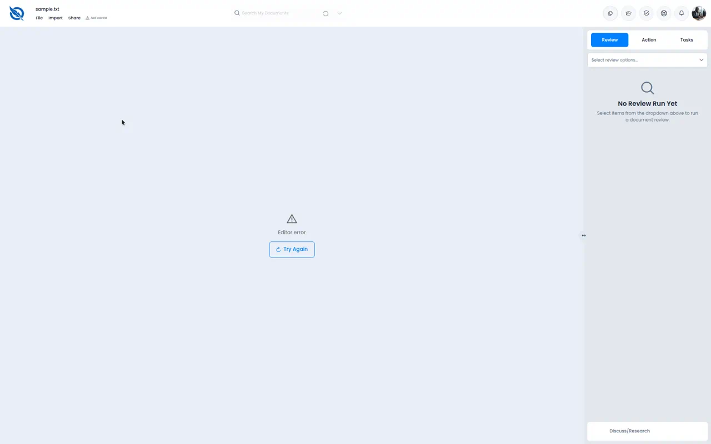
Figure 3. sample.txt — Editor error

BUG-04 · RTF files fail to open with Editor error
Severity | Critical
Retest status | Still broken (17 Aug 2026 retest)
Area | Document editor / file formats
Environment | RND — app.rnd.legalassistant.au — Chrome maximized

Description
Rich Text Format files are listed as supported but fail after a short “Preparing editor…” period with the same generic Editor error as PDF and TXT.
Steps to reproduce
1. Log in to the RND app.
2. Open sample.rtf.
3. Wait through “Preparing editor…”.
4. Click Try Again if the error appears.
Actual result
After ~8 seconds of preparing, the canvas shows “Editor error” and Try Again. Content is not shown. Header shows “Not saved”.

Expected result
The RTF file converts and opens with formatting preserved (or a clear conversion warning if features are dropped).

Screenshot
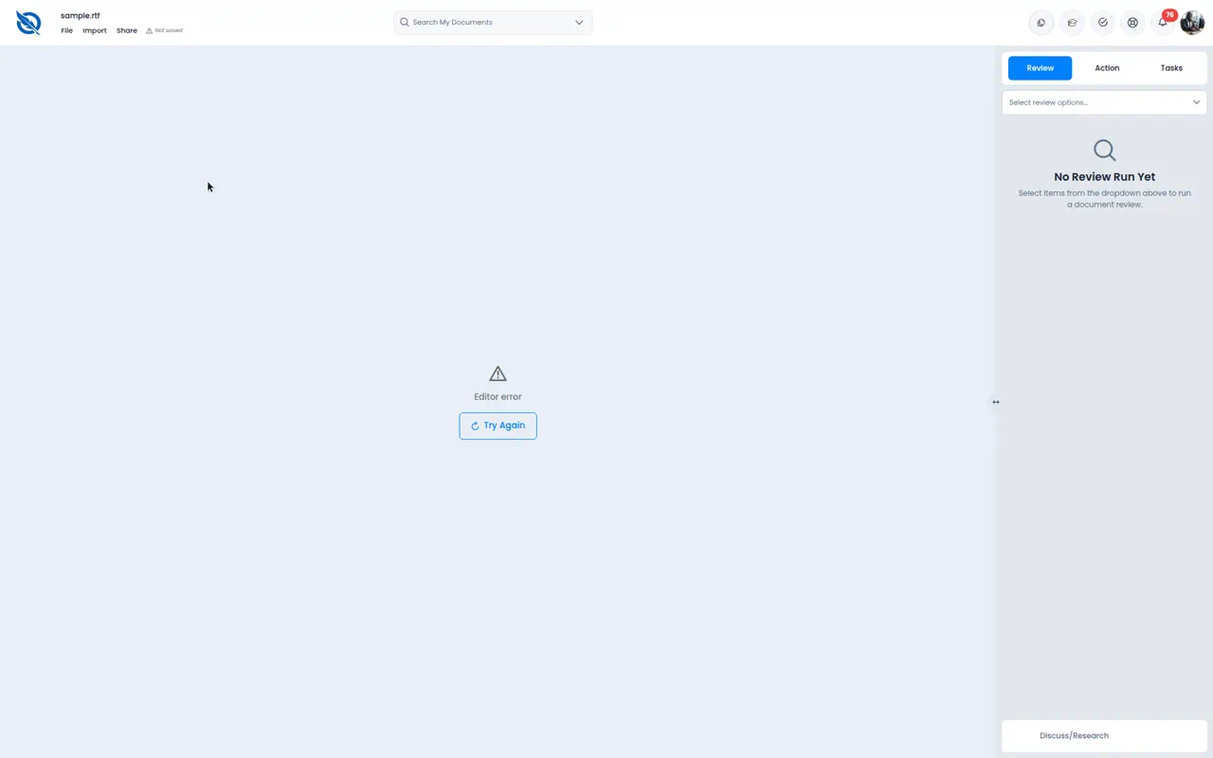
Figure 4. sample.rtf — Editor error

BUG-05 · Typed text appears after an approximately 2-second delay
Severity | High
Retest status | Still broken (17 Aug 2026 retest)
Area | Document editor / file formats
Environment | RND — app.rnd.legalassistant.au — Chrome maximized

Description
In a working DOCX, characters typed quickly do not paint on the page immediately. Text appears about two seconds later (autosave may still run). Users can believe typing failed and type duplicates.
Steps to reproduce
1. Open a working DOCX (e.g. QA-FORMAT-20260716-235000.docx).
2. Click in the document body to place the caret.
3. Type quickly: DELAYTEST typing check 12345
4. Observe whether the characters appear as they are typed.
Actual result
Immediately after typing, the new sentence is not visible on the page. After about 2 seconds the text appears. Autosave may show Saving… during the gap.

Expected result
Characters appear immediately as the user types, with no multi-second render lag.

Screenshot
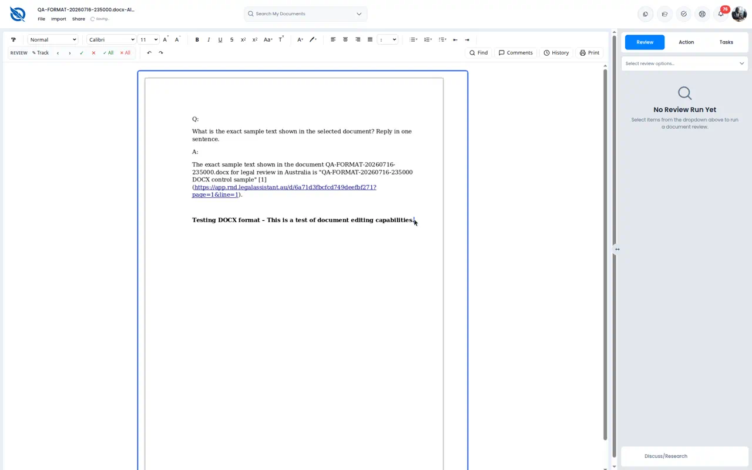
Figure 5a. Immediately after typing — DELAYTEST text not yet visible
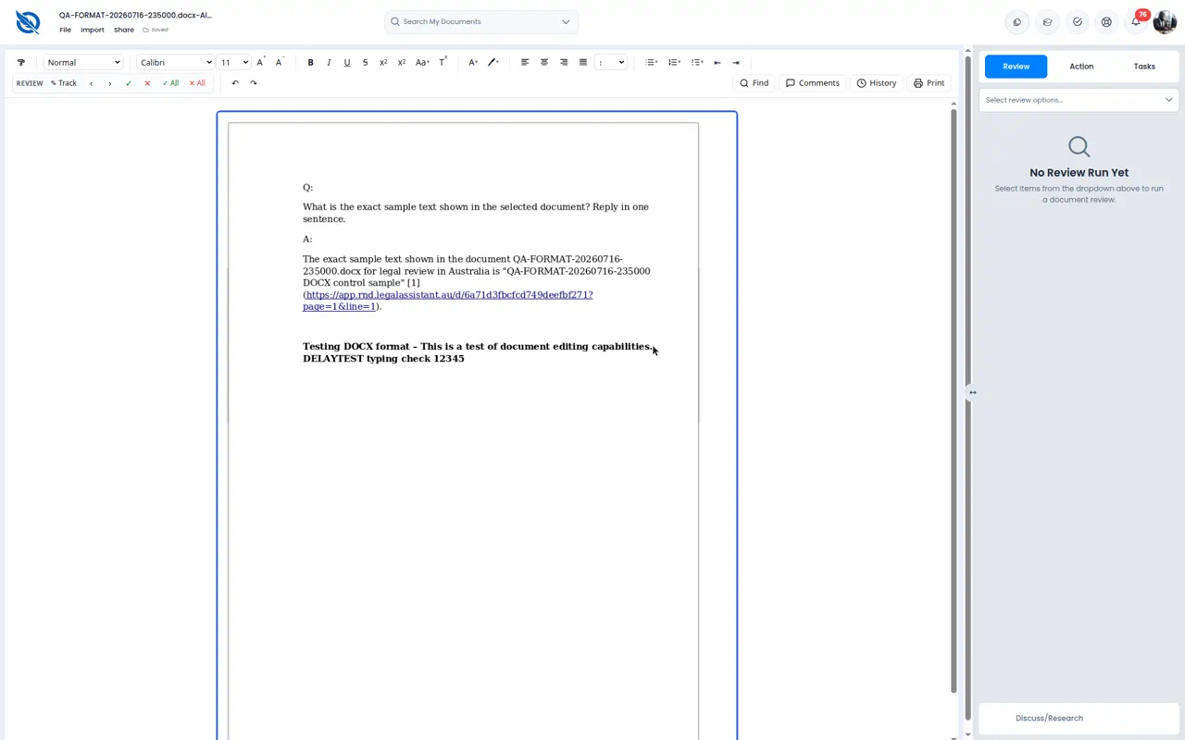
Figure 5b. About 2 seconds later — typed text has appeared

BUG-06 · No way to insert a hyperlink, image, or table in the editor
Severity | High
Retest status | Still broken (17 Aug 2026 retest)
Area | Document editor / file formats
Environment | RND — app.rnd.legalassistant.au — Chrome maximized

Description
The editor toolbar has rich text formatting but no Insert Link, Insert Image, or Insert Table controls. File menu covers Create/Clone/Move/Export/Trash only. Right-click opens an AI assistant menu (outline, draft, write clause, summarise, etc.) with no standard insert or paste-insert options. Import opens an upload dialog, not in-document insert.
Steps to reproduce
1. Open a working DOCX in the editor.
2. Inspect the formatting toolbar for link, image, or table icons.
3. Open the File menu.
4. Right-click in the document body and review the context menu.
5. Open Import and confirm it is upload-only.
Actual result
No insert link/image/table affordance exists in toolbar, File menu, or context menu. Users cannot add hyperlinks, images, or tables while editing.

Expected result
Standard insert actions are available (toolbar and/or Insert menu and context menu): hyperlink, image, table, and ideally page break / horizontal rule.

Screenshot
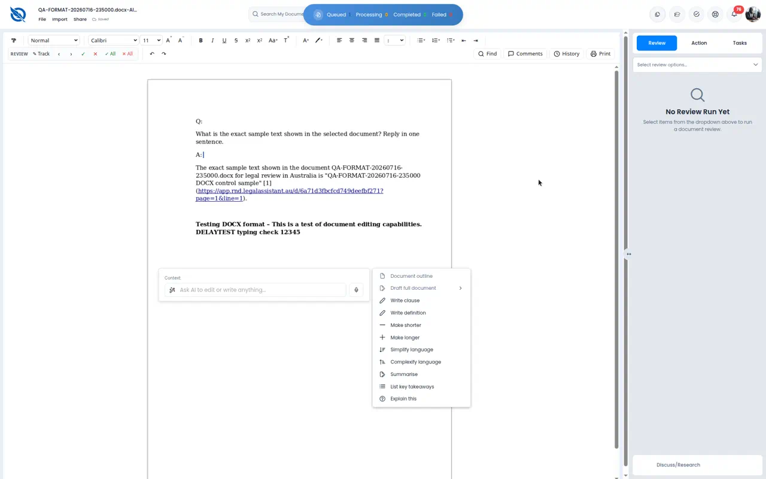
Figure 6a. Full toolbar — formatting present, no insert link/image/table
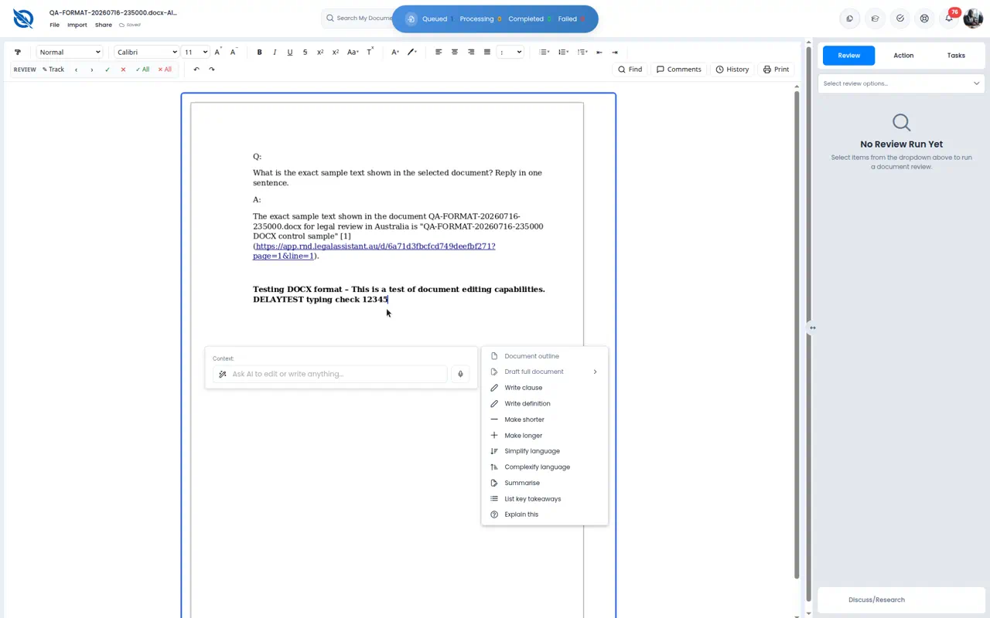
Figure 6b. Right-click menu is AI-only — no insert options

BUG-07 · CSV Date Filed column shows ######## and headers are truncated
Severity | High
Retest status | Still broken (17 Aug 2026 retest)
Area | Document editor / file formats
Environment | RND — app.rnd.legalassistant.au — Chrome maximized

Description
CSV files open in a Word-style page as a narrow table rather than a spreadsheet grid. The Date Filed column displays hashes (########) for every row — typical overflow when a column is too narrow. Headers are also clipped (Case Numb, Client Nam). Dates are unreadable without a workaround.
Steps to reproduce
1. Open sample.csv from the document library.
2. Inspect the table, especially Date Filed and column headers.
3. Try to read the date values.
Actual result
Date Filed shows ######## on all rows. Headers are truncated (Case Numb, Client Nam). The table sits on a large empty word-processor page instead of a spreadsheet view.

Expected result
CSV data displays with readable dates and full headers. Columns auto-fit (or the user can resize). A spreadsheet-style view is preferable for tabular files.

Screenshot
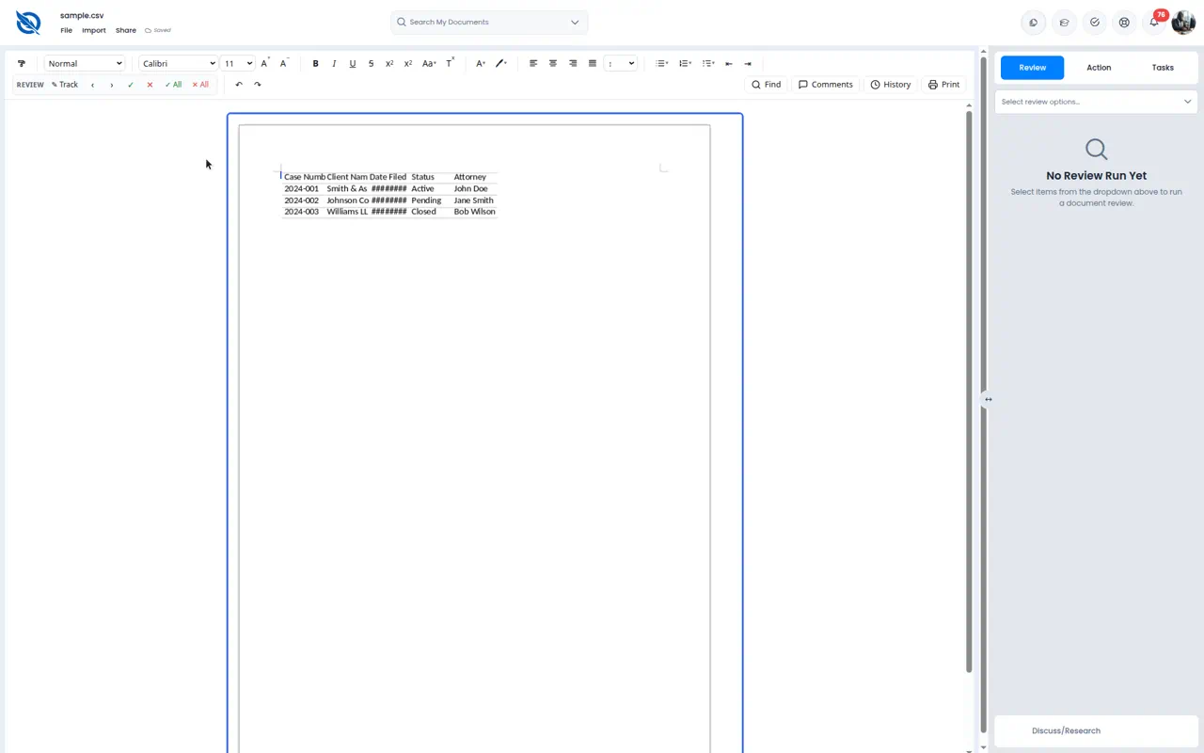
Figure 7. sample.csv — Date Filed as ######## and truncated headers

BUG-08 · XLSX opens as a blank Word document showing only Sheet1
Severity | High
Retest status | Still broken (17 Aug 2026 retest)
Area | Document editor / file formats
Environment | RND — app.rnd.legalassistant.au — Chrome maximized

Description
Excel workbooks are listed as supported (.xls / .xlsx) but conversion into the editor drops spreadsheet structure. QA-FORMAT-20260716-235000.xlsx opens as a nearly empty Word page containing only the sheet name.
Steps to reproduce
1. Open QA-FORMAT-20260716-235000.xlsx from the library.
2. Wait for the editor to load.
3. Inspect whether cells, rows, columns, and values are present.
Actual result
The editor shows a blank page with the word “Sheet1” only. No grid, no cell data.

Expected result
Workbook content is visible as a table/grid (or each sheet converted with cell values intact).

Screenshot
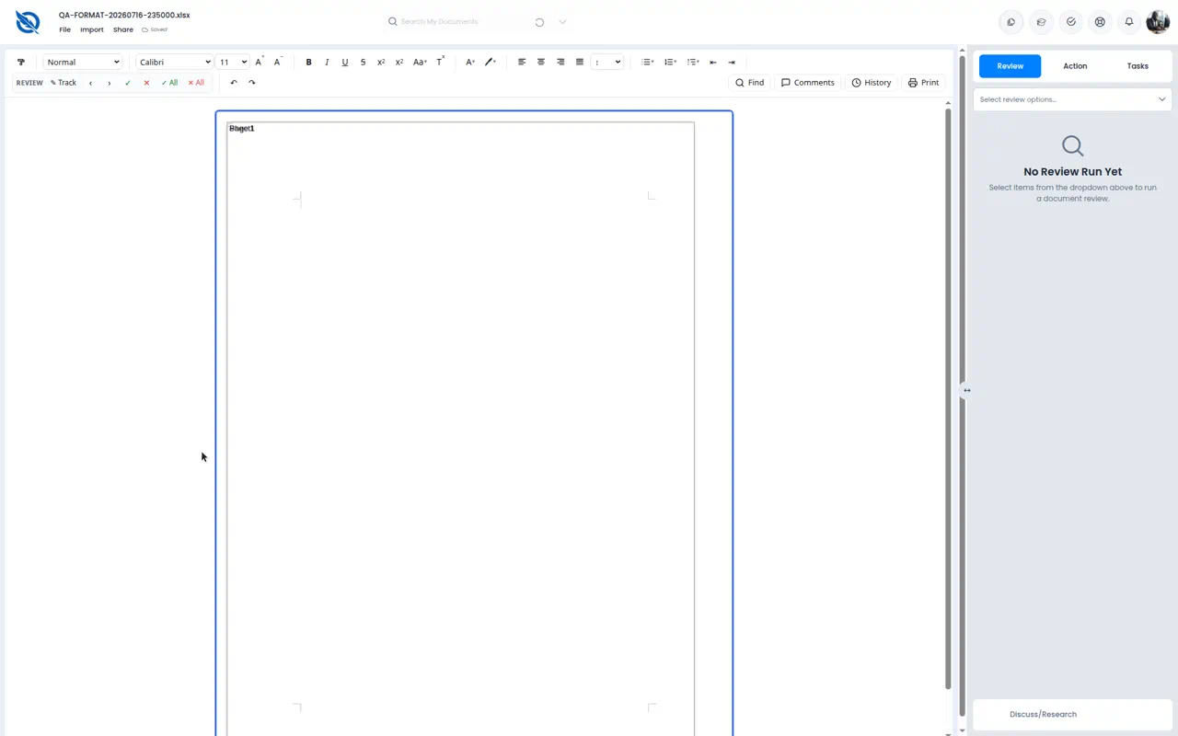
Figure 8. QA-FORMAT-20260716-235000.xlsx — only Sheet1 on a blank page

BUG-09 · PNG no longer hangs, but the image renders as a placeholder
Severity | High
Retest status | Partial fix (17 Aug 2026 retest)
Area | Document editor / file formats
Environment | RND — app.rnd.legalassistant.au — Chrome maximized

Description
Previously, PNG files could remain on “Preparing editor…” indefinitely. On this retest, QA-FORMAT-20260716-235000.png did finish loading, but the canvas does not show the actual image — only a small placeholder box with an “i” icon on an otherwise blank page.
Steps to reproduce
1. Open QA-FORMAT-20260716-235000.png (or fixture-image.png).
2. Wait until Preparing editor finishes.
3. Check whether the real image is visible and correctly sized.
Actual result
Load completes (Saved). The page is mostly blank with a tiny blue-bordered placeholder icon, not the PNG content.

Expected result
The image displays at a readable size in the document (or in an image viewer), matching the uploaded file.

Screenshot
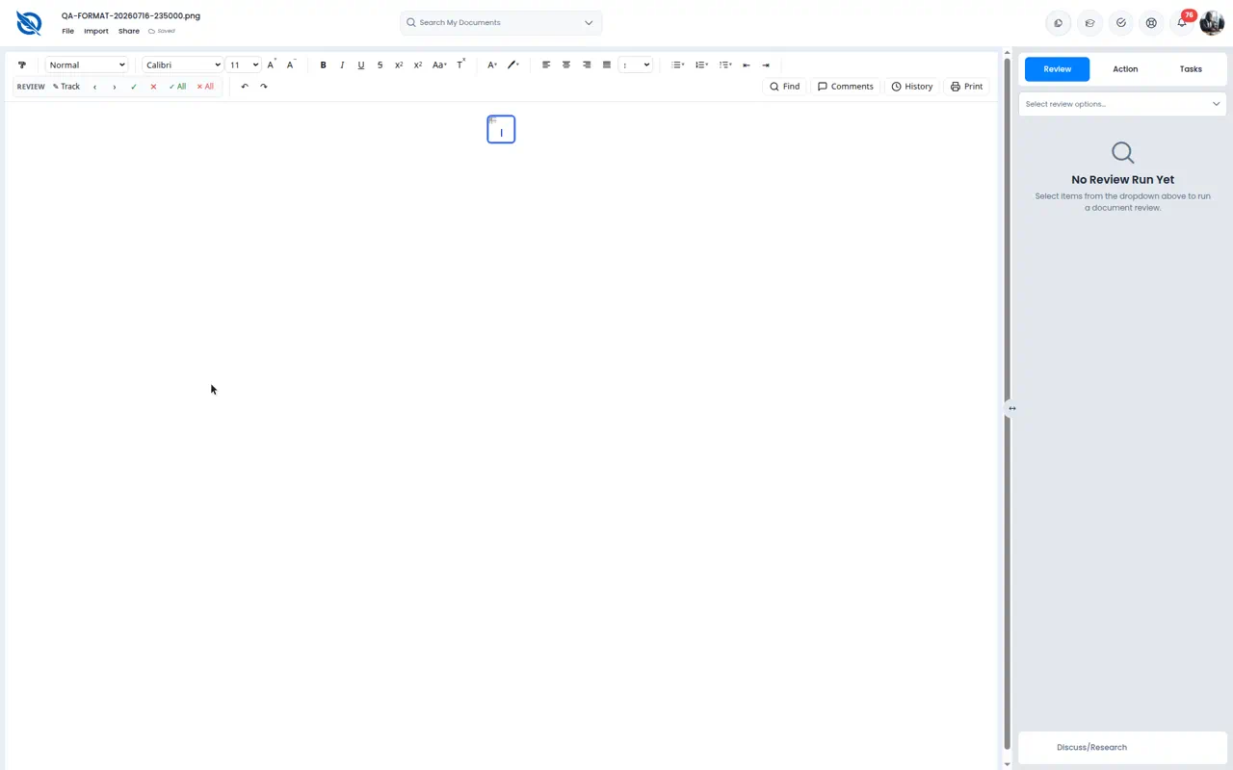
Figure 9. PNG opened — placeholder icon instead of the actual image

BUG-10 · PowerPoint (.ppt / .pptx) is not a supported import format
Severity | Medium
Retest status | Still missing (17 Aug 2026 retest)
Area | Document editor / file formats
Environment | RND — app.rnd.legalassistant.au — Chrome maximized

Description
The Upload / Import dialog lists many office, image, audio, video, and email types, but not .ppt or .pptx. Selecting a .pptx via All Files is rejected and the dialog returns to empty upload. Legal matters often include decks.
Steps to reproduce
1. Open any document or folder and click Import.
2. Read the supported-format list under the drop zone.
3. Attempt to choose qa-sample.pptx (or any .pptx) from the file picker.
Actual result
Supported list is: .doc, .docx, .txt, .rtf, .pdf, .xls, .xlsx, .csv, .png, .jpg, .jpeg, .heic, .mp3, .mp4, .wav, .m4a, .mov, .webm, .msg, .eml. PPT/PPTX are absent. A selected PPTX is not accepted.

Expected result
Either PPT/PPTX are supported with conversion to a viewable document, or the UI clearly states they are unsupported and the picker does not imply they can be uploaded.

Screenshot
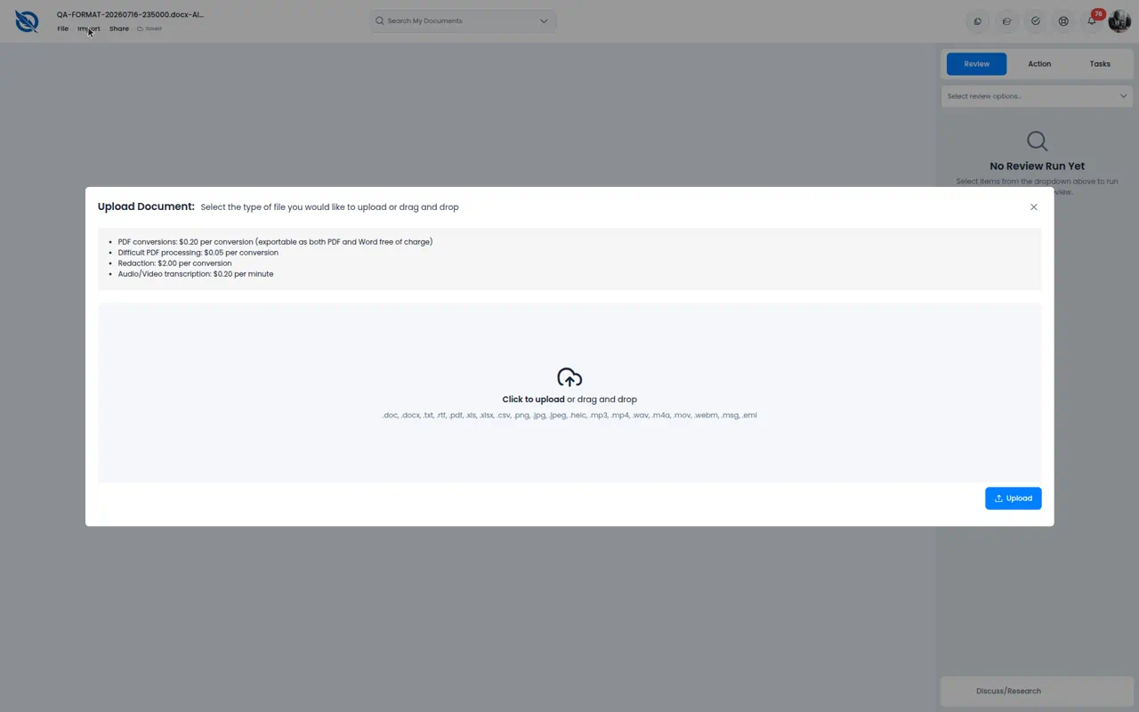
Figure 10. Import dialog — supported formats; PPT/PPTX not listed

BUG-11 · Uploaded files remain in Queued and do not finish processing
Severity | Medium
Retest status | Partial (queue UI exists; processing still stalls)
Area | Document editor / file formats
Environment | RND — app.rnd.legalassistant.au — Chrome maximized

Description
The Processing Documents dialog shows Queued / Processing / Completed / Failed. On retest, a selected file stayed in Queued without moving to Processing or Completed within a reasonable wait. A background “uploading” bar can remain visible after the dialog is closed. This blocks testing of new formats via upload.
Steps to reproduce
1. Click Import (from a folder or document).
2. Select a small supported file (e.g. a .txt).
3. Confirm upload and watch Queued / Processing / Completed.
4. Wait 30–60 seconds and refresh if needed.
Actual result
The file remains under Queued (1). It does not progress to Processing or Completed in the observed wait. Users cannot tell if the pipeline is stuck or merely slow.

Expected result
Uploads move Queued → Processing → Completed (or Failed with a reason) within a short time for small files. Stuck jobs should timeout with an error, not sit in Queued indefinitely.

Screenshot
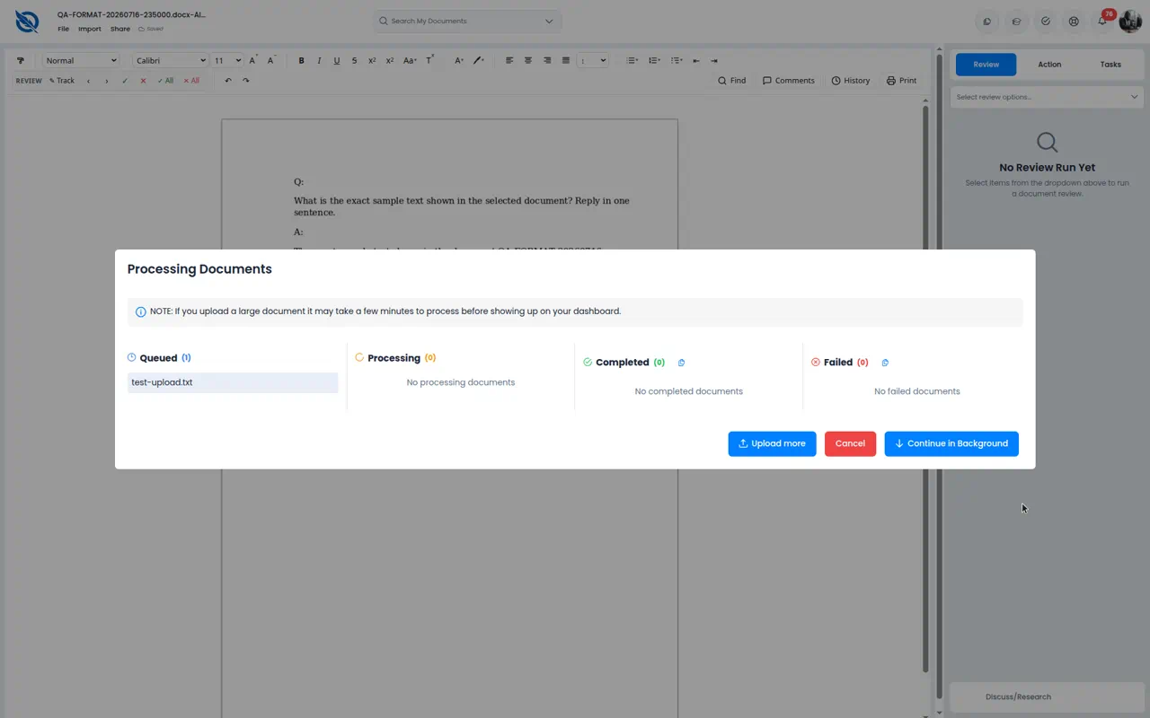
Figure 11. Processing Documents — file stuck in Queued

BUG-12 · Failed document opens show “Not saved” in the header
Severity | Medium
Retest status | Still broken (observed on PDF, TXT, RTF, and failed DOC)
Area | Document editor / file formats
Environment | RND — app.rnd.legalassistant.au — Chrome maximized

Description
When a document fails to load (upgrade error or Editor error), the chrome still shows a warning triangle and “Not saved”. That implies an unsaved edit session even though the user never edited anything. It is misleading and may worry users about data loss.
Steps to reproduce
1. Open a known-failing file (1-MB-DOC.doc, sample.txt, sample.rtf, or a PDF).
2. Wait for the error canvas.
3. Look at the header next to File / Import / Share.
Actual result
Status reads “Not saved” with a warning icon, even though no content loaded and the user made no edits.

Expected result
Failed loads should show an error state (e.g. “Failed to load”) without implying unsaved user changes. Not saved should only appear after the user has unsaved edits on a successfully opened document.

Screenshot

Figure 12. Same upgrade-error screen as BUG-01 — Not saved in the header

Appendix A — What improved vs prior runs
Some DOCX files open and can be edited (e.g. QA-CLIO-*.docx, QA-FORMAT-*.docx). A small QA-FORMAT .doc opened in this retest (unlike 1-MB-DOC.doc). PNG no longer stays on Preparing editor indefinitely. The File menu opened normally (Create, Clone, Move To Folder, Tags, Export DOCX, Move to Trash). Clicking the logo returned Home without the “Content temporarily unavailable” crash (not reproduced this run).
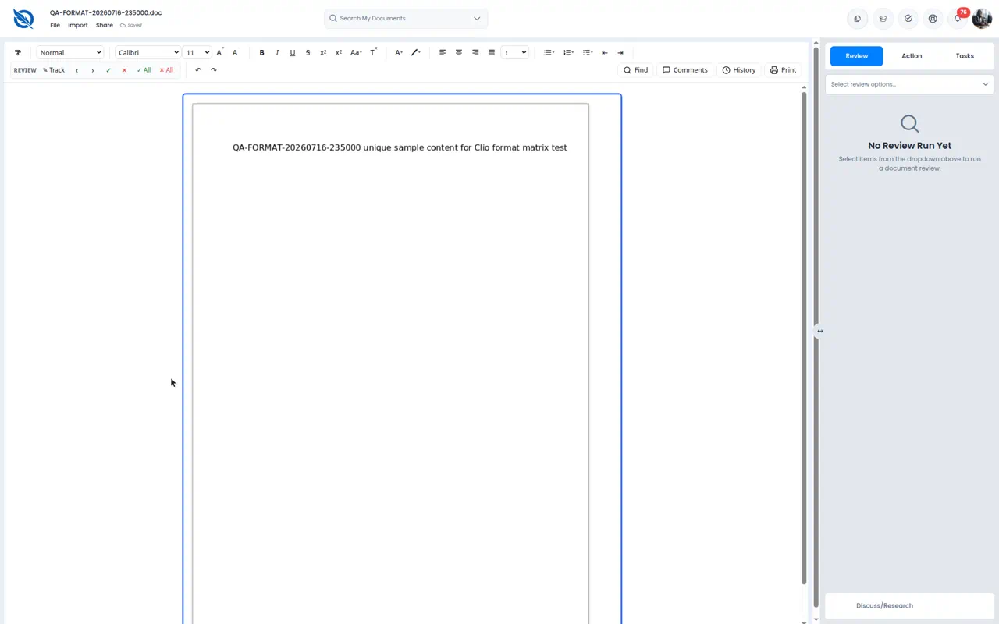
Figure A1. QA-FORMAT-20260716-235000.doc opened successfully (contrast with BUG-01)
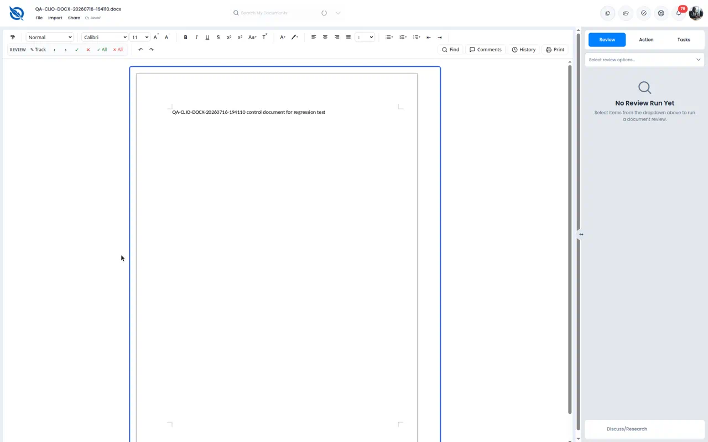
Figure A2. QA-CLIO DOCX opened with content (DOCX not universally broken)
Appendix B — Test notes
ECONOMIC DISPARITY REPORT.docx was not found in the library on this retest, so the previously failing DOCX could not be re-opened. Comments, History, Share, Export, Print, Track Changes, and Discuss/Research were not fully exercised in the 17 August session. Upload of PPTX was rejected because the format is unsupported. Screenshots were captured in maximized Chrome on the RND environment.

