Quillio RND — 17 August Bugs Retest
Retest date: 18 August 2026 (~16:20–16:50 UTC)
This report retests the format/editor defects first logged on 17 August 2026. The default RND editor path still mounts the native Editor SDK and fails with HTTP 503, so this pass forced editor_sdk_enabled OFF to load the OnlyOffice iframe editor (https://editor.legalassistant.au). Results below are against that iframe path unless noted.

1. Environment
Application | Quillio Legal Assistant (RND) v10.2.2
URL | https://app.rnd.legalassistant.au
Default editor | Native SDK — POST /editor/session → 503 (still broken)
Retest editor path | OnlyOffice iframe (feature flag editor_sdk_enabled forced OFF)
Test account | samuel+4@botprofits.co
Browser | Chromium / Playwright 1600×1000
Original report | 17 August 2026
Retest date | 18 August 2026

2. Retest register
ID | 17 Aug title | Severity | 18 Aug status
H-01 | Legacy/large DOC cannot be upgraded | Critical | Still broken — now most DOC/DOCX fail upgrade
H-02 | PDF / TXT / RTF Editor error | Critical | Still broken — upgrade failure (not “Editor error”)
H-03 | Typing delay; no Insert Link/Image/Table | High | Partially blocked — no editable DOCX; OO toolbar present on CSV
H-04a | CSV dates as ######## | High | Blocked for sample.csv; QA-FORMAT CSV opens as Word (no ########)
H-04b | XLSX blank page with only Sheet1 | High | Still broken — XLSX opens as Word page with Sheet1-like text
H-04c | PNG placeholder | High | Not retested — PNG not in this account’s library
H-05 | PPT/PPTX not in Import | Medium | Still missing — Import lists many types, not .ppt/.pptx
H-05b | Failed docs Not saved / uploads queued | Medium | Failed docs show Failed to load (Not saved not seen this pass)

3. Method note
Default /d/{id} without the flag patch still shows SDK 503. For this retest, Nuxt chunks containing editor_sdk_enabled were rewritten to enabled:!1 so QuillioDocEditor (OnlyOffice iframe) mounts. My Files search finds sample.txt / sample.rtf / sample.csv / 1-MB-DOC.doc, but clicking a name only checks the checkbox and does not navigate to /d/{id} (separate dashboard bug). Those fixtures were therefore only reachable when a known document id was available.

H-01 · Document upgrade failure (DOC / DOCX) — Still broken
Severity | Critical
17 Aug status | Still broken (1-MB-DOC.doc)
18 Aug status | Still broken — broader than legacy DOC
Area | Document editor / upgrade pipeline

Description
On 17 August, large/legacy .doc files failed upgrade. On this retest, with OnlyOffice enabled, almost every Word document tested fails the same upgrade gate: “This document could not be upgraded for the editor. Try again to retry the upgrade.” Clicking Try Again makes it permanent: “This document cannot be upgraded for the editor. Retrying will not help — please contact support.” Header shows Failed to load. Affected examples: Word File.docx, Sample Contract.docx, Load Balancing 2.docx, Untitled document(s), Untitled (10).docx, 354-EdgeMaster …docx, and the Traders .docx.docx file. 1-MB-DOC.doc appears under Test Folder in My Files search but could not be opened via the UI click path.
Steps to reproduce
1. Force OnlyOffice (SDK flag off) or use a build where iframe loads.
2. Open Word File.docx (/d/66d64f8847b031ca18c4b874).
3. Observe the upgrade error; click Try Again.
4. Repeat with Sample Contract.docx or any Untitled document.
Actual result
Initial upgrade error with Try Again. After retry: permanent support message. No document content. Failed to load in header.
Expected result
DOC/DOCX files upgrade and open with editable content. If conversion is impossible, show a single clear error without a useless Try Again.
Screenshot
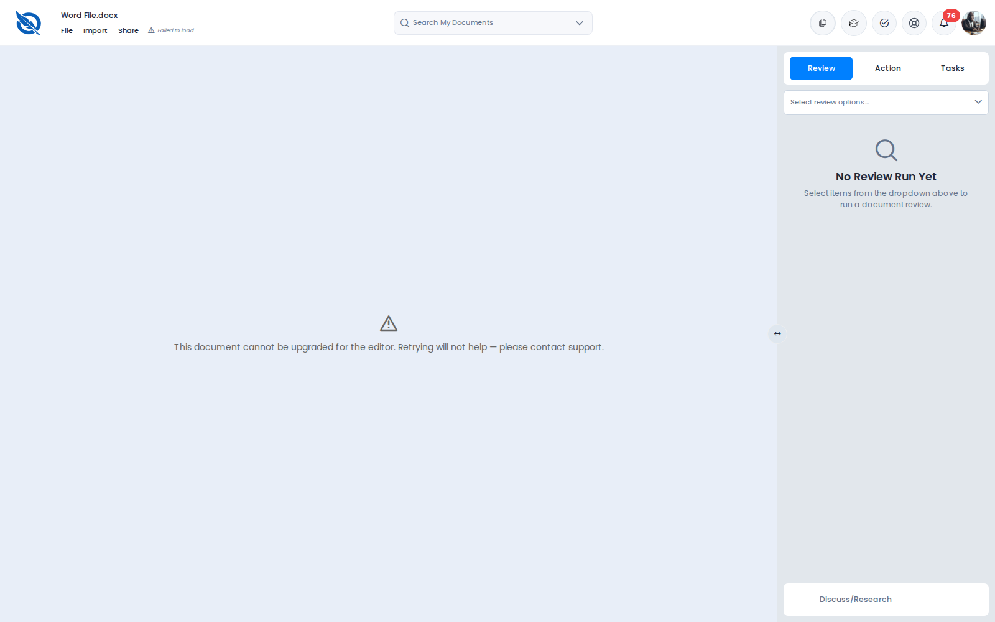
Figure H1. Word File.docx — permanent upgrade failure after Try Again

Screenshot
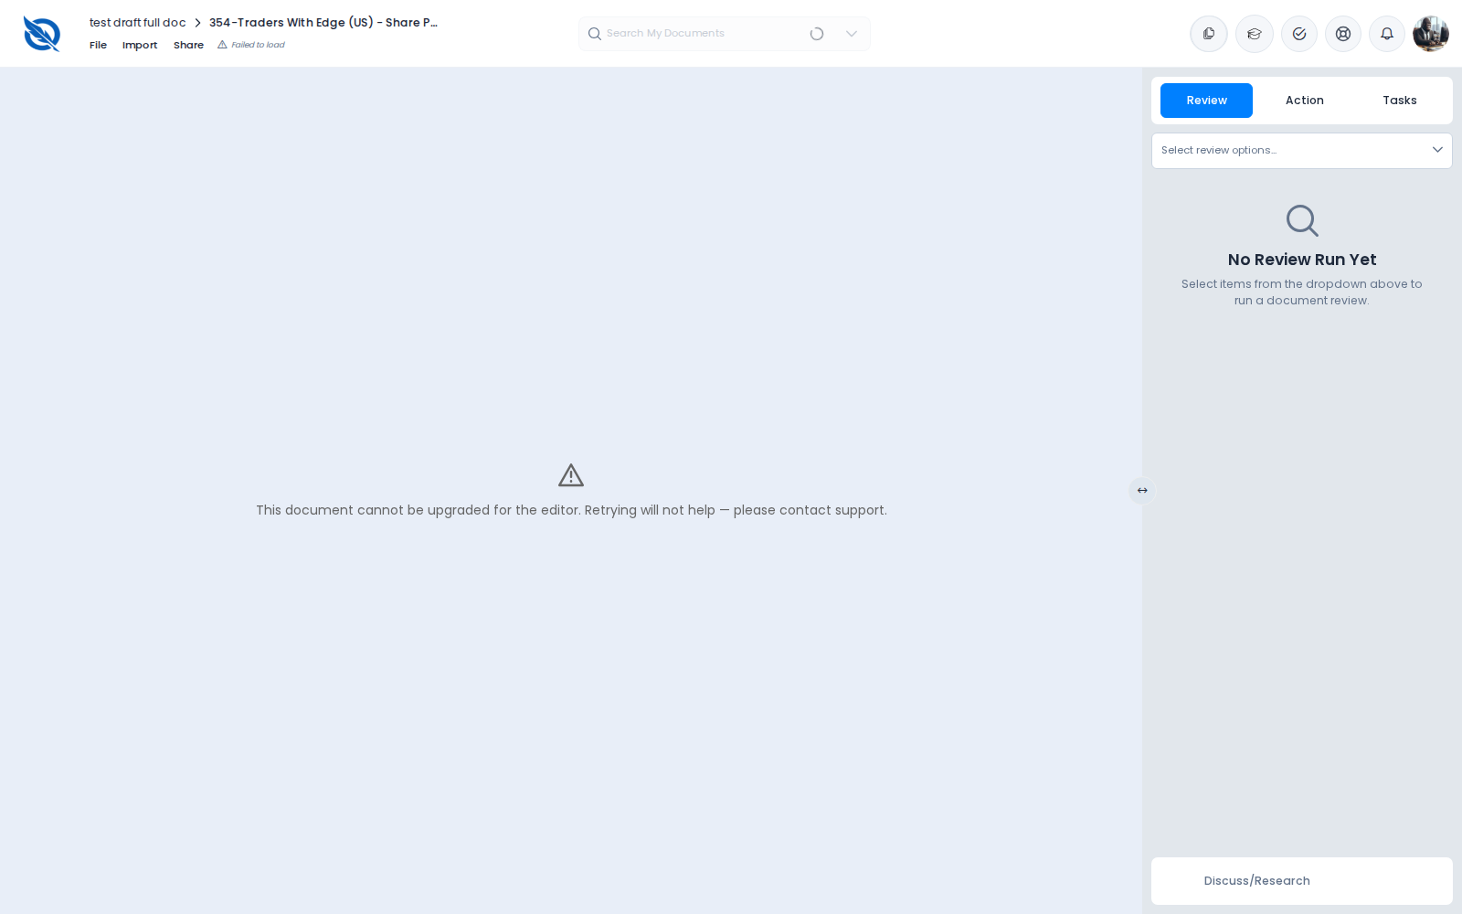
Figure H2. Traders / related DOC(X) open — upgrade / Failed to load state

H-02 · PDF / TXT / RTF fail to open — Still broken
Severity | Critical
17 Aug status | Still broken (Editor error)
18 Aug status | Still broken — messaging is now upgrade failure
Area | Document editor / file formats

Description
On 17 August these formats showed a generic Editor error. On this retest PDF and TXT fail with the upgrade message instead. PDF (2024 Annual Conference Delegates List) and IAS_16.txt both show Failed to load and “could not be upgraded…”. Try Again on PDF and TXT becomes permanent. sample.rtf and sample.txt appear in My Files search but could not be opened because the explorer does not navigate on click. No RTF content was rendered in this pass.
Steps to reproduce
1. Open /d/67b05abd53d35f08452a1cea (PDF) with OnlyOffice path.
2. Open /d/66bf220942de10760a24e823 (IAS_16.txt).
3. Click Try Again where shown.
4. Search My Files for sample.rtf / sample.txt (open if navigation works).
Actual result
PDF and TXT: upgrade failure → permanent after Try Again. RTF: found in search, not opened (UI navigation bug).
Expected result
PDF/TXT/RTF open with readable content, or a clear format-unsupported message without a dead Try Again.
Screenshot
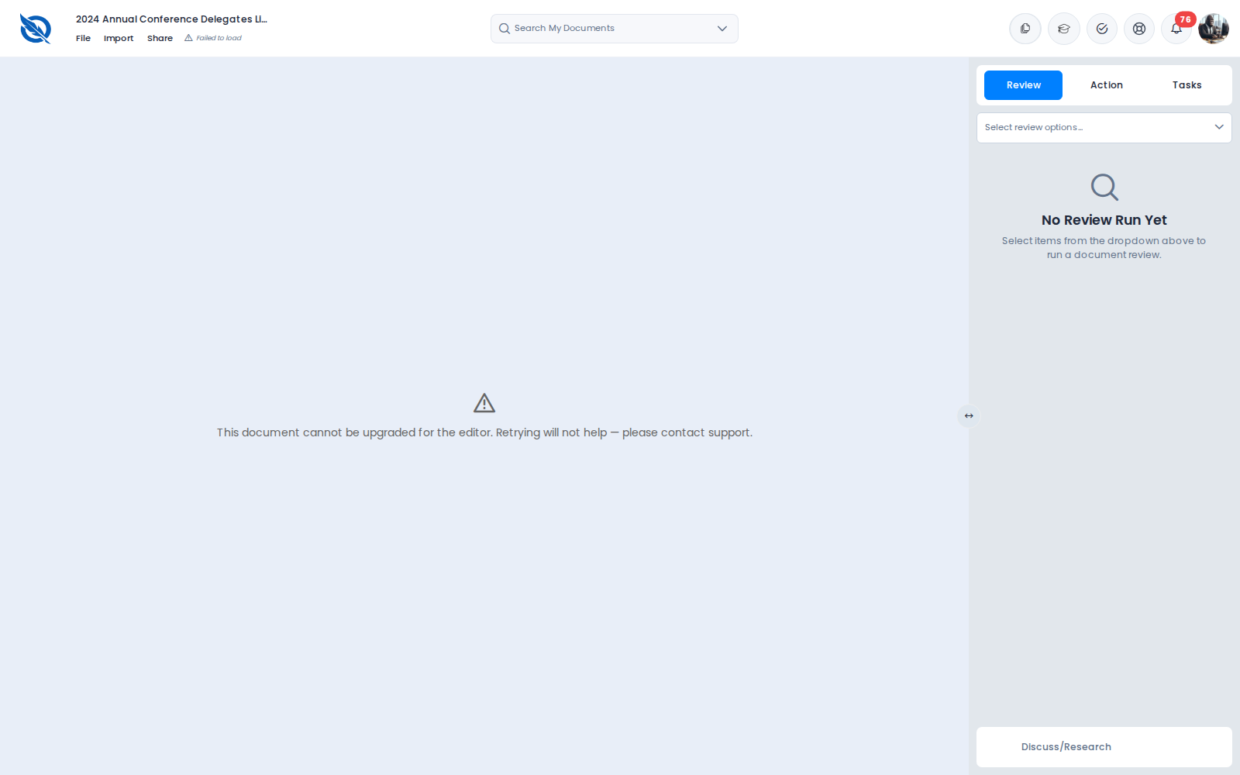
Figure H3. PDF — permanent upgrade failure

Screenshot
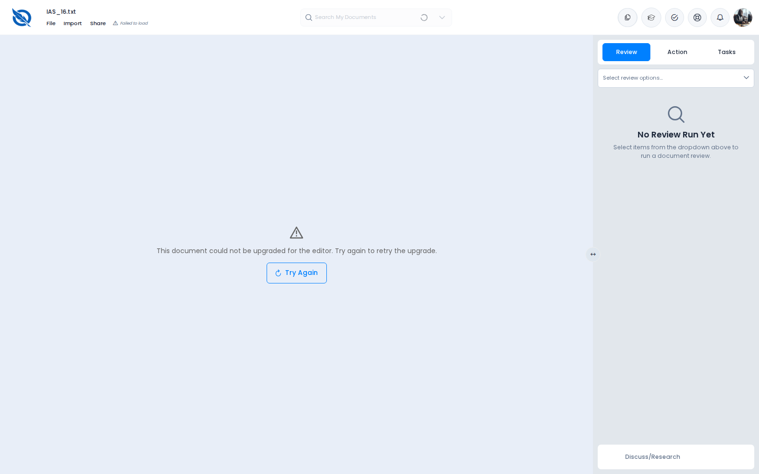
Figure H4. IAS_16.txt — could not be upgraded (Try Again)

H-03 · Typing delay / Insert Link-Image-Table — Partially blocked
Severity | High
17 Aug status | Still broken
18 Aug status | Typing not retested (no editable DOCX); toolbar present on loaded CSV
Area | Document editor / toolbar

Description
No DOCX in this account opened in OnlyOffice (all hit H-01 upgrade). Therefore the ~2-second typing delay could not be retested on a Word document. QA-FORMAT CSV does load in OnlyOffice as a rich-text page. On that loaded document the OnlyOffice toolbar shows standard formatting (fonts, bold, lists, review/track). Outer Quillio chrome still has no separate Insert Link / Image / Table menu; insert controls live inside the OnlyOffice toolbar when the iframe loads. Conclusion: typing-delay remains unverified; “no insert at all” is less absolute when OnlyOffice mounts — but users still cannot reach insert on the documents that matter (DOCX) because of H-01.
Steps to reproduce
1. Attempt to open any DOCX until one loads (currently fails — H-01).
2. If a document loads (e.g. QA-FORMAT CSV), inspect the OnlyOffice toolbar for link/image/table.
3. Type quickly and observe paint delay.
Actual result
DOCX never loads → typing delay not retested. On loaded CSV, OO toolbar is present; Quillio File menu is Create/Clone/Move/Export style, not Insert.
Expected result
DOCX opens; typing paints immediately; Insert Link/Image/Table are obvious in toolbar or Insert menu.
Screenshot
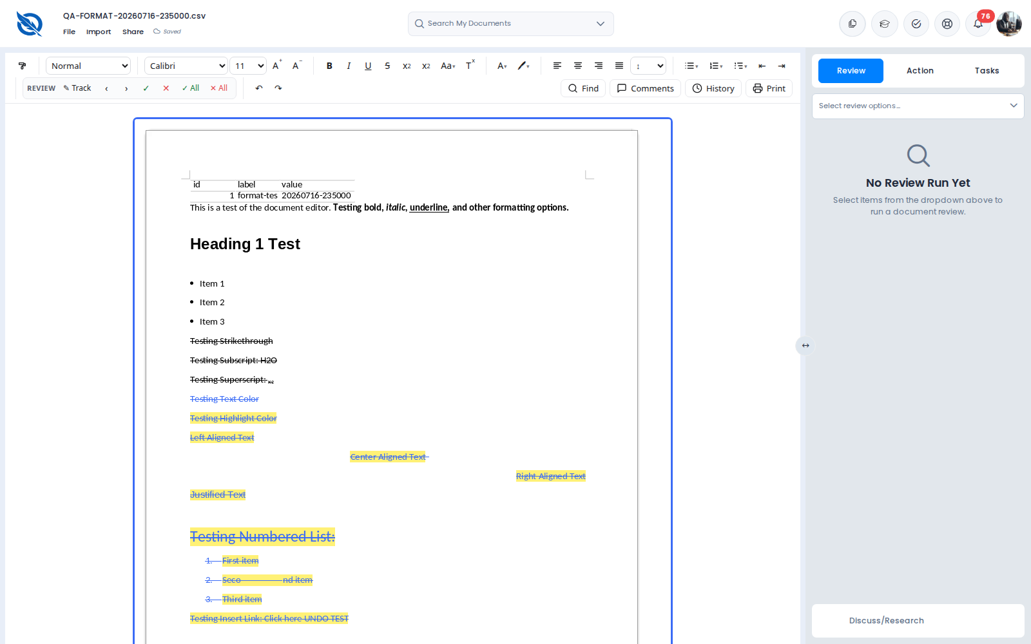
Figure H5. Loaded QA-FORMAT CSV — OnlyOffice toolbar visible (DOCX still blocked by upgrade)

H-04a · CSV ######## dates — Blocked / not confirmed on available fixture
Severity | High
17 Aug status | Still broken on sample.csv
18 Aug status | sample.csv not opened; QA-FORMAT CSV opens as Word format-test doc
Area | CSV conversion

Description
The 17 August bug was on sample.csv (Date Filed column as ########, truncated headers). sample.csv is visible in My Files search but could not be opened via click. The known QA-FORMAT CSV id loads successfully in OnlyOffice, but its content is a rich-text formatting test page (headings, lists, highlights) — not the date-column spreadsheet. ######## was not observed on that fixture. Status: original sample.csv bug not reconfirmed this pass.
Steps to reproduce
1. Open sample.csv from the library (requires working open-from-list).
2. Inspect Date Filed and headers.
Actual result
Could not open sample.csv. QA-FORMAT CSV loads as a Word-style format test document (screenshot).
Expected result
CSV shows readable dates and full headers in a spreadsheet or well-fitted table.
Screenshot
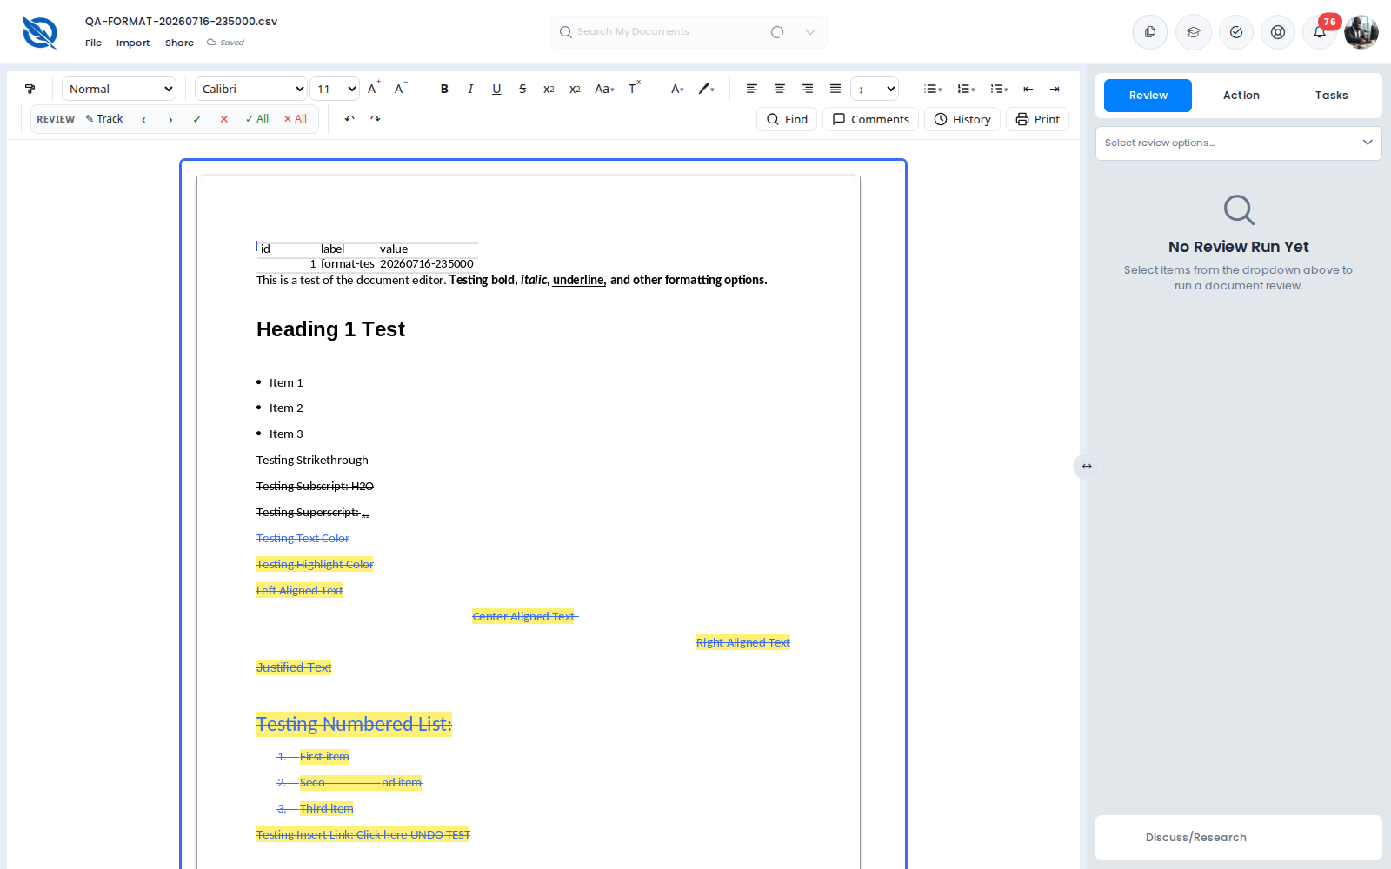
Figure H6. QA-FORMAT CSV loaded in OnlyOffice as Word content (not the ######## fixture)

Screenshot
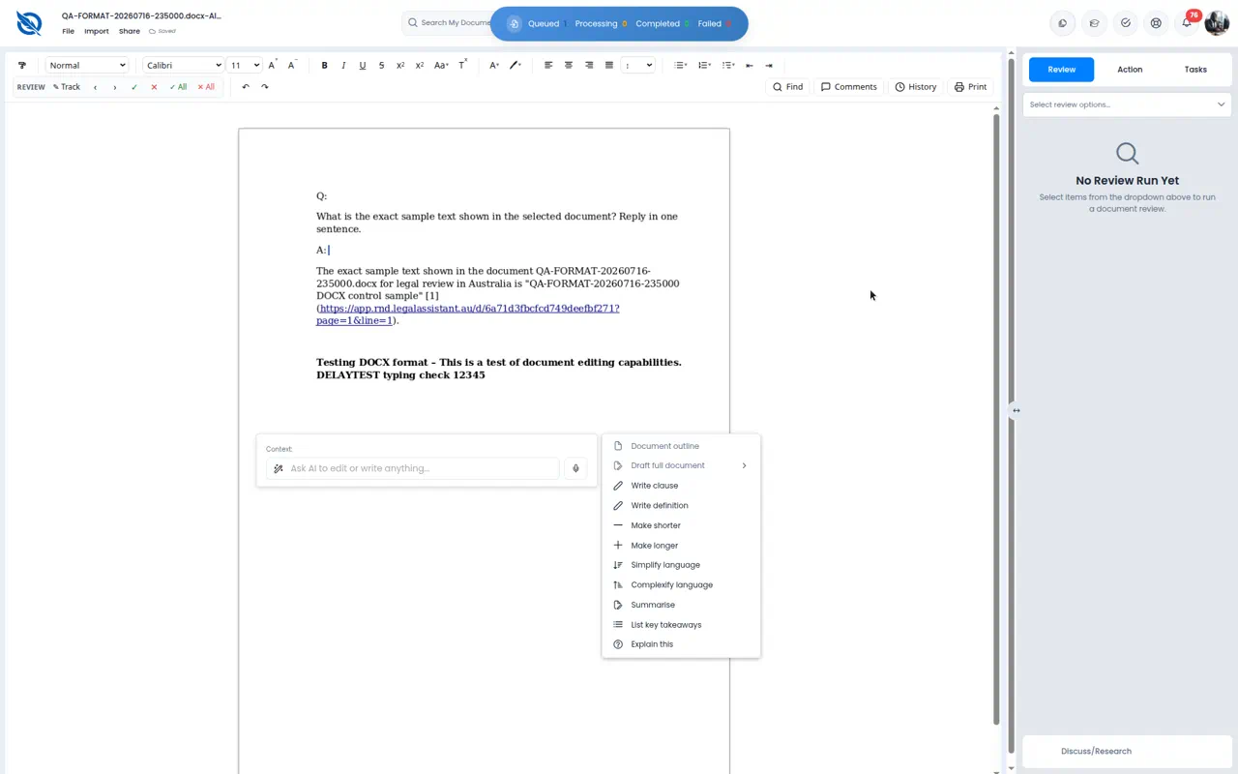
Figure H7 (17 Aug). sample.csv — Date Filed as ######## (original evidence)

H-04b · XLSX opens as blank Word page (Sheet1) — Still broken
Severity | High
17 Aug status | Still broken
18 Aug status | Still broken
Area | XLSX conversion

Description
QA-FORMAT-20260716-235000.xlsx mounts OnlyOffice (Saved) but converts into a Word-style page. When content appears, the page is essentially blank aside from a single Sheet1-like word (observed as “Blaget1” / Sheet1-style text on an empty page). There is no spreadsheet grid or cell data. Other waits show “Loading the document into the tile engine…” for a long time before/without useful content.
Steps to reproduce
1. Open /d/6a71d6cfe436a371f0d8efed with OnlyOffice path.
2. Wait until Saved / loading finishes.
3. Inspect whether a grid and cell values appear.
Actual result
XLSX opens in a Word editor chrome. Page is blank or shows only a sheet-name-like word. No grid/data.
Expected result
Workbook content visible as a table/grid with cell values intact.
Screenshot
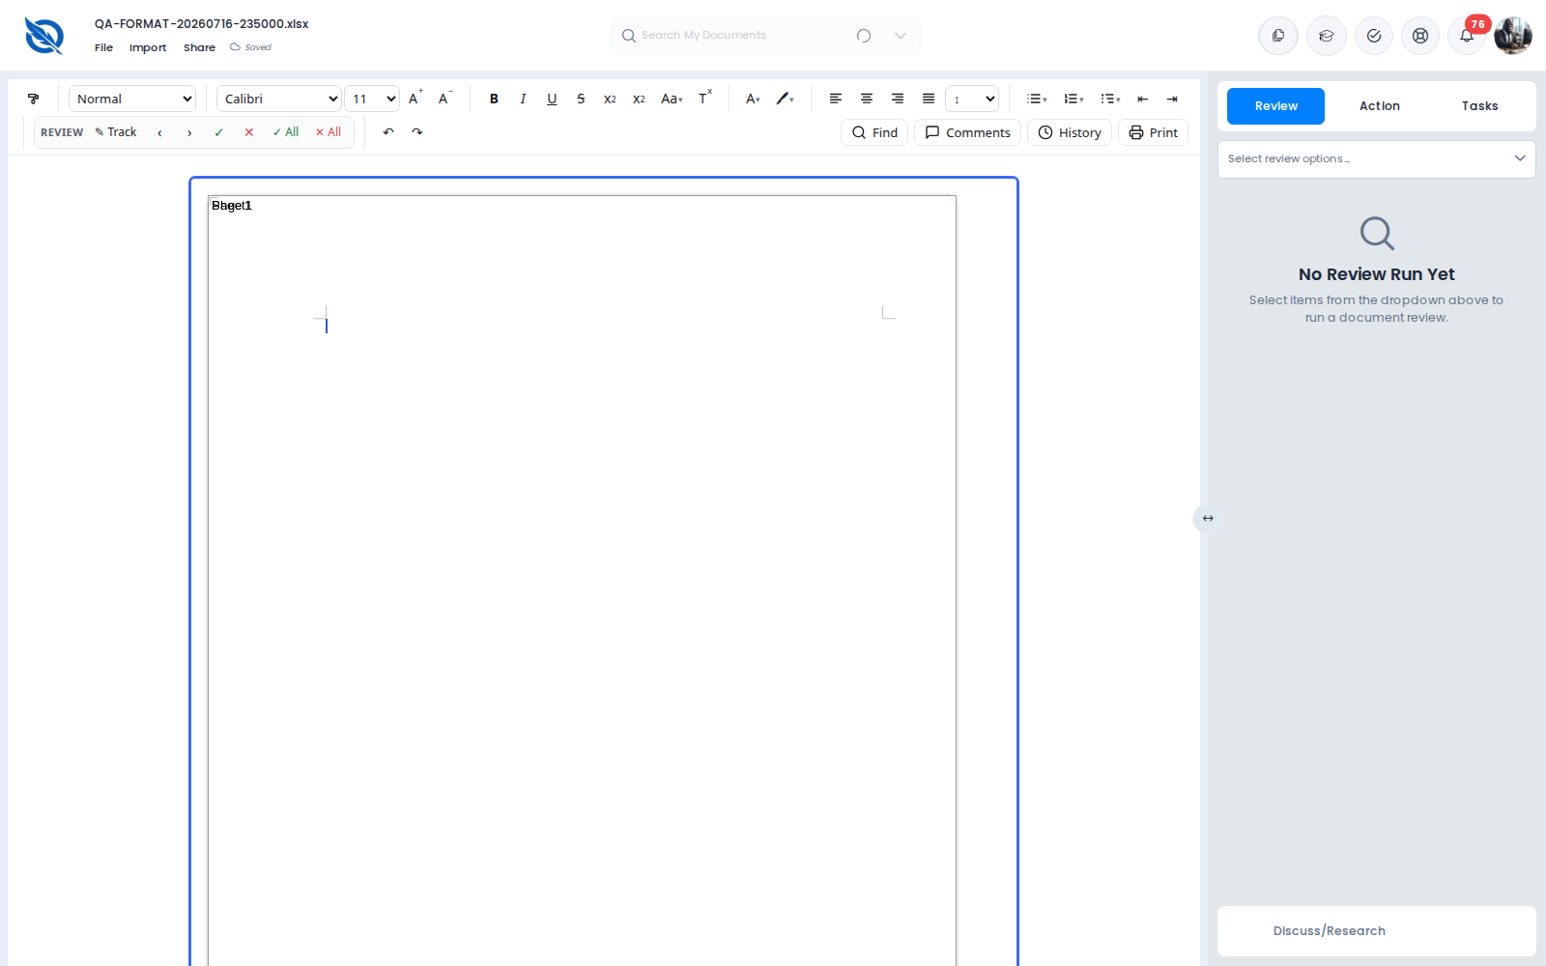
Figure H8. XLSX — Word page with Sheet1-like text only (“Blaget1”)

Screenshot
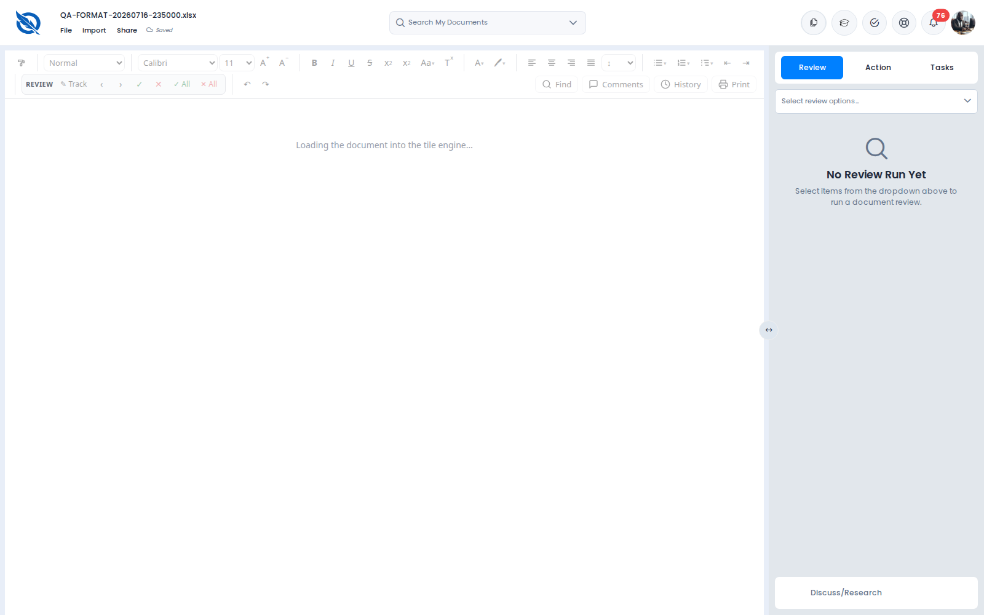
Figure H9. XLSX — stuck on “Loading the document into the tile engine…”

H-04c · PNG placeholder — Not retested
Severity | High
17 Aug status | Partial (loaded but placeholder)
18 Aug status | Not retested — no PNG in API library for this account
Area | Image open

Description
GET /documents for this account returned no .png titles. My Files search for .png also returned empty. Cannot confirm or clear the 17 August placeholder-image defect this pass.
Screenshot
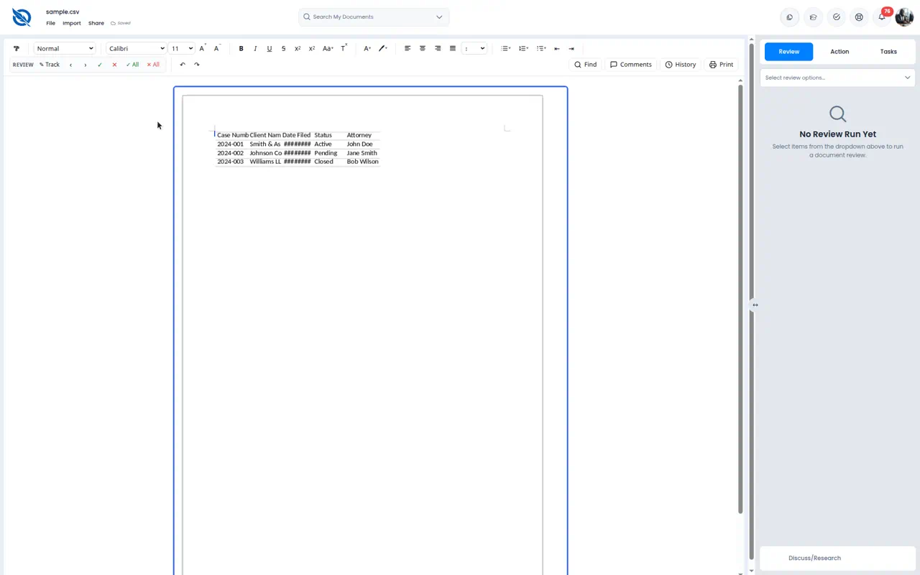
Figure H10 (17 Aug). PNG placeholder icon (original evidence)

H-05 · PPT / PPTX not in Import — Still missing
Severity | Medium
17 Aug status | Still missing
18 Aug status | Still missing
Area | Import dialog

Description
From a loaded CSV, Import opens Upload Document. Supported types listed: .doc, .docx, .txt, .rtf, .pdf, .xls, .xlsx, .csv, .png, .jpg, .jpeg, .heic, .mp3, .mp4, .wav, .m4a, .mov, .webm, .msg, .eml. No .ppt or .pptx.
Steps to reproduce
1. Open a document that loads (QA-FORMAT CSV).
2. Click Import.
3. Read the supported-format line under the drop zone.
Actual result
Import lists many office/media types but not PowerPoint (.ppt / .pptx).
Expected result
PPT/PPTX are supported, or clearly marked unsupported instead of omitted while “all files” is rejected.
Screenshot
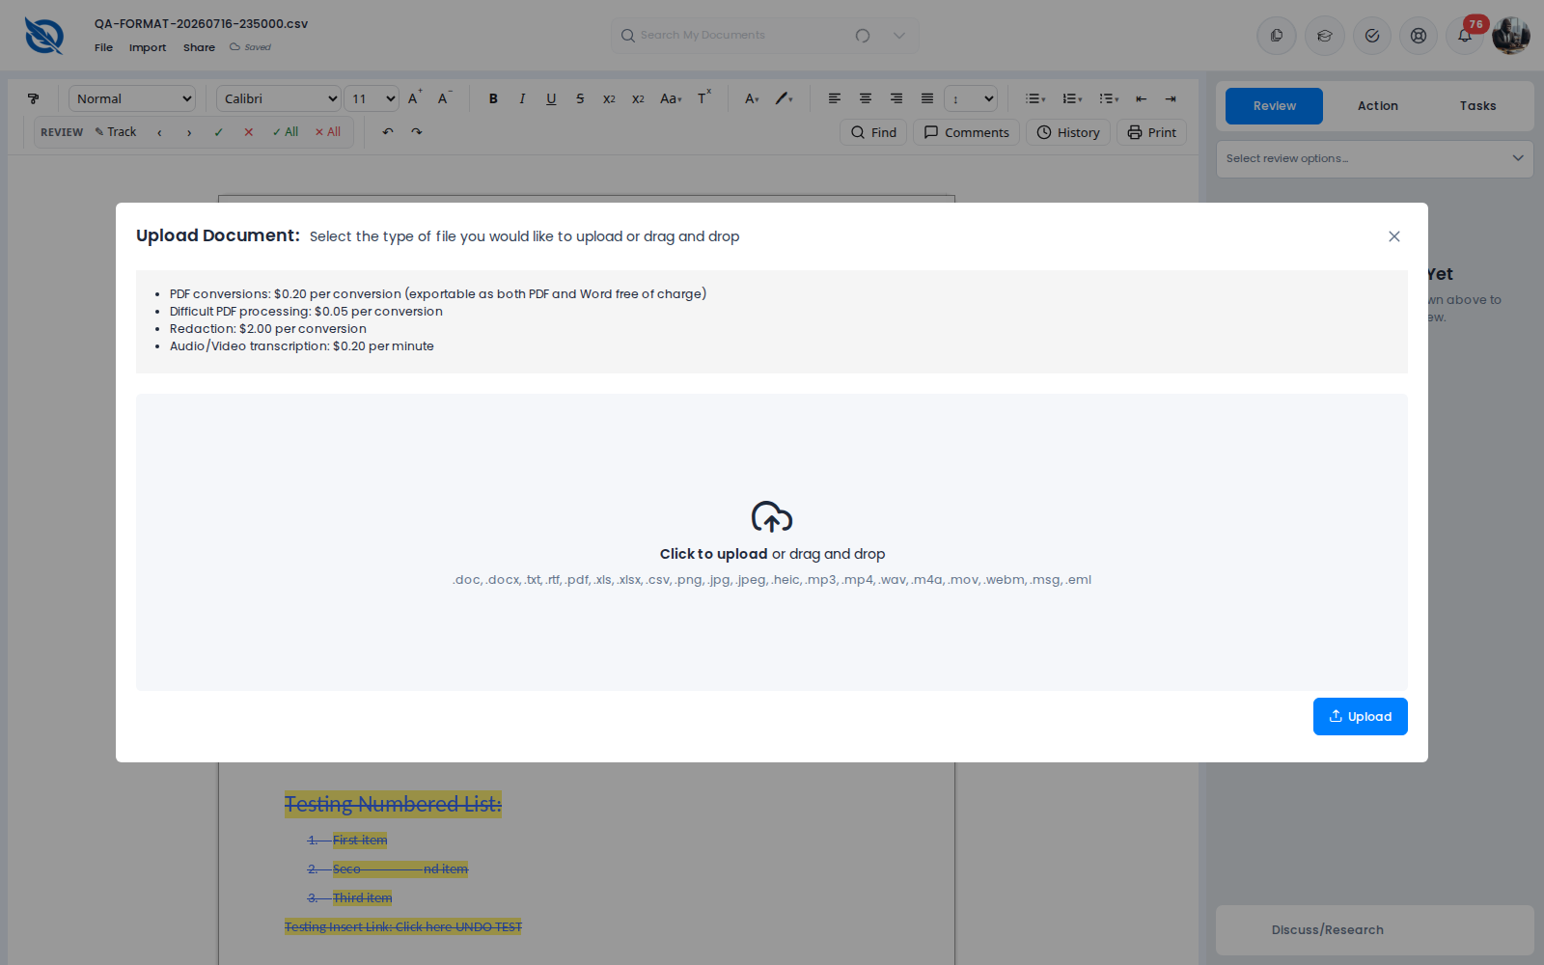
Figure H11. Import — supported formats list without .ppt / .pptx

4. Related observation this pass
Failed upgrade documents show “Failed to load” in the header. The older “Not saved” wording from 17 August was not seen on these failures. Queued uploads were not retested (no upload completed in this session).

5. Summary
- Still broken: H-01 upgrade (now most DOC/DOCX), H-02 PDF/TXT, H-04b XLSX Sheet1-only page, H-05 PPT missing.
- Blocked / not confirmed: H-03 typing delay (no DOCX), H-04a sample.csv ########, H-04c PNG.
- Default SDK path remains 503 — production users without a flag-off build still cannot reach OnlyOffice.
- My Files click-to-open remains broken, which blocked some fixture opens (sample.* / 1-MB-DOC).
Report generated 18 August 2026. Historical retest used OnlyOffice via forced editor_sdk_enabled=false. This is a QA report, not a product code change.

