Quillio Legal Assistant — RND Editor Bug Report
Fresh editor retest — 18 August 2026 (~14:25 UTC)
This report is from a new live pass of the document editor on RND (app v10.2.2). The editor remains unusable. Documents that reach the native Editor SDK fail with HTTP 503 or a 15-second client timeout. Other documents hang on a spinner and never call /editor/session. Clicking a file in My Files selects the checkbox but does not open the editor. Prior format-quality bugs from 17 August could not be retested because no document canvas loaded with content.

1. Environment
Application | Quillio Legal Assistant (RND) v10.2.2
URL | https://app.rnd.legalassistant.au
Editor | Native Editor SDK (.quillio-doc-editor) on /d/{id}
Editor API | POST https://api.rnd.legalassistant.au/editor/session → 503 (when called)
OnlyOffice iframe | Not mounted (Chatwoot widget only when chrome loads)
Test account | samuel+4@botprofits.co
Browser | Chromium 1600×1000 (Playwright)
Retest date | 18 August 2026, ~14:25 UTC
Previous reports | 7 Aug, 12 Aug, 17 Aug, 18 Aug morning & afternoon
Scope | Open CSV, XLSX, PDF, DOCX, DOC, TXT, MP3, invalid id; My Files; File/Import/Share

2. Executive summary
- Critical: editor session still returns 503 for CSV and XLSX. Header Failed to load.
- Critical: PDF now fails with “timeout of 15000ms exceeded” (new message this pass) after ~30s.
- Critical: DOCX / DOC / TXT / MP3 hang — spinner or blank canvas; often no /editor/session call.
- High: File / Import / Share on the failed editor page are not clickable (overlay intercepts clicks).
- High: Clicking a document name in My Files only checks the checkbox; it does not navigate to /d/{id}.
- Medium: Invalid document id spins 25–35s before Unable to Load Document; tab title is undefined | Quillio.
- Medium: HTTPS /auth/login (no slash) still 301-redirects to http://.
- Note: My Files listed documents on this pass (earlier afternoon pass showed an empty create-folder state — intermittent).
- Blocked: 17 August format bugs could not be retested (canvas never showed content).

3. Defect register
ID | Severity | Status | Title
BUG-01 | Critical | Still failing | Editor session API returns 503 — SDK cannot load
BUG-02 | Critical | Still failing | All tested formats fail to open (503, timeout, or hang)
BUG-03 | Critical | New this pass | PDF fails with “timeout of 15000ms exceeded”
BUG-04 | High | Still failing | Inconsistent failure UX: 503 vs timeout vs spinner
BUG-05 | High | Still failing | File / Import / Share unclickable — overlay intercepts clicks
BUG-06 | High | New this pass | My Files click selects checkbox but does not open editor
BUG-07 | Medium | Still failing | Missing document: long spinner; title “undefined | Quillio”
BUG-08 | Medium | Still failing | Login URL without slash redirects HTTPS → HTTP
BUG-09 | Low | Still failing | Home first paint shows “Loading files…”
H-01 | Critical | Blocked | Legacy DOC cannot be upgraded (17 Aug)
H-02 | Critical | Blocked | PDF / TXT / RTF Editor error (17 Aug)
H-03 | High | Blocked | Typing delay; no Insert Link/Image/Table (17 Aug)
H-04 | High | Blocked | CSV ########; XLSX Sheet1-only; PNG placeholder (17 Aug)
H-05 | Medium | Blocked | PPT not in Import; queued uploads; Not saved (17 Aug)

4. Format matrix — this retest
Each row is a live open of /d/{id} after login. Wait was 16 seconds unless noted. SDK host means .quillio-doc-editor was in the DOM.
Format | Sample | Result | Session
CSV | QA-FORMAT-20260716-235000.csv | 503 + Failed to load (16s) | POST 503
XLSX | QA-FORMAT-20260716-235000.xlsx | 503 + Failed to load (16s) | POST 503
PDF | 2024 Annual Conference Delegates List (1).pdf | Spinner at 16s; timeout 15000ms at 30s | No call observed at 16s
DOCX | Word File.docx | Full-page spinner (16s) | No session call
DOCX | Sample Contract.docx | Spinner / blank chrome (16s) | No session call
DOC | 354-Traders .doc | Spinner / blank chrome (16s) | No session call
TXT | IAS_16.txt | Spinner / blank chrome (16s) | No session call
MP3 | Conversation with Lee.mp3 | Spinner / blank chrome (16s) | No session call
Invalid id | 000000000000000000000000 | Spinner 25s; not-found at 35s | No session call

5. Defects from this retest

BUG-01 · Editor session API returns 503 — SDK cannot load
Severity | Critical
Status | Still failing (18 Aug 2026 ~14:25 UTC)
Area | Document editor / Editor SDK session
Environment | RND v10.2.2

Description
The default document route mounts the native Editor SDK. POST https://api.rnd.legalassistant.au/editor/session returns HTTP 503 for documents that reach the SDK (confirmed on CSV and XLSX this pass). The canvas shows “Request failed with status code 503” and the header shows “Failed to load”. No document body is rendered.
Steps to reproduce
1. Log in at https://app.rnd.legalassistant.au/auth/login/ (trailing slash; see BUG-08).
2. Open /d/6a71d6d2e436a371f0d8eff8 (QA-FORMAT CSV).
3. Wait until Loading / Preparing finishes.
4. Check canvas, header, and Network for editor/session.
Actual result
POST /editor/session returns 503. Canvas: Request failed with status code 503. Header: Failed to load. Only iframe is Chatwoot.
Expected result
POST /editor/session returns 200 with a valid session. Document content renders and can be edited.
Screenshot
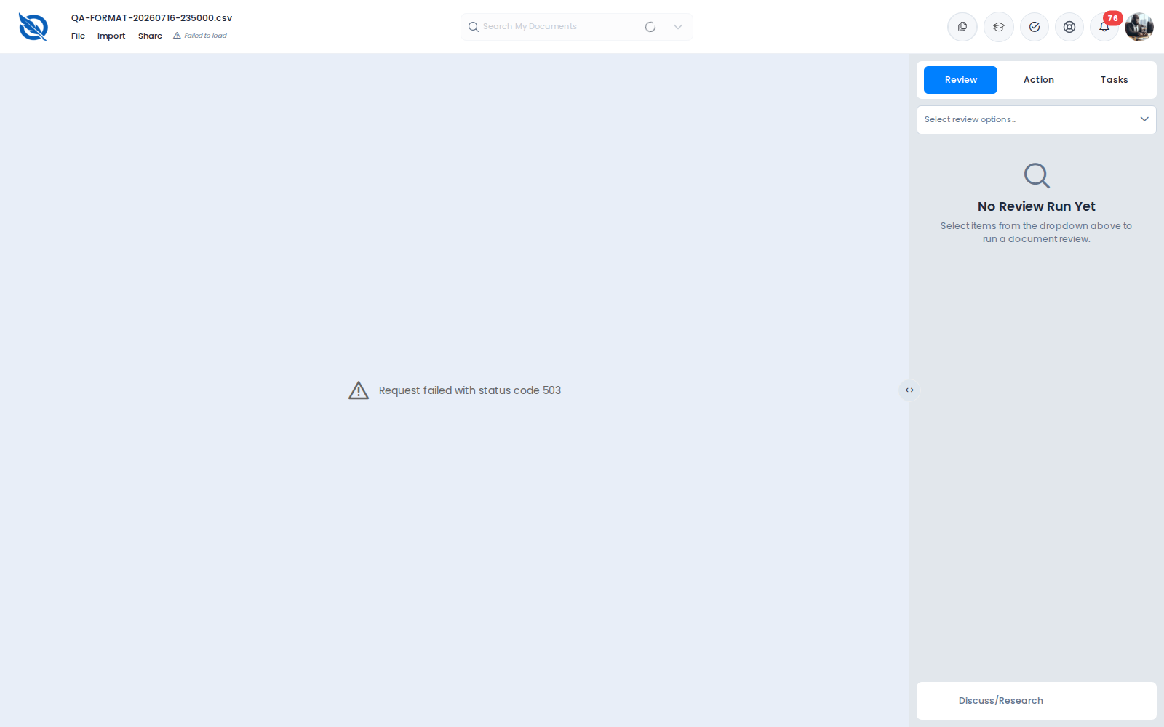
Figure 1. QA-FORMAT CSV — Failed to load and HTTP 503

Screenshot
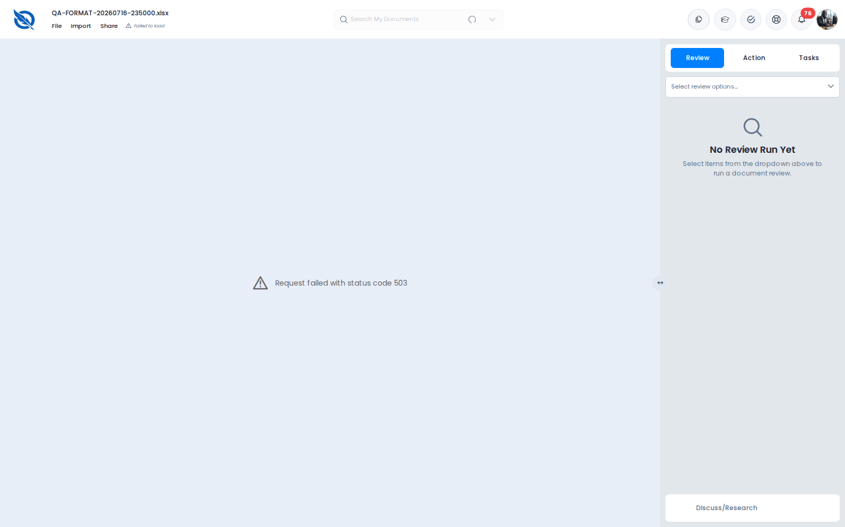
Figure 2. QA-FORMAT XLSX — Failed to load and HTTP 503

BUG-02 · All tested formats fail to open (503, timeout, or hang)
Severity | Critical
Status | Still failing
Area | Document editor / file formats
Environment | RND v10.2.2

Description
No tested format showed readable content. CSV and XLSX fail with 503. PDF eventually fails with a client timeout. DOCX, DOC, TXT, and MP3 hang without mounting a working editor. Some URLs never call /editor/session within 16 seconds.
Steps to reproduce
1. Open CSV, XLSX, PDF, two DOCX files, a TXT, a legacy DOC, and an MP3 via known /d/{id} URLs.
2. Wait at least 16 seconds (30s for PDF).
Actual result
CSV/XLSX: 503. PDF: timeout of 15000ms exceeded. DOCX/DOC/TXT/MP3: spinner or blank, no content.
Expected result
Each supported format opens with readable content within a bounded wait.
Screenshot

Figure 3. Word File.docx — full-page spinner

Screenshot
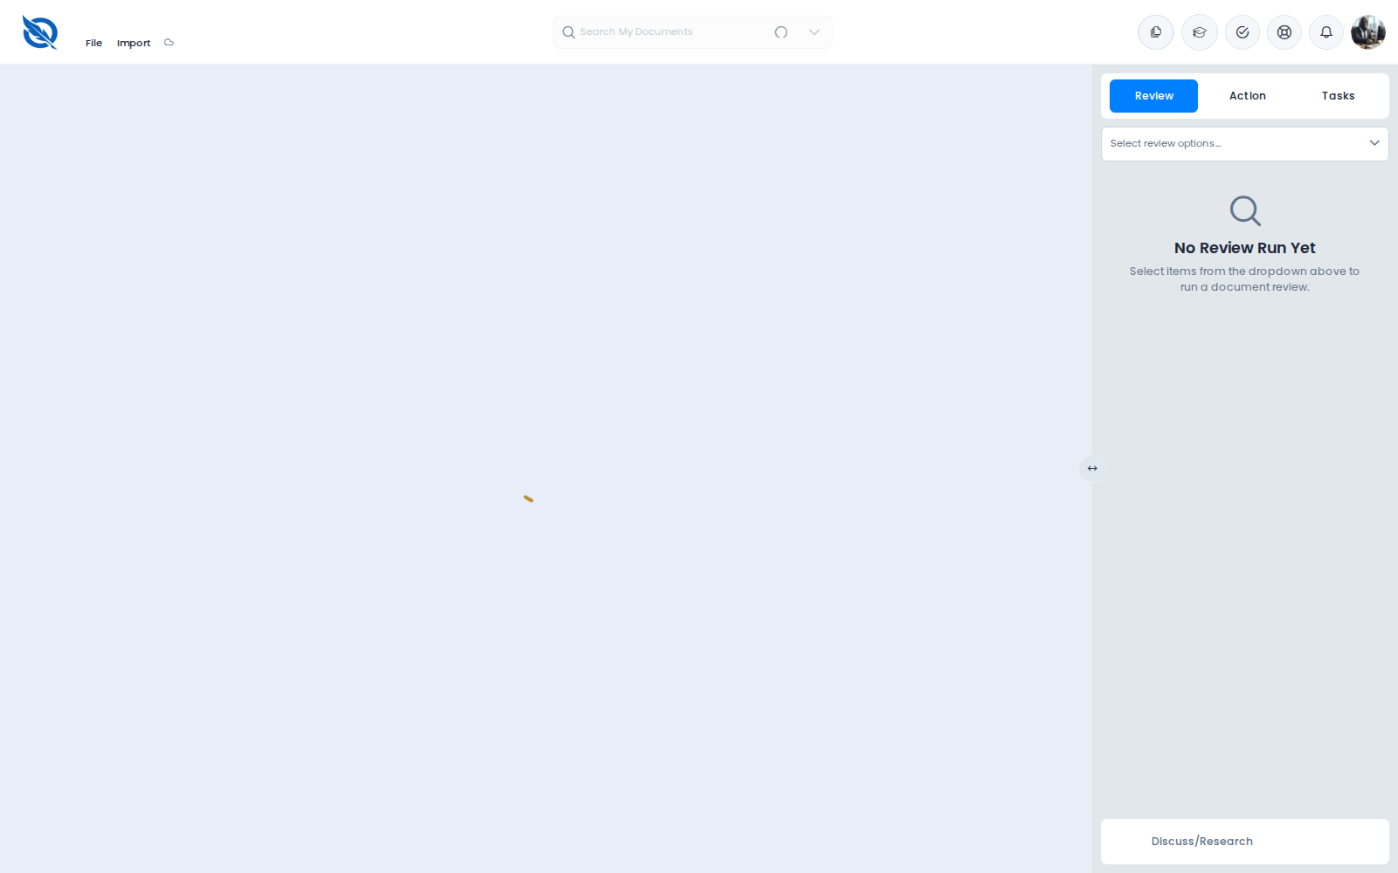
Figure 4. Legacy DOC / other hang — blank or spinner, no content

BUG-03 · PDF fails with “timeout of 15000ms exceeded”
Severity | Critical
Status | New / newly observed this pass
Area | Document editor / PDF
Environment | RND v10.2.2

Description
Opening 2024 Annual Conference Delegates List (1).pdf shows a spinner / blank canvas at 16 seconds. After ~30 seconds the canvas shows “timeout of 15000ms exceeded” and the header shows Failed to load. Earlier today the same PDF often showed HTTP 503. The failure mode is unstable, but the PDF never opens.
Steps to reproduce
1. Open /d/67b05abd53d35f08452a1cea.
2. Wait 16 seconds, then wait until ~30 seconds.
Actual result
16s: blank/spinner. 30s: timeout of 15000ms exceeded + Failed to load. No PDF pages.
Expected result
PDF opens in the editor or a viewer within a reasonable time, or fails with a clear, immediate error.
Screenshot
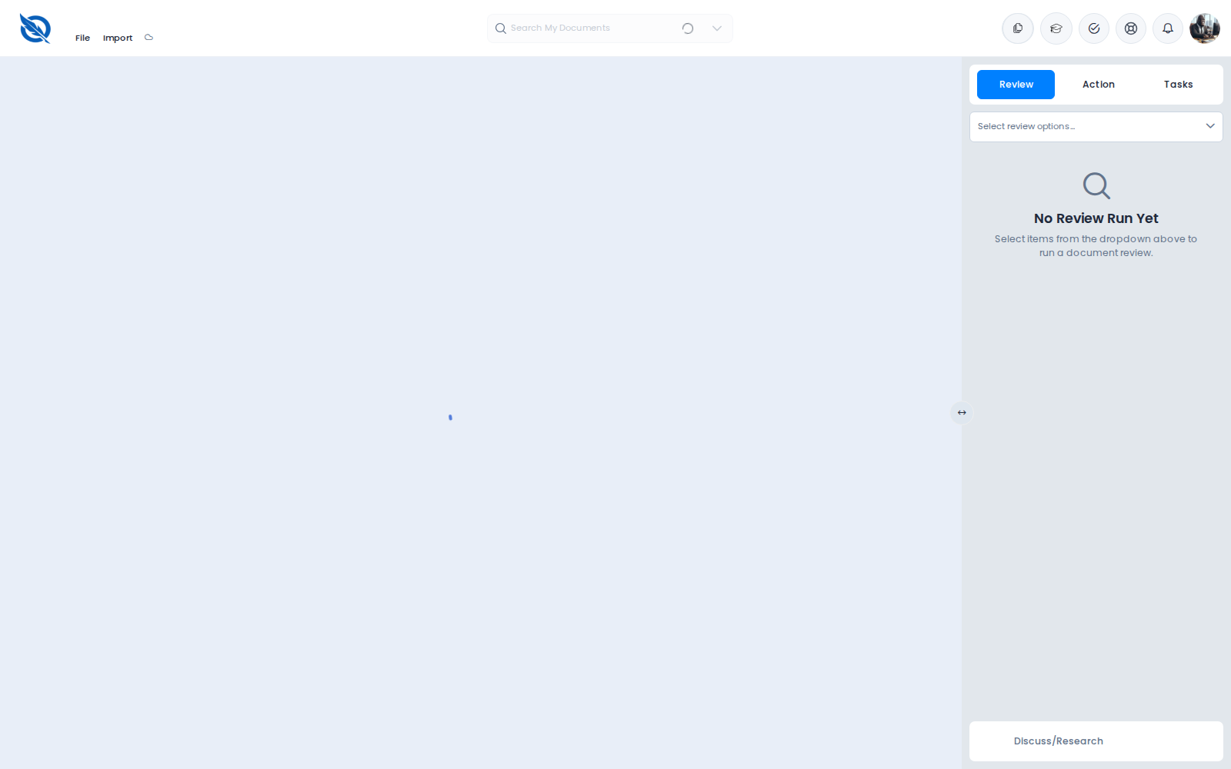
Figure 5. PDF at 16 seconds — blank canvas / spinner

Screenshot
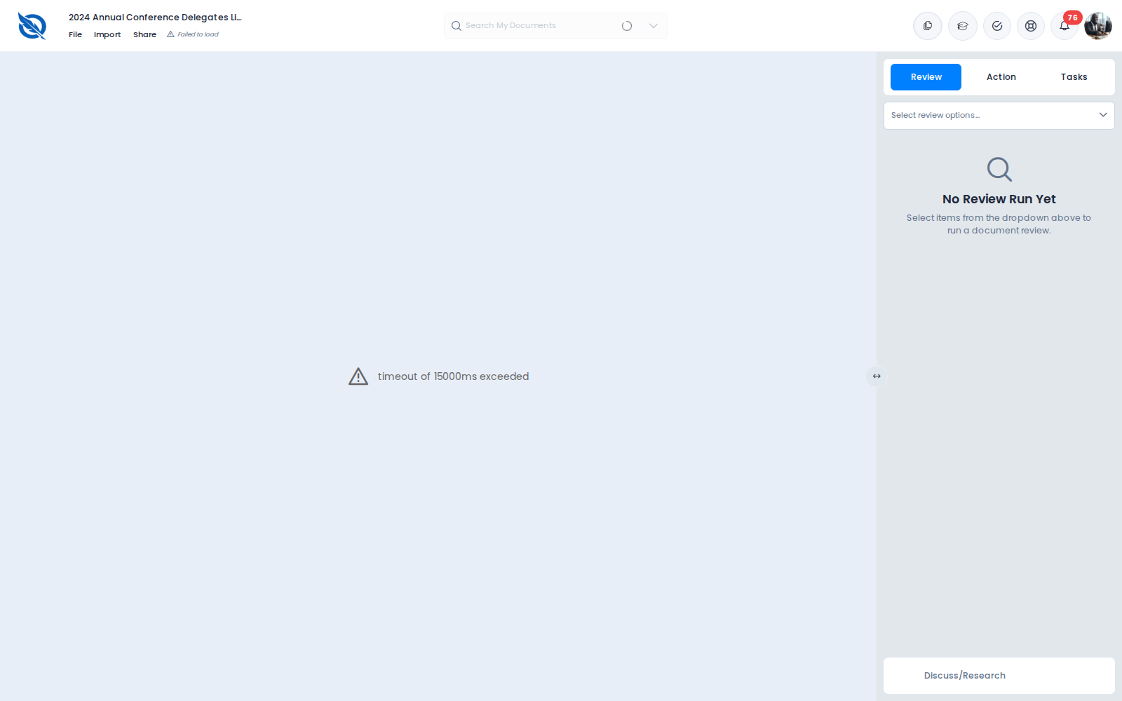
Figure 6. PDF at 30 seconds — timeout of 15000ms exceeded

BUG-04 · Inconsistent failure UX: 503 vs timeout vs spinner
Severity | High
Status | Still failing
Area | Document editor / error handling
Environment | RND v10.2.2

Description
The same product failure produces different UIs: HTTP 503 text, a 15s client timeout message, a spinner inside editor chrome, or a full-page spinner with no chrome. Users cannot tell whether to wait, retry, or leave. There is no consistent timeout policy.
Steps to reproduce
1. Open CSV (503), PDF (timeout), Word File.docx (full-page spinner), Sample Contract.docx (chrome + blank).
2. Compare messages and elapsed time.
Actual result
Four different failure presentations. Some never error within 16 seconds.
Expected result
After a bounded wait, every failure shows the same actionable error with Retry and Go to Dashboard.

BUG-05 · File / Import / Share unclickable — overlay intercepts clicks
Severity | High
Status | Still failing
Area | Document editor / chrome
Environment | RND v10.2.2

Description
On a failed editor page (CSV 503), File, Import, and Share are visible but not clickable. Playwright click times out because a layout overlay intercepts pointer events. Users cannot recover via File or Share from the dead editor.
Steps to reproduce
1. Open the QA-FORMAT CSV so the 503 canvas is showing.
2. Click File, then Import, then Share.
Actual result
Clicks never open a menu or dialog.
Expected result
Those controls stay usable when the canvas has failed.
Screenshot

Figure 7. File / Import / Share visible during 503 — clicks do not open menus

BUG-06 · My Files click selects checkbox but does not open editor
Severity | High
Status | New this pass
Area | Dashboard / file explorer
Environment | RND dashboard

Description
My Files correctly listed documents on this pass (Dashboard folder with Untitled (10).docx, Report.pdf, etc.). Clicking the document name Untitled (10).docx only checked the selection checkbox. The URL stayed on the dashboard (/). The editor never opened. Users who do not know the /d/{id} deep link cannot open documents from the UI.
Steps to reproduce
1. Log in and open My Files. Wait until the file list appears.
2. Click Untitled (10).docx (the name, not only the checkbox).
3. Observe whether the app navigates to /d/{id} and loads the editor.
Actual result
File is selected (checkbox). URL remains https://app.rnd.legalassistant.au/. Editor does not open.
Expected result
Clicking a document opens it in the editor (navigate to /d/{id}). Selection for Amelia can remain a separate checkbox action.
Screenshot
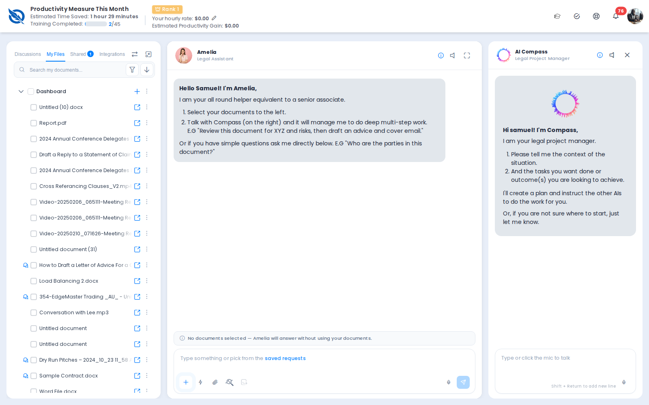
Figure 8. My Files — documents listed under Dashboard

Screenshot
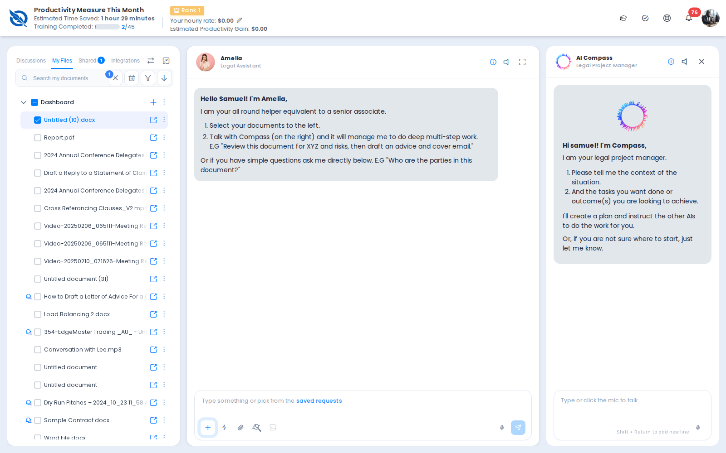
Figure 9. After clicking Untitled (10).docx — still on dashboard, file checked, editor not opened

BUG-07 · Missing document: long spinner; title “undefined | Quillio”
Severity | Medium
Status | Still failing
Area | Document editor / missing document
Environment | RND v10.2.2

Description
Opening /d/000000000000000000000000 is a full-page spinner at 25 seconds. At ~35 seconds the canvas correctly shows Unable to Load Document / This document could not be found with Try Again and Go to Dashboard. The browser tab title is “undefined | Quillio”.
Steps to reproduce
1. Open /d/000000000000000000000000 while logged in.
2. Observe the canvas at 25s and at 35s.
3. Read the browser tab title.
Actual result
25s: spinner. 35s: correct not-found empty state. Tab title: undefined | Quillio.
Expected result
Not-found should appear within a few seconds. Tab title should never be the string undefined.
Screenshot

Figure 10. Invalid id at 25 seconds — still spinning

Screenshot
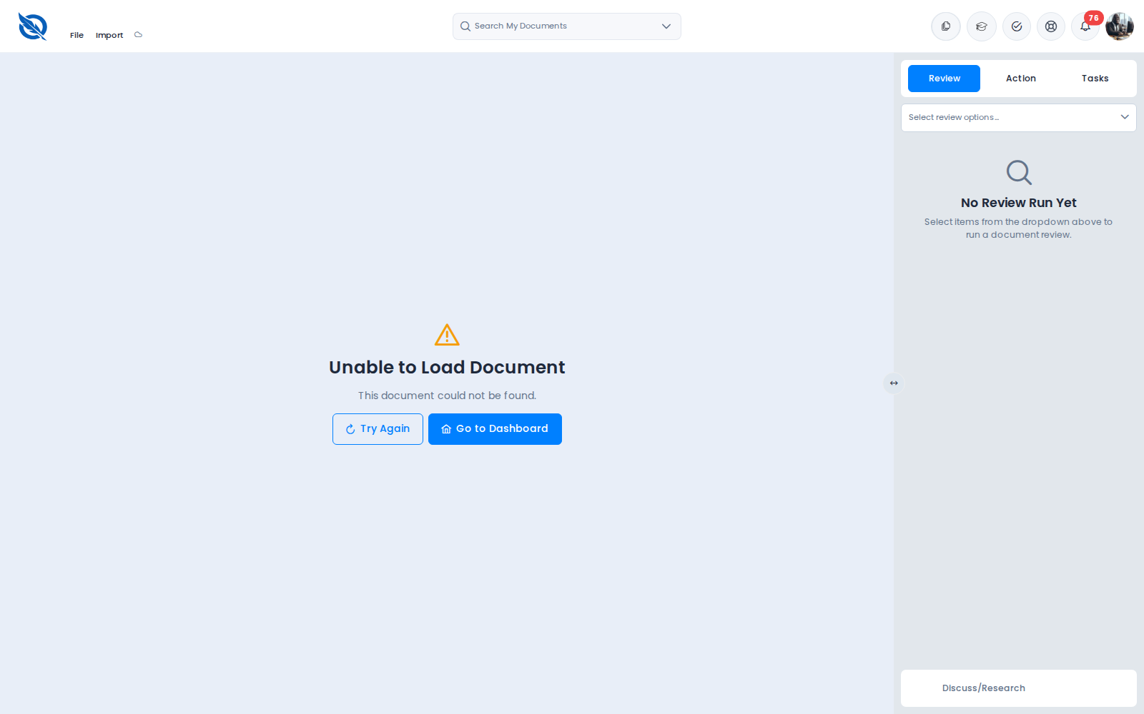
Figure 11. Invalid id at 35 seconds — correct empty state (tab title remains undefined | Quillio)

BUG-08 · Login URL without slash redirects HTTPS → HTTP
Severity | Medium
Status | Still failing
Area | Auth / hosting
Environment | https://app.rnd.legalassistant.au/auth/login

Description
GET https://app.rnd.legalassistant.au/auth/login (no trailing slash) returns HTTP 301 Location: http://app.rnd.legalassistant.au/auth/login/ (scheme downgraded). Confirmed again this pass with curl. The slash URL returns 200. Chromium can fail the HTTP hop with net::ERR_CONNECTION_RESET.
Steps to reproduce
1. Request https://app.rnd.legalassistant.au/auth/login without a trailing slash.
2. Compare with https://app.rnd.legalassistant.au/auth/login/.
Actual result
No-slash URL 301s to an http:// Location.
Expected result
Both URLs stay on HTTPS. Never redirect HTTPS to HTTP.

BUG-09 · Home first paint shows “Loading files…”
Severity | Low
Status | Still failing
Area | Dashboard / file list
Environment | RND dashboard

Description
Immediately after login, My Files shows Loading files…. On this pass the list did populate after several seconds. First paint still looks broken and can confuse users.
Steps to reproduce
1. Log in and look at My Files without waiting.
Actual result
First paint: Loading files…. List appears later.
Expected result
File list should render quickly or show a skeleton with a clear timeout.
Screenshot
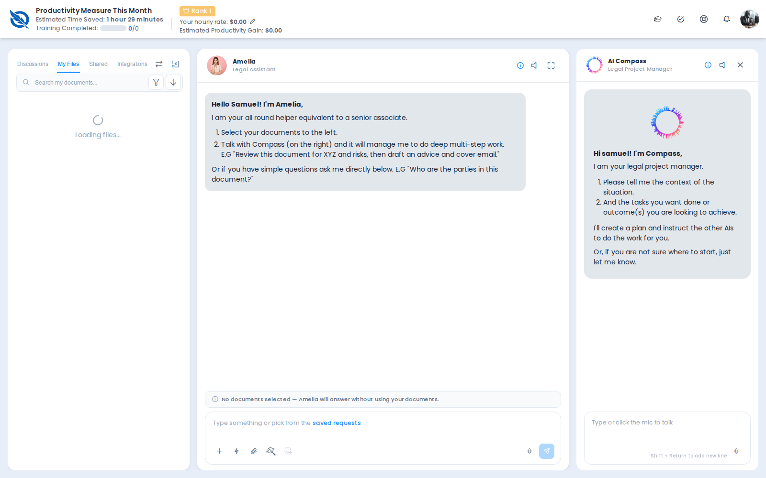
Figure 12. Home immediately after login — Loading files…

6. Prior format bugs (17 August) — blocked, not retested
These were still failing on 17 August when the OnlyOffice iframe loaded. This pass the native SDK is the default and no canvas showed document content, so they remain open.

H-01 Legacy / large DOC cannot be upgraded
1-MB-DOC.doc: could not be upgraded. Retry became permanent. Header Not saved.
Screenshot
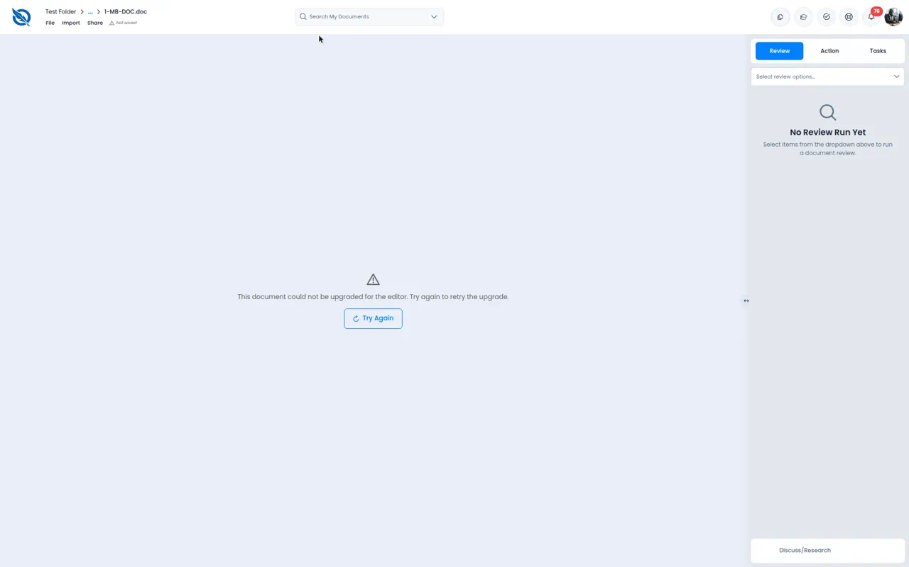
Figure (17 Aug). H-01 Legacy / large DOC cannot be upgraded

H-02 PDF / TXT / RTF Editor error
Supported formats failed with generic Editor error after Preparing editor…
Screenshot
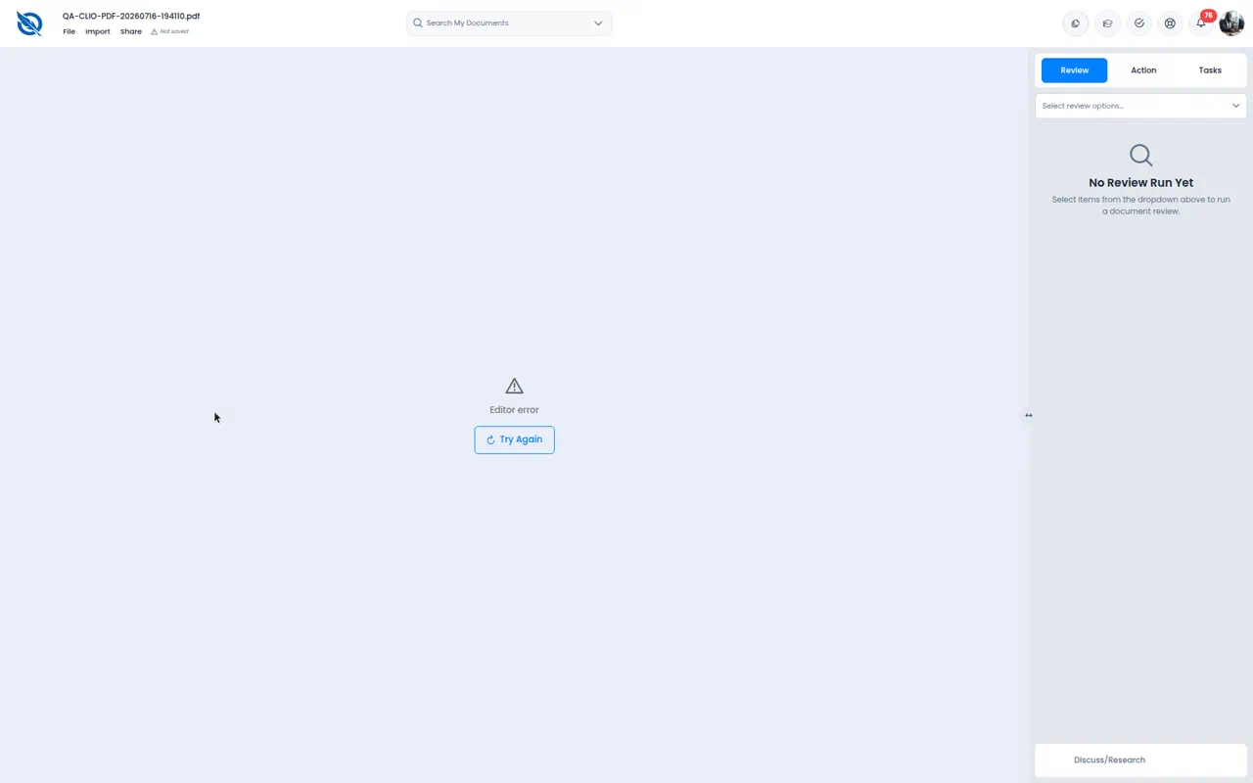
Figure (17 Aug). H-02 PDF / TXT / RTF Editor error

H-04a CSV Date Filed as ########
sample.csv opened as a narrow Word table. Dates unreadable; headers clipped.
Screenshot
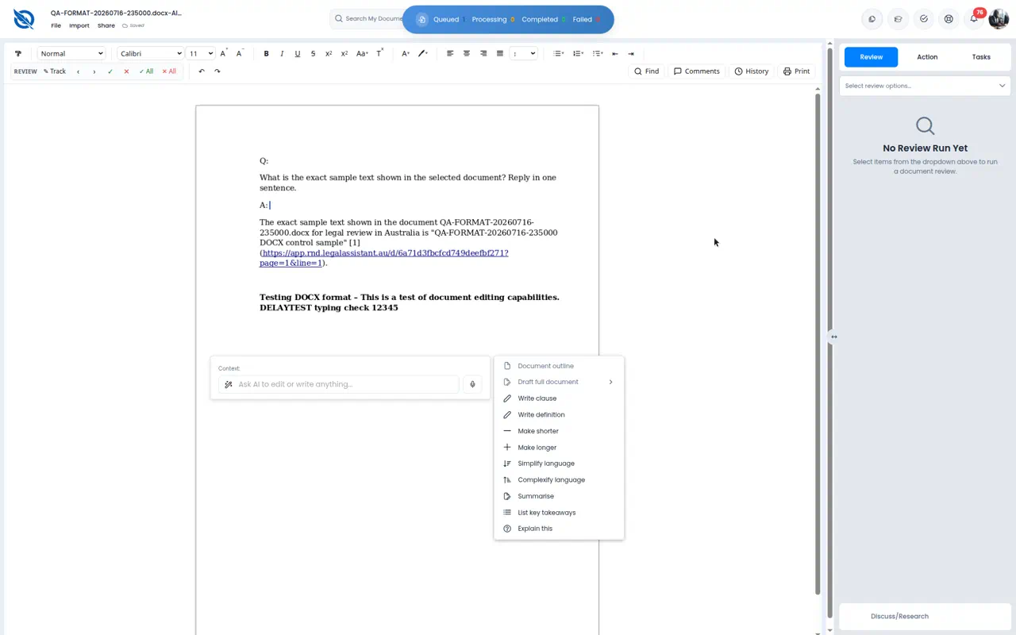
Figure (17 Aug). H-04a CSV Date Filed as ########

H-04b XLSX as blank page with only Sheet1
QA-FORMAT xlsx converted to an empty page containing the sheet name only.
Screenshot
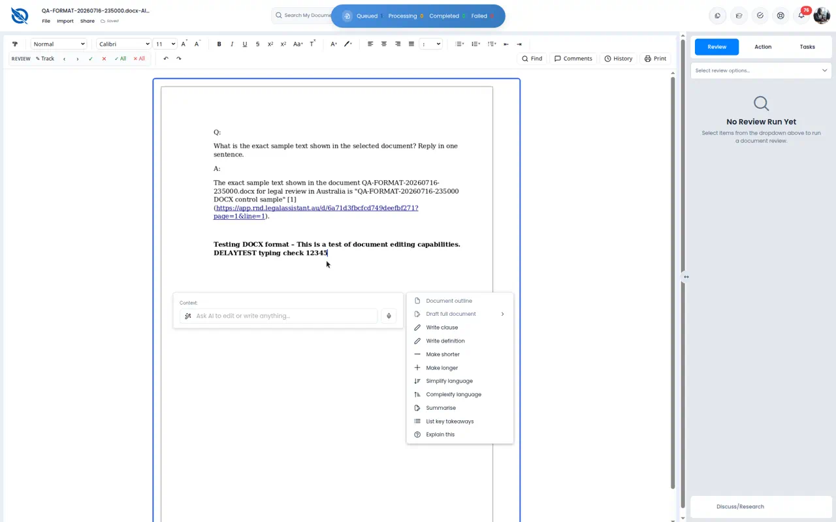
Figure (17 Aug). H-04b XLSX as blank page with only Sheet1

H-04c PNG placeholder instead of the image
PNG finished loading but showed a tiny placeholder icon, not the file.
Screenshot
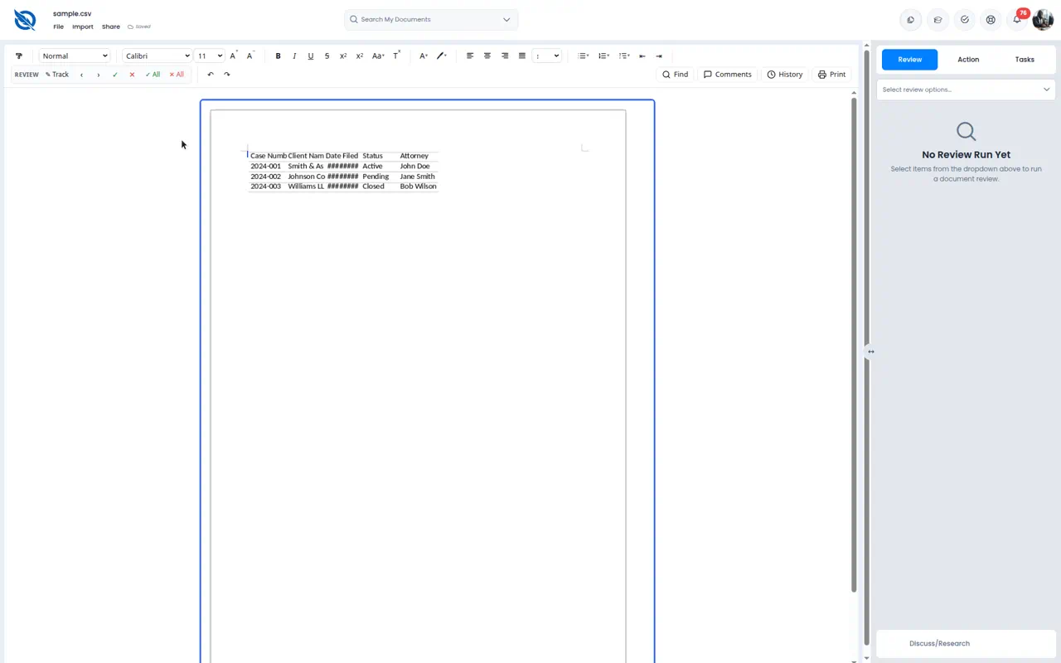
Figure (17 Aug). H-04c PNG placeholder instead of the image

H-05 PPT / PPTX not in Import
Import listed many types but not .ppt/.pptx.
Screenshot
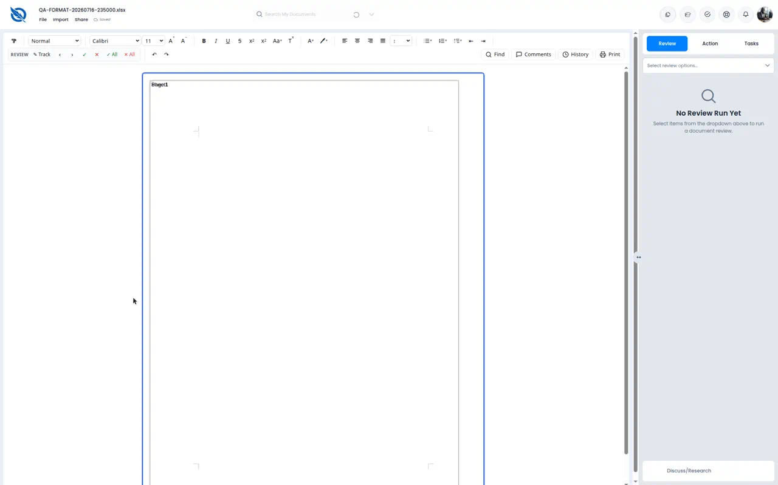
Figure (17 Aug). H-05 PPT / PPTX not in Import

7. What still works
- Login with email/password on /auth/login/ succeeds.
- Dashboard Amelia and Compass chrome load.
- GET /documents returns 26 files; My Files listed them on this pass.
- Invalid id eventually shows Unable to Load Document (after a long spinner).
- Some document titles resolve in the editor header (CSV, XLSX, PDF) before failure.

8. Recommended next checks (after session/timeout is fixed)
- Retest BUG-01–BUG-05: session 200, formats open, File/Import/Share clickable, consistent errors.
- Fix My Files open-on-click (BUG-06) so dashboard navigation reaches the editor.
- Retest 17 August format bugs on the same fixtures.
- Keep /auth/login on HTTPS with or without a trailing slash.
Report generated 18 August 2026 from a fresh live RND pass (Playwright Chromium). This is a QA report, not a product code change.

