RND Editor 503 — Root Cause Investigation
19 August 2026 · Verdict: backend environment misconfiguration

1. Verdict
Root cause: The 503 is returned deliberately by the RND API because the native Editor SDK is not configured on the RND environment. It is not a frontend bug, not an auth failure, and not a transient overload.
Failing response body: {"detail":"Editor is not configured on this environment"}
The frontend correctly calls POST /editor/session with a valid Bearer token and document_id. The API answers 503 with that explicit configuration message (correlation id example: b4a9ae1a13eb). Other authenticated APIs such as GET /documents still work, so the RND backend is up — only the editor session service/config is missing.

2. Reproduction (consistent)
Timestamp (UTC) | 2026-08-19 ~03:12–03:16
Environment | RND — app v10.2.2
App URL | https://app.rnd.legalassistant.au
Document URL | https://app.rnd.legalassistant.au/d/6a71d6d2e436a371f0d8eff8
Account | samuel+4@botprofits.co
Browser | Chromium (Playwright) 1600×1000
Consistency | 3/3 rapid repros returned the same 503 + same detail message
Also fails for | CSV, XLSX, PDF, DOCX, and even invalid document ids (same 503 body)

Steps
1. Open https://app.rnd.legalassistant.au/auth/login/ and sign in.
2. Open any document, e.g. /d/6a71d6d2e436a371f0d8eff8.
3. Wait for the editor canvas (~5–15s).
4. Observe header “Failed to load” and canvas “Request failed with status code 503”.
5. In DevTools → Network, filter editor/session.
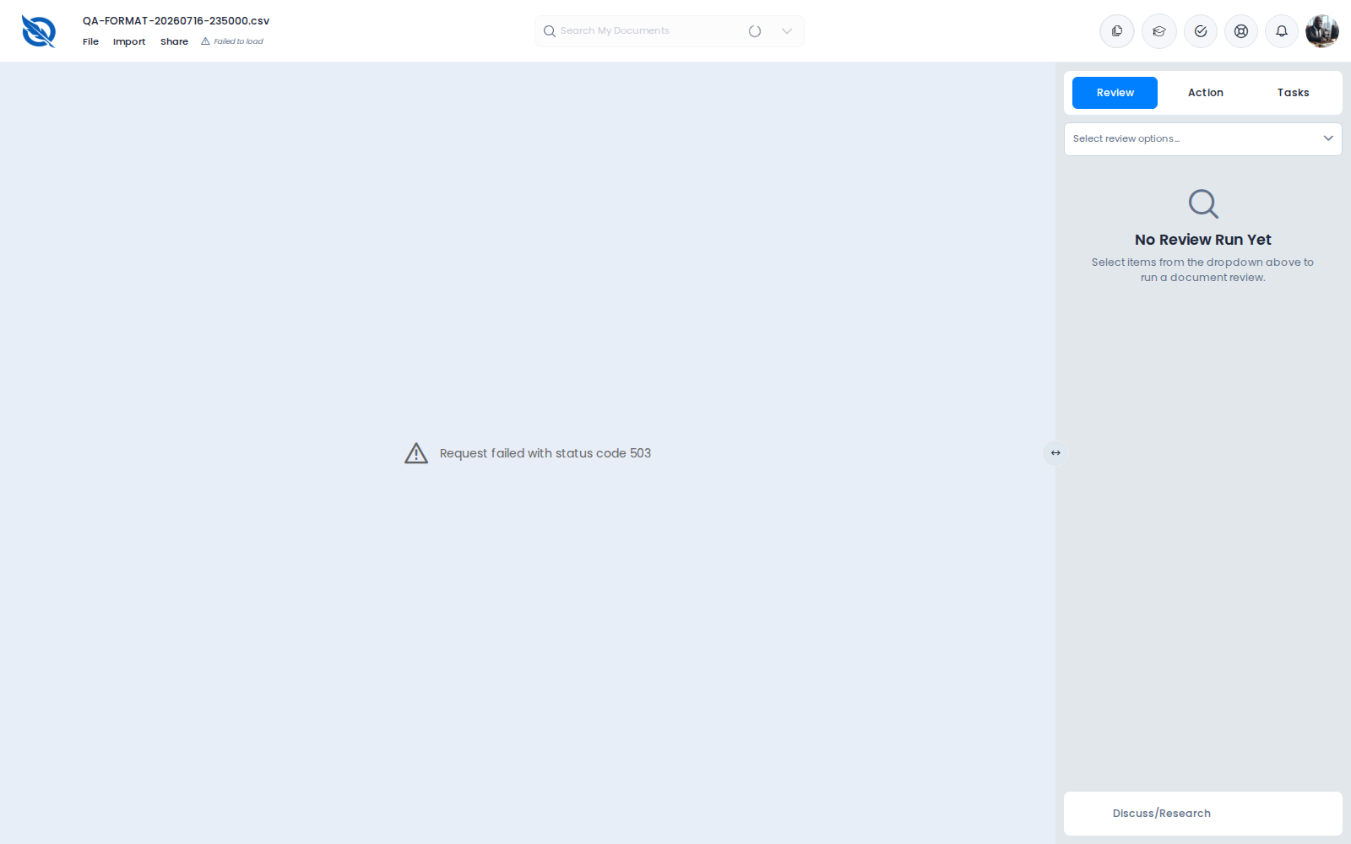
Figure 1. RND editor UI after 503 — Failed to load / Request failed with status code 503

3. Frontend vs backend
This is backend-related (API configuration), surfaced by the frontend SDK host.
Layer | Finding
Frontend | Mounts native SDK (.quillio-doc-editor). Displays axios-style “Request failed with status code 503”. OnlyOffice iframe is not used on the default path.
Network request | POST https://api.rnd.legalassistant.au/editor/session
Request body | {"document_id":"<id>","mode":"edit"} (valid shape; confirmed by 422 when wrong field names are sent)
Network response | HTTP 503 application/json — {"detail":"Editor is not configured on this environment"}

4. Captured failing request (example)
Method / URL | POST https://api.rnd.legalassistant.au/editor/session
Auth | Bearer access token (valid — documents API works with same token)
Content-Type | application/json
Body | {"document_id":"6a71d6d2e436a371f0d8eff8","mode":"edit"}
Status | 503
Response body | {"detail":"Editor is not configured on this environment"}
X-Correlation-ID | b4a9ae1a13eb
X-Process-Time-S | 0.697
Date header | Wed, 19 Aug 2026 03:12:23 GMT
CORS allow-origin | https://app.rnd.legalassistant.au (OK)

Control checks on the same authenticated session: GET /documents returns 200 with the library; GET /health returns {"detail":"OK","observability":{"sentry_configured":false}}. So the API is healthy overall; the editor subsystem is the missing piece.

5. Who / what is affected
- Not limited to one document: CSV, XLSX, PDF, DOCX all get the same 503 detail when the SDK calls /editor/session.
- Not limited to “bad” ids: even document_id 000…000 returns the same configured-environment 503 (not a not-found).
- Not an auth problem: unauthenticated POST returns 401 {"detail":"Not authenticated"}; authenticated calls reach the config gate and get 503.
- Affects the default native SDK path for this RND deployment. The older OnlyOffice iframe path can still open some files if editor_sdk_enabled is forced OFF in the frontend bundle (separate workaround used in prior QA).

6. Environment comparison
Check | RND | Stage
App login | Works (app.rnd…) | Blocked by nginx 401 Authorization Required on app.stage…
POST /editor/session | 503 — Editor is not configured on this environment | 404 — Not Found (route absent/unexposed)
GET /health | 200 OK (sentry_configured:false) | 200 OK (sentry_configured:true)

Stage could not be fully compared end-to-end because the Stage web app is behind basic auth and this account cannot pass the nginx gate. Stage API health is OK, but /editor/session is not present (404), which also suggests editor SDK wiring is environment-specific. Production app.legalassistant.au was reachable at login; full editor compare was not completed in this run.

7. Likely fix (for backend / platform)
- Enable/configure the native Editor SDK on the RND API environment (whatever flags/secrets/services back “editor session” — JWT signing, document storage bridge, LibreOffice/Collabora/OnlyOffice SDK host, etc.).
- Until that is done, either turn editor_sdk_enabled OFF in the RND frontend so the app uses the OnlyOffice iframe path, or block the SDK UI with a clear “Editor not available on RND” message instead of a raw 503.
- After enabling config: retest POST /editor/session → 200 with session token/expires_at; confirm CSV/DOCX/PDF open; retest prior format bugs.

8. Retest checklist (after config change)
- POST /editor/session with {"document_id":"<owned-id>","mode":"edit"} returns 200 (not 503).
- UI no longer shows Failed to load / status code 503.
- Same account opens CSV, DOCX, PDF successfully.
- Confirm Stage/Prod behaviour matches expectations.
- Regression: OnlyOffice iframe path still works if still supported; File/Import/Share clickable; no new console errors.
Evidence folder: /opt/cursor/artifacts/rnd-503-investigation/ (capture JSON, screenshots, run.log). Investigation by cloud agent 19 Aug 2026.

