**Server Cluster Management**

There are two scenarios in this document

1. Local cluster management
2. Cluster management via LAN

**Local cluster management**

In this scenario we have some prerequisites

1. Multiple instances of the eserver should installed in a single virtual machine
2. There must be a tcm folder which can be access by isas1 isas2 …… isasn users

To get the instances of application servers in cluster, there are some required settings and pointes to keep in mind. For cluster management you should follow a simple approach which is given below step by step.

* Get the instances of application server in tcc.
* Get the instances of application server in SMC.
* Every webadapter should have capability to route the request on all application server instance.

If these three steps are completed and tested. It means your servers are in cluster.

**Application servers in tcc**

The Tomcat Cluster Console (TCC) is an instrument to control an Intershop application cluster. This tool is able to spawn new virtual application servers and start, stop, restart single instances of application servers.

NOTE: x is used as placeholder in this document

To make it easily understandable this task is divided into three major points given below.

1. To get instances of application server in tcc, IS_TCM_SHARED variable in intershop.properties (eserver<x>/intershop.properties) of each eserver<x> must point towards same dictionary.
2. Cluster ID(/eserver<x>/share/system/tcm/config/cluster.id) of each eserver<x> must be same.

It is recommended to make a global /tcm directory in root directory so that it is easy for all eserver<x> to point that global /tcm. And copy tcm folder in global tcm. Then create a group (example: isgrp) which should have all the isas<x> and iswa<x> users. Now assign this group to /tcm by command **chown**. The permissions of global /tcm should be 770. Command to change permission chmod 770 /tcm.

su root

groupadd <xxxx> isgrp

cp -R /eserver<x>/share/system/tcm /tcm (copy from eserver1 or eserver2)

chown training:isgrp -R /tcm

**isas1 isas2 isas3 and training users should be in isgrp group**

su root

groupadd <xxxx> isgrp

usermod -aG isgrp training

usermod -aG isgrp isas<x>



Before Cluster

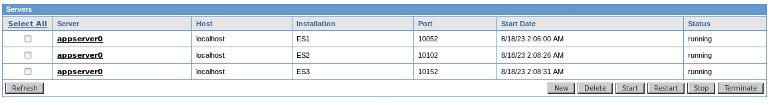

After Cluster

**Application servers in SMC**

The multicast settings in appserver.properties (eserver<x>/share/system/config/cluster/appserver.prop) of each eserver<x> should be same. If intershop.event.multicastInterface is comment out then uncomment it and enter

Below Figures shows the compression between appserver.properties of different instances. ES1 & ES2

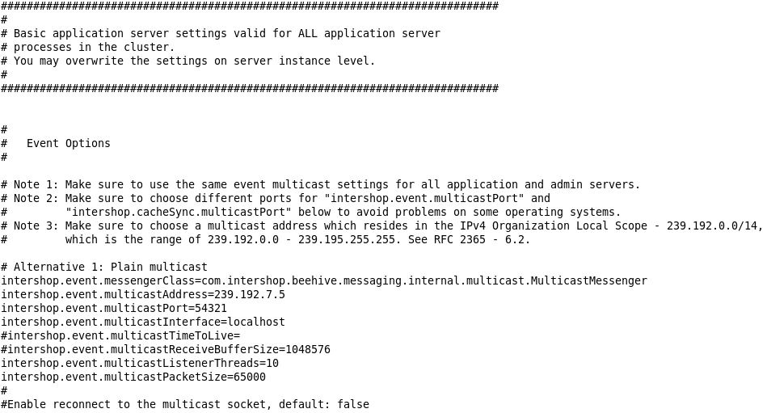

ES1 appserver.properties

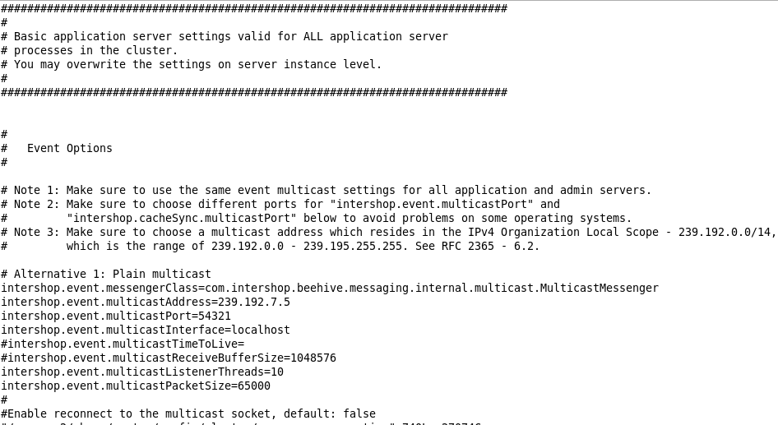

ES2 appserver.properties

You can see two or three servers in SMC after login.

Figure 1.3 shows result in SMC

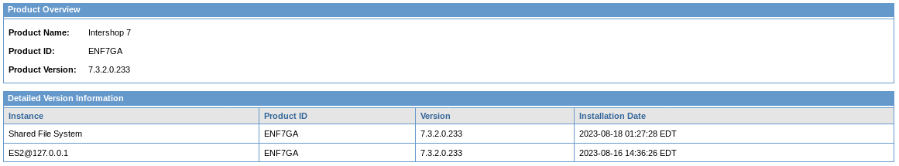

Before Cluster

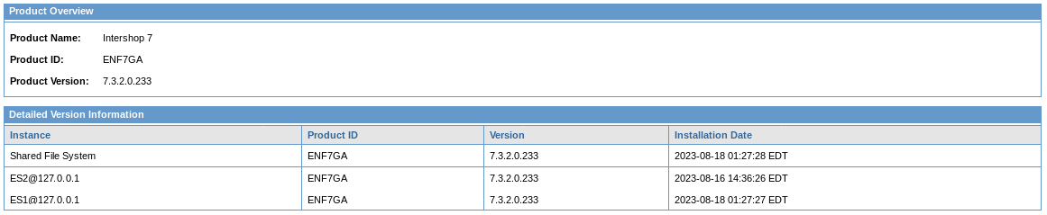

**WebAdapter Confugration**

To make webadapters capable to route requests to any application server there is an important property in webadapter.properties (eserver<x>/webadapter/webadapter.properties) file. At the end of the file **Confugration Servelet** is present. Here you have to give the link of all application servers.

cs.url.0=http://localhost:10054/servlet/ConfigurationServlet

cs.url.1=http://localhost:10104/servlet/ConfigurationServlet

cs.url.0=http://localhost:10154/servlet/ConfigurationServlet

…..

This is how you have to register the link.

Below Figure 1.4 shows how to register links in Confugration Servlet of webadapter.properties file.

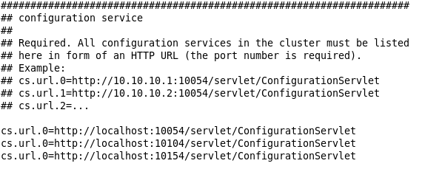

Figure 1.4

**Cluster management via LAN**

To put 2 servers in a cluster which are installed on 2 different physical machine. We have some prerequisites

1. One of the machine should share tcm directory
2. Other machine should mount the tcm folder **Everytime when machine restarts.**
3. All the machines should be connected to LAN all the time (When the servers are on)
4. Rpcbind and nfs-utils must installed
5. firewalld service must be disabled and stopped

**Network Adapter Configuration**

We have to configure the bridge adapter on Virtual machine.

* Shutdown VM
* Select vm on welcome page and Click on settings

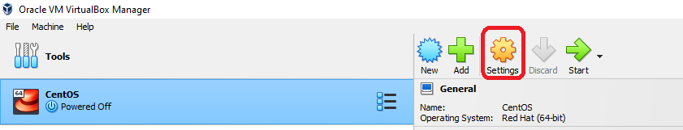

* Click on network
* Change network from **Attached to:**

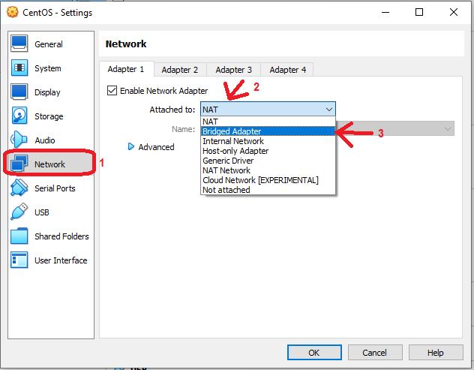

* Click on Advanced
* Select **Allow ALL** from **Promiscuous Mode:**

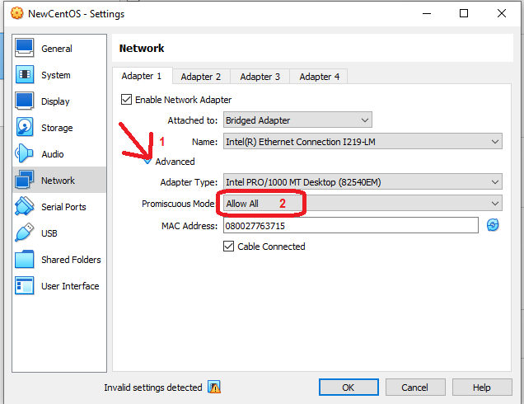

* Click on Ok
* Start the VM

**Check IP Address**

* Run

ifconfig

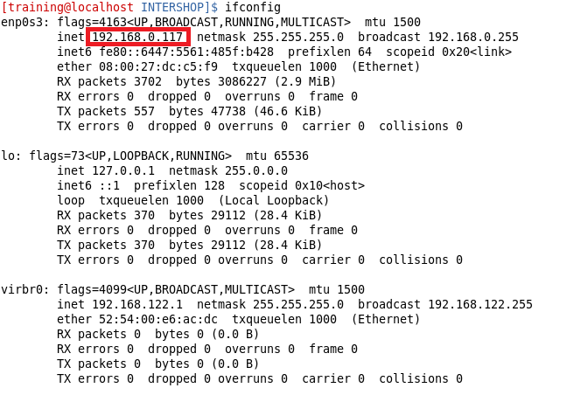

**Map new IP with localhost**

* Run

sudo vi /etc/hosts

* Change 127.0.0.1 with your new IP



**Run postinstall.pl**

su root

/eserver<x>/bin/postinstall.pl

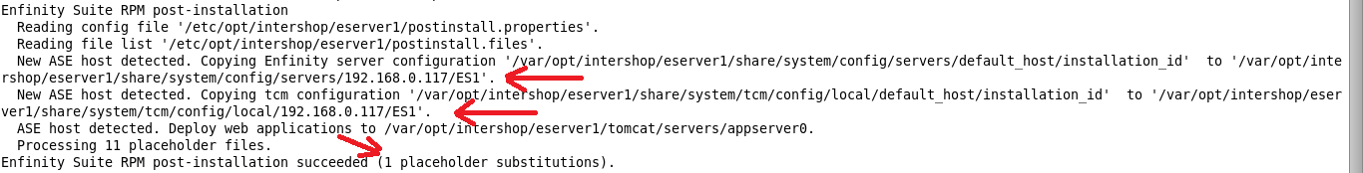

Run postinstall for all the eservers you want to put in cluster

Steps to share files and directories between virtual machines located on different computers.

* su root. (Login through root user)
* yum install -y rpcbind nfs-utils. (installing nfs packages)
* vi /etc/exports (register the folder which is to be shared (/tcm))

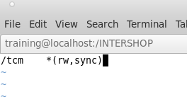

* systemctl restart rpcbind.
* systemctl restart nfs
* showmount -e. (Shows the directory’s which are shared)



**Mount the Shared directory into other machine**

* systemctl restart rpcbind
* systemctl start nfs
* showmount –e 192.168.<xxx>.<xxx> (to check the directory is shared or not)



* make a directory

su root

mkdir /tcm

mount 192.168.<xxx>.<xxx>:/tcm /tcm



**Application servers in tcc**

Edit intershop.properties

su root

vi /eserver<x>/intershop.properties

Change IS_TCM_SHARE=/tcm



**Application Server in SMC**

Edit appserver.properties

su root

vi /eserver<x>/share/system/config/cluster/appserver.properties

Edit

intershop.event.multicastInterface=localhost

