Technical Report: Genetic-Algorithm Strategy Engine for a UAV Disaster-Surveillance Fleet
Artificial Intelligence (BSCS-5) · Assignment 2 · CLO-4 · Bahria University, Lahore Campus
Github Repo Link: https://github.com/Shafey67/AI-assignment-2-

1. Problem and system overview
A fleet of K = 4 UAVs launches from a base at one corner of a 50 × 50 hazard grid. The grid holds four disaster zones of different priority (0.6–1.0, background 0.1), three hazard pockets (wind/radiation, value 0–1) and three no-fly zones. The Strategy Engine uses a Genetic Algorithm (GA) to choose, for every UAV, its deployment position, waypoint trajectory, leg speeds and sensor power/activation schedule. Because coverage competes with energy, flight time and hazard exposure, the landscape has no single optimum, and the GA is used to find good compromises. Each UAV is limited to 110 cells of flight (including return) and 125 time units, and may not enter no-fly cells.

2. Chromosome design and rationale
We use a hybrid real-valued/binary encoding: K × L = 4 × 8 waypoints with five genes each (160 genes). Real genes are the waypoint coordinates (x, y), the speed on the leg arriving at the waypoint (0.5–2.0) and the sensor power on that leg (0.2–1.0); one binary gene switches the sensor on or off for that leg. Waypoint 0 is the UAV’s deployment position and the route is BASE → wp0 … wp7 → BASE.
Rationale. (i) Real coordinates give fine spatial resolution and allow geometric crossover and Gaussian mutation, which a cell-index encoding would not. (ii) Waypoint order is part of the genome, so routing and deployment are optimised jointly with no separate path planner. (iii) Speed and power are per-leg genes because they create genuine trade-offs: energy per cell grows as 1 + 0.5v², detection quality falls with speed (q = min(1, p/√v)), and sensor radius grows with power (r = 1 + 3p) at a power cost of 1.2·p²·time. (iv) The on/off bit lets a UAV save energy on transit legs. (v) A fixed number of waypoints per UAV keeps crossover simple and shapes compatible across individuals.

3. Multi-objective fitness and weighting
Each solution is flown on the grid by sampling every leg at 1-cell steps. The fitness to maximise is F = 0.55·C − 0.15·E − 0.10·T − 0.20·H − penalties, where C is the priority-weighted detection rate (sum of priority × detection quality ÷ total priority), E is total energy divided by the energy of a fleet flying full range with sensors on, T is the mission makespan divided by the deadline, and H is the hazard-exposure integral divided by a reference exposure. All terms are normalised to roughly [0, 1] so the weights are comparable.
Weights. Coverage gets the largest weight (0.55) because it is the mission purpose. Hazard (0.20) is weighted above energy (0.15) and time (0.10) because losing a UAV is costlier than extra battery or minutes; time is lowest because the deadline is also enforced as a hard constraint. Section 6 shows how the evolved behaviour changes under other weightings.
Constraint handling combines repair and penalties. Waypoints outside the grid or inside a no-fly cell are always repaired (snapped to the nearest free cell using a distance transform). With probability 0.5, offspring exceeding the range limit are repaired by geometric contraction of the route towards the base, and those exceeding the deadline by raising leg speeds; applying repair only half the time keeps some infeasible genetic material alive. Any remaining violation (range, deadline, flight length inside a no-fly zone, e.g. a leg that crosses one) is punished with a penalty of 4 × the normalised violation, large enough that feasibility always dominates the objective gain.

4. Genetic operators and diversity maintenance
Selection is k-tournament (default k = 3) with 2 elites. Crossover works per UAV and picks one of three operators at random: whole-route swap, waypoint-segment swap, or geometric blend (child waypoint lies on the line between the parents’ waypoints, with α ~ U(−0.1, 1.1)). Mutation acts per waypoint: Gaussian shift (50%), jump to a cell drawn in proportion to the priority map (20%), swap of two waypoints in the route (10%), and speed/power/activation mutation (20%). To resist premature convergence the Gaussian step shrinks over time, the mutation rate is multiplied by 2.5 when population diversity falls below 35% of its initial value, and 5% random immigrants are inserted each generation. The run ends at the maximum number of generations or after 80 generations without improvement.

5. Results of the evolved strategy
Figure 1 shows convergence for a single run (population 100, 300 generations): best and average fitness rise steadily while diversity stays high. Figure 2 shows the best flight paths and coverage heat-maps at generations 0, 10, 50, 150 and the final generation. Early UAVs cluster near the base, mostly covering low-priority background; later they stretch out to the high-priority zones and arrange their sweeps with little overlap.
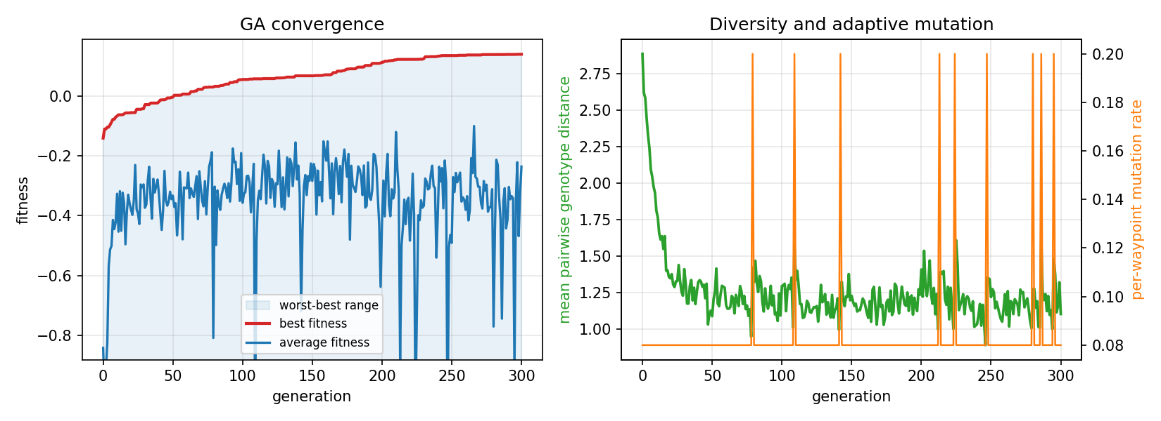
Figure 1: Best vs. average fitness (left) and diversity / adaptive mutation rate (right).
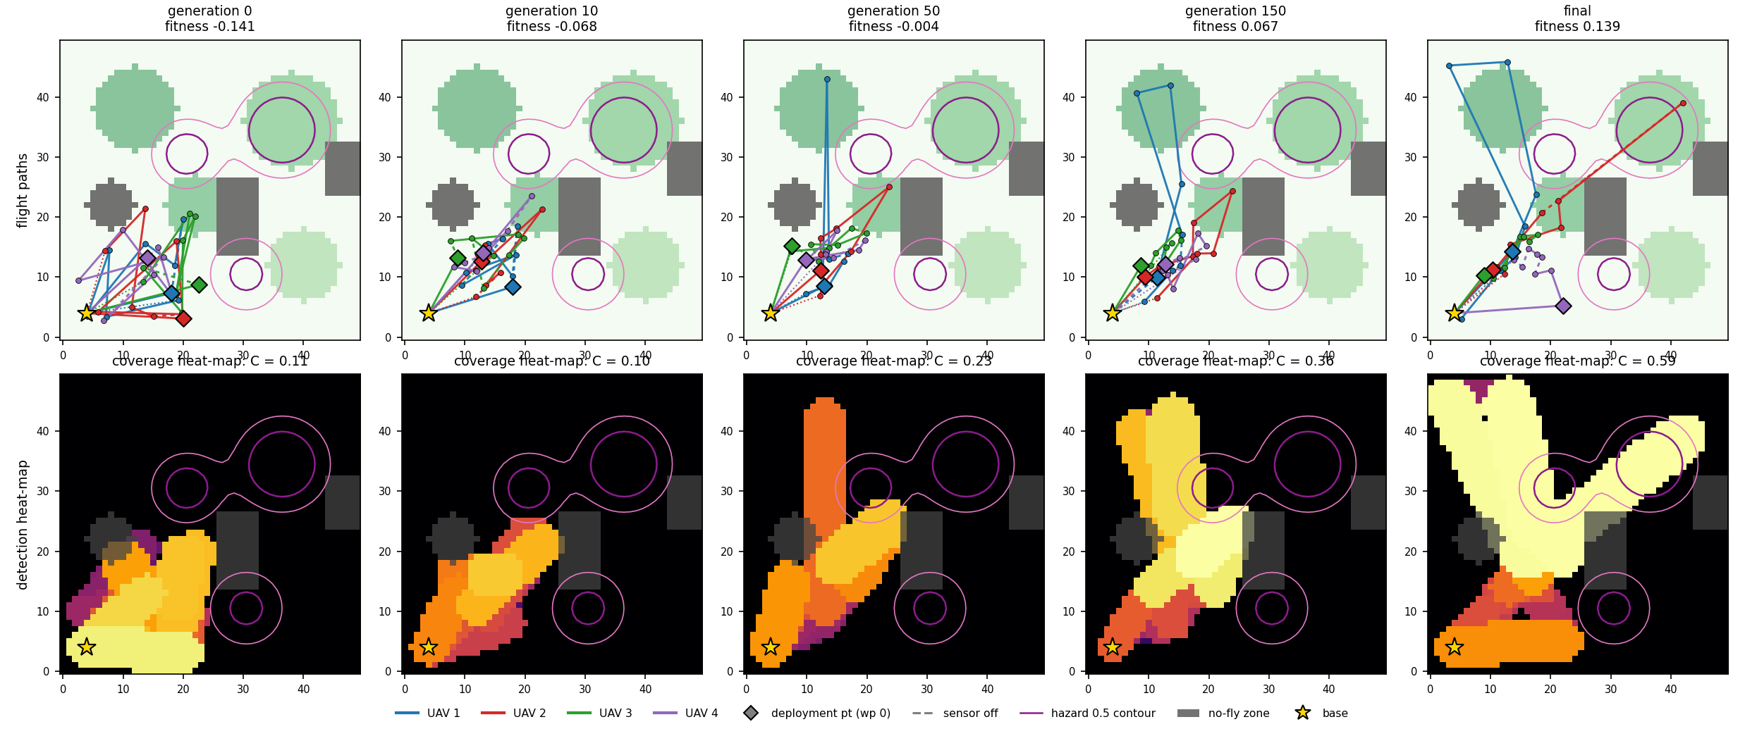
Figure 2: Evolved flight paths (top) and coverage heat-maps (bottom) across generations.

6. Hyper-parameter sensitivity analysis
To isolate each factor, we ran a plain GA (adaptive mutation and immigrants off) for 150 generations with 5 seeds per setting, varying one parameter from the base (population 60, mutation 0.08, k = 3). Results are final best fitness, mean ± sd (Figure 3).
Population size | Fitness | Mutation rate | Fitness
20 | 0.070 ± 0.021 | 0.01 | 0.099 ± 0.020
50 | 0.101 ± 0.025 | 0.03 | 0.138 ± 0.028
100 | 0.098 ± 0.015 | 0.08 | 0.123 ± 0.024
200 | 0.118 ± 0.013 | 0.15 | 0.050 ± 0.005
 |  | 0.3 | -0.031 ± 0.023

Tournament size | Fitness | Ablation (diversity) | Fitness / end diversity
2 | 0.063 ± 0.010 | full (adaptive + immigrants) | 0.105 / 1.09
3 | 0.123 ± 0.024 | no adaptive mutation | 0.124 / 0.94
5 | 0.140 ± 0.022 | no immigrants | 0.114 / 1.01
10 | 0.162 ± 0.024 | neither | 0.126 / 0.76
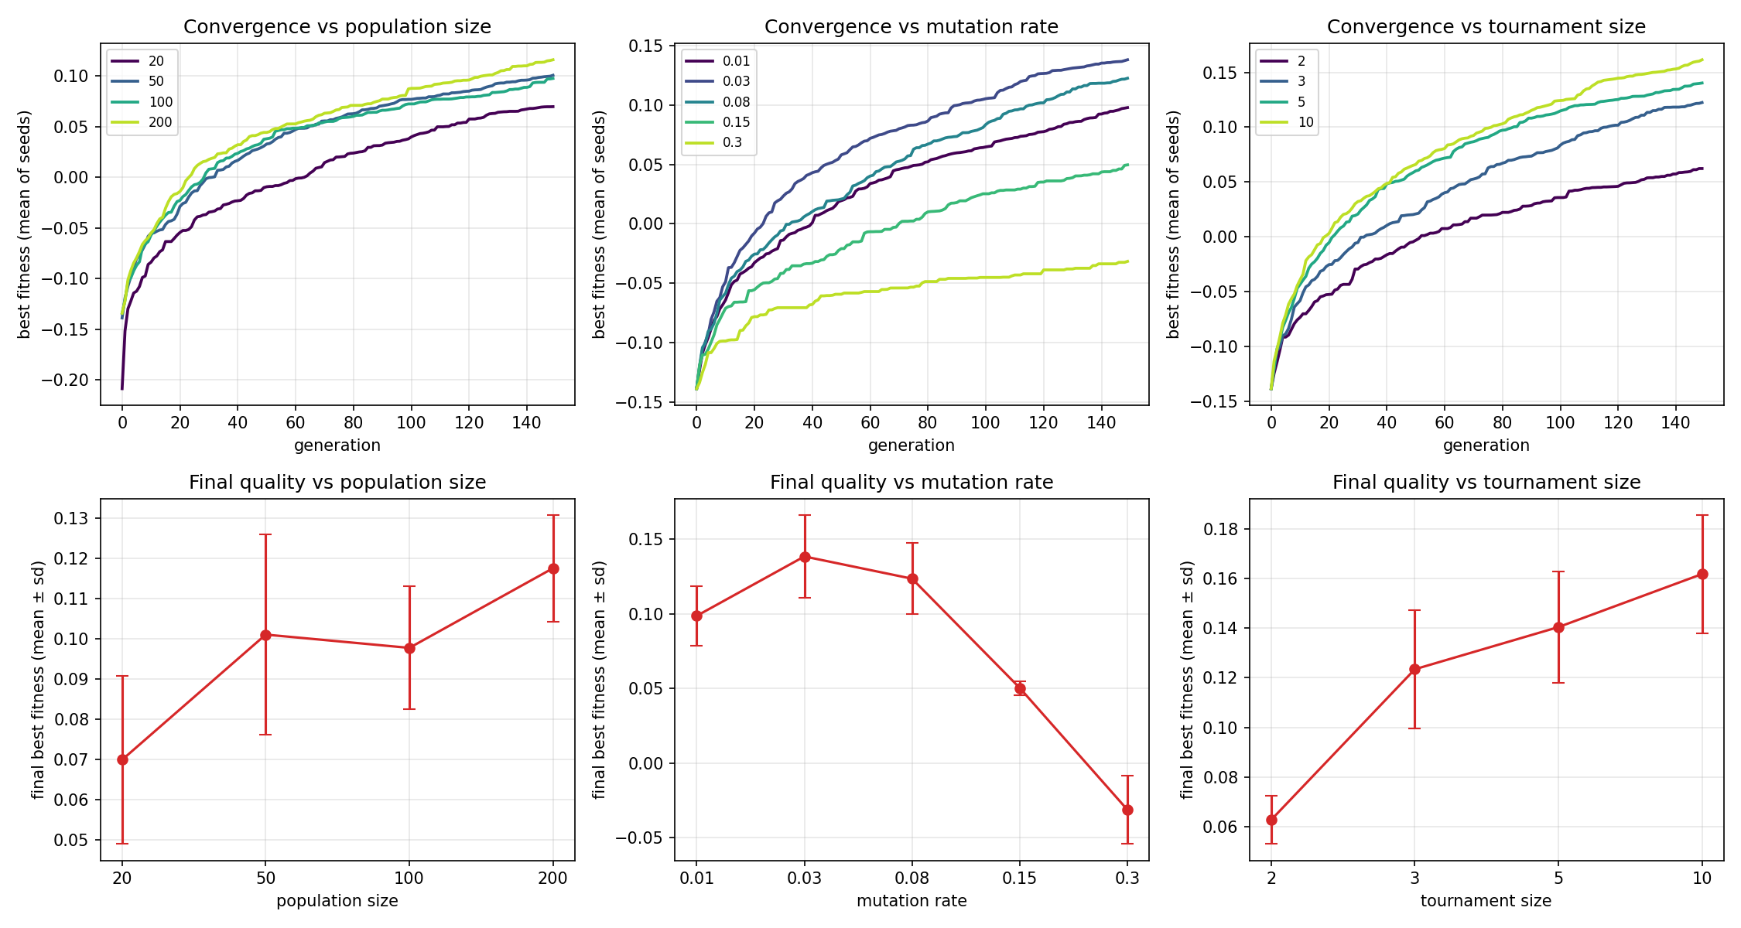
Figure 3: Sensitivity to population size, mutation rate and tournament size.
Population size. Larger populations converge faster per generation and reach better fitness (0.070 at 20 vs 0.118 at 200), but the benefit is uneven (50 and 100 are statistically similar) and cost grows linearly, so 100 is a sensible default.
Mutation rate. There is a clear optimum near 0.03–0.08. At 0.01 the search stalls (0.099); above 0.15 mutation destroys good routes faster than crossover can assemble them and fitness collapses (0.050 at 0.15, −0.031 at 0.30). Crossover therefore does the main work and mutation should be a refinement.
Selection pressure. Fitness rises monotonically with tournament size (0.063 at k = 2 to 0.162 at k = 10). Within our budget of 150 generations the problem rewards exploitation. The risk of premature convergence at high k is what the diversity mechanisms are for, and with k = 7 and population 40 (ablation) they kept diversity higher (1.09 vs 0.76 at the end). They did not raise final fitness in that short horizon (0.105 full vs 0.126 with neither; the gap is about one standard deviation), so in this experiment they act as insurance, not as an improvement. We did not test whether they help over much longer runs.

7. Evolved solution vs. random search; uniqueness
The baseline draws the same number of random individuals (29,500) from the same initialiser with the same repair, so only evolution differs. Over 8 seeds the GA reaches 0.145 ± 0.016 against -0.103 ± 0.005 for random search (Mann–Whitney p = 7.8e-5, Figure 4); the best random-search run is worse than the worst GA run. All 16 final solutions are feasible.
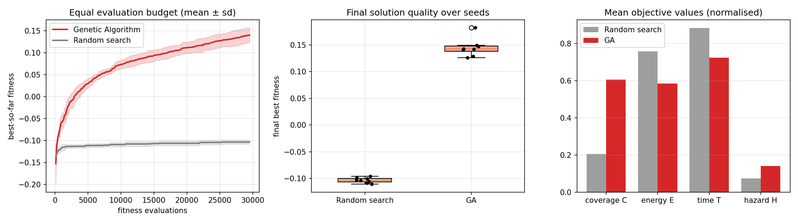
Figure 4: GA vs. random search: convergence on equal budget, final fitness, and mean objectives.
Metric (mean over seeds) | GA | Random search | Comment
Priority-weighted coverage C | 0.605 | 0.206 | 3× higher
High-priority cells covered | 0.72 | 0.21 | targeted
Energy E / time T | 0.58 / 0.72 | 0.76 / 0.88 | GA cheaper
Hazard exposure H | 0.141 | 0.074 | GA higher (trade-off)
Overlap between UAV footprints | 0.16 | 0.50 | GA partitions area
Range budget used | 0.72 | 0.96 | GA does not need to max out
Route distance between seeds (cells) | 1.44 | 1.15 | GA routes are distinct

Uniqueness. The evolved solutions are not just better scores; they have a different character. Random search spends its range on short, redundant sweeps near the base (UAVs overlap 50% of the time and use 96% of their range yet cover only 21% of high-priority cells). The GA solutions reach 72% of high-priority cells with only 16% overlap, using 72% of the range: it divides the area between UAVs and spends its range on the priority zones. Independent GA seeds also reach similar fitness through different geometry (mean route distance 1.44 cells between seeds, Figure 5), i.e. the engine returns several distinct, comparably good plans rather than one rigid answer.
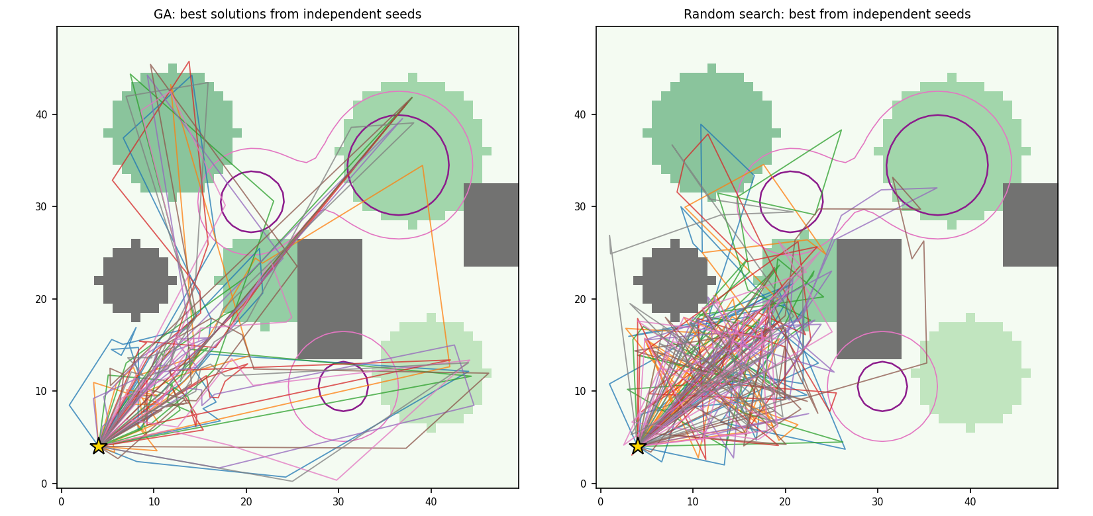
Figure 5: Routes of the best solution from each of 8 seeds, GA (left) vs. random search (right).
Weight trade-off. Re-running the GA with other weights moves the solution along the trade-off front: coverage-first weights give C = 0.66 but E = 0.75, T = 0.90, H = 0.19; the default gives C = 0.53, E = 0.56, H = 0.11; the safety/energy-saver weights give C = 0.03 with almost no hazard exposure, so the fleet barely leaves the base. Weight choice is thus a mission decision, not a tuning detail.

8. Limitations and conclusion
The study uses a single synthetic map, a simplified sensor/energy model and a weighted-sum scalarisation (a Pareto method such as NSGA-II would return the whole front in one run). The GA also accepts more hazard exposure than random search because it flies to the hazardous high-priority zones; with the hazard weight raised it would avoid them. Sensitivity results use 5 seeds, so small differences (e.g. population 50 vs 100) should not be over-read. Within these limits, the hybrid encoding, spatial operators and repair/penalty constraint handling give feasible, well-structured fleet plans that clearly outperform an equal-budget random search.

