JALA HOME SOLUTION
Pillow Catalog

Molty
SKU: Pillow-Molty
Rs. 5,500 Rs. 4,500 Save 18%
The Molty Pillow brings back classic everyday comfort with its soft, generously filled fiber core wrapped in a smooth cotton-blend cover. Finished with a neat maroon piping edge, it offers gentle, consistent support for back and side sleepers alike, night after night. Machine-made for consistent quality, it holds its shape and softness through regular use.
✨ Short & Punchy Description
Everyday softness with a classic, comfortable feel.
Fabric: Cotton-Blend Cover, Premium Fiber Fill
Design: Plain with Maroon Piping Trim

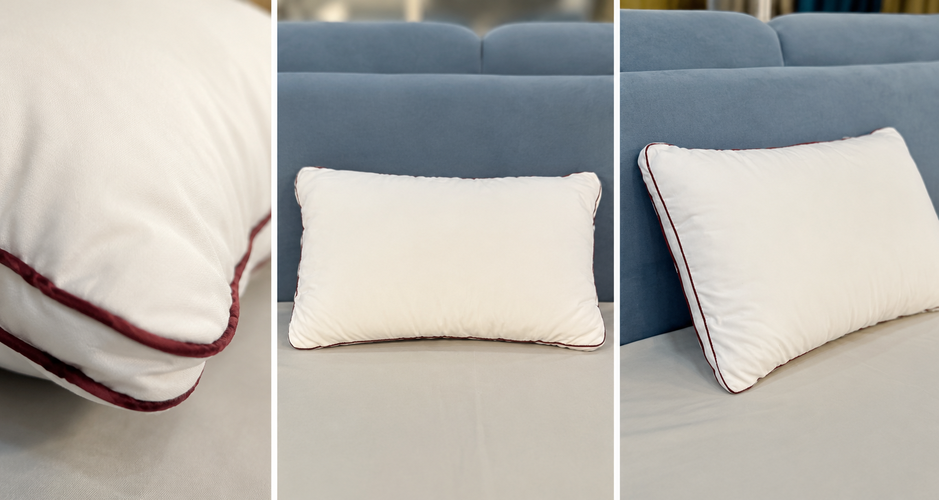

C-Luxury Gel Pillow
SKU: Pillow-C-Luxury Gel
Rs. 7,500 Rs. 6,500 Save 13%
The C-Luxury Gel Pillow is engineered for hot sleepers, featuring a breathable circular gel-vent panel that channels heat away and keeps the sleeping surface cool through the night. The vibrant red cover wraps a cooling gel-infused fiber fill that stays supportive without trapping warmth. A machine-made construction ensures the vent panel and fill stay consistent across every piece.
✨ Short & Punchy Description
Stay cool all night with breathable gel-vent comfort.
Fabric: Cooling Gel-Infused Fiber Fill
Design: Circular Mesh Gel-Vent Panel

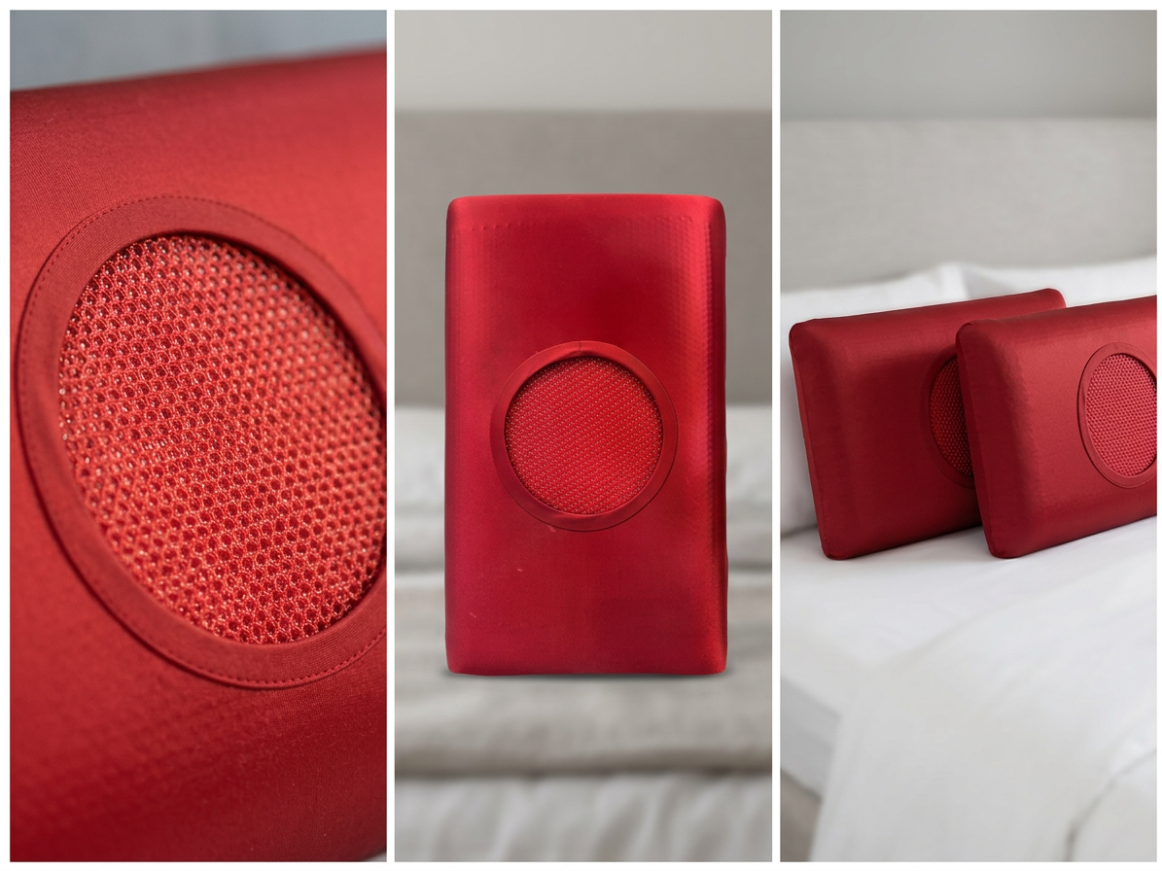

Memory Pillow
SKU: Pillow-Memory
Rs. 4,500 Rs. 3,500 Save 22%
The Memory Pillow uses viscoelastic memory foam that responds to your body's warmth and weight, gradually molding to the shape of your head and neck, then slowly returning to its original form once you get up. Wrapped in a white jacquard floral cover, it offers a denser, more contoured feel than a standard fiber pillow. Every pillow is machine-made to the same precise shape for consistent quality across the batch.
✨ Short & Punchy Description
Contoured foam support that holds its shape.
Fabric: Foam, White Jacquard Floral Cover
Design: Contour Ergonomic Shape

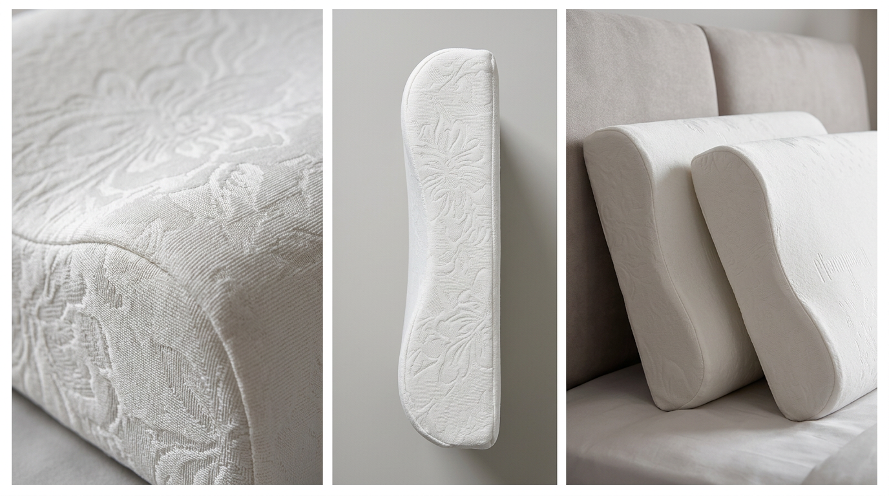

C-Soyabean Fiber Pillow
SKU: Pillow-C-Soyabean Fiber
Rs. 2,000 Rs. 1,500 Save 25%
The C-Soyabean Fiber Pillow elevates the everyday pillow with a plush diamond-quilted cover finished in crisp white with a warm gold piping trim. Filled with resilient soyabean fiber, it stays fluffy and supportive wash after wash, adding a touch of hotel-style luxury to any bed. Machine-made quilting keeps the diamond stitch pattern uniform across every pillow.
✨ Short & Punchy Description
Plush soyabean fiber comfort with a touch of everyday luxury.
Fabric: Soyabean Fiber Fill, Quilted Cover
Design: Diamond Quilted Stitch with Gold Piping

