Name: Shafique Ahmed

DSA LAB2

Leet code Tasks:

|  |
| --- |
|  |

Task2:

|  |
| --- |
|  |

Task3:

|  |
| --- |
|  |

Task4:

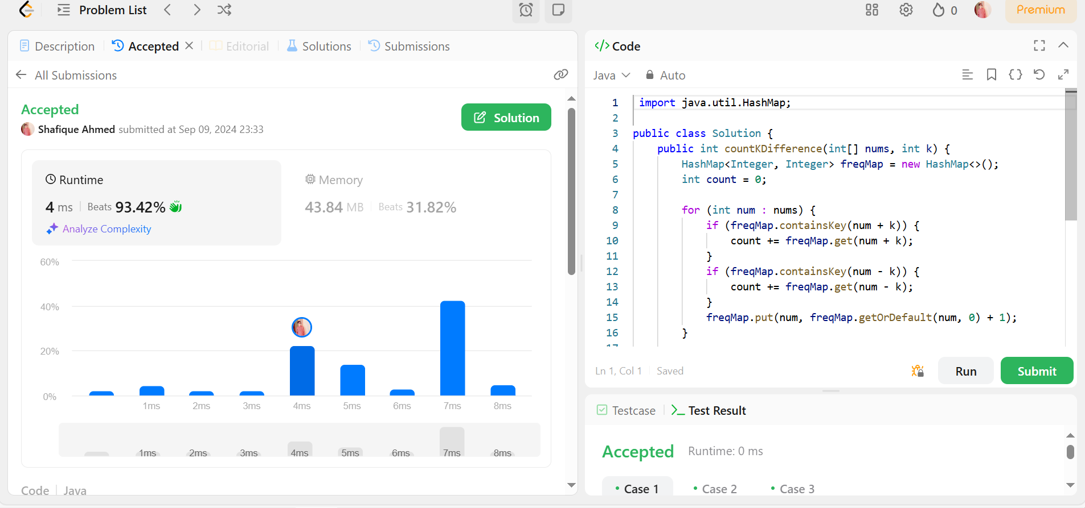

Task5:

|  |
| --- |
|  |

Task6:

