|  |  |
| --- | --- |
| Name: Shafique Ahmed | Section : B |
| Submitted to: Sir Abdul Ghafoor. | LAB :10 |

Task:01(Leet Code Tasks)

<https://leetcode.com/problems/symmetric-tree/description/?envType=problem-list-v2&envId=tree>

|  |
| --- |
|  |

Task:02

<https://leetcode.com/problems/maximum-depth-of-binary-tree/description/?envType=problem-list-v2&envId=tree>

|  |
| --- |
|  |

Task:03

<https://leetcode.com/problems/path-sum/description/?envType=problem-list-v2&envId=tree>

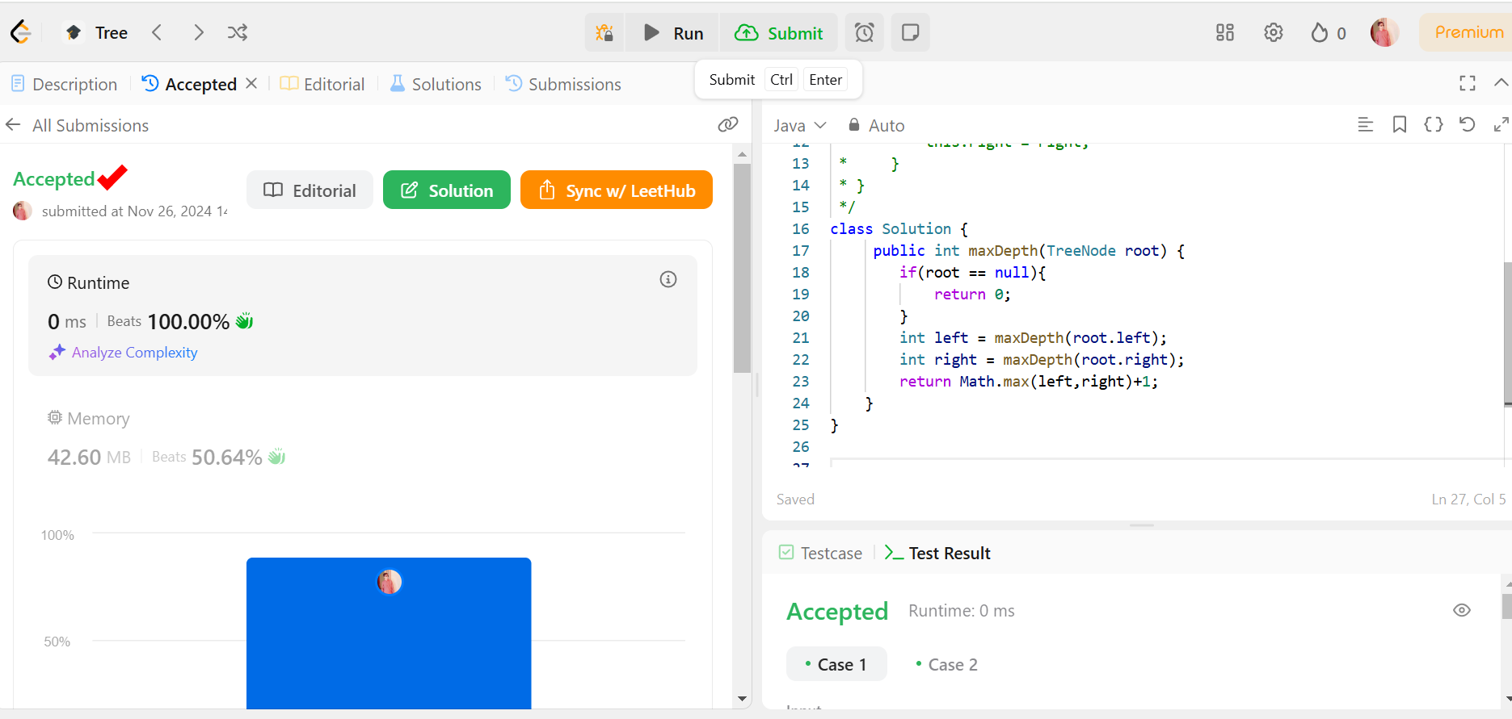

Task:04

<https://leetcode.com/problems/invert-binary-tree/description/?envType=problem-list-v2&envId=tree>

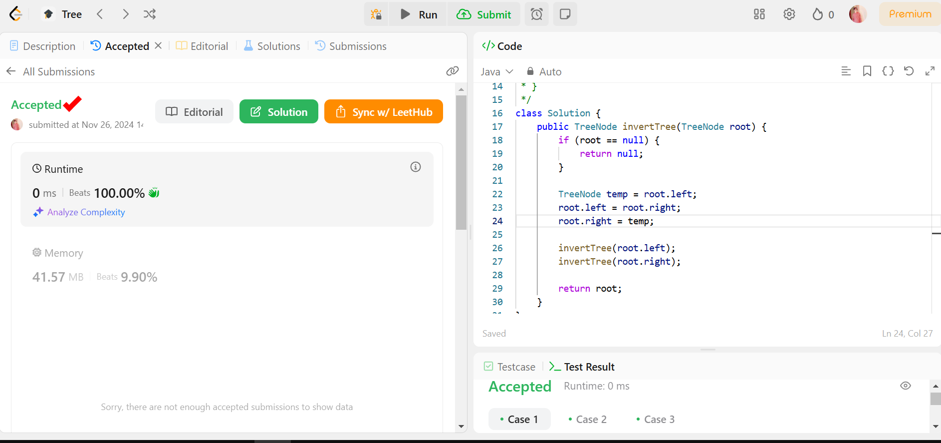

Task:05

<https://leetcode.com/problems/path-sum-ii/description/?envType=problem-list-v2&envId=binary-tree>

