Faculty of Engineering Sciences and Technology

Activity # 01

 | Course: | Final Year Project 1 | FYP Instructor | Saira Khurram
 | Marks Allocated: | 10 Marks | Time Allocated: | 1 Week
 | CLO Allocated: | CLO-1 (BT Level- C3), CLO-2 (BT Level- C4), CLO-8 (BT Level- A2) and CLO – 10 (BT Level- A1) | PLO Allocated: | GA2- Engineering Knowledge, GA3- Problem Analysis, GA7- Communication
- Project Title:

- Funding / Sponsoring Organization (if any):
- Project Start Date:
- Project Finish Date:
- Project Summary (200 - 300 words):

- Objective, Benefits and Deliverables

Plan:
Development / Research Methodology:
(Please describe the technical details and justification of your development and research plan. The block diagrams, system flow charts, high level algorithm details etc. have to be provided in this section. Maximum 3000 words.)

Implementation Plan: Complete your FYP-2 plan (In FYP-2 you work on your development timeline (e.g., design front-end, design bac-end, coding……………). Please list and describe the principal milestones and associated deliverables of the development phase. The timing of milestones is also to be shown in the Gantt chart in Annexure-A.

(Please add more rows if required.)

Project Schedule / Milestone Chart

(Project schedule using MS-Project (or similar tools) with all tasks, deliverables, milestones, dependencies.)

Example:
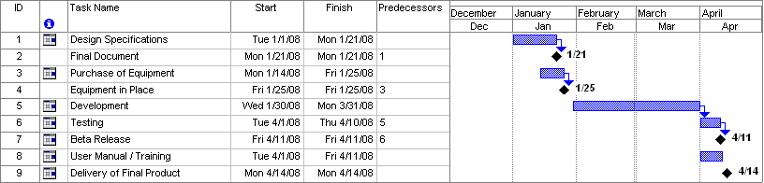
SPECIMEN

Gantt chart
Create the Grant Chart and provide estimated start and end dates of all proposed modules/tasks
for each team member. Also identify the dependencies (which tasks cannot be started/completed,
until the dependent task is completed). Gantt chart can be created using MS Project.
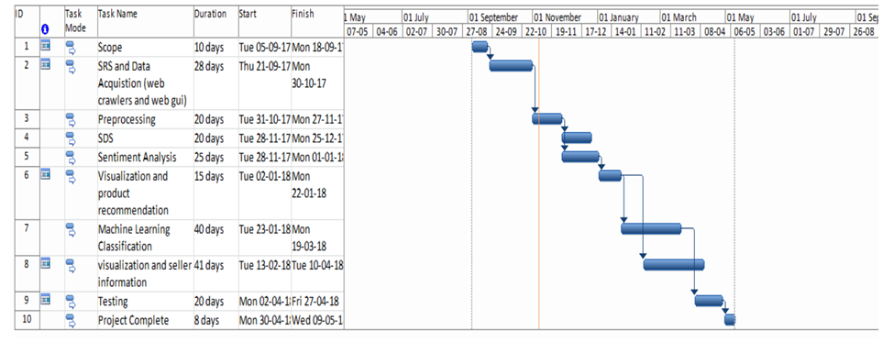

- Key Milestones of the Project / Project Management:

S. No. | Elapsed time since start of the project | Milestone |  | Deliverable
1. | Week 01 – 04
2. | Week 05
3. | Week 06
4. | Week 07
5. | Week 08
6. | Week 09
7. | Week 10
8. | Week 11
9. | Week 12
10. | Week 13
11. | Week 14
12. | Week 15
13. | Week 16
14. | Week 17
15. | Week 18
16. | Week 19
17. | Week 20
18. | Week 21
19. | Week 22
20. | Week 23
21. | Week 24
22. | Week 25
23. | Week 26
24. | Week 27
25. | Week 28
26. | Week 29
27. | Week 30
- Final deliverable of the project (please tick one of the following)
- Hardware system |  | - Software system | - HW/SW integrated system
- Software simulation results |  | - Comparative study | - Mobile App
- Web App |  | - Other (please specify)
- Equipment required for the project with Estimated Cost:

- How many GAs are you covering in this Proposal? List all GAs

GA-2 Knowledge for Solving Computing Problems 
GA-3 Problem Analysis 
GA-4 Design/Development of Solutions 
GA-5 Modern Tool Usage 
GA-8 Computing Professionalism and Society 
GA-9 Ethics 
GA-6 Individual and Teamwork 
GA-7 Communication 
GA-10 Life-long Learning 
GA-1 Academic Education 

- How many SDGs are you covering in this Proposal? List all SDGs

1.No poverty  | 10. Reduced inequalities 
2.Zero hunger  | 11. Sustainable cities and communities 
3.Good health and well being  | 12. Responsible consumption and production 
4.Quality education  | 13. Climate action 
5.Gender equality  | 14. Life below water 
6.Clean water and sanitation  | 15. Life on land 
7.Affordable and clean energy  | 16. Peace, justice and strong institutions 
8.Decent work and economic growth  | 17. Partnership for the goals. 
9.Industry innovation and infrastructure 

- WP’s Through This Project:
WP’s | How it is addressed in this Project
Reference:
Attributes | WP1 and some or all of WP2 to WP7
Depth of knowledge required | WP1: A solution requires the use of in-depth computing or domain knowledge and an analytical approach that is based on well-founded principles .One or more of WK3, WK4, WK5, WK6 or WK8
Range of conflicting requirements | WP2: Involves wide-ranging or conflicting technical, computing, and other issues
Depth of analysis required | WP3: Has no obvious solution, and requires conceptual thinking and innovative analysis to formulate suitable abstract models.
Familiarity of issues | WP4: Involve infrequently encountered issues
Extent of applicable codes | WP5: Outside problems encompassed by standards and codes of practice
Extent of stake-holder involvement and conflicting requirements | WP6: Diverse group of stakeholders with widely varying needs
Interdependence | WP7: Many component parts or sub-problems. Is a high-level problem possibly including many component parts or sub-problems?

Key for WK (knowledge profile):
WK | Short Name
WK1 | Natural Sciences
WK2 | Mathematics
WK3 | Engineering Fundamentals
WK4 | Specialist Knowledge
WK5 | Engineering Design
WK6 | Engineering Practice
WK7 | Comprehension

Supervisor Signature

