My Climate Story Research Study
NASA Earth data evidence and research direction for Delta Detectives
Research briefing | 23 October 2026 | Bangladesh pilot with a global extension

Executive research conclusion
The strongest starting hypothesis is that late-monsoon temperature change may be geographically widespread but season-specific in Bangladesh. We downloaded NASA POWER MERRA-2 temperature and rainfall data for Dhaka, Satkhira, Sylhet, and Bhola and examined 1985 to 2024. A focused 2001 to 2024 analysis found positive September temperature trends in all four sampled locations. These pass an exploratory multiple-test adjustment but still require autocorrelation checks and independent verification before they can be presented as robust climate conclusions.
This matters for My Climate Story because the official 2026 challenge Be An Earth System Trend Detective asks for what changed, where, by how much, and whether the trend is significant. A locally understandable scientific investigation can fit this brief more closely than a generic climate-awareness website.
Research position. Use Bangladesh as the pilot laboratory, demonstrate a transparent statistical method, then make the same analysis usable for any selected place with suitable NASA coverage.

The research question
Primary question: Has September near-surface air temperature shown a measurable change across different geographic settings in Bangladesh from 2001 to 2024?
Secondary questions: Does the pattern remain after checking data quality and temporal dependence? How is it related to rainfall and vegetation changes? Do coastal, urban, and wetter northeastern areas behave similarly? How can a story about one local area be compared fairly with a global climate indicator?

What the NASA data currently show
Location | 2024 T2M (C) | 2024 rainfall (mm) | Sep C per decade | Adjusted q
Dhaka | 25.44 | 3,046 | +0.425 | 0.0014
Satkhira | 26.26 | 2,670 | +0.373 | 0.0019
Sylhet | 24.54 | 5,503 | +0.317 | 0.0319
Bhola | 25.80 | 4,133 | +0.453 | 0.0003

The 2024 annual columns summarize the NASA POWER model for the chosen coordinates. The trend column applies to September monthly mean temperature over 2001 to 2024, not annual temperature and not a 40-year warming rate. The adjusted q-value accounts for 48 tests across four sites and 12 calendar months. Smaller q-values indicate stronger evidence under the statistical test assumptions.
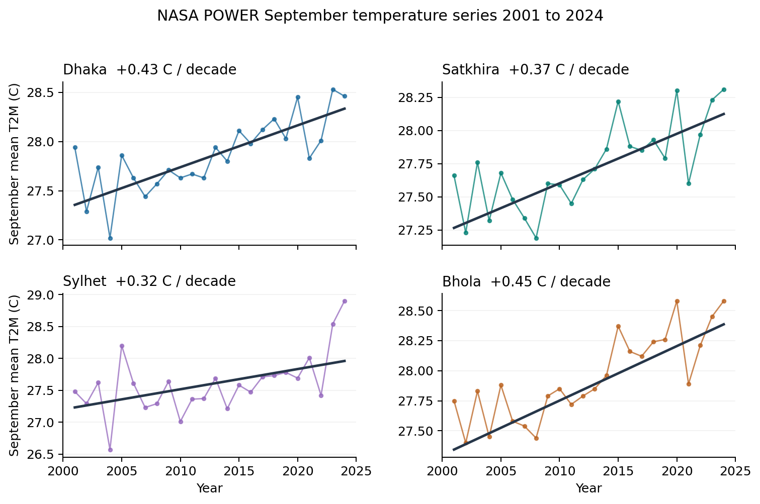
Figure 1. The colored series are individual September means at each NASA POWER grid location; the dark lines show robust Theil-Sen trends. September warming is a research lead, not a demonstrated causal attribution to climate change.

Global context from NASA GISTEMP
NASA GISTEMP uses global land and ocean surface temperature anomalies relative to 1951 to 1980. In the downloaded GISTEMP v4 series, 2024 is +1.28 C against that reference. It was the warmest year in the global record at the time of this research. The GISTEMP global anomaly is not directly the same quantity or reference baseline as the absolute NASA POWER T2M values from Bangladesh; use it as context, not as a number to subtract.
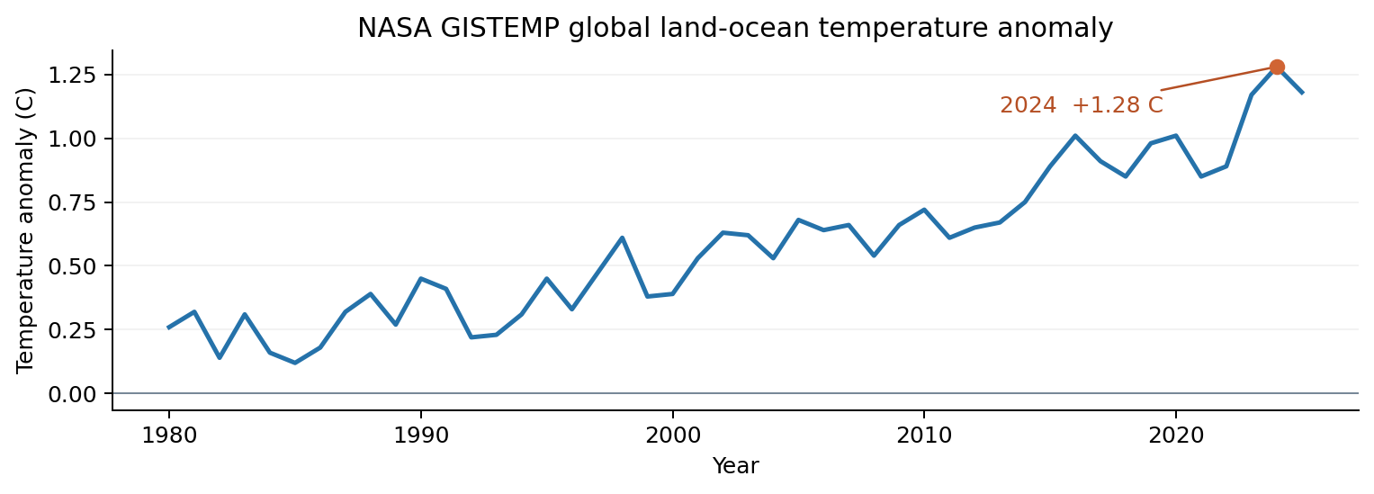
Figure 2. Global temperature context from the NASA GISS Land-Ocean Temperature Index, 1980 to 2025. The baseline is 1951 to 1980.

NASA data sources and appropriate uses
Source | Useful variable or output | Period and spatial scale | Research role
NASA POWER from MERRA-2 | 2-m air temperature T2M and PRECTOTCORR precipitation | Meteorological record from 1981; regional grid about 0.5 degrees | Fast exploratory trends and local comparisons
NASA GISTEMP v4 | Global surface temperature anomaly | 1880 onward; global and 2-degree gridded products | Global climate context and benchmark
NASA and USGS Landsat | Optical land surface imagery | Multidecadal archive since 1972; later 30-m data | Before and after land or river change
NASA MODIS MOD13Q1 | NDVI and vegetation quality | From 2000; 16-day 250-m product | Vegetation trend hypothesis
NASA GPM IMERG V07 | Rainfall estimates | From 2000; around 0.1-degree grid | Independent rainfall cross-check
NASA OPERA DSWx | Dynamic surface water extent | Recent observations; 30-m product | Flood-water case evidence
NASA GIBS Worldview | Time-stamped visualization tiles | Layer-specific coverage; many layers start after 2000 | Visual exploration, not universal 1985 imagery

Selection principle. NASA POWER is convenient for charts, but its values are modeled reanalysis estimates, not thermometer or rain-gauge measurements at a house. A typed latitude and longitude selects/interpolates a coarse cell. For the original 40-year photo slider concept, use Landsat images from compatible seasons, cloud-mask them, and choose dates with valid coverage. Do not assume GIBS supplies the same true-color imagery back to 1985.

Research methodology and reproducibility

1 Choose comparable locations
The pilot uses the city-center coordinates Dhaka (23.8103 N, 90.4125 E), Satkhira (22.7185 N, 89.0705 E), Sylhet (24.8949 N, 91.8687 E), and Bhola (22.6859 N, 90.6482 E). These are illustrative query points, not exact community-level climate measurements. Keep the location coordinates visible on each story card.

2 Retrieve raw monthly variables
NASA POWER request parameters: T2M in degrees Celsius, PRECTOTCORR in millimeters per day, monthly granularity, 1985 to 2024. For a year, compute the mean annual T2M from monthly temperatures weighted by calendar days. Estimate annual rainfall by multiplying each monthly mm/day average by the days in that month and summing. Preserve raw values in their original units and retain the API response metadata.

3 State the trend question before testing
For each location and calendar month in 2001 to 2024, estimate a Theil-Sen slope in C per decade. Test a monotonic trend with Kendall rank correlation. Correct the 48 p-values jointly across the four locations and 12 months using Benjamini-Hochberg. Report the number of years, slope, 95-percent slope interval, raw p, adjusted q, data source and the period. The findings above have adjusted q values below 0.05.

4 Improve the statistical validity
- Examine serial autocorrelation in the yearly September series. If it is material, use a modified Mann-Kendall procedure or appropriate block-resampling before making a final significance claim.
- Repeat the test for different time windows such as 2001 to 2024 and 2010 to 2024. A robust signal should not depend entirely on one chosen start year.
- Cross-check local temperature against independent ground measurements or another validated gridded product. Use NASA GISTEMP regional anomalies only at its stated spatial scale.
- Avoid comparing an urban neighborhood with a regional grid and claiming the contrast measures urban heat islands. Landsat land-surface temperature and surface land cover require separate spatial methods.

Important data quality finding
The unvalidated 1985 to 1994 versus 2015 to 2024 NASA POWER annual comparisons imply cooling in all four sampled grid points and unusually large modeled precipitation increases. For Dhaka alone, the model-derived 10-year annual average shifts from about 26.49 C to 25.51 C, while annual precipitation shifts from roughly 1,101 mm to 2,809 mm. These are arithmetically correct outputs from the downloaded NASA POWER values, but they should not be reported as established 40-year climate trends.
Why this requires investigation: reanalysis depends on changing input observations, model assumptions and correction procedures. In the raw series, visible shifts are substantial. The next task is to locate whether they reflect true local variation, reanalysis artifacts, product changes, or a combination. Comparing the NASA GPM rainfall record from 2000 onward and Bangladesh Meteorological Department observations is essential before using those 40-year rainfall numbers in a public story.
Scientific rule for the app: show No reliable conclusion yet when a signal fails data-quality checks. This can strengthen credibility with judges because the product demonstrates how scientific reasoning works, including uncertainty.

Research tracks beyond temperature

Vegetation change
Use MODIS MOD13Q1 NDVI for 2001 onward. Aggregate quality-screened observations by season, compare like-for-like months, test for trend, and distinguish urbanization, farming cycles, flood damage and vegetation health. A lower NDVI is not automatically proof of climate-caused deforestation.

Floods and water coverage
Use Landsat for historic surface water geometry and NASA OPERA DSWx for recent flood-water maps. Match pre-event and flood dates while displaying cloud or radar limitations. Bangladesh flood products provide a relevant case study. Seasonal flooding and permanent river migration are different processes and must not be conflated.

Rainfall variability
Use NASA GPM IMERG V07 to examine 2000 onward changes in monsoon totals, extremes, and dry spells. Compare years only after enforcing the same spatial extent and data version. For trends, distinguish year-to-year variability from a consistent multi-decade change.

Long historical satellite change
For a 40-year before/after visual, choose Landsat scenes around 1985 to 1990 and 2020 to 2025 in the same season. Co-register and cloud-mask imagery; report pixel resolution, dates, land-cover classification method, and limitations. Never label a visually changed river course as caused solely by global climate change.

From local analysis to a global research framework
A Bangladesh pilot can demonstrate the research method. The eventual global application should not assume that the Bangladesh results generalize worldwide. Instead, the procedure generalizes: select a place, retrieve available NASA time series, inspect data coverage and quality, estimate a properly scoped trend, test its statistical reliability, and explain the result in the local language.
Research layer | Bangladesh pilot | Global extension
Place selection | Dhaka, Satkhira, Sylhet, Bhola | Any location with adequate dataset coverage
Time comparison | September T2M 2001 to 2024 | A season and period chosen to suit local climate
Evidence | Slope, interval, p, adjusted q, source | Same method and clear data-quality rules
Story | Bangla-English location narratives | Translation plus locally relevant context
Trust | NASA model disclaimer and validation notes | Source, uncertainty and missing-data labeling everywhere

Research implications for a standout Space Apps entry
The 2026 Earth System Trend Detective summary asks teams to identify what is changing, where, how quickly and whether change is significant. The proposed research aligns closely. Winning cannot be guaranteed, but the following evidence would make a defensible submission:
- A reproducible statistical result that survives multiple comparisons and sensitivity checks.
- A demonstrated NASA data lineage from raw series to derived trend and user-facing explanation.
- A compelling local case that motivates why the change matters, while avoiding unsupported causal statements.
- At least one independent cross-validation or known limitation disclosed honestly.
- A global method that changes the data and interpretation for each place rather than only changing the map label.

A practical research schedule before the hackathon
Window | Research task | Proof to keep
23 to 27 Oct | Review NASA POWER units, GISTEMP baseline, Landsat imagery availability and statistical assumptions | Dataset ledger and a one-page methods note
28 Oct onward | Read the complete official challenge, its datasets, participant rules and judging requirements | Challenge-fit matrix and approved research scope
Early Nov | Compare September trends against another source, investigate annual-series shifts, choose test locations | Validation results and documented uncertainties
Before 14 Nov | Rehearse a research story and identify responsibilities without pre-building a competition submission | Research questions, team roles and demonstration outline
14 to 15 Nov | Build the competition work during the authorized event window and submit by official deadline | Working reproducible demonstration and project page

2026 event guidance indicates the competition is November 14 to 15 with a November 15 submission deadline. A 2026 local organizer states that teams may research and learn beforehand but should begin developing the solution at hackathon kickoff. Confirm the rules with your registered local event and do not submit a prebuilt project as newly created hackathon work.

Questions to answer next
1. Does September warming remain statistically significant after correcting for autocorrelation?
2. Does an independent observational temperature dataset support the directional change?
3. What changed in POWER rainfall and annual temperature around apparent discontinuities?
4. Which one river, farming area, or city neighborhood has imagery from comparable seasons 40 years apart?
5. Can one combined temperature and vegetation story be told without attributing every change to climate?
6. What exact NASA datasets does the October 28 challenge statement recommend?

Primary sources and data access
NASA POWER monthly API documentation: https://power.larc.nasa.gov/docs/services/api/temporal/monthly/
NASA POWER parameter dictionary: https://power.larc.nasa.gov/parameters/
NASA GISTEMP source tables: https://data.giss.nasa.gov/gistemp/data_v4.html
NASA GISTEMP downloaded global CSV: https://data.giss.nasa.gov/gistemp/tabledata_v4/GLB.Ts%2BdSST.csv
NASA 2026 challenge summary: https://www.spaceappschallenge.org/2026/challenges/be-an-earth-system-trend-detective/
NASA 2026 hackathon registration and schedule: https://www.spaceappschallenge.org/2026/
NASA Landsat data overview: https://science.nasa.gov/mission/landsat/data-overview/
NASA MOD13Q1 on Earthdata Search: https://search.earthdata.nasa.gov/search?q=MOD13Q1
NASA GPM IMERG rainfall: https://gis.earthdata.nasa.gov/portal/home/item.html?id=598df0e6fd674ab7855f448f7f6f0e39
NASA OPERA water extent Bangladesh: https://gis.earthdata.nasa.gov/portal/home/item.html?id=feb8ab36293f4bcfa20ca61e54fa1298
NASA Worldview and GIBS: https://worldview.earthdata.nasa.gov/
NASA MERRA-2 reanalysis: https://www.earthdata.nasa.gov/data/projects/merra-2
Data retrieved 23 October 2026. Analysis uses 1,920 NASA POWER monthly records, 160 derived annual location-year rows, 96 exploratory temperature trend tests over two starting-period choices, and the NASA GISTEMP global annual anomaly series. A companion workbook contains the reproducible source values and outputs.

