Report Lab 1

MNIST Fashion-MNIST
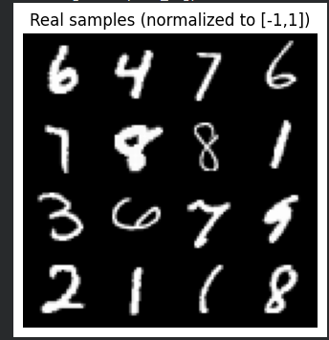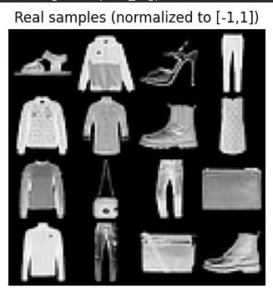
GAN samples, Z_DIM=64, d_loss_bce
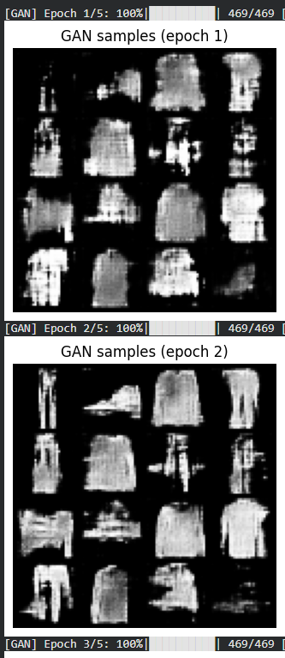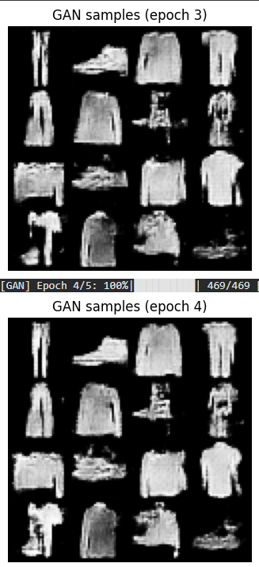

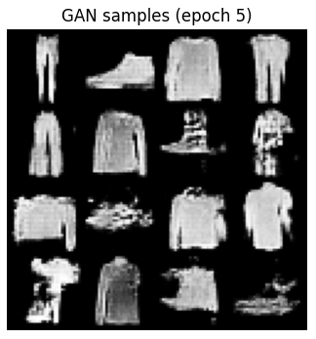
GAN samples, Z_DIM=32, d_loss_bce
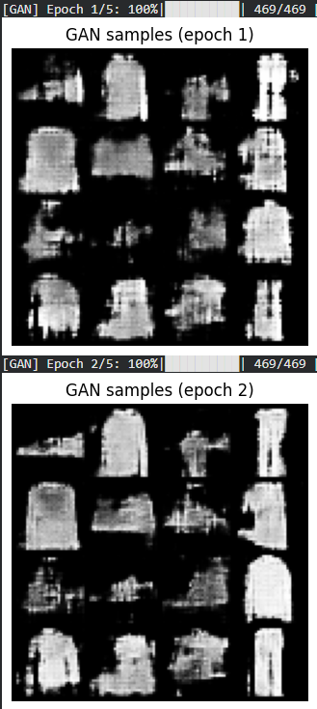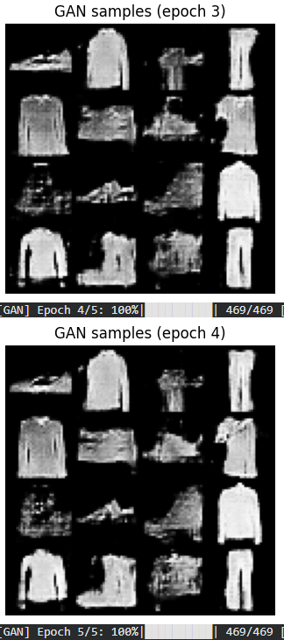
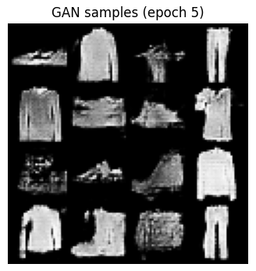

GAN samples, Z_DIM=128, d_loss_bce
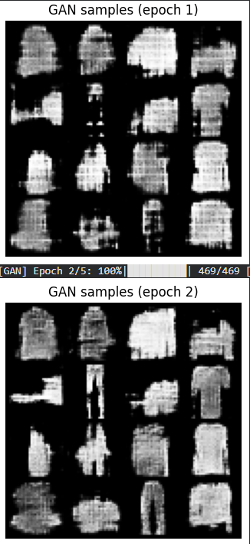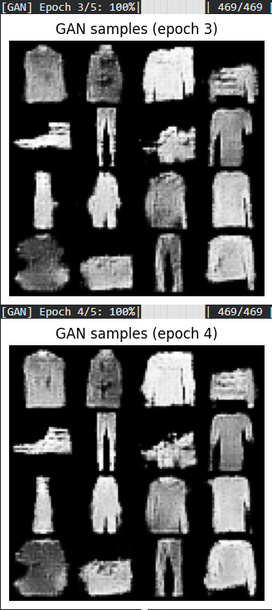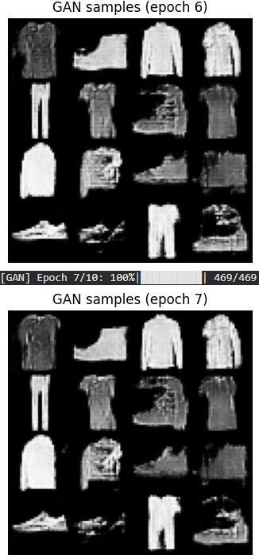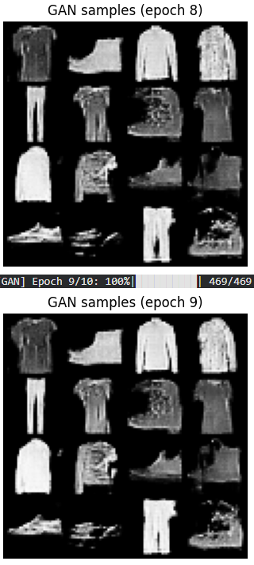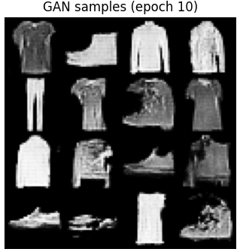
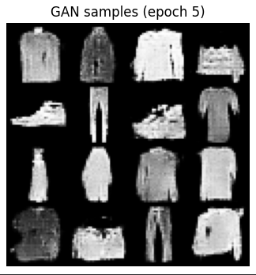

VAE reconstructions
VAE, 8
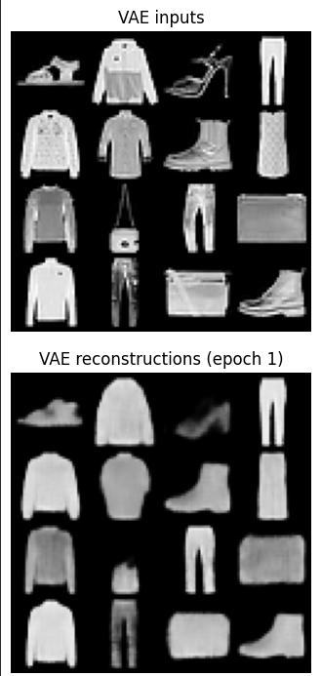
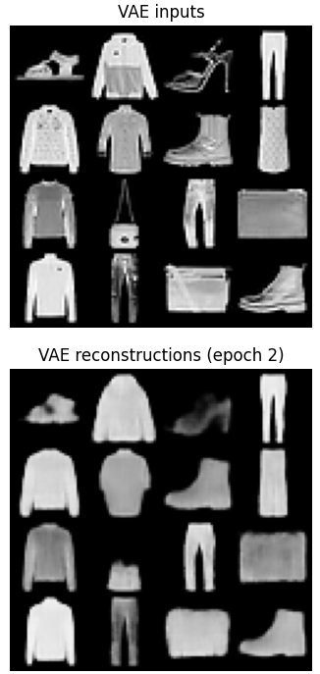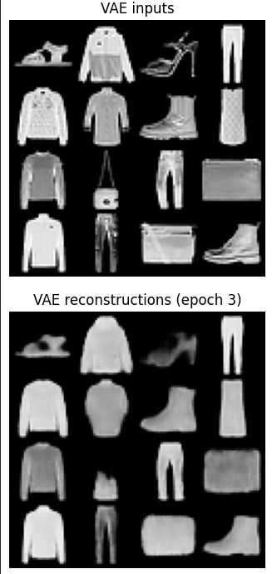
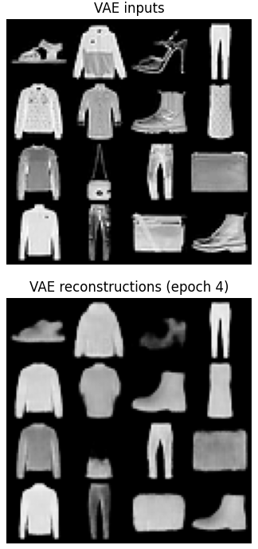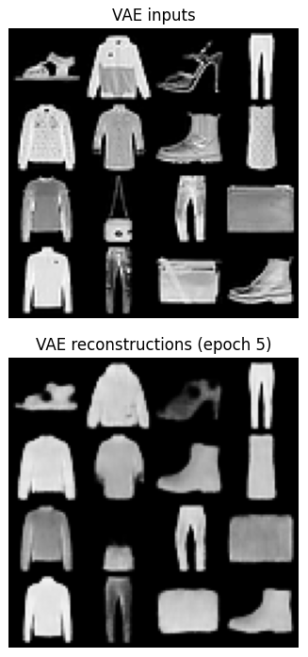

VAE, 16
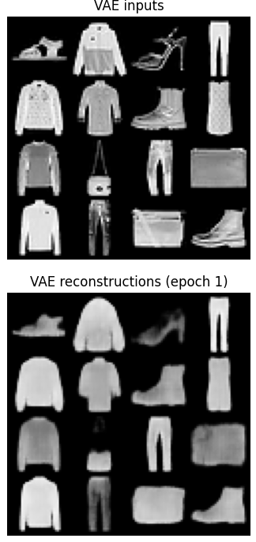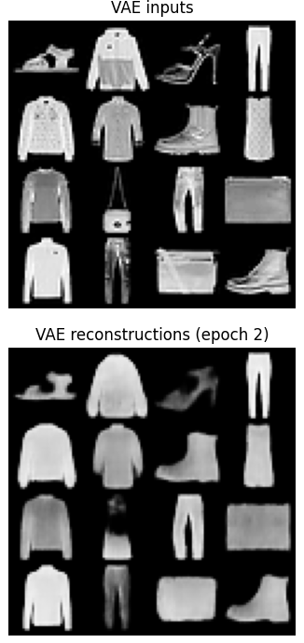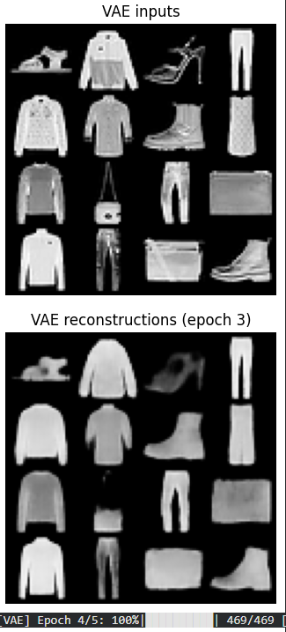
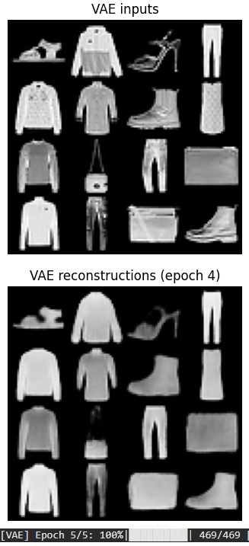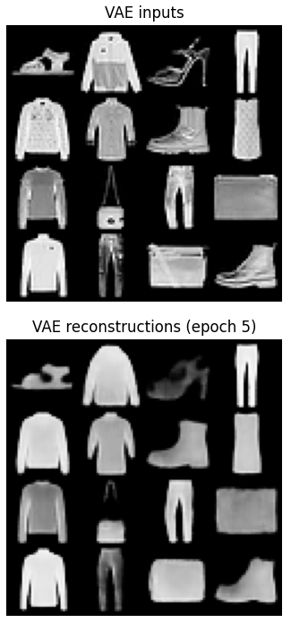

VAE, 32
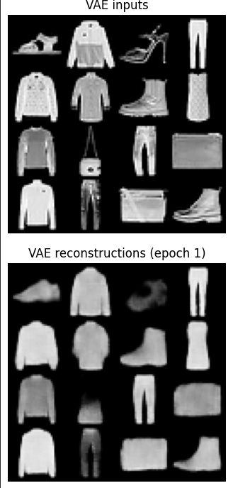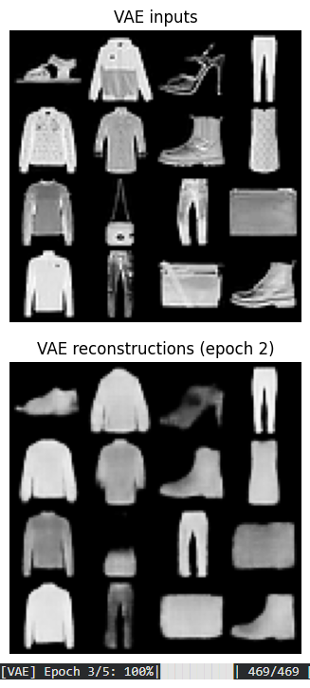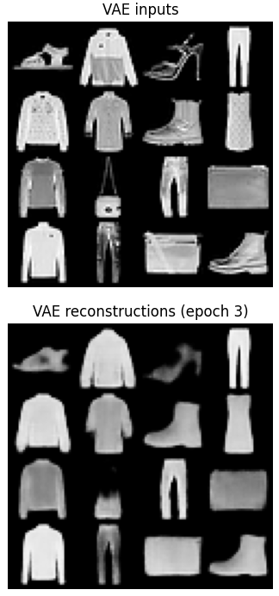
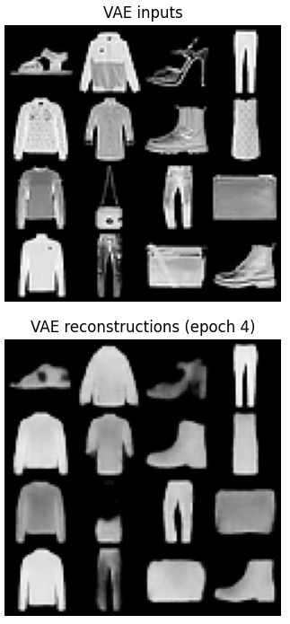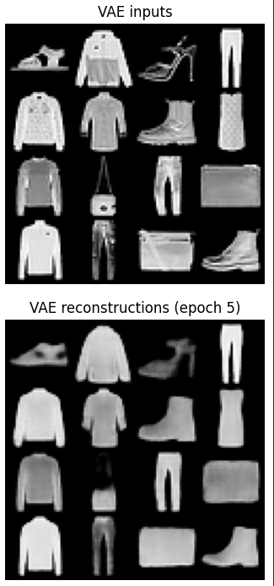

VAE latent interpolation
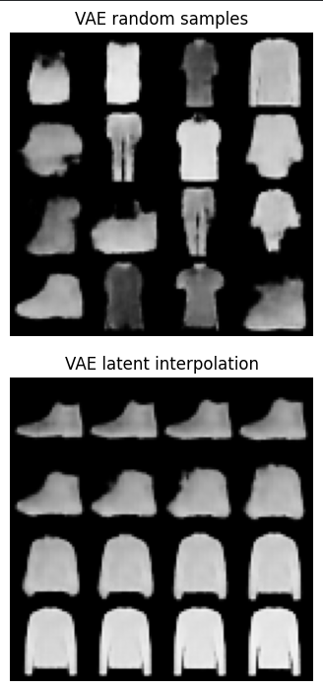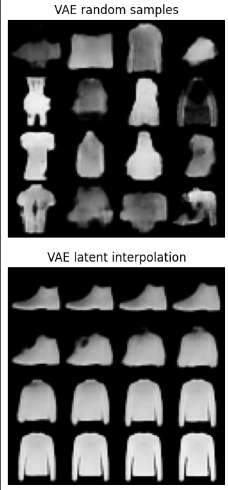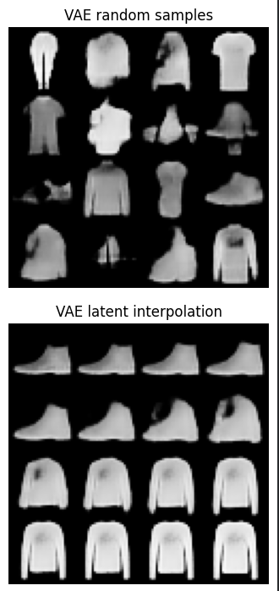
VAE, 8 VAE, 16 VAE, 32
proxy FID-like numbers for GAN and VAE.
- What hyperparameters most influenced GAN stability in your runs?
Ans:- Latent Space Dimensions and Epochs
- Evidence of mode collapse (if any)? What helped?
Ans:- Yes, Hinge loss + BatchNorm in G
- How did latent dim affect VAE reconstructions and samples?
Ans:- When latent dim increases, reconstruction quality and sample diversity improve because the model has greater capacity to encode data features, the image features are absorbed more as we the latent dim increases.
- One idea to combine benefits of both.
- Ans:- The VAE part encodes input data into a smooth latent representation and decodes it back, ensuring that the model can generate diverse samples and interpolate between them. It focuses on learning the overall structure of the data.
- The GAN part introduces a discriminator that distinguishes real data from generated data, forcing the decoder to produce sharper and more realistic outputs.
- Combining both of them - The VAE ensures a structured latent space for controlled sampling and diversity.
- The GAN ensures high-quality, realistic outputs.

