Report Lab 3
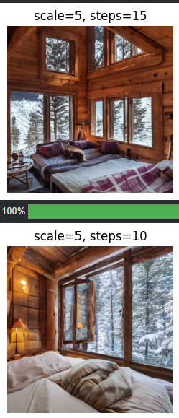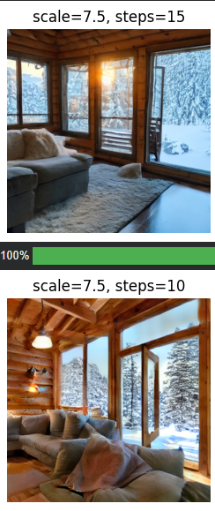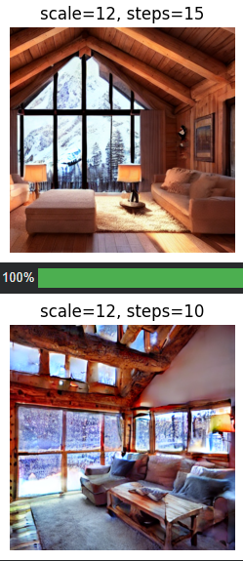
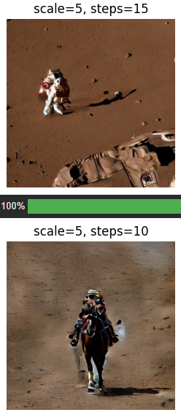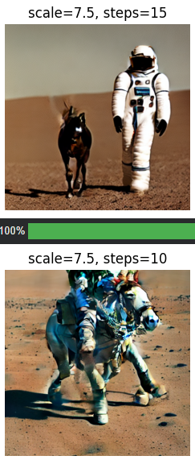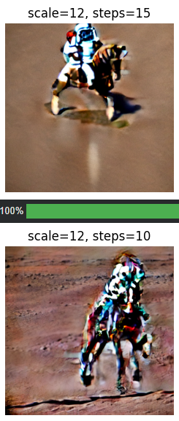
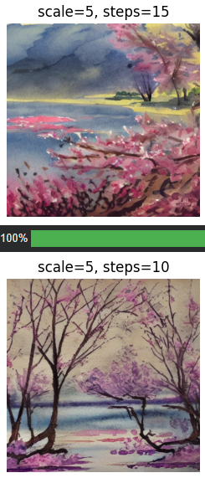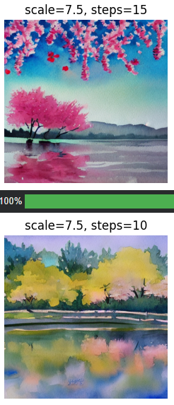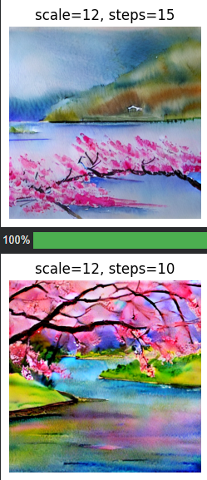
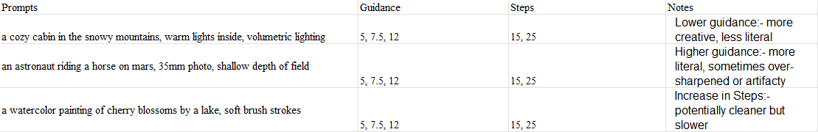
Before
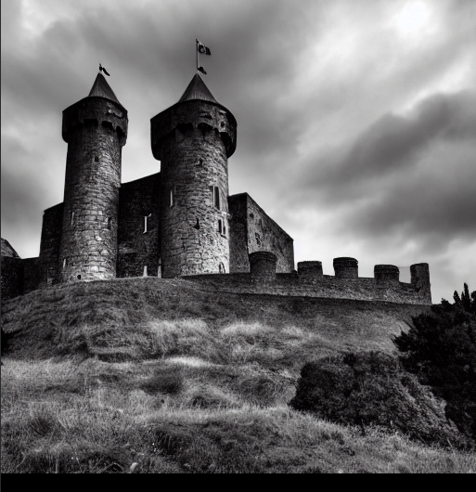

After
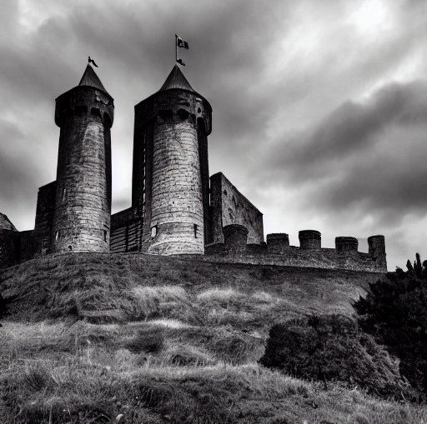
What Changed?
The base image is a medieval castle on a hill.
The mask selects a rectangular region
The inpainting step replaces whatever is inside that region with, “a modern glass skyscraper, realistic photo, matching lighting”
- Why does high guidance (>15) cause “deep-fried,” neon, or noisy results?
A:- Because Classifier-Free Guidance (CFG) literally forces the model to obey the prompt too strongly.
- Which scheduler produced the most realistic human skin texture? Which one felt more "painterly"?
A:- Scheduler DDIM produced the most realistic human skin texture. Images produced by Scheduler PNDM are painterly.
Insights
- Guidance vs creativity: CFG is the most powerful knob:
Lower → artistic/freedom
Medium → realism
High → strict but fragile and “AI-looking”
- Steps vs speed/quality:
More steps ≠ always better.
15–25 steps is best for SD1.5
- Editing best practices:
Soft masks
Small region edits
Specific edit prompts
Inpainting-specific checkpoint
- Major failure cases & ideas to fix them:
Negation → use negative prompts
Deep-fry → lower CFG or switch scheduler
Prompt overload → simplify
Inconsistent edits → soften mask and add “match lighting
- Why Case A Still Generated Apples
A:- Stable Diffusion does not understand natural-language negation logically the way humans do.
Instead, the text encoder (CLIP) converts the text into an embedding. This is why the model “hears” the presence of apples even though your intent was absence.
- The Math of Negative Prompts — What Happens to the Noise Vectors
A:- Negative prompts change the noise direction during sampling.
The model adjusts the latent noise vectors so they avoid features associated with the negative embedding, instead of deleting anything afterward.
- When you add a negative prompt, what replaces the "Uncond" (Unconditional) part?
A:- The negative-prompt embedding replaces the Uncond term.
- Does the model "move towards" the negative prompt or "push away" from it?
A:- First it moves toward the negative prompt (because it’s used as Uncond), then CFG pushes the final result away from it.

