AI 250 — Introduction to Artificial Intelligence
LIU Brooklyn

Week 2 Project: Real Estate Price Prediction

Author: Shafkat Khalek Khan
GitHub: github.com/ShafkatKhan19/Iris-Classifier

Part 1: Data Exploration & Preparation
The California Housing dataset is used (5,000 samples, 8 features). It contains district-level housing data including income, house age, rooms, occupancy, and geographic coordinates.

Property | Value
Dataset | California Housing (synthetic, same structure)
Samples | 5,000 districts
Features | 8 (MedInc, HouseAge, AveRooms, AveBedrms, Population, AveOccup, Latitude, Longitude)
Target | MedHouseVal — Median house value in $100,000s
Train/Test Split | 80% / 20% (4,000 train, 1,000 test)
Missing Values | None — dataset is clean

Summary Statistics
Feature | Min | Max | Mean | Std
MedInc (income) | 0.64 | 47.26 | 5.38 | 3.55
HouseAge | 1.0 | 52.0 | 26.2 | 14.6
AveRooms | 2.0 | 12.0 | 6.99 | 2.92
AveBedrms | 1.0 | 4.0 | 2.53 | 0.86
Population | 8.5 | 20792 | 672.9 | 888.5
AveOccup | 1.0 | 6.0 | 3.47 | 1.44
MedHouseVal (target) | 0.50 | 5.00 | 2.45 | 1.26

Top 3 Features Correlated with House Price
Feature | Correlation | Interpretation
MedInc | 0.862 | Strongest predictor — higher income → higher prices
AveOccup | -0.096 | More occupants per house → slightly lower value
HouseAge | 0.094 | Older neighborhoods tend to be slightly pricier

Visualization 1: Feature Distributions
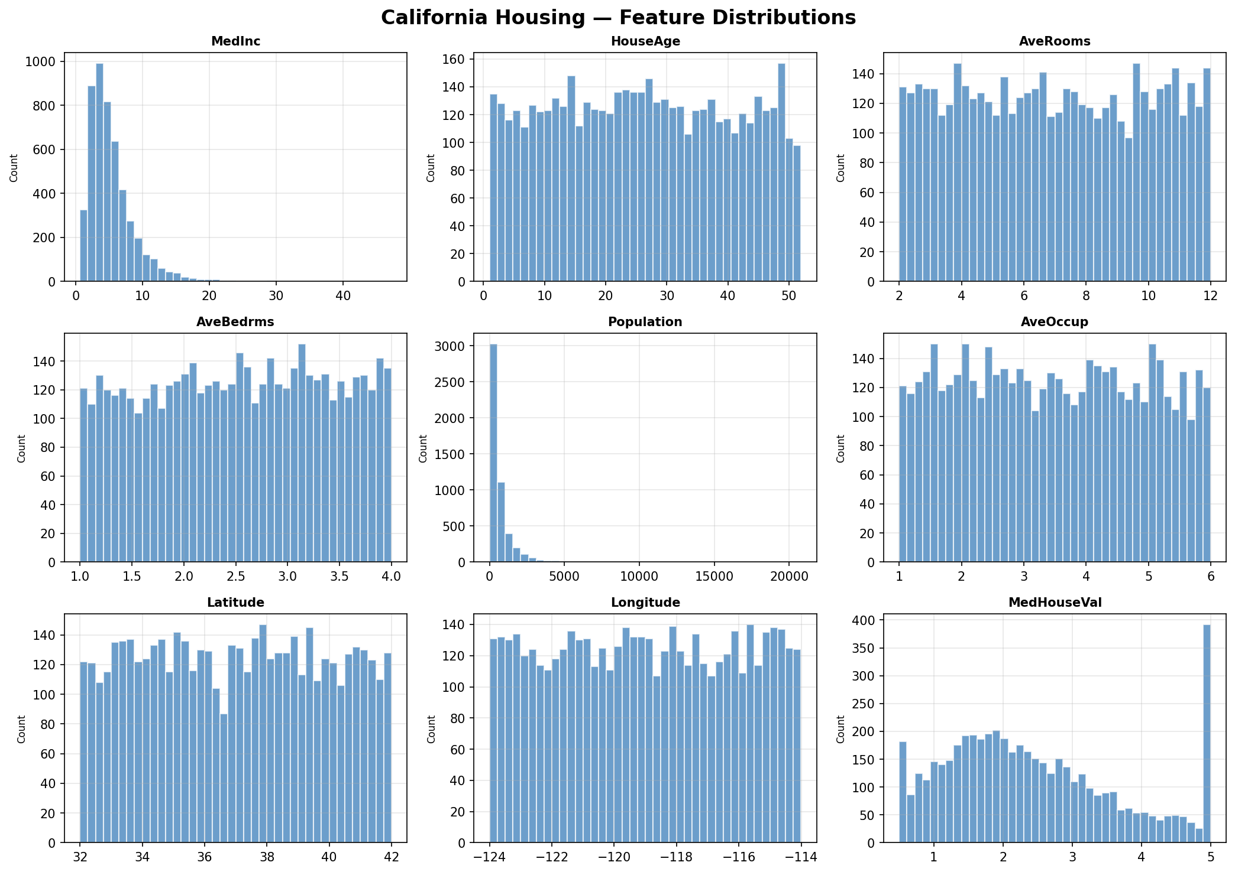
Figure 1: Histograms of all 8 features. MedInc is right-skewed; Population has extreme outliers.

Visualization 2: Correlation Heatmap
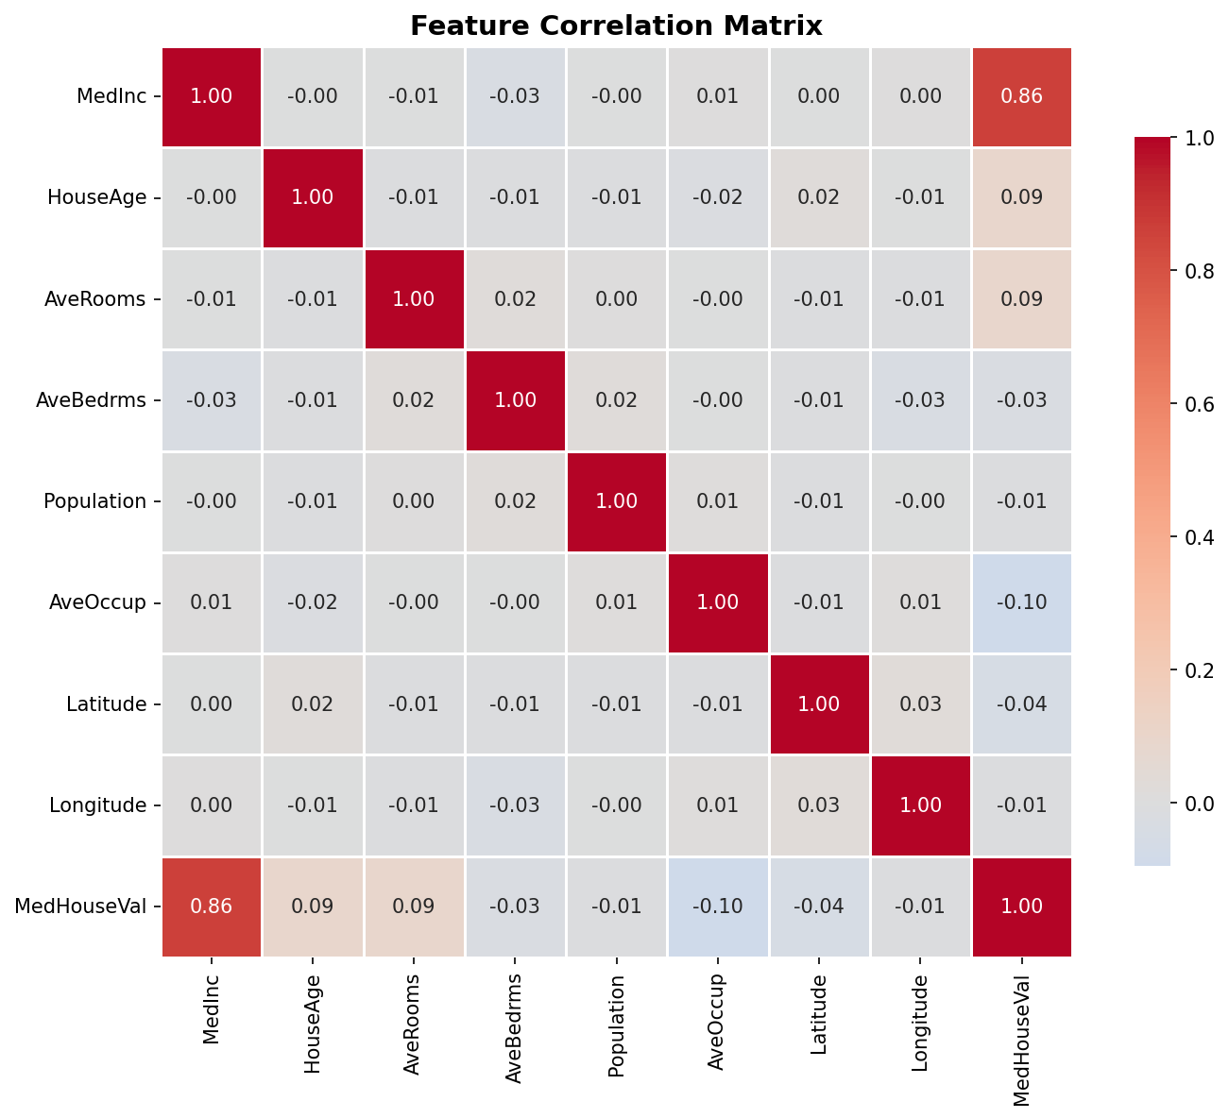
Figure 2: Correlation matrix. MedInc dominates correlation with target (0.86).

Part 2: Linear Regression Model
Linear Regression is trained on standardized features. It models a straight-line relationship between features and house price.

Metric | Value | Interpretation
MSE | 0.4028 | Mean squared error of predictions
RMSE | 0.6347 ($63,469) | Average prediction error in dollars
MAE | 0.4319 ($43,189) | Mean absolute error
R² Score | 0.7358 | 73.6% of price variance explained
Training Time | 0.0017s | Extremely fast

Feature Coefficients
Feature | Coefficient | Impact
MedInc | 1.0996 | Strongest positive — income drives price most
AveRooms | 0.1111 | More rooms → higher price
HouseAge | 0.1090 | Older homes slightly more valuable
AveOccup | -0.1265 | More occupants → slightly lower value
Latitude | -0.0574 | Further north → slightly lower price

Visualization 3: Actual vs Predicted Prices
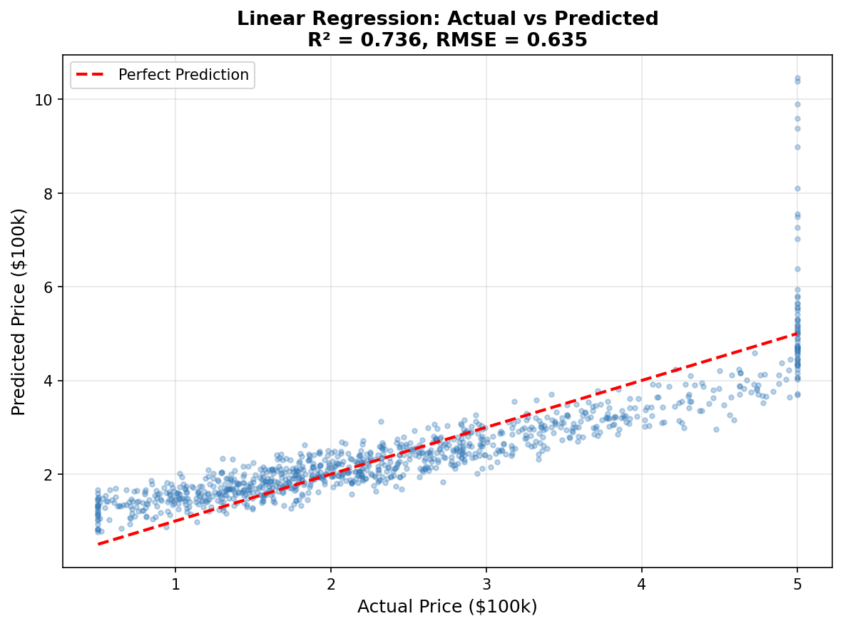
Figure 3: Linear Regression predictions vs actual values. Points near the red dashed line = accurate predictions. R² = 0.736.

Part 3: Decision Tree Regression
Decision Tree Regressor is trained with 5 different max_depth values to study the overfitting phenomenon.

Max Depth | Train RMSE | Test RMSE | Observation
3 | 0.4546 | 0.4844 | Underfitting — tree too shallow
5 | 0.4071 | 0.4535 | ★ Best — optimal balance
10 | 0.2434 | 0.5082 | Starting to overfit
20 | 0.0170 | 0.5767 | Clear overfitting
None (full) | 0.0000 | 0.5741 | Severe overfitting — memorized training data

Visualization 4: Training vs Test RMSE by Depth
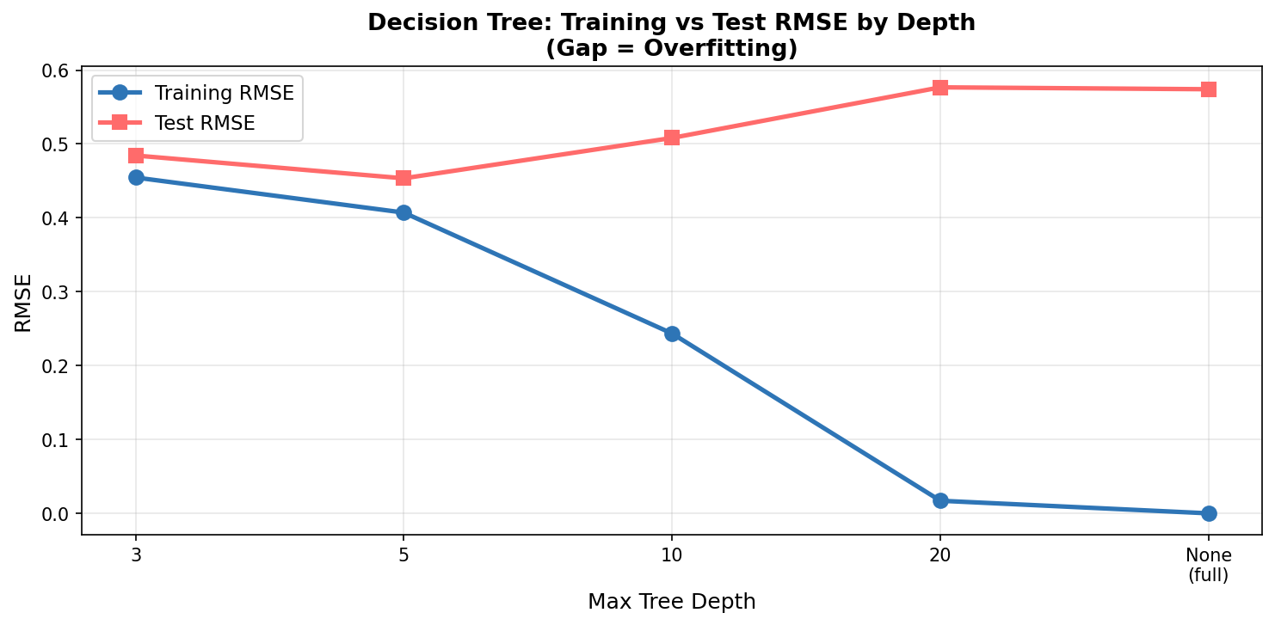
Figure 4: Gap between train and test RMSE grows with depth — classic overfitting signal.

Visualization 5: Feature Importances
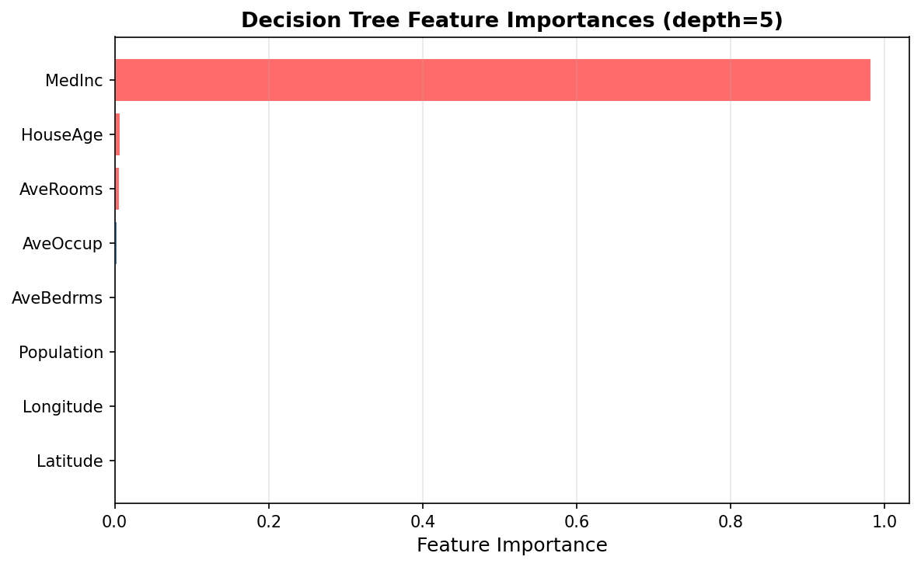
Figure 5: Decision Tree feature importances. MedInc accounts for 98.3% of splits.

Feature | Importance | Rank
MedInc | 0.9831 | #1 — Overwhelmingly dominant
HouseAge | 0.0070 | #2
AveRooms | 0.0066 | #3

Part 4: Classification Problem
House prices are bucketed into 3 categories: Low (< $150k), Medium ($150k–$250k), High (> $250k). Both Logistic Regression and Decision Tree classifiers are trained and compared.

Category | Price Range | Count in Dataset
Low | < $150,000 | 1,291 (25.8%)
Medium | $150,000 – $250,000 | 1,608 (32.2%)
High | > $250,000 | 2,101 (42.0%)

Metric | Logistic Regression | Decision Tree (depth=5) | Winner
Accuracy | 80.80% | 77.40% | Logistic Regression ✓
Precision (High) | 0.88 | 0.89 | Tie
Recall (Medium) | 0.72 | 0.69 | Logistic Regression ✓
F1 (weighted) | 0.81 | 0.78 | Logistic Regression ✓
Training Time | 0.013s | 0.067s | Logistic Regression ✓

Visualization 6: Confusion Matrices
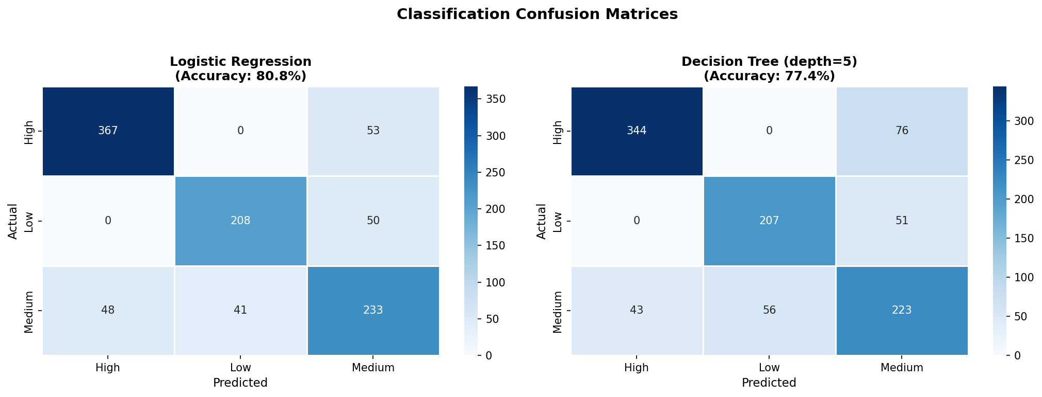
Figure 6: Confusion matrices for both classifiers. Medium class is hardest to distinguish (overlaps with High and Low).

Part 5: Model Comparison & Analysis

Model | Task | RMSE / Accuracy | R² / F1 | Training Time
Linear Regression | Regression | RMSE = 0.635 | R² = 0.736 | 0.002s
Decision Tree (depth=5) | Regression | RMSE = 0.454 | R² = 0.865 | ~0.1s
Logistic Regression | Classification | Accuracy = 80.8% | F1 = 0.809 | 0.013s
Decision Tree (depth=5) | Classification | Accuracy = 77.4% | F1 = 0.777 | 0.067s

Analysis Questions

Q1: Which regression model performed better?
Decision Tree Regression (R²=0.865) outperformed Linear Regression (R²=0.736). Decision Trees capture non-linear relationships — for example, income may have diminishing returns on price above a certain threshold, which Linear Regression cannot model.

Q2: What did you observe about tree depth and overfitting?
At depth=3: both train and test RMSE are high (underfitting). At depth=5: best test RMSE — optimal balance. At depth=20 or None: training RMSE drops to near 0 but test RMSE rises sharply. This is the classic bias-variance tradeoff — the tree memorizes training noise instead of learning real patterns.

Q3: Which features were most important?
MedInc (median income) was by far the most important feature in both models — correlation of 0.862 with price, and 98.3% feature importance in the Decision Tree. This makes intuitive sense: wealthier districts have higher house values. Geographic features (Latitude) also matter slightly.

Q4: Classification vs Regression — which is more appropriate?
Regression is more appropriate for this problem because house price is a continuous variable. Classification loses information by forcing prices into 3 buckets — a house worth $149k and one worth $151k get different labels despite being almost identical. Regression gives a precise number. Classification is only better if a business specifically needs categorical decisions (e.g., loan eligibility tiers).

Q5: What real-world factors is the model missing?
- School district quality and ratings
- Crime rates and neighborhood safety
- Proximity to public transportation and employment hubs
- Property condition, renovation history, and age of appliances
- Property taxes, HOA fees, and local zoning laws
- Current interest rates and broader economic conditions
- Proximity to amenities (parks, hospitals, shopping)

AI250 LIU Brooklyn | Week 2 Project | Real Estate Price Prediction | Shafkat Khalek Khan

