**Packet Tracer – Configuring RIPv2**

# Topology

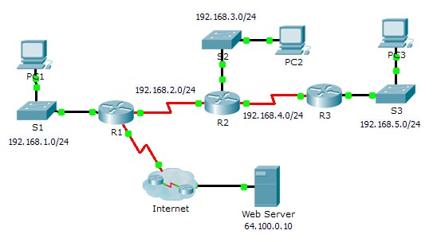

# Objectives

**Part 1: Configure RIPv2**

**Part 2: Verify Configurations**



# Background

Although RIP is rarely used in modern networks, it is useful as a foundation for understanding basic network routing. In this activity, you will configure a default route, RIP version 2, with appropriate network statements and passive interfaces, and verify full connectivity.

# Part 1: Configure RIPv2

**Step 1: Configure RIPv2 on R1.**

1. Use the appropriate command to create a default route on **R1** for all Internet traffic to exit the network through S0/0/1.   
   **R1(config)# ip route 0.0.0.0 0.0.0.0 s0/0/1**
2. Enter RIP protocol configuration mode.   
   **R1(config)# router rip**
3. Use version 2 of the RIP protocol and disable the summarization of networks.   
    **R1(config-router)# version 2**

**R1(config-router)# no auto-summary**

1. Configure RIP for the networks that connect to **R1**.   
   **R1(config-router)# network 192.168.1.0**

**R1(config-router)# network 192.168.2.0**

1. Configure the LAN port that contains no routers so that it does not send out any routing information.  
   **R1(config-router)# passive-interface g 0/0**
2. Advertise the default route configured in step 1a with other RIP routers.  
   **R1(config-router)# default-information originate**
3. Save the configuration.

© 2013 Cisco and/or its affiliates. All rights reserved. This document is Cisco Public. Page **1** of **2**

**Packet Tracer – Configuring RIPv2**

**Step 2: Configure RIPv2 on R2.**

1. Enter RIP protocol configuration mode.  
   **R2(config)# router rip**
2. Use version 2 of the RIP protocol and disable the summarization of networks.   
   **R2(config-router)# version 2  
   R2(config-router)# no auto-summary**
3. Configure RIP for the networks directly connected to **R2**.   
   **R2(config-router)# network 192.168.2.0  
   R2(config-router)# network 192.168.3.0  
   R2(config-router)# network 192.168.4.0**
4. Configure the interface that contains no routers so that it does not send out routing information. e. Save the configuration.   
   **R2(config-router)# passive-interface g 0/0**

**Step 3: Configure RIPv2 on R3**

Repeat Step 2 on **R3**.

# Part 2: Verify Configurations

**Step 1: View routing tables of R1, R2, and R3.**

1. Use the appropriate command to show the routing table of **R1**. RIP (R) now appears with connected (C) and local (L) routes in the routing table. All networks have an entry. You also see a default route listed.
2. View the routing tables for **R2** and **R3**. Notice that each router has a full listing of all the 192.168.x.0 networks and a default route.

**Step 2: Verify full connectivity to all destinations.**

Every device should now be able to ping every other device inside the network. In addition, all devices should be able to ping the **Web Server**.

© 2013 Cisco and/or its affiliates. All rights reserved. This document is Cisco Public. Page **2** of **2**