**Curriculum Vitae**

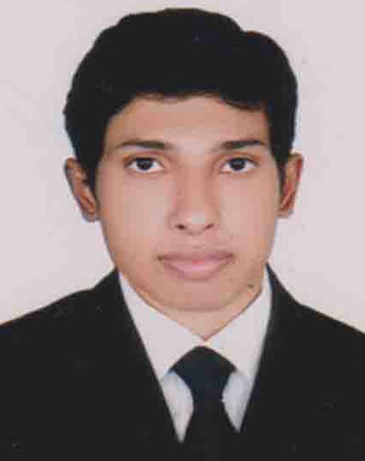

**OF**

**SHEIKH SHAWON**

|  |  |
| --- | --- |
| **Mailing Address:**  **Santidhara,satgara,Rangpur** | **Contact Details:** Phone:01774266507  E-mail:sheikhshawon520@gmail.com |

**Career Objective:**

To work for an organization using my knowledge and potentials that I have acquired from my academic & professional experience to achieve best results and to value my post together with initiative ideas. My ultimate aim is to work as an active member of an energetic team in a large environment so that I can exploit my full potential.

**Self Assessment:**

* Adaptable to complex and challenging situation.
* A self-driven attitude, willingness to learn and strong presence of mind.
* Optimistic, confident and creative.
* Energetic, devoted, sincere and hard working.
* Able to work as a team leader as well as part of a team.
* Open to new ideas and sharing thoughts.

**Educational Qualification:**

**Post Graduation: Master in Governance studies**

Under Department of political science

University of Dhaka

Result : 3.41out of 4

Passing Year: 2018

**Graduation: Bachelor of Laws LL.B(Hons)**

Daffodil international University.

Result : 3.18 out of 4

Passing Year : 2015

**Higher Secondary: Higher Secondary Certificate (H.S.C.)**

Cantonment public school and college, Rangpur

Board : Dinajpur ,

Group : Humanities

Result : 4.40 out of 5

Passing Year : 2009

**Secondary : Secondary School Certificate (S.S.C.)**

Police lines school and college, Rangpur

Board : Rajshahi,

Group : Humanities

Result : 4.94 out of 5

Passing Year : 2007

**Computer Literacy:**

Microsoft Office Tools(MS Word, Excel, Power Point),Internet.

**Language Proficiency:**

Fluent in Spoken & Written both in Bengali and English

**Personal Details:**

**Father’s Name** **:** MD.MAZIBUR RAHMAN

**Mother’s Name :** SHEIKH LATIFA SULTINA

**Religion :** ISLAM

**Home District** **:** RANGPUR

**Marital Status** **:** SINGLE

**Blood Group :** A+ (POSITIVE)

**Nationality** **:** BANGLADASHI (By Birth)

**National ID Number** **:** 5075661073

**Permanent Address** **:** HOUSE:84,ROAD:1/4,SANTIDHARA,

R.K. ROAD, RANGPUR.

**Signature:**

Sheikh shawon