

12/21/2023

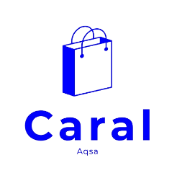

**Intr**

**oduction to Co**

**mmunication Technology**

**(**

**E**

**-**

**Commerce Website**

**)**

**SUBMITTED BY**

Shafqaat Ahmad (230450)

Aqsa Akhtar

(232977)

**BACHELOR OF COMPUTER SCIENCE**

**(**

**FALL**

**–**

**23**

**)**

**SUBMITTED TO**

MA’AM

RAMEEN

ABRAR

**DEPARTMENT OF COMPUTER SCIENCE**

**(**

**ADCS**

**-**

**A**

**-**

**1)**

**AIR UNIVERSITY,**

**ISLAMABAD**

**(**

**CARAL B**

**y**

**AQSA O**

**utfit**

**B**

**rand**

**)**



Contents

Introduction: ................................................................................................................................................. 1

Key Features and Functionalities: ................................................................................................................. 1

User-Friendly Navigation: ......................................................................................................................... 1

Homepage Dynamics: ............................................................................................................................... 1

Product Presentation: ............................................................................................................................... 1

Innovative Specifications Section: ............................................................................................................ 1

Special Offers and New Arrivals: ............................................................................................................... 2

Strategic Banner Displays: ........................................................................................................................ 2

Newsletter Engagement: .......................................................................................................................... 2

Footer Information Hub: ........................................................................................................................... 2

Dark Mode Feature: .................................................................................................................................. 2

Navigation and Design: ................................................................................................................................. 3

Logo and Brand Identity: ........................................................................................................................... 3

Navigation Menu: ..................................................................................................................................... 3

Mobile Responsiveness: ............................................................................................................................ 3

Visual Design: ............................................................................................................................................ 3

Dark Mode Feature: .................................................................................................................................. 3

Homepage Features: ..................................................................................................................................... 4

Trade-in Offers and Super Value Deals: .................................................................................................... 4

Featured Products Section: ....................................................................................................................... 4

Specifications Section: .............................................................................................................................. 4

Special Offers and New Arrivals: ............................................................................................................... 5

Banner Section: ......................................................................................................................................... 5

Newsletter Section: ................................................................................................................................... 5

Design: .......................................................................................................................................................... 5

Logo and Branding: ................................................................................................................................... 5

Navigation Menu: ..................................................................................................................................... 5

Product Cards: ........................................................................................................................................... 6

Responsive Design: ................................................................................................................................... 6

Footer Design: ........................................................................................................................................... 6

Dark Mode Feature: .................................................................................................................................. 6 Specifications Section: .................................................................................................................................. 6 Free Shipping: ........................................................................................................................................... 6

Online Order: ............................................................................................................................................ 7

Save Money: .............................................................................................................................................. 7

Promotions:............................................................................................................................................... 7

Happy Sell: ................................................................................................................................................ 7

24/7 Support: ............................................................................................................................................ 7

Shop Page ...................................................................................................................................................... 8

Navigation ................................................................................................................................................. 8

Header ....................................................................................................................................................... 8

Product Collection ..................................................................................................................................... 8

Pagination/Navigation Buttons ................................................................................................................. 9

Newsletter Section .................................................................................................................................... 9

Footer ........................................................................................................................................................ 9

Product Details: ........................................................................................................................................... 10

Product Name: ........................................................................................................................................ 10

Description: ............................................................................................................................................. 10

Key Features:........................................................................................................................................... 10

Product Images: ...................................................................................................................................... 10

Additional Information: .......................................................................................................................... 11

Navigation: .............................................................................................................................................. 11

**Footer:** .................................................................................................................................................... 11

Newsletter: ............................................................................................................................................. 11

Contact Us ................................................................................................................................................... 11

Navigation ............................................................................................................................................... 11

Header Section ........................................................................................................................................ 12

Contact Information ................................................................................................................................ 12

Head Office: ........................................................................................................................................ 12

Map Location .......................................................................................................................................... 12

Contact Form .......................................................................................................................................... 13

Contact Person ........................................................................................................................................ 13

Profiles of Marketing Managers: ........................................................................................................ 13

Newsletter Signup ................................................................................................................................... 14 Cart Page ..................................................................................................................................................... 14 Navigation ............................................................................................................................................... 14

Cart Contents: ......................................................................................................................................... 15

Product(s): ........................................................................................................................................... 15

Cart Functionality: ............................................................................................................................... 15

Blog Page ................................................................................................................................................. 15

The Cotton-Jersey Zip-Up Hoodie ....................................................................................................... 15

How to Style a Quiff ................................................................................................................................ 16

Must-Have Skater Girl Items ................................................................................................................... 16

Runway Inspired Trends.......................................................................................................................... 16

AW20 Women's Wear Trends ................................................................................................................. 17

Page Structure:........................................................................................................................................ 17

Login Page ................................................................................................................................................... 17

Navigation ............................................................................................................................................... 17

Page Layout and Design: ......................................................................................................................... 18

Login Form: ............................................................................................................................................. 18

Conclusion: .................................................................................................................................................. 19

Pictures ....................................................................................................................................................... 20

CARAL E-Commerce ................................................................................................................................ 20

Index Page: .................................................................................................................................................. 20

Shop Page:................................................................................................................................................... 22

Contact Page: .............................................................................................................................................. 23

Cart Page: .................................................................................................................................................... 24

Blog Page: .................................................................................................................................................... 25

Login Page: .................................................................................................................................................. 26

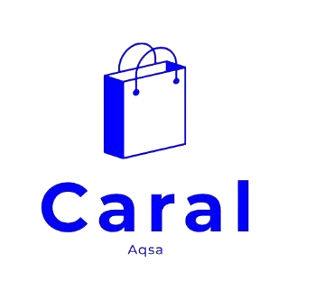

Introduction:

Caral Ecommerce Website is a cutting-edge online shopping platform designed to redefine the digital retail experience. Committed to providing users with a seamless and enjoyable journey, Caral boasts a visually appealing design and an array of innovative features. From intuitive navigation to a diverse product range, Caral aims to establish itself as a prominent player in the ecommerce landscape.

Key Features and Functionalities:

* User-Friendly Navigation:
  + The website's navigation is crafted for simplicity and efficiency. A well-organized menu ensures easy access to various sections, enhancing the overall user experience. The inclusion of a recognizable logo, Aqsa, not only reinforces brand identity but also adds a touch of familiarity for users.



* Homepage Dynamics:
  + Caral's homepage sets the stage with compelling features, including enticing trade-in offers and super value deals. This strategic placement aims to capture users' attention immediately, creating a sense of urgency and excitement. The featured products section showcases a carefully curated selection, encouraging users to explore and discover the latest trends.

* Product Presentation:
  + Each product is meticulously presented through visually appealing product cards. These cards provide essential information such as brand names, product details, star ratings, and prices, facilitating informed decision-making for potential buyers. The call-to-action buttons drive users to explore further or make a purchase effortlessly.

## • Innovative Specifications Section:

▪ Caral goes beyond the traditional product display by incorporating a specifications section featuring icons that represent key offerings. Free shipping, online ordering, money-saving promotions, and 24/7 customer support are highlighted, creating a transparent and trustworthy shopping environment.

## • Special Offers and New Arrivals:

* The website introduces an exciting section dedicated to special offers and new arrivals. Users can explore repair services with exclusive discounts, creating a unique and engaging shopping experience. The new arrivals section showcases the latest products with a focus on modern design, catering to evolving customer preferences.

* 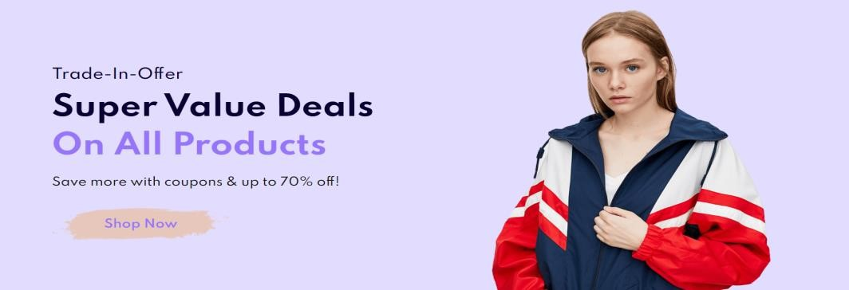

* Strategic Banner Displays:
  + Caral maximizes visual impact through strategically placed banners that promote a range of offers, upcoming seasons, sales, and new collections. Catchy headlines, informative descriptions, and clear call-to-action buttons guide users to relevant pages, ensuring they stay informed and engaged.

* Newsletter Engagement:
  + Recognizing the importance of user engagement, Caral invites visitors to sign up for newsletters. The newsletter section, accompanied by an input field for email addresses and a user-friendly 'Sign Up' button, fosters a direct communication channel with customers.

* + 

## • Footer Information Hub:

▪ The footer serves as an information hub, featuring contact details, social media links, and essential navigation menu items. App download buttons for both App Store and Google Play underline Caral's commitment to accessibility and user convenience.

## • Dark Mode Feature:

▪ Caral's commitment to user customization and accessibility is evident in the implementation of a dark mode feature. This innovative addition enhances the

user experience, especially in low-light conditions, showcasing Caral's dedication to inclusivity.



# Navigation and Design:

The navigation and design of Caral's ecommerce website play a pivotal role in providing users with a seamless and visually appealing online shopping experience.



## 1. Logo and Brand Identity:

* The prominently placed CARAL logo serves as a distinctive brand identifier.
* Creates a sense of trust and recognition among users.

## 2. Navigation Menu:

* Intuitive and user-friendly navigation menu for easy access to different sections.
* Clearly labeled menu items, including Home, Shop, Blog, About, Contact, Login, and Cart.
* Responsive design ensures a consistent experience across various devices.

1. Mobile Responsiveness:
   * The website is designed to be responsive, catering to the growing number of mobile users.
   * Mobile navigation is simplified for efficient use on smaller screens.

1. Visual Design:
   * Clean and visually appealing design enhances user engagement.
   * Consistent color scheme and typography for a cohesive brand identity.
   * High-quality images and icons contribute to an aesthetically pleasing layout.

1. Dark Mode Feature:
   * Recognizing the importance of user customization, the website incorporates a dark mode feature.

Enhances user experience, particularly in low-light environments.

* + Toggles between light and dark modes seamlessly.

# Homepage Features:

## 1) Trade-in Offers and Super Value Deals:

* Engages users with exclusive trade-in opportunities.
* Creates a sense of urgency through super value deals.
* Encourages users to take advantage of limited-time offers.

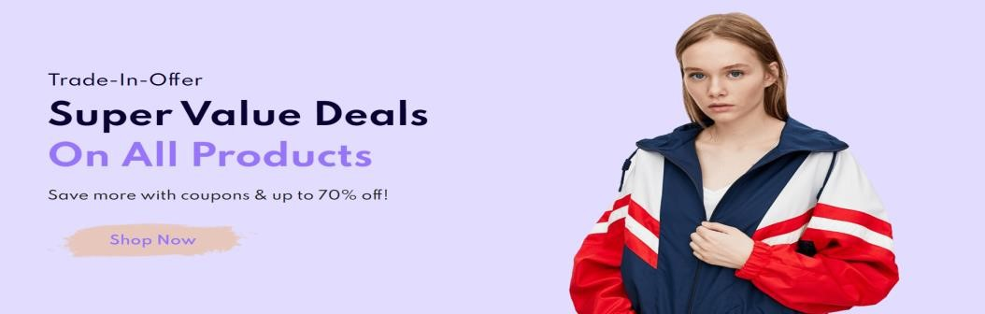

## 2) Featured Products Section:

* Showcases a curated selection of products.
* Highlights key products with visually appealing cards.
* Prominent call-to-action buttons prompt users to explore further.

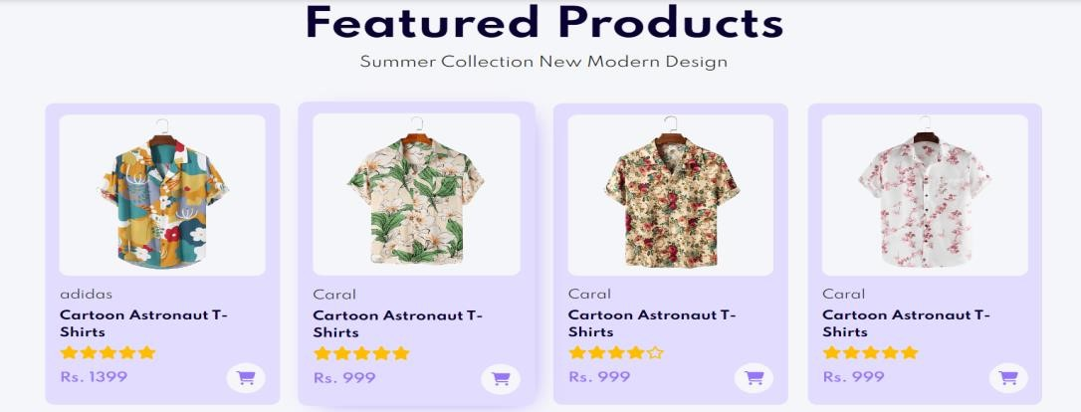

## 3) Specifications Section:

* Displays essential product specifications.
* Utilizes icons for a quick and visually engaging overview.

Reinforces key selling points such as free shipping, online ordering, and promotions.

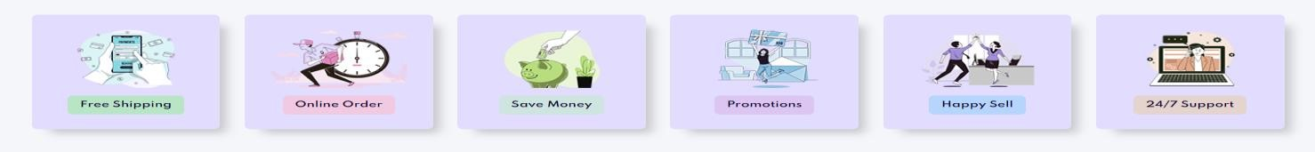

## 4) Special Offers and New Arrivals:

* Presents special offers on repair services with significant discounts.
* Highlights new arrivals with a focus on modern designs.
* Creates opportunities for users to explore diverse product categories.

## 5) Banner Section:

* Utilizes banners for promoting various deals and collections.
* Headlines and descriptions convey key messages effectively.
* Call-to-action buttons direct users to specific pages for more information.

## 6) Newsletter Section:

* Encourages user engagement through newsletter sign-ups.
* Simple input field for easy subscription.
* Incentivizes users to stay informed about the latest offers and updates.



# Design:

1. Logo and Branding:

* Features a recognizable logo (CARAL) for brand identity.
* Contributes to a cohesive and professional visual identity.

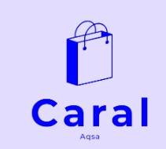

## 2. Navigation Menu:

• Intuitive navigation menu for easy access to key sections.

Prominently displays links to essential pages like Shop, Blog, About, Contact, and Login.

## 3. Product Cards:

* Visually appealing product cards in the featured products section.
* Consistent design elements for a cohesive and organized look.
* Integrates images, brand names, product names, ratings, and prices for quick user comprehension.

## 4. Responsive Design:

* Ensures a seamless experience across various devices.
* Adapts to different screen sizes, emphasizing accessibility.
* Prioritizes user experience on both desktop and mobile platforms.

## 5. Footer Design:

* Structured footer for organized information.
* Includes contact details, social media links, and footer menu items.
* App download buttons and payment gateway icons for visual appeal and trust.

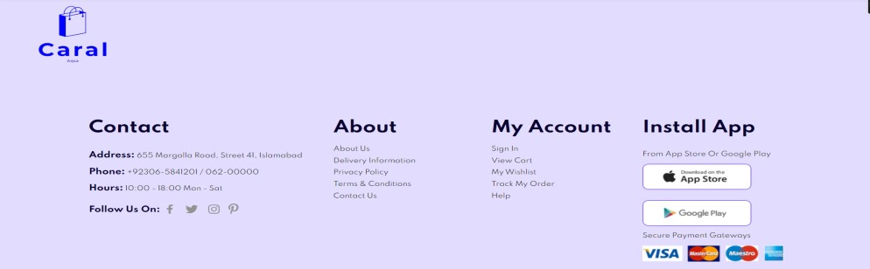

## 6. Dark Mode Feature:

* Enhances user experience with a dark mode option.
* Addresses user preferences for customization.
* Promotes accessibility and reduces eye strain in low-light environments.

# Specifications Section:

## 1. Free Shipping:

* Icon representation for clear identification.
* Highlights the benefit of free shipping for user convenience.

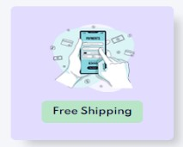

## 2. Online Order:

* Distinct icon indicating the option for online ordering.
* Reinforces the ease of placing orders through the website.

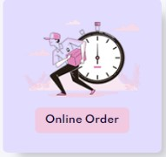

3. Save Money:

* Icon reflecting cost savings for the users.
* A commitment to providing value through competitive pricing.

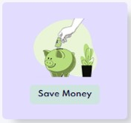

## 4. Promotions:

* Visual icon denoting ongoing promotions.
* Alerts users to special discounts and offers.

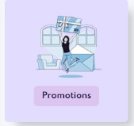

1. Happy Sell:
   * Iconic representation of a positive selling experience.
   * Emphasizes customer satisfaction and joyful transactions.

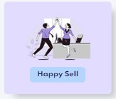

1. 24/7 Support:
   * Icon indicating round-the-clock customer support.
   * Assures users of assistance at any time.

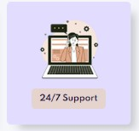

# Shop Page

## ➢ Navigation

* Home
* **Shop (Active)**
* Blog
* About
* Contact
* Login
* Cart

1. Header
   * #StayHome Heading
   * Save more with coupons & up to 70% off!



1. Product Collection
   * Collection of various products categorized by:
   * Product Images
   * Brand Name (Caral)
   * Product Name
   * Product Rating (in stars)
   * Product Price
   * Add to Cart Button

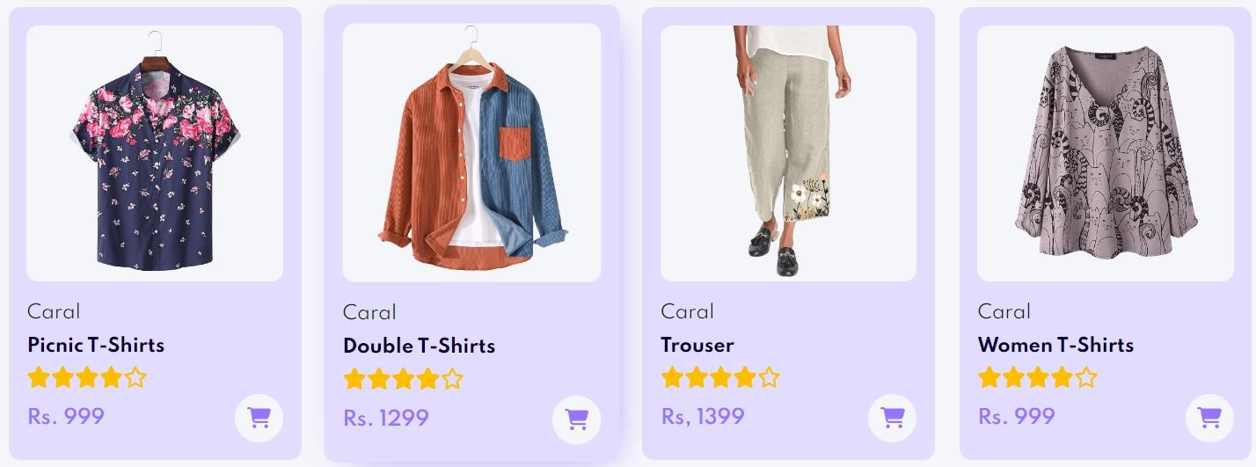

1. Pagination/Navigation Buttons
   * Buttons to navigate through multiple pages of products • Display additional pages or products (if applicable)

## 4. Newsletter Section

* Sign up for newsletter
* Get e-mail updates about the latest shop and special offers
* Email input field
* Sign up button (redirects to login page)

## 5. Footer

* Logo link to Home
* Contact Information
* Address: 655 Margalla Road, Street 41, Islamabad
* Phone: +923065841201 / 062-00000
* Hours: 10:00 - 18:00 Mon - Sat
* Social Media Links
* About, My Account, App Installation Links
* Copyright & Website Information

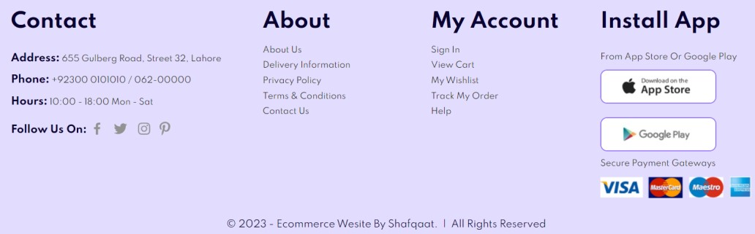

# Product Details:

## 1. Product Name:

* Men's Fashion T-Shirt
* Category: Home/T-Shirts
* Price: Rs. 999.00

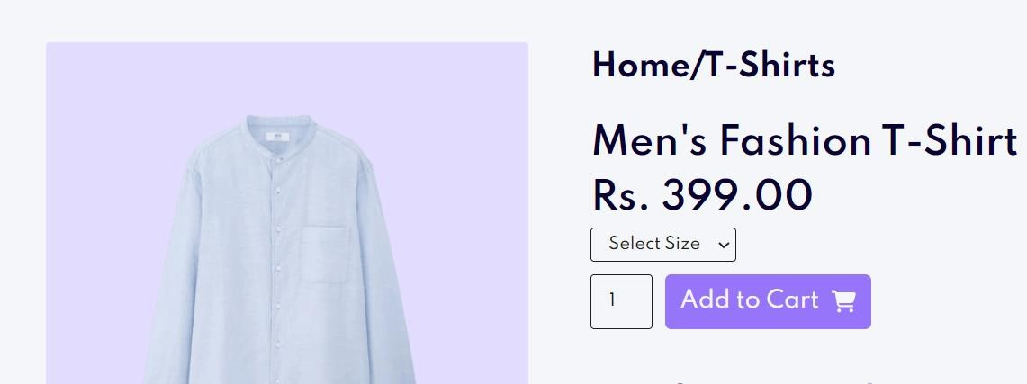

1. Description:

The Men's Fashion T-Shirt by Caral is a classic fit preshrunk jersey knit made from 100% cotton, weighing 6.0 oz. per sq. yd. This comfortable shirt features a taped neck and shoulder, seamless double-needle collar, and is available in various colors.

1. Key Features:
   * **Material:** 100% cotton, 6.0 oz. per sq. yd.
   * **Fit:** Classic fit preshrunk jersey knit.
   * **Comfort:** Unmatched comfort with each wear.
   * **Design:** Taped neck and shoulder, seamless double-needle collar.
   * **Variety:** Available in a range of colors.

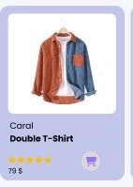

N

a

me Product

Stars

Price

Cart

## 4. Product Images:

* Main Image: Men's Fashion T-Shirt.
* Additional Images: Variants showcasing different colors and angles.

## 5. Additional Information:

* Size Options: Small, Large, XL, XXL.
* Add to Cart: Quantity selector and 'Add to Cart' button.
* Product Details: Detailed description of the T-Shirt's features and benefits.

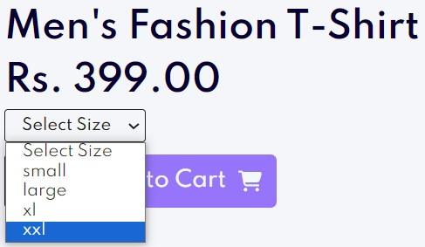

## 6. Navigation:

The page structure includes a navigation bar featuring Home, Shop (active), Blog, About, Contact, Login, and Cart pages. It uses a hamburger icon for mobile navigation and a logo for easy site identification.

## 7. Footer:

* **Contact Information:** Address, phone, and operating hours
* **Social Links:** Facebook, Twitter, Instagram, Pinterest
* **Footer Links:** About us, Delivery information, Privacy policy, Terms & Conditions, Contact us, My account links

## 8. Newsletter:

A section for users to sign up for the newsletter, receiving updates and special offers via email.

# Contact Us

## ➢ Navigation

* Home
* Shop
* Blog
* About
* **Contact (Active)**
* Login
* Cart

## 1. Header Section

* **Title:** "#Let’s talk"
* **Introduction:** "Leave a Message, we love to hear from you!"



## 2. Contact Information

i. Head Office:

o Address: 655, Street # 41, Margalla Road, Islamabad o Email: contact@example.com o Phone: 0800-10101010 o Working Hours: Monday to Saturday, 9:00am to 16:00pm



3. Map Location

Embedded Google Maps showing the location of the head office in Lahore, Pakistan

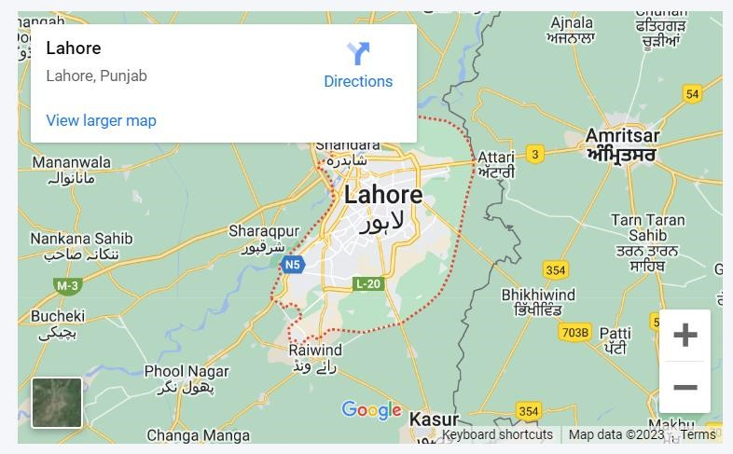

## 4. Contact Form

* Heading: "Leave a Message"
* Subheading: "We Love to Hear from You"
* Form Fields: o Your Name o E-mail o Subject o Your Message o Submit Button

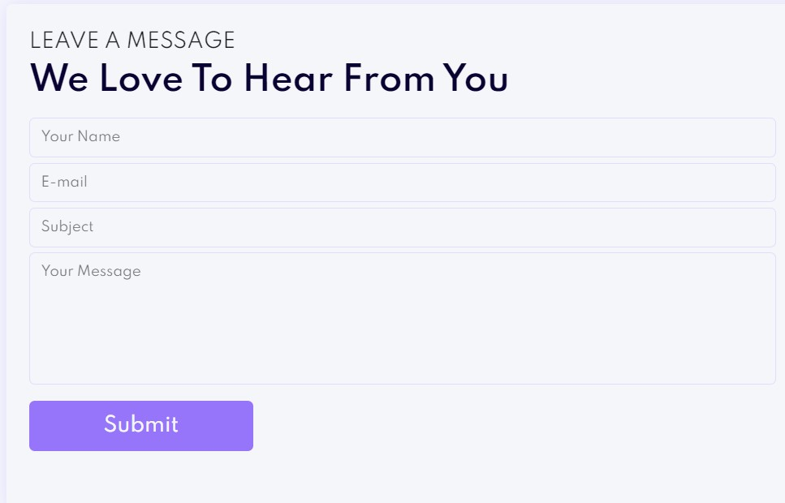

## 5. Contact Person

I. Profiles of Marketing Managers:

o **Name:** Shafqaat Ahmad

* Position: Senior Marketing Manager ✓ Phone: 0800-1010101
* Email: Shafqaat2034@example.com o **Name:** Aqsa Akhtar
* Position: Senior Marketing Manager
* Phone: 0800-1010101
* Email: aqsa007@gmail.com o **Name:** Shafqaat Ahmad
* Position: Senior Marketing Manager
* Phone: 0800-1010101
* Email: shafqaat2034@gmail.com



## 6. Newsletter Signup

* **Heading:** "Sign Up for Newsletter"
* **Description:** "Get e-mail updates about our latest shop and special offers"
* Email Input Field
* Signup Button

# Cart Page

## ➢ Navigation

* Home
* Shop
* Blog
* About
* Contact
* Login
* **Cart (Active)**

1. Cart Contents:

i.Product(s):

* Displayed items added from the shop with images, names, and details
* Each product contains a price and quantity selector

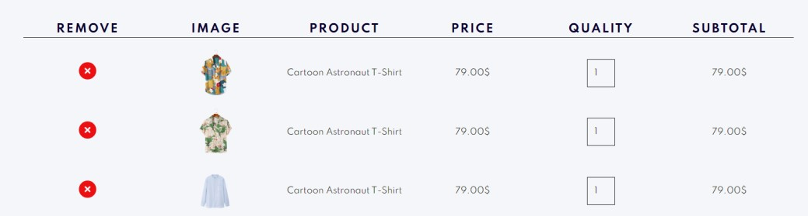

ii.Cart Functionality:

1. *Quantity Selection:*

Allows users to adjust the quantity of each product in the cart

1. *Continue Shopping:*

Option to return to the Shop page for more purchases

1. *Checkout Button:*

Likely leads to the checkout/payment page

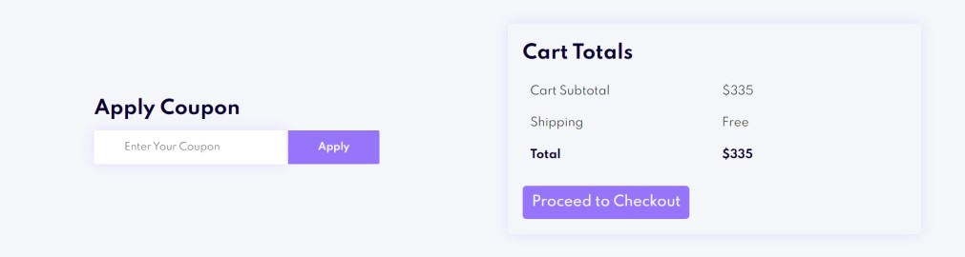

## Blog Page

Featured Blog Articles:

1. The Cotton-Jersey Zip-Up Hoodie
   * + **Content:** Engaging storytelling about the Starship Enterprise and a lovely lady's story.
     + **Link:** Continue Reading

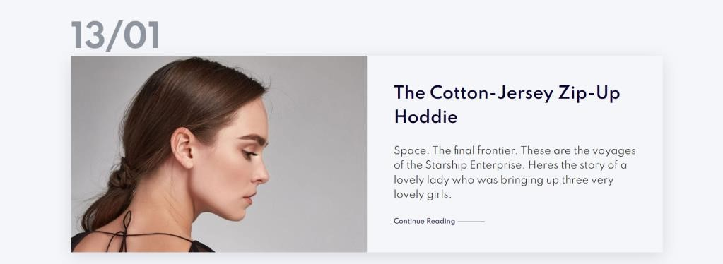

1. How to Style a Quiff
   * **Content:** Explains the process and importance of styling a quiff hairstyle. • **Link:** Continue Reading

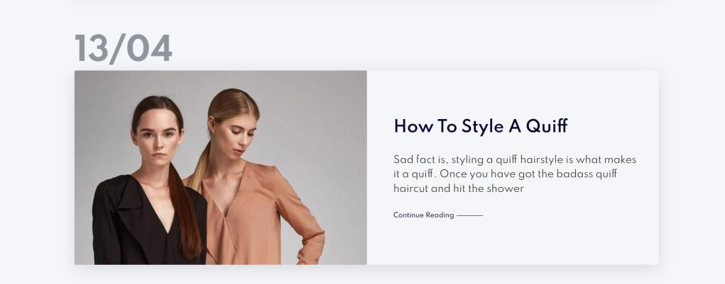

1. Must-Have Skater Girl Items
   * **Content:** Discusses unique fashion items with intriguing references.
   * **Link:** Continue Reading

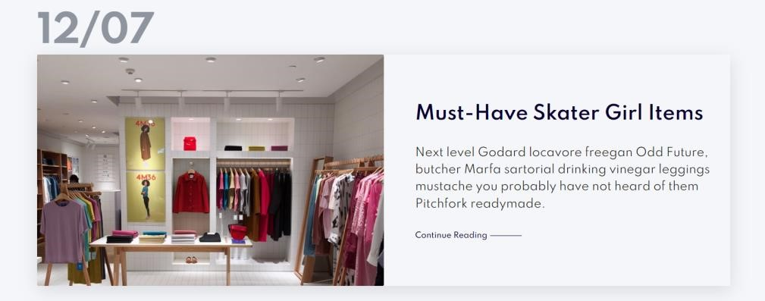

1. Runway Inspired Trends
   * **Content:** Highlights the significance of visuals in fashion and their influence.
   * **Link:** Continue Reading

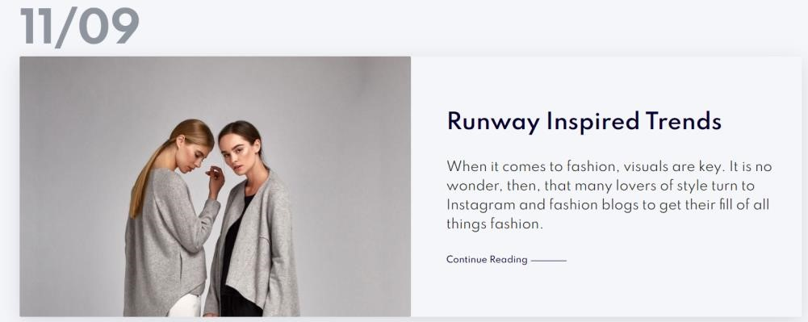

1. AW20 Women's Wear Trends

• **Content:** Addresses the recent fashion month and its impact on wardrobe trends. • **Link:** Continue Reading

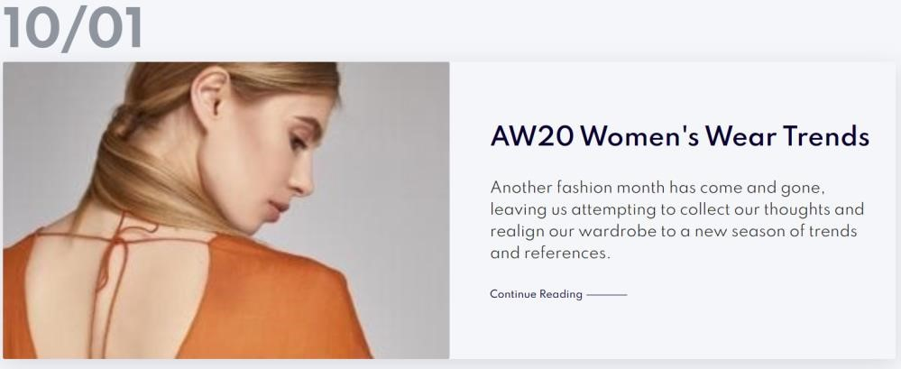

1. Page Structure:
   * + **Header Section:** Promotes reading case studies about the products.
     + **Blog Section:** Contains individual blog items with images, titles, brief descriptions, and "Continue Reading" buttons.
     + **Pagination Buttons:** Allows navigation between different blog pages.
     + **Newsletter Section:** Encourages users to sign up for updates and special offers via email.

# Login Page

## ➢ Navigation

* Home
* Shop
* Blog
* About
* Contact
* **Login (Active)**
* Cart

1. Page Layout and Design:

• **Header Section:** Divided into two sections - Left (image) and Right (login form).

* **Left Section:** Displays an image, potentially adding visual appeal or branding to the login page.
* **Right Section:** Contains the login form and relevant elements.

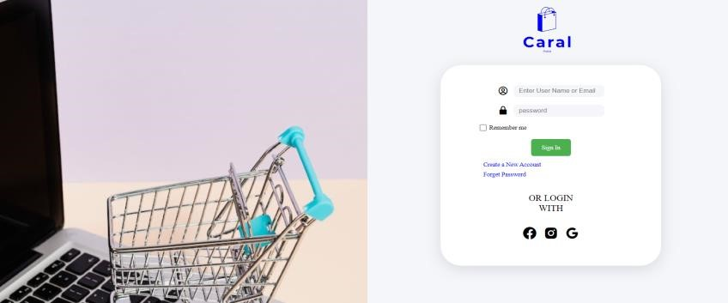

## 2. Login Form:

**i. Input Fields:**

* **Username or Email**: Text input field with an icon for user identification.
* **Password:** Password input field with a lock icon for security. **ii. Remember Me Option:** Checkbox allowing users to stay logged in. **iii. Sign In Button:** Redirects to the index page after authentication.

1. **Additional Links:** 
   * **"Create a New Account":** Redirects users to the account creation page.
   * **"Forget Password":** Assists users in resetting their password.
2. **Social Login Options:** Provides the ability to log in via social media platforms like Facebook, Instagram, and Google.

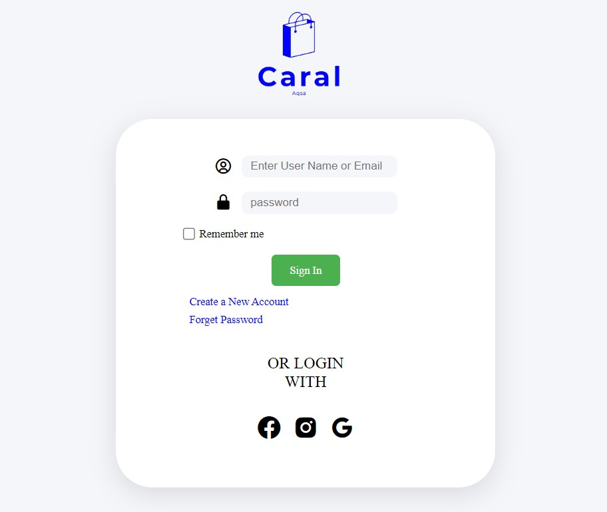

Conclusion:

The report above is about the website development project. this website is an ecommerce website of a wear brand named CARAL. This website has all the fundamental elements for the user convenience. using "Hypertext Markup Language." And” Cascading Style Sheets”.

The website Caral, came into being by the collective teamwork of Aqsa Akhtar and Shafqaat Ahmad as the semester project of Information Communication Technology under the instructor Rameen Abrar and Asim Fayyaz.

E-commerce has transformed the way business is conducted, offering unprecedented opportunities and challenges. Its continued evolution is likely to be shaped by technological advancements, changing consumer preferences, and the ability of businesses to adapt to a dynamic and competitive digital landscape.

# Pictures

CARAL E-Commerce

# Index Page:

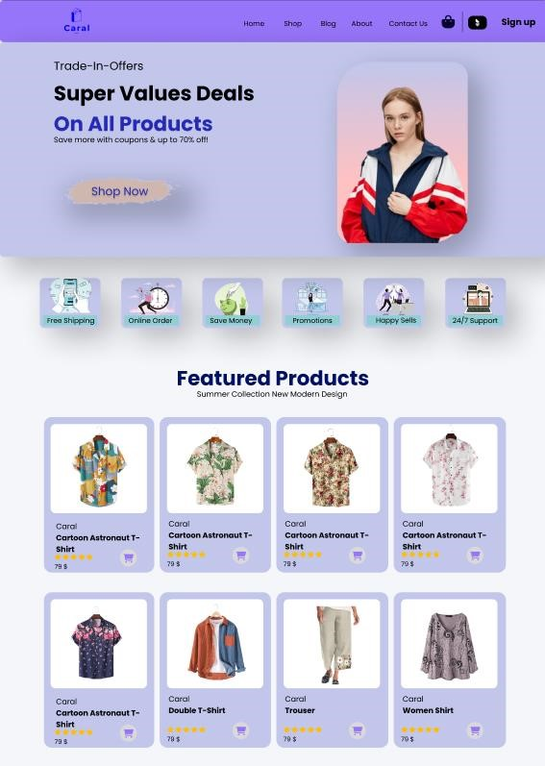

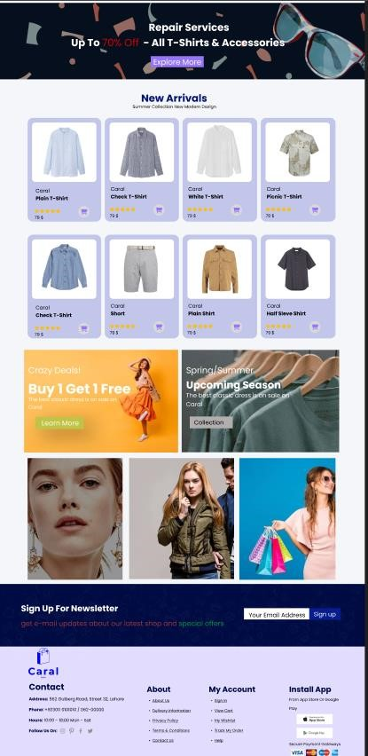

Shop Page:

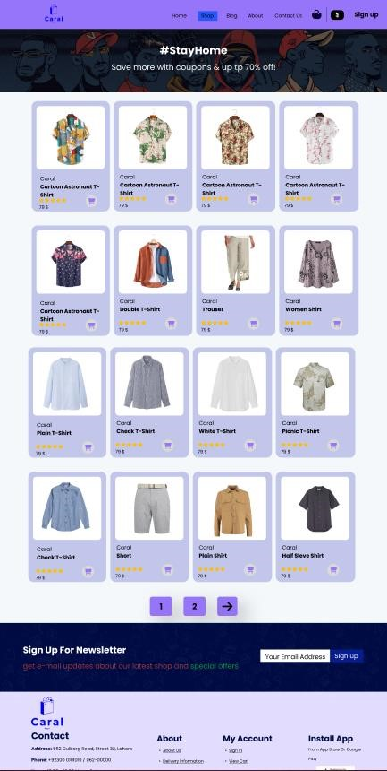

Contact Page:

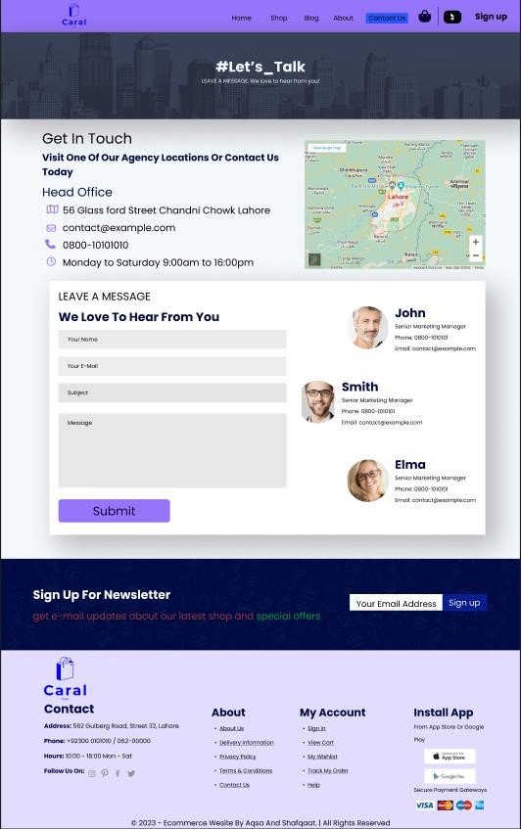

Cart Page:

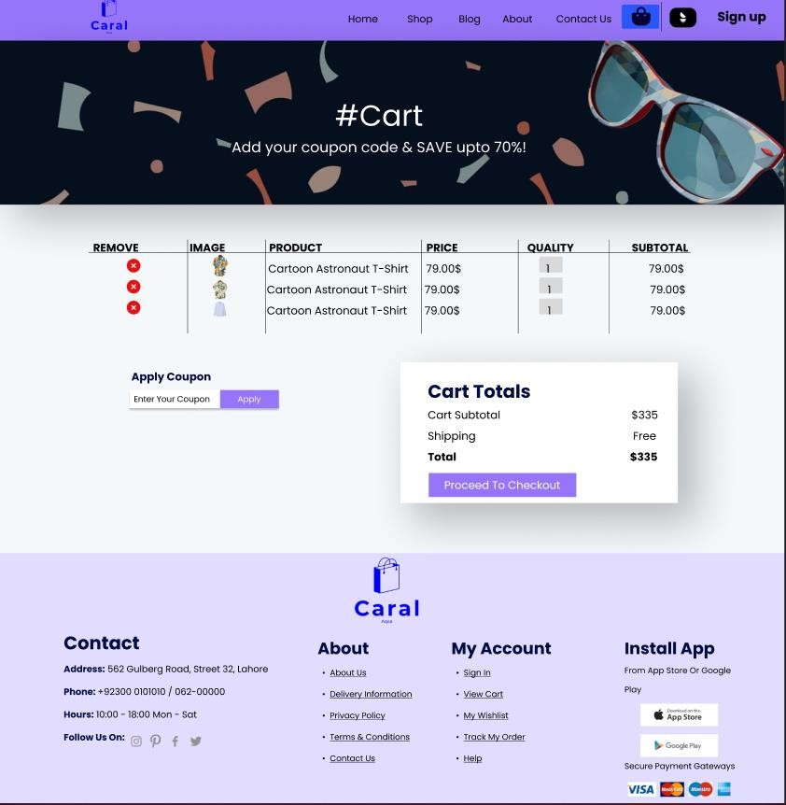

Blog Page:

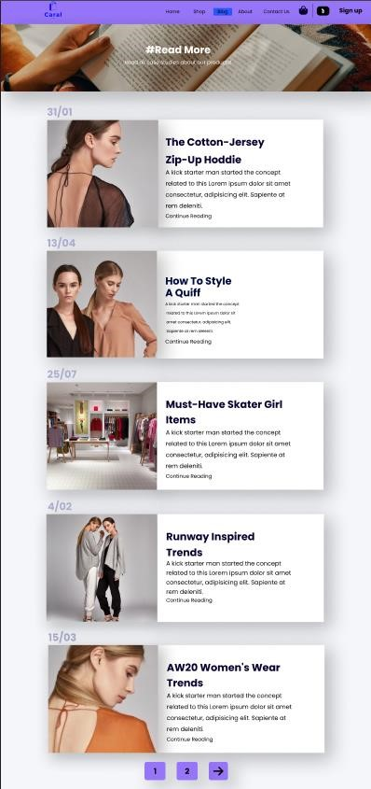

Login Page:

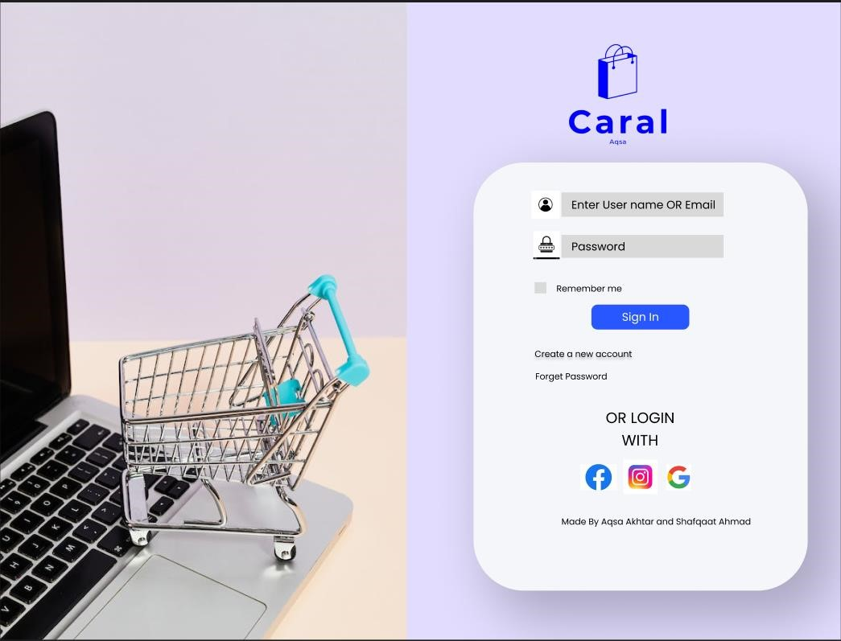



12/21/2023

X



Shafqaat Ahmad And Aqsa Akhtar

CARAL

Signed by: shafq