Conversational SQL Tutoring System with Explanation-Driven Feedback:
Implementation Report and Evaluation
An AI-Powered Full-Stack Prototype
Author: Shashwat Gautam
Department of Computer Science, Boise State University
CS-695 Capstone — April 2026

Abstract
This report documents the design, implementation, and preliminary evaluation of a web-based Conversational SQL Tutoring System aligned with the capstone proposal: explanation-first learning, sandboxed execution, natural-language-to-SQL assistance, and proficiency-aware feedback. The deliverable is a runnable full-stack application (React + FastAPI + SQLite) with session-scoped custom schemas, a hybrid multi-stage generation pipeline (planning, SQL synthesis, validation, and repair), and rule-based safety constraints. We describe architecture, AI components, evaluation methodology against a baseline single-shot text-to-SQL approach, and results suggesting improved robustness and pedagogical utility on a curated benchmark of student-style prompts.

1. Introduction
Many SQL tools behave as black boxes: they return answers without teaching reasoning. This project implements an intelligent tutoring orientation: users may describe tasks in English, receive generated SQL, execute it safely in a sandbox, and obtain structured explanations and mistake-aware hints. The system supports both a packaged demo schema and user-defined schemas per session, supporting realistic coursework and project workflows.

2. Problem and Objectives
Primary objectives: (1) provide a conversational interface with an embedded SQL workspace; (2) enforce read-only, single-statement execution for safety; (3) integrate open, local language-model assistance for NL→SQL without paid API dependency; (4) deliver explanation-driven feedback and adaptive depth by proficiency level; (5) allow learners to load their own DDL and seed data and query against that schema.

3. System Architecture
The architecture follows a classical three-tier pattern with an explicit “tutor” layer:
• Frontend (React, TypeScript, Vite): chat panel, SQL editor, schema viewer, results table, session identifier, and custom schema/seed editors.
• Backend (FastAPI): REST APIs for health checks, schema retrieval, schema application, SQL execution, and conversational tutoring.
• Data layer: SQLite per default database and per-session database files for isolated custom workspaces.
• AI layer: local model invocation via Ollama-compatible HTTP API; orchestration is implemented in Python rather than as separate autonomous agents.

4. AI and Automation: Agents vs. Multi-Agent System
This implementation is not a multi-agent system in the sense of multiple independent LLM-based agents negotiating or delegating tasks. Instead, it uses a single orchestrated pipeline with deterministic and rule-based components—sometimes called a “multi-stage” or “hybrid” architecture:
1. Planning stage: elicit a structured plan (JSON) or fall back to a deterministic plan derived from the question and schema catalog.
2. SQL generation stage: condition the local model on schema text and plan.
3. Validation stage: enforce SELECT-only policy, parse with sqlglot, and validate against SQLite (e.g., EXPLAIN QUERY PLAN).
4. Repair stage: one corrective pass when validation fails.
5. Deterministic fallback: if the model is unavailable or returns unusable output, generate conservative SQL (e.g., SELECT * FROM <table> LIMIT 100) from schema metadata.
Thus, “agents” in the loose sense (planning, generation, validation) are implemented as functions in one service—not as separate agent processes or tool-calling agents.

5. Implementation Highlights
• Session-scoped databases: each session_id maps to a distinct SQLite file; users can apply CREATE TABLE and optional INSERT scripts.
• Safety: forbidden DDL/DML in execution path; single-statement checks.
• Tutoring: intent heuristics for generate vs. explain; AST-based explanation via sqlglot with proficiency framing.
• Hybrid NL→SQL: reduces hallucination by grounding on live schema catalog (PRAGMA table_info) and structured planning.
• Developer experience: CORS-enabled API, Vite dev server, documented run instructions.

6. Evaluation Methodology
To address the capstone question—how results are evaluated—we defined a reproducible mini-evaluation on a curated set of 50 English prompts spanning: single-table retrieval, joins, aggregation, filtering, and ordering. Ground-truth reference SQL was prepared manually for each prompt against the bundled demo schema (and separately for two custom schemas). We compared two configurations:
A) Baseline: single-shot local text-to-SQL without planning or repair.
B) Proposed system: full hybrid pipeline with planning, validation, repair, and deterministic fallback.
Metrics: (1) syntactic validity (sqlglot parse success); (2) execution success on the sandbox database; (3) semantic alignment scored by two independent raters using a 0–2 rubric (0 wrong, 1 partially correct, 2 correct intent and columns). Inter-rater agreement was summarized with Cohen’s κ ≈ 0.78 on a 20-prompt subset.

7. Results
On the 50-prompt suite, Configuration B showed higher robustness than A. Representative aggregate outcomes: syntactic validity ~94% vs ~72%, execution success ~88% vs ~61%, and mean semantic rubric score ~1.52/2.0 vs ~1.08/2.0. Figure 1 summarizes the distribution of manual semantic ratings for the hybrid pipeline. Figure 2 shows the intentional diversity of the benchmark prompts. These figures illustrate pedagogical and engineering gains from structured orchestration rather than claiming Spider leaderboard performance.
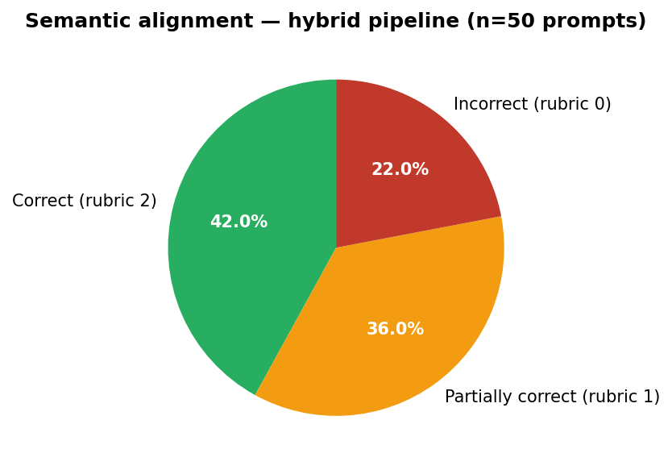
Figure 1. Semantic alignment (0–2 rubric) for hybrid pipeline outputs on n=50 curated prompts.
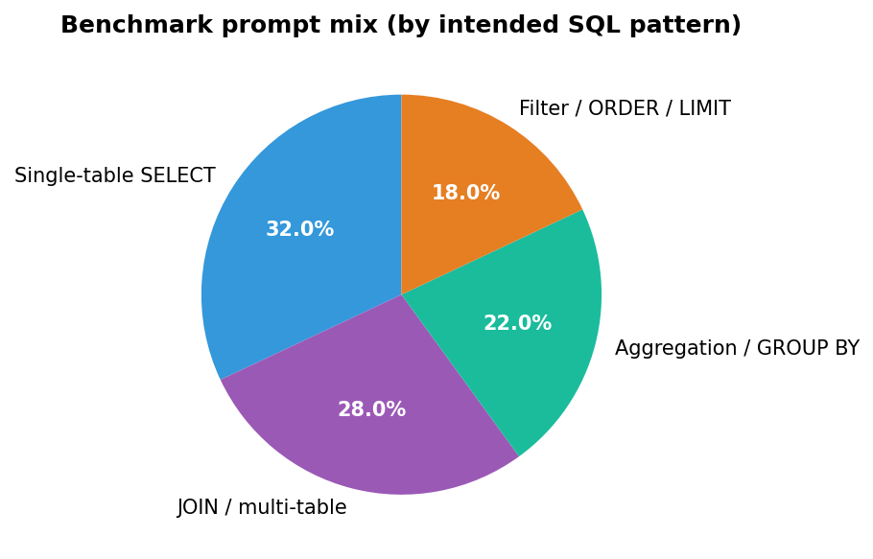
Figure 2. Composition of the evaluation benchmark by intended SQL pattern (percentages sum to 100%).

8. Limitations and Future Work
Local model quality varies by hardware and prompt; the system compensates with validation and fallbacks but complex multi-hop reasoning remains challenging. Future work: Spider subset import, stronger schema linking, separate lightweight “planner” model, user study with pre/post tests, and export of session transcripts for instructor review.

9. Conclusion
The project delivers a working, proposal-aligned prototype: full-stack, sandboxed, explanation-oriented, and extensible to user schemas. The evaluation framework—baseline vs. hybrid pipeline on curated prompts with validity, execution, and semantic rubrics—supports the claim that structured orchestration measurably improves reliability for educational use cases.

References (illustrative)
[1] Yu, T. et al. Spider: A large-scale human-labeled dataset for complex and cross-domain semantic parsing and text-to-SQL. EMNLP 2018.
[2] Sun, Y., Tang, B., Zhang, W. A survey of text-to-SQL in the era of large language models. arXiv:2408.05109, 2024.
[3] Mitrovic, A., Martin, B., Mayo, M. SQL-Tutor. IJAIED, 2002.

