Create a complete website design for any business/topic (like for any Education institute, IT company any, it’s upto your choice) with complete images and text description(dummy data)

**Home page**

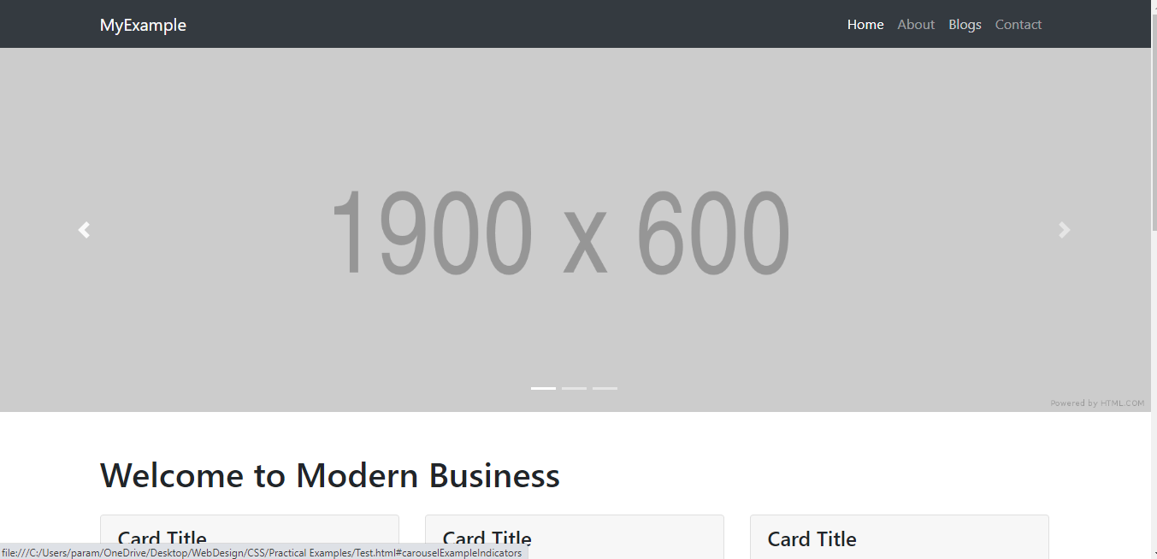

**Blog page (linked to your home page)**

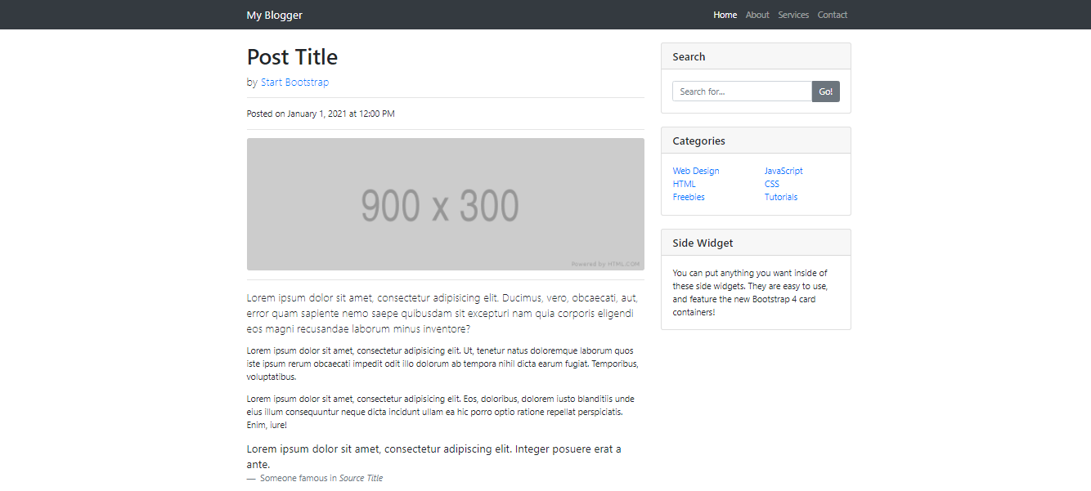

**About page**

It contains some information about you and your image(page layout will be any, it’s upto you), but it should be responsive with bootstrap

**Login Page**

Below layout will be in middle of the page with responsive design.

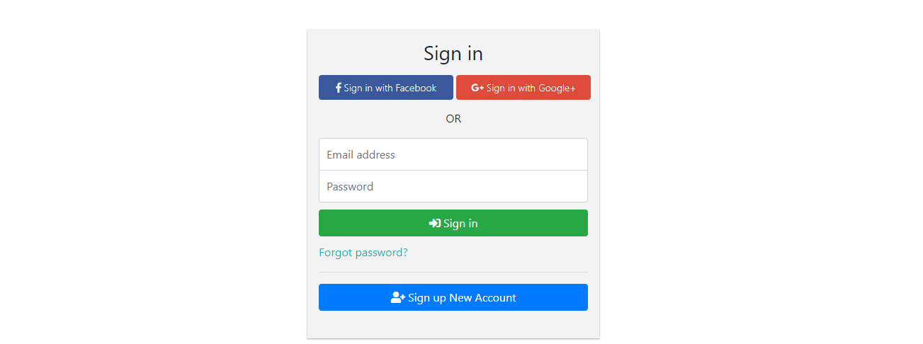

**Contact us page**

This page contains few form controls to take few information from user like name, email, phone number and submit button(page layout will be any, it’s upto you),but it should be responsive with bootstrap.

**Footer**

It will be same and consistent throughout in your application or same in all webpages, and it contains your social media account links/ or mention any dummy links in behind of these icons.

