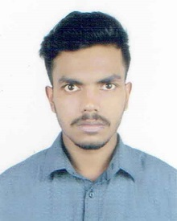**CURRICULUM VITAE OF**

**ALAUDDIN MOLLAH**

**Career Objective:** My objective is to build up a career, Which is not merely a means of living but rather a means of for making life meaningful and satisfying. I believe that my academic degree will provide me necessary knowledge to address challenging situations at my work place and in the process, will also help me to pursue a successful career.

**Personal Information:**

**Name** **: Alauddin Mollah**

Father’s Name : Md. Mosleh Uddin Mollah

Mother’s Name : Shaheen Akter

Present Address : Block- H, Lane- 2, House- 22, H/E, Halishahar,

Chittagong.

Permanent Address : Block- H, Lane- 2, House- 22, H/E, Halishahar,

Chittagong.

Date of Birth : 02/12/2001

Nationality : Bangladeshi by Birth.

Blood Group : A+

Sex : Male

Religion : Islam

Martial Statas : Unmarried

**Educational Qualification: : SSC Pass**

Passing Year : 2017

Subject : Science

GPA : 4.32

Board : Chittagong Board.

**HSC Pass**

Passing Year : 2019

Subject : Science

GPA : 3.75

Board : Chittagong Board.

**Computer Science Engineering**

Session : 1st

University : International Islamic

University, Chittagong .

**Contact**  : 01854-245617

**Computer Skills** : Microsoft Word, Excel, Graphics Design,

Internet Browsing, Digital Marketing.

**Strength :**

Honesty, Integrity, Punctuality, Hardworking, Patience, Interpersonal skill, Ability to work

under pressure Presentation ability.



**Signature:**