

**Green University of Bangladesh**

**Department of Computer Science and Engineering(CSE)**

**Faculty of Sciences and Engineering**

**Semester: (Spring, Year:2022), B.Sc. in CSE (Day)**

**Project Proposal**

**Course Title:**

**Database System Lab**

**Course Code: CSE 210 Section: DI**

**Project Name: _** Super Shop Management System**_**

**Student Details**

|  |  |  |
| --- | --- | --- |
| **Name** | | **ID** |
| **1.** | Shagor Kumar Das | 201002403 |

**Lab Date : _/ _ _ /_ _ _ _ _ _ _ _ _ _ __ _ _ _ _ _ _ _ _ _ _ _**

**Submission Date : __ _ /_ /_ _ _ _ _ _ _ _ _ _ _ _ _ _ _ _ _ _ _ _ _**

**Course Teacher’s Name : _ _ _ _ _Fatema Tuj Johora _ _ _ _ _ _ _ _ _ _ _**

**[For Teachers use only: Don’t Write Anything inside this box]**

|  |
| --- |
| **Lab Report Status**  **Marks: ………………………………… Signature:.....................**  **Comments:.............................................. Date:..............................** |

**Project Title:**

Super Shop Management System

**Introduction:**

Super shop is the active control program which allows the sales and purchases reelected activities.

Super shop management software helps create invoices, product category, purchase orders, receiving lists, and payment receipts and can print bar code labels. A Super shop management software system configured to our warehouse, retail or product line will help to create revenue for company. The Super shop Management will control operating costs and provide better understanding.

**Objective:**

The main objective of the super shop management system is to manage the details of stock, payments, sales, discounts and products. It manages all the information about stock, inventory and products. The product is totally build at the administrative end thus only the administrator is grunted access.

**Goal:**

The main aim of this type of software is to automate the existing manual system by the help of computerized equipment and software.

**Relational Schemas:**

|  |  |
| --- | --- |
| Entities | Attribute |
| Customer | Name, ID, NID, Address, Contact no |
| Employee | Name, ID, NID, Joining Date, Salary, Contact no, Address, designation |
| Product | Name, ID, type, company Name, Exp. Date, Mfg. date, Bar code, price |
| Receipt | Transaction no, Products name, Quantity, Cashier Name, Total Amount ,date, product id, customer id |
| Supplier | Supplier name, ID, Address, Contact no |
| Order List | Order ID, Order Date, Delivery Date, Supplier ID, Product ID |

**ER-Diagram:**

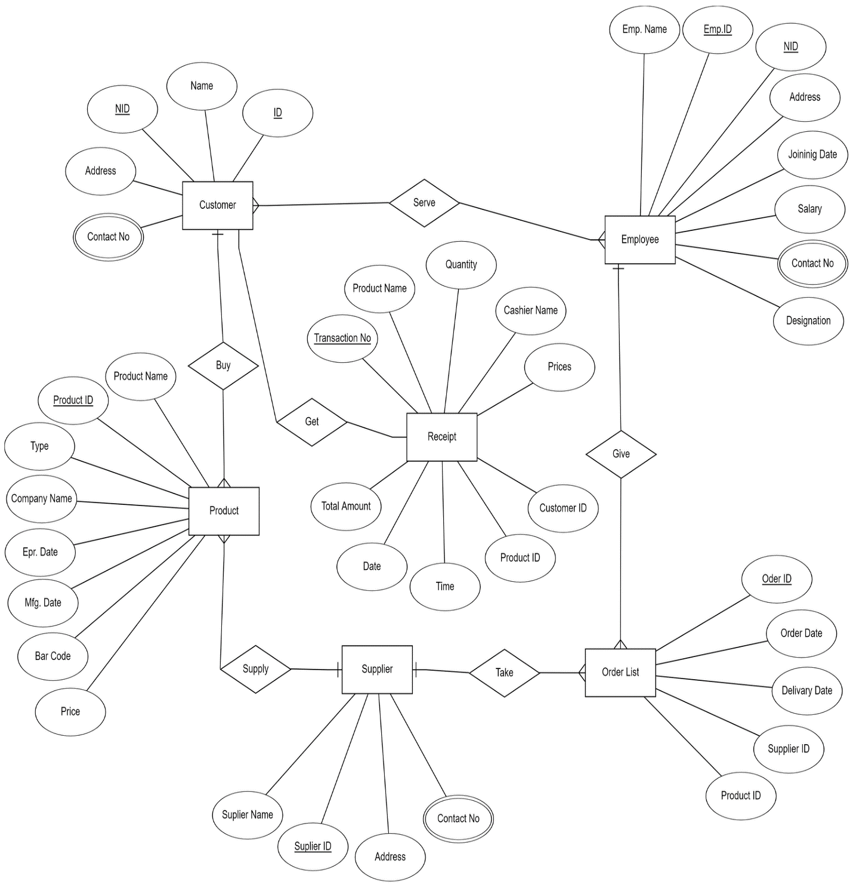

**Components:**

To complete this project I will used this type of tools. Here I provide the information and details about them.

1. **XAMPP:** An abbreviation for cross-platform, Apache, MySQL, PHP and Perl, and it allows you to build Word Press site offline, on a local web server on your computer.
2. **MySQL:** MySQL is an open-source relational database management system.
3. **Operating System:** Windows 10.