MySensor small PCB board MD-MS
Revision 1 — 16.04.2015

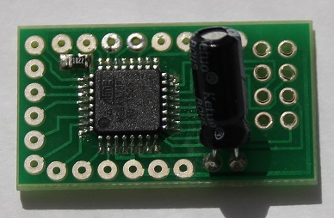

Components:
Chip ATMega328P QFP32
Capacitor 4,7mf
Resistor SMD 0805 10k

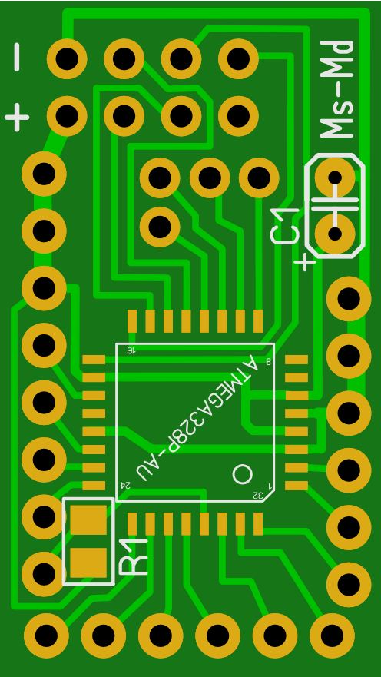
VCC
Gnd
Reset
A1
A0
A7
A6
A2
A3
A4/SDA
A5/SCL
RX
TX
D2
D3
D4
D5
D6
D7
D8

VCC
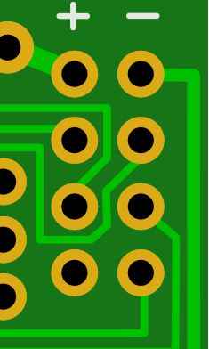
Gnd
CE
SCK
MISO
CSN
MOSI
IRQ

NRF24L01+ inserted into MD-MS after the firmware boot loader

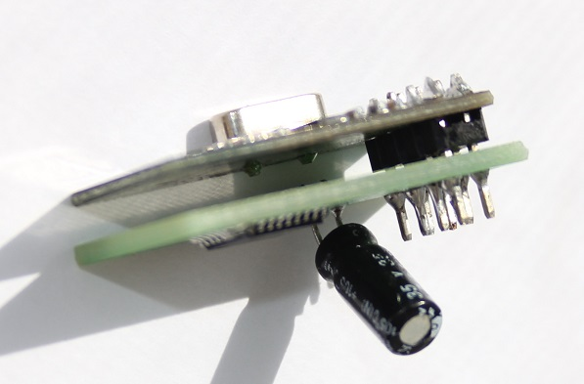

Assembly
- Solder processor
- Solder the resistor
- Write boot loader
- Solder the wires to the contacts D5-D8
- Solder the remaining wires (You can later, but uncomfortable)
- Solder NRF24L01+
- Solder the capacitor
- Write Sketch

Write boot can be after assembly, but there may be conflicts SPI NRF24L01+

If you do not cut the connectors NRF24L01 + then they can connect to flash

Warning For Reset working. Between the programmer and the board Reset must be 0.1uf capacitor

