player (player_id, pname,speciality,date_of joining,num_matches,team_id)

team(team_id, tname,player_num)
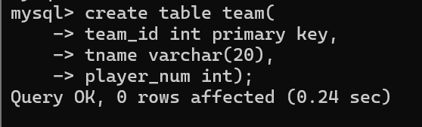
matches(match_id, team1,team2,match_date,winner,man_of_the match)
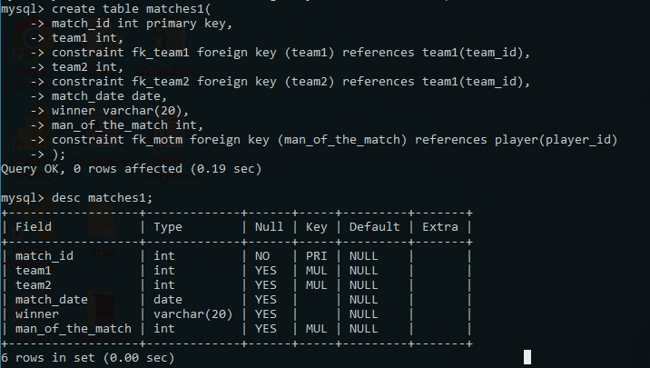

simple query
1. display all players playerid, player name and experience

2. display all player with experience > 5 years

3. display all players joined in march month, any year

4. display all players joined in march 1995

5. display all player with number of matches played are either 5 or 10
or 8

6. display all employees who are either batsman, bowler

7. display all employees who joined in year 1995 or 1996 or 1997

Nested query
1. list all player who plays in virat kohalis team
2. list all players who played matches in year 2024
3. list all matches in which man of the match is from team1
4. list all matches in which man of the match is from team1
5. list all matches in which csk team win.
6. list all matches in which either csk or rcb team won the match
7. list all teams who one atleast one match
8. list all teams who does not played any match
9. list all team name, in which no players are their
10. list all players who are in dhoni’s team
11. list all players who are in either dhoni’s or virat’s team
12. find all team names who one more than 3 matches
create following tables.
Table: Movies
Id Title Director Year Length_minutes Release date
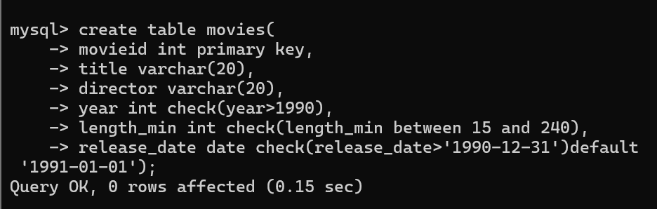

1 Toy Story John Lasseter 1995 81

2 A Bug's Life John Lasseter 1998 95

3 Toy Story 2 John Lasseter 1999 93

4 Monsters, Inc. Pete Docter 2001 92

5 Finding Nemo Andrew Stanton 2003 107

6 The Incredibles Brad Bird 2004 116

movieid is primary key
year >1970
length_minutes>15 min and < 240 mins
Release_date >1990-12-31 default ‘1991-01-01’
create table movie(movieid int primary key,
title varchar(20),
director varchar(20),
year int chek(year>1990),
length_min int check(length_min between 15 and 240)
release_date date check(release_date>’1990-12-31’) default ‘1991-01-01’)
insert into movie values(1,'Toy story','John Lasseter',1995,81,'1995-03-02'); insert into movie values(2,'A Bugs Life','John Lasseter',1998,95,'1998-03-02');
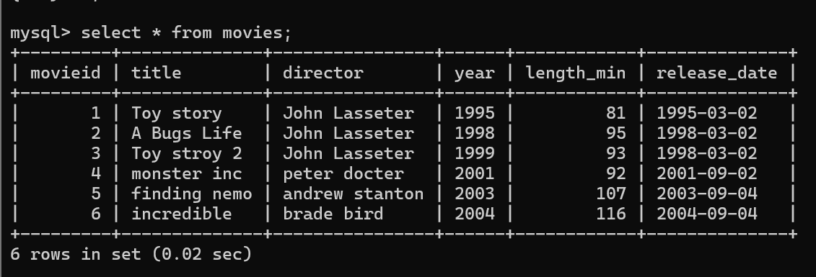
Table: Boxoffice
Movie_id Rating Domestic_sales International_sales
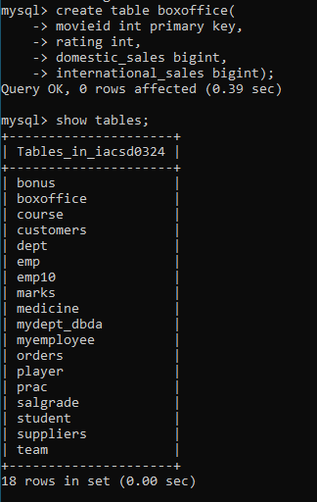
5 8.2 380843261 555900000
14 7.4 268492764 475066843
8 8 206445654 417277164
12 6.4 191452396 368400000

3 7.9 245852179 239163000
6 8 261441092 370001000


