CHAPTER 1
INTRODUCTION
1.1 Project Overview
This project applies statistical analysis and machine learning to classify breast tumour samples as benign or malignant using numerical measurements from the Breast Cancer Wisconsin (Diagnostic) dataset. It studies LDA, logistic regression, and methods for handling class imbalance.
1.2 Problem Statement
When benign samples greatly outnumber malignant samples, a model may favour the majority class and miss malignant cases. This project compares classification models and imbalance strategies to improve malignant detection while monitoring false positives.
1.3 Objectives
- Analyse the breast cancer diagnostic dataset.
- Create an artificially imbalanced dataset with about 10% malignant samples.
- Explore feature distributions, correlations, and multicollinearity.
- Apply VIF-based feature reduction.
- Compare LDA and logistic regression.
- Study equal class priors, class weighting, and threshold tuning.
- Evaluate accuracy, precision, recall, F1-score, and confusion matrices.
1.4 Scope of the Project
The project covers data preparation, exploratory analysis, feature selection, model training, and evaluation. It is an academic experiment using an artificially imbalanced dataset and is not intended for clinical diagnosis.

CHAPTER 2
DATASET DESCRIPTION
2.1 Dataset Source
The project uses the Breast Cancer Wisconsin (Diagnostic) dataset, available from the UCI Machine Learning Repository and scikit-learn. It contains measurements derived from digitized images of breast mass samples.
Source: https://doi.org/10.24432/C5DW2W
2.2 Dataset Description and Features
The original dataset contains 569 observations and 30 numerical features. Ten characteristics—radius, texture, perimeter, area, smoothness, compactness, concavity, concave points, symmetry, and fractal dimension—are recorded as mean, standard error, and worst values.
Parameter | Description
Original observations | 569
Predictor features | 30
Original benign samples | 357
Original malignant samples | 212
Samples retained for project | 357 benign + 40 malignant
Final dataset | 397 observations
Malignant proportion | Approximately 10.1%

2.3 Target and Predictor Variables
The target represents diagnosis: in scikit-learn, 0 means malignant and 1 means benign. The predictors are the 30 numerical measurements. The project retains all 357 benign samples and randomly selects 40 malignant samples to create an artificially imbalanced dataset.

CHAPTER 3
EXPLORATORY DATA ANALYSIS (EDA)
3.1 Data Loading and Inspection
The dataset is loaded, and its dimensions, feature names, data types, target distribution, missing values, and numerical ranges are inspected. The processed imbalanced dataset is saved as a CSV file.
3.2 Data Cleaning and Preprocessing
The data is split into training and testing subsets using stratification. StandardScaler is fitted on training data only and applied to both subsets. VIF analysis reduces the predictor set from 30 to 13 features for reduced-feature model comparison.
3.3 Descriptive Statistics
Mean, standard deviation, minimum, maximum, and quartiles summarize the features. These statistics help identify scale differences, variability, and unusual values. Use the actual output from the final program for numerical summaries.
3.4 Measures of Central Tendency and Variability
Mean and median describe central values; variance and standard deviation measure spread; and the interquartile range (Q3 − Q1) describes the middle 50% of observations.
3.5 Univariate Analysis
Histograms and box plots are used to inspect individual features. The class distribution confirms 357 benign and 40 malignant observations in the imbalanced dataset.
3.6 Bivariate Analysis
Correlation analysis examines relationships between pairs of features. Size-related measurements such as radius, perimeter, and area are strongly related and may contain overlapping information.
3.7 Data Visualization
The project uses a class-distribution chart, correlation heatmap, and feature plots to present data patterns. Insert the actual figures from the results folder with captions.
CHAPTER 4
STATISTICAL ANALYSIS AND METHODOLOGY
4.1 Statistical Techniques Used
Descriptive statistics summarize the data; covariance and correlation examine feature relationships; VIF assesses multicollinearity; LDA and logistic regression classify samples; and a binomial GLM supports coefficient interpretation.
Covariance, Correlation and VIF
Covariance measures joint variation. Correlation describes the direction and strength of a linear relationship, ranging from −1 to +1. VIF = 1/(1 − R²) measures how strongly a feature is explained by other predictors. Features with high VIF are removed iteratively using the project's threshold.
LDA and Logistic Regression
LDA seeks a linear projection that separates classes and uses class priors in its decisions. Logistic regression estimates the probability of a binary outcome. A binomial GLM is used to examine selected coefficients, odds ratios, confidence intervals, and p-values.
4.2 Hypothesis Testing and Statistical Interpretation
For a model coefficient, the null hypothesis is that the coefficient equals zero. A p-value below 0.05 is commonly treated as evidence against the null hypothesis. Odds ratios are calculated as exp(coefficient). Interpretation depends on target encoding and describes association, not causation.
  - Methodology and Workflow
- Load and inspect the dataset.
- Create the imbalanced sample.
- Split into training and testing data.
- Scale features using training data only.
- Perform EDA and correlation analysis.
- Reduce multicollinearity using VIF.
- Train LDA and logistic regression variants.
- Apply imbalance strategies and tune thresholds.
- Evaluate models and save tables and graphs.
4.4 Train-Test Split
The project uses an 80:20 stratified split: 317 training observations and 80 testing observations. The hold-out set contains 72 benign and 8 malignant samples. Five-fold stratified cross-validation repeated ten times provides 50 fold evaluations.

CHAPTER 5
MACHINE LEARNING MODEL DEVELOPMENT
5.1 Algorithm Selection
Four configurations are compared: LDA with default priors, LDA with equal priors, logistic regression, and class-weighted logistic regression. They show how prior probabilities and class weights affect classification.
5.2 Algorithm Description
LDA separates classes using discriminant scores. Logistic regression estimates the probability of a binary outcome. Class weighting gives more influence to the minority class during training. Threshold tuning changes the probability required to predict malignancy.
5.3 Model Implementation
Python libraries include NumPy, pandas, Matplotlib, Seaborn, scikit-learn, and statsmodels. The main program, main.py, performs data preparation, feature selection, model training, evaluation, threshold tuning, and GLM analysis.
5.4 Model Training and Prediction
Models are trained on standardized training data and evaluated using cross-validation and the separate hold-out set. Predicted labels are compared with actual labels to calculate accuracy, precision, malignant recall, F1-score, and confusion matrices.

CHAPTER 6
RESULTS AND DISCUSSION
6.1 Experimental Results
The project compares cross-validation results on the reduced 13-feature dataset and results on the 80-observation hold-out set. Because only eight hold-out observations are malignant, recall is sensitive to individual predictions.
Model | CV Accuracy | CV Precision | CV Malignant Recall | CV F1
LDA (default priors) | 98.0% | 99.8% | 80.5% | 88.6%
LDA (equal priors) | 98.4% | 95.2% | 88.8% | 91.5%
Logistic regression | 98.9% | 99.3% | 89.5% | 93.7%
Class-weighted logistic regression | 97.6% | 85.4% | 95.0% | 89.3%

Verify these supplied values against the final model_comparison_cv.csv before submission.
6.2 Model Evaluation Metrics
Accuracy measures all correct predictions; precision measures how many predicted malignant cases are truly malignant; recall measures how many actual malignant cases are detected; and F1-score combines precision and recall. A confusion matrix shows true positives, true negatives, false positives, and false negatives.

6.3 Result Visualization
1. Correlation Heatmap
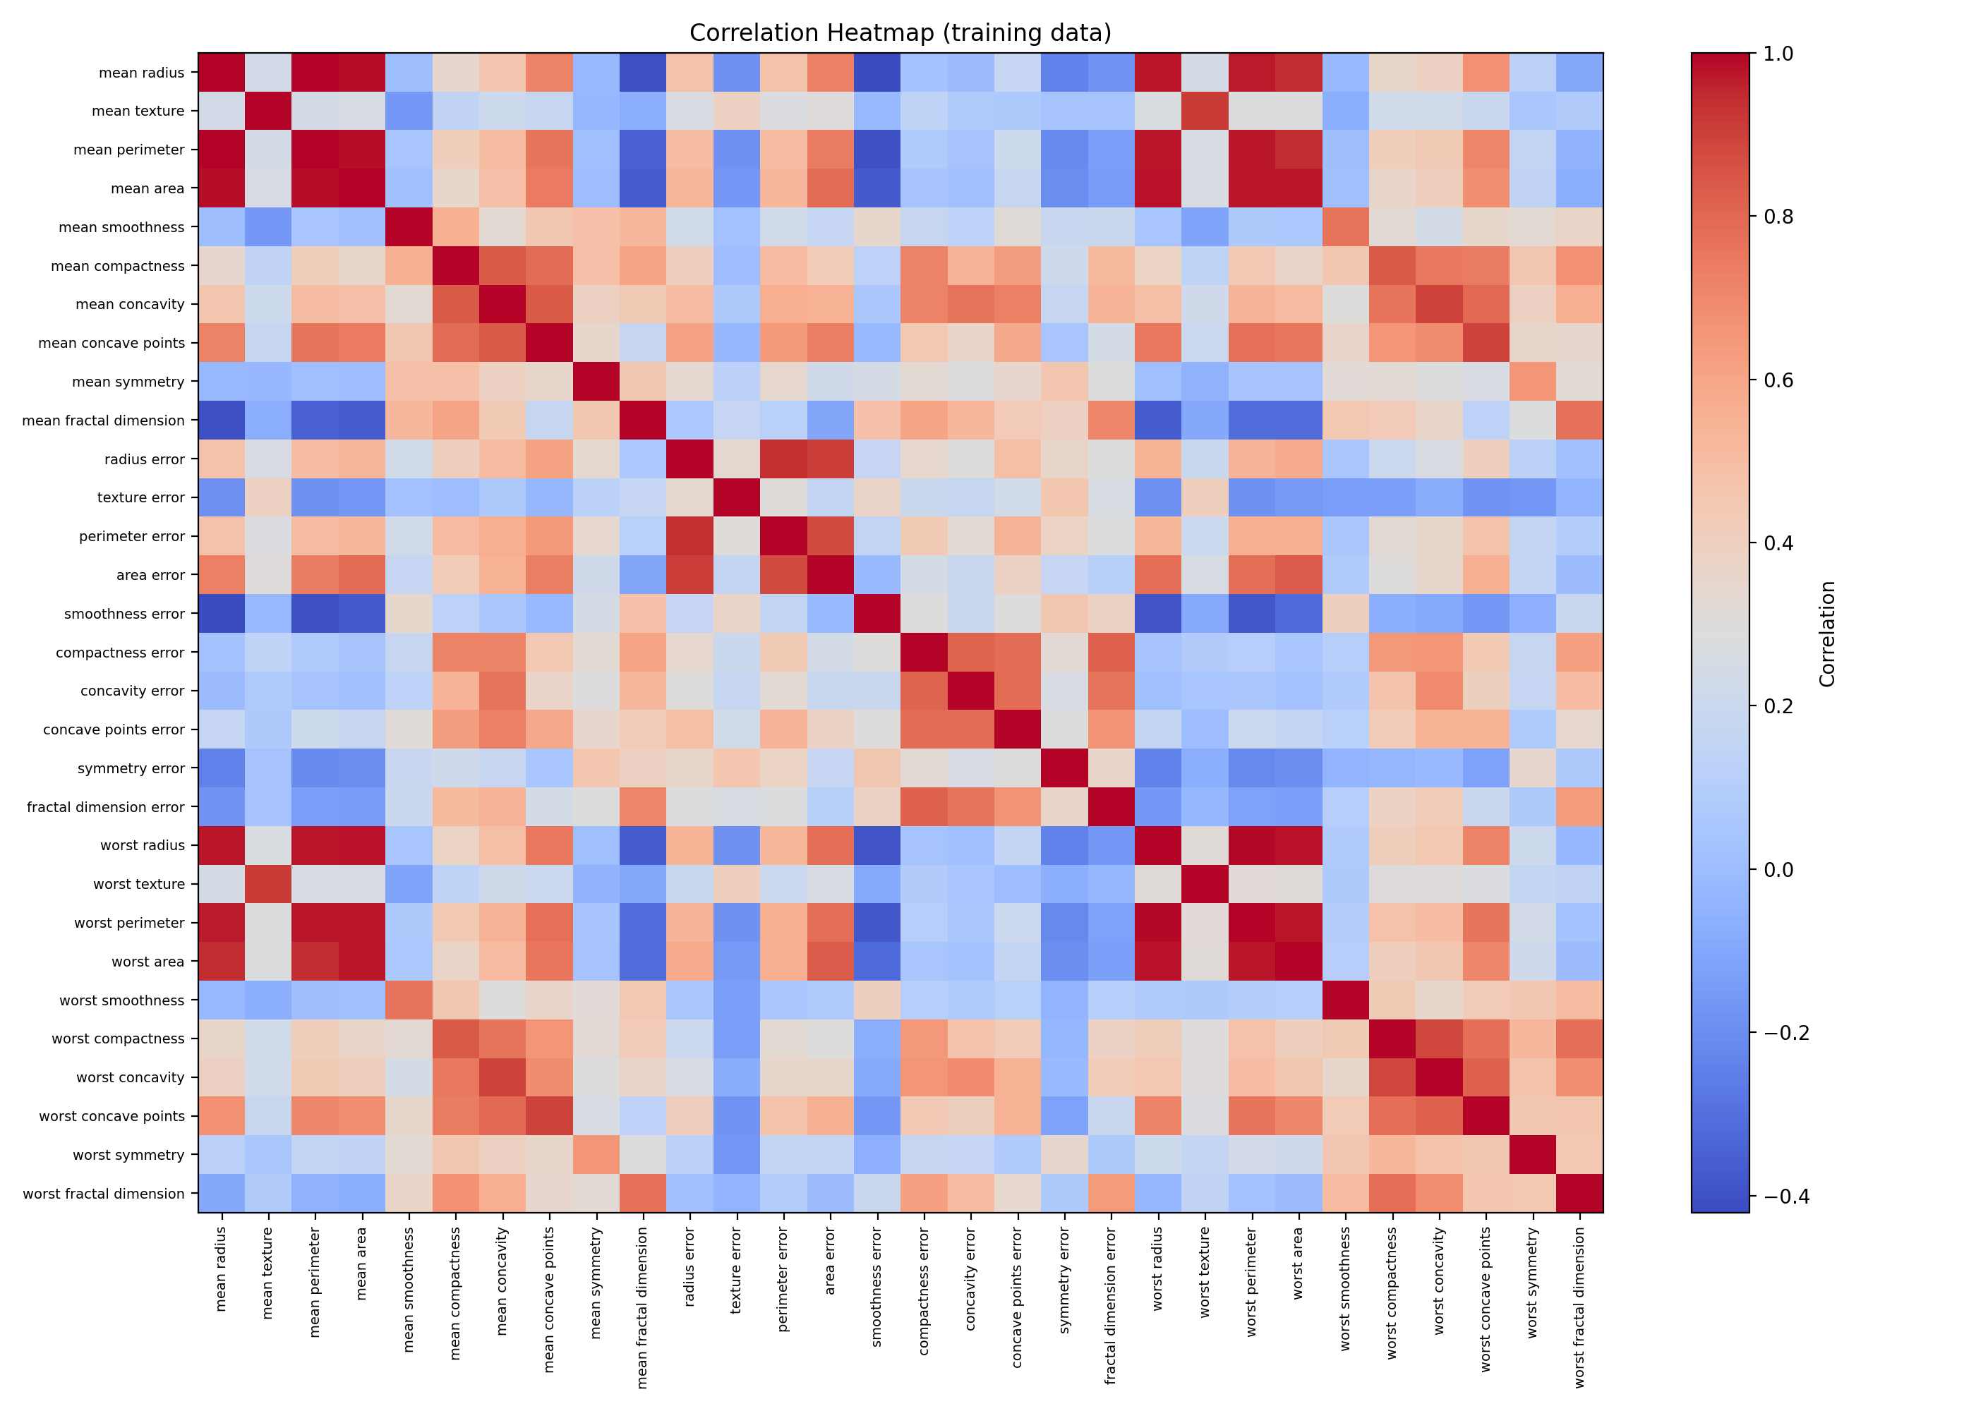
The heatmap displays correlations among the dataset features and helps identify highly correlated variables.
2. LDA Class Separation
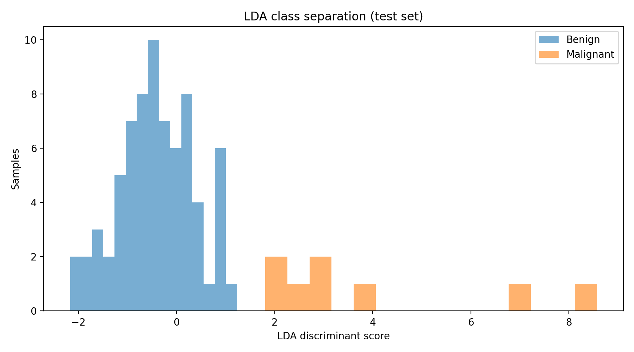
The histogram shows the distribution of discriminant scores for benign and malignant samples.

3. LDA Confusion Matrix

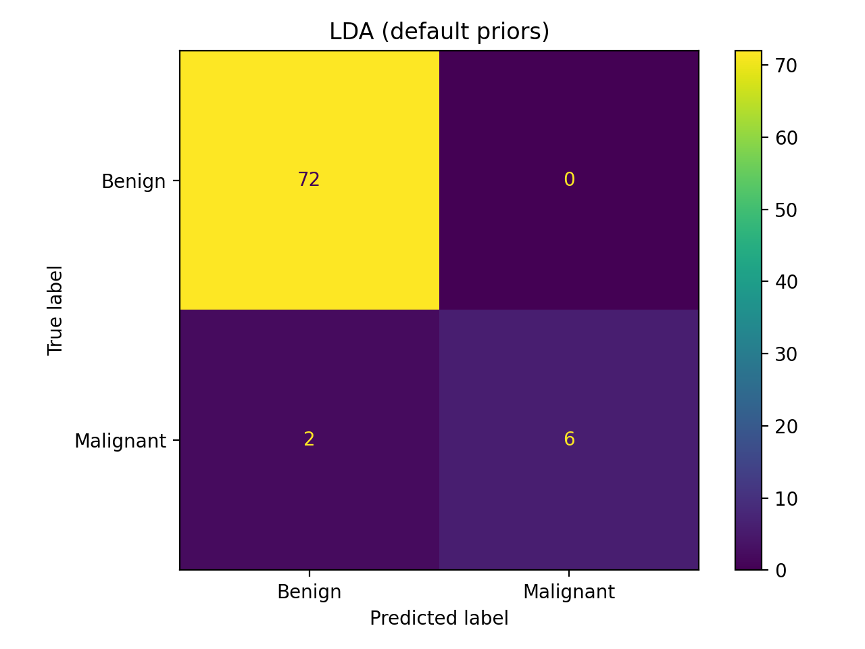
The confusion matrix summarizes the benign and malignant samples correctly and incorrectly classified by LDA.
4. Model Comparison
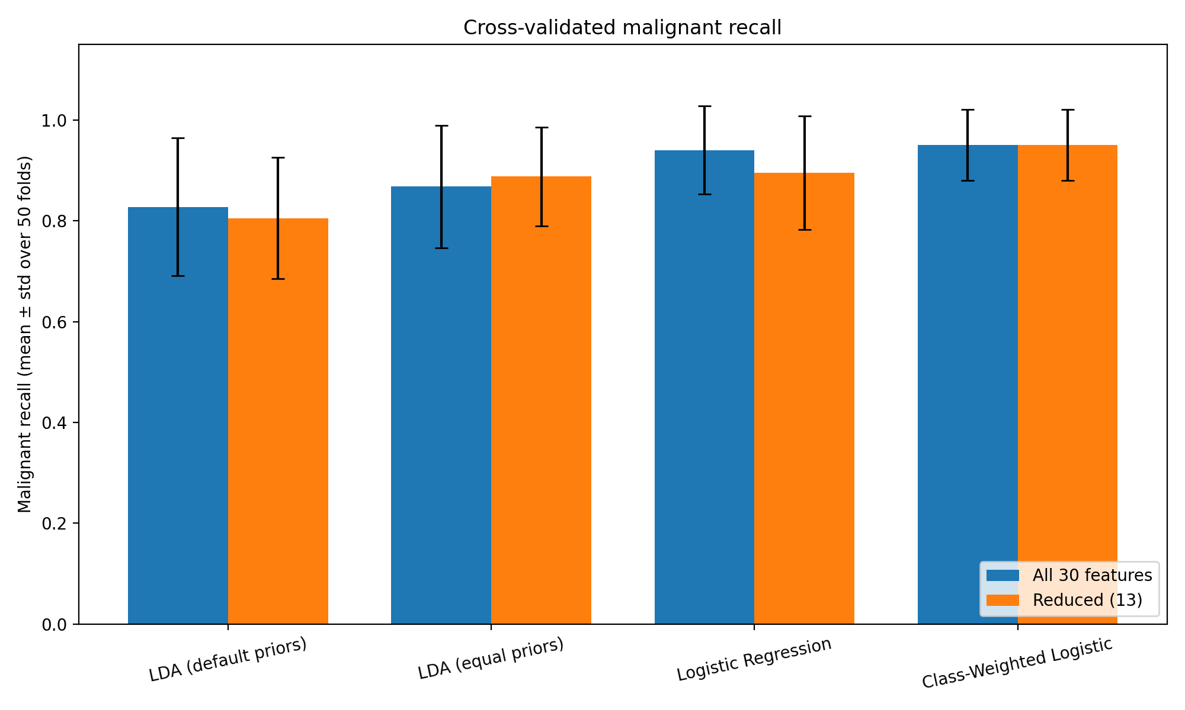
The chart compares malignant-case recall across models using repeated stratified cross-validation.

6.4 Performance Comparison
Model | Accuracy | Precision | Malignant Recall | F1-score
LDA (default priors) | 97.5% | 100% | 75.0% | 85.7%
LDA (equal priors) | 98.75% | 100% | 87.5% | 93.3%
Logistic regression | 100% | 100% | 100% | 100%
Class-weighted logistic regression | 97.5% | 80% | 100% | 88.9%

These hold-out results must be verified against model_comparison_holdout.csv. Perfect performance on one small test split does not guarantee performance on new data.
6.5 Interpretation of Results
- Accuracy alone can hide missed malignant cases.
- Equal priors improved LDA malignant recall in the supplied comparison.
- Class weighting produced the highest cross-validated malignant recall, with lower precision.
- Lower thresholds may increase recall but can also increase false positives.
- VIF-based reduction helps manage multicollinearity.
- External validation is required before real-world medical use.

CHAPTER 7
CONCLUSION AND FUTURE SCOPE
7.1 Conclusion
The project demonstrates a statistical machine learning workflow for classifying benign and malignant samples using LDA, logistic regression, feature selection, and imbalance-handling strategies. Results show why malignant recall should be considered alongside accuracy. The work is educational and does not establish clinical diagnostic performance.
7.2 Limitations
- The class imbalance is created artificially.
- The dataset is small, with only 40 malignant samples in the final dataset.
- Only eight malignant samples appear in the hold-out test.
- Model performance may not generalize to independent datasets.
- Feature reduction may remove useful information.
- The system has not been clinically validated.
7.3 Future Enhancements
- Test larger and independent datasets.
- Compare additional classifiers and imbalance strategies.
- Use robust validation and confidence intervals.
- Choose thresholds using validation data.
- Improve model explanation and probability calibration.
- Seek expert clinical validation before considering real-world use.

REFERENCES / BIBLIOGRAPHY

- UCI Machine Learning Repository. Breast Cancer Wisconsin (Diagnostic) Dataset. https://doi.org/10.24432/C5DW2W
- Scikit-learn Developers. load_breast_cancer documentation. https://scikit-learn.org/stable/modules/generated/sklearn.datasets.load_breast_cancer.html
- Scikit-learn Developers. Linear and Quadratic Discriminant Analysis. https://scikit-learn.org/stable/modules/lda_qda.html
- Scikit-learn Developers. Logistic Regression. https://scikit-learn.org/stable/modules/linear_model.html#logistic-regression
- Scikit-learn Developers. Model Evaluation. https://scikit-learn.org/stable/modules/model_evaluation.html
- Statsmodels Documentation. https://www.statsmodels.org/
- NumPy Documentation. https://numpy.org/doc/
- pandas Documentation. https://pandas.pydata.org/docs/

APPENDIX A
SOURCE CODE
The following snippet illustrates the main workflow: loading the Wisconsin dataset, creating an imbalanced dataset, training a class-weighted logistic regression model, and evaluating its predictions. The complete implementation is provided in main.py.
import pandas as pd
from sklearn.datasets import load_breast_cancer
from sklearn.model_selection import train_test_split
from sklearn.pipeline import make_pipeline
from sklearn.preprocessing import StandardScaler
from sklearn.linear_model import LogisticRegression
from sklearn.metrics import accuracy_score, classification_report, confusion_matrix
# Load dataset and label malignant cases as 1
raw = load_breast_cancer(as_frame=True)
df = raw.data.copy()
df["malignant"] = (raw.target == 0).astype(int)
# Create an imbalanced dataset: all benign + 40 malignant samples
malignant = df[df["malignant"] == 1].sample(n=40, random_state=42)
benign = df[df["malignant"] == 0]
data = pd.concat([benign, malignant]).sample(frac=1, random_state=42)
X = data.drop(columns="malignant")
y = data["malignant"]
X_train, X_test, y_train, y_test = train_test_split(
X, y, test_size=0.20, stratify=y, random_state=42
)
# Train model and evaluate malignant-case detection
model = make_pipeline(
StandardScaler(),
LogisticRegression(class_weight="balanced", max_iter=2000, random_state=42)
)
model.fit(X_train, y_train)
predictions = model.predict(X_test)
print("Accuracy:", accuracy_score(y_test, predictions))
print("Confusion Matrix:\n", confusion_matrix(y_test, predictions))
print(classification_report(y_test, predictions,
target_names=["Benign", "Malignant"]))

APPENDIX B
ADDITIONAL RESULTS AND OUTPUTS
This appendix presents selected output figures generated by the Early Breast Cancer Detection system. The figures illustrate feature correlation, class separation, classification performance, and comparison of the models.
B.1 Correlation Heatmap
The heatmap displays correlations among the dataset features and helps identify highly correlated variables.
B.2 LDA Class Separation
The histogram shows the distribution of discriminant scores for benign and malignant samples.

B.3 LDA Confusion Matrix
The confusion matrix summarizes the benign and malignant samples correctly and incorrectly classified by LDA.
B.4 Model Comparison
The chart compares malignant-case recall across models using repeated stratified cross-validation.

