BASAVARAJESWARI GROUP OF INSTITUTIONS
BALLARI INSTITUTE OF TECHNOLOGY & MANAGEMENT
 | NACC Accredited Institution*  (Recognized by Govt. of Karnataka, approved by AICTE, New Delhi & Affiliated to Visvesvaraya Technological University, Belagavi)  “JnanaGangotri” Campus, No.873/2, Ballari-Hospet Road, Allipur,  Ballari-583 104 (Karnataka) (India)  Ph: 08392 – 237100 / 237190, Fax: 08392 – 237197 | 

DEPARTMENT OF CSE (DATA SCIENCE)
A Mini-Project Report On
“Handwritten Digit Recognition Using Convolutional Neural Networks”
A report submitted in partial fulfilment of the requirements for the
NEURAL NETWORKS AND DEEP LEARNING
Submitted By
SHAGUFTHA NIKHAR | 3BR23CD087

Under the Guidance of
Ms Chaitra BM
Assistant Professor
Dept of CSE(DS)


Visvesvaraya Technological University
Belagavi, Karnataka 2026-2027

BASAVARAJESWARI GROUP OF INSTITUTIONS
BALLARI INSTITUTE OF TECHNOLOGY & MANAGEMENT
NACC Accredited Institution*
(Recognized by Govt. of Karnataka, approved by AICTE, New Delhi & Affiliated to Visvesvaraya Technological University, Belagavi)
“JnanaGangotri” Campus, No.873/2, Ballari-Hospet Road, Allipur,
Ballari-583 104 (Karnataka) (India)
Ph: 08392 – 237100 / 237190, Fax: 08392 – 237197

DEPARTMENT OF CSE (DATA SCIENCE)
CERTIFICATE
This is to certify that the MINI-PROJECT of NEURAL NETWORKS AND DEEP LEARNING title “Handwritten Digit Recognition Using Convolutional Neural Networks” has been successfully presented by Shaguftha Nikhar bearing USN: 3BR23CD087 a student of semester B.E for the partial fulfilment of the requirements for the award of Bachelor Degree in CSE(DS) of the BALLARI INSTITUTE OF TECHNOLOGY & MANAGEMENT, BALLARI during the academic year 2026-2027.

Signature of guide | Signature of HOD
Ms. Chaitra BM | Dr. Aradhana D

TABLE OF CONTENTS

Sl. No. | Topic | Page No
 | Certificate | i
 | Abstract | ii
1 | Introduction | 4
2 | Dataset Description and System Requirements | 6
3 | Data Preparation and System Architecture | 8
4 | Model Development and Methodology | 10
5 | Implementation, Results and Discussion | 12
6 | Conclusion and Future Scope | 15
 | References | 16

ABSTRACT
DigitAI Studio is an interactive deep-learning application developed to recognize handwritten digits using neural network techniques. The project demonstrates the practical application of Neural Networks and Deep Learning (NNDL) in image classification. It uses the MNIST dataset, which contains grayscale images of handwritten digits from 0 to 9.
The project uses Python and TensorFlow/Keras to develop neural-network models. A Convolutional Neural Network (CNN) learns spatial features such as edges, curves, and shapes. A Multilayer Perceptron (MLP) provides a comparison with a fully connected neural-network approach. The application interface is developed using Streamlit.
DigitAI Studio includes interactive features such as Draw & Predict, Beat the AI, Analytics Lab, and CNN Explorer, as implemented in the project. Users can draw a digit and obtain a prediction, explore model performance, and learn about the image-classification process. The project covers data preprocessing, model training, evaluation, visualization, and application integration.
The project provides practical experience with deep learning, image classification, model evaluation, and interactive application development. Actual performance values should be reported from the model's recorded evaluation output.
Keywords: Neural Networks, Deep Learning, CNN, MLP, MNIST, Image Classification, TensorFlow, Keras, Streamlit.

CHAPTER 1
INTRODUCTION

1.1 PROJECT OVERVIEW
Neural Networks and Deep Learning are important areas of artificial intelligence that allow computers to learn patterns from data. Deep learning is widely used in image recognition, speech processing, language understanding, and other complex tasks.
Handwritten digit recognition is an image-classification problem in which a computer identifies a digit from an image. DigitAI Studio demonstrates this task using the MNIST dataset and neural-network models. The application combines model development with an interactive interface so users can test predictions and explore how a trained model behaves.

1.2 PROBLEM STATEMENT
Handwritten digits vary in shape, size, thickness, alignment, and writing style. Some digits also have similar visual patterns. The project aims to build a deep-learning system that processes a handwritten digit image and predicts one of ten classes, from 0 to 9, while providing an accessible interface for experimentation.

1.3 OBJECTIVES
- Understand the fundamentals of neural networks and deep learning.
- Use the MNIST dataset for handwritten digit classification.
- Preprocess grayscale images into a consistent numerical representation.
- Implement a CNN and an MLP for classification and comparison.
- Train and evaluate the models using appropriate metrics.
- Build an interactive Streamlit application for predictions and visualization.
- Demonstrate model behaviour through interactive features.

1.4 SCOPE
The project focuses on isolated handwritten digits represented as images. It covers preprocessing, model training, evaluation, and interactive prediction. It does not aim to recognize complete words, sentences, or arbitrary scanned documents. Performance depends on the model, preprocessing, and similarity between input images and the training data.

CHAPTER 2
DATASET DESCRIPTION AND SYSTEM REQUIREMENTS

2.1 DATASET DESCRIPTION
The project uses the MNIST handwritten digit dataset, a standard benchmark for image classification. It contains 70,000 grayscale images of handwritten digits, divided into 60,000 training images and 10,000 test images. Each image has a resolution of 28 × 28 pixels and is labelled with a digit from 0 to 9.
Property | Description
Dataset | MNIST
Total images | 70,000
Training images | 60,000
Test images | 10,000
Image dimensions | 28 × 28 pixels
Image type | Grayscale
Number of classes | 10 (digits 0–9)

2.2 HARDWARE REQUIREMENTS
Component | Requirement
Processor | Modern Intel or AMD processor
RAM | 8 GB recommended
Storage | Sufficient space for libraries, data and model files
Graphics | CPU supported; compatible GPU optional
Display | Standard monitor or laptop display

2.3 SOFTWARE REQUIREMENTS
Software | Purpose
Python | Main programming language
TensorFlow/Keras | Neural-network implementation and training
Streamlit | Interactive application interface
NumPy | Array operations and numerical processing
Matplotlib | Visualization of images and training results
Scikit-learn | Metrics and evaluation utilities, where used
Pillow | Image processing, where used

2.4 FUNCTIONAL REQUIREMENTS
- Load and preprocess the dataset.
- Train or load trained neural-network models.
- Accept a handwritten digit image as input.
- Predict one of the ten digit classes.
- Display prediction results and supported confidence information.
- Show model evaluation and visualization outputs.
- Provide navigation among the implemented application features.

2.5 NON-FUNCTIONAL REQUIREMENTS
Usability: the interface should be easy to navigate. Performance: predictions should be produced within a reasonable time. Reliability: valid inputs should be processed consistently. Maintainability: preprocessing, models, and interface code should be organized for updates. Reproducibility: model settings and evaluation results should be documented.

CHAPTER 3
DATA PREPARATION AND SYSTEM ARCHITECTURE

3.1 DATA PREPROCESSING
The MNIST images are prepared before being supplied to the models. Pixel intensities range from 0 to 255 and are normalized by dividing each pixel value by 255, converting the values to the range 0 to 1.
x_normalized = x / 255
For the CNN, each image is represented with height, width, and a grayscale channel, giving an input shape of 28 × 28 × 1. For the MLP, the image is flattened into a vector of 784 pixel values. Labels identify the correct digit class.

3.2 SYSTEM ARCHITECTURE
Input Image → Preprocessing → Trained Model → Predicted Digit → Results Display
During training, the model learns parameters from labelled images. During prediction, an input image is transformed into the expected format and passed to the trained model. The model generates scores for the ten digit classes and the highest-scoring class is selected as the prediction.

3.3 MAJOR SYSTEM COMPONENTS
- Dataset module: loads the MNIST images and labels.
- Preprocessing module: normalizes and reshapes image data.
- Model module: contains the CNN and MLP architectures.
- Training module: fits the models using labelled images.
- Evaluation module: calculates metrics and generates visualizations.
- Prediction module: processes user input and obtains a predicted digit.
- Interface module: provides the Streamlit application and interactive features.

3.4 DATA FLOW
The data flow begins with loading the dataset, followed by normalization and reshaping. The processed images are used to train the models. After evaluation, the trained model is made available to the Streamlit application. User-drawn or supplied images pass through compatible preprocessing before inference, and the result is displayed to the user.

CHAPTER 4
MODEL DEVELOPMENT AND METHODOLOGY

4.1 METHODOLOGY
The project follows a structured workflow: dataset loading, data preprocessing, model construction, model training, performance evaluation, visualization, and integration into the interactive application. The same test data should be used consistently when comparing models.

4.2 CONVOLUTIONAL NEURAL NETWORK
A Convolutional Neural Network (CNN) is designed to process grid-like data such as images. Convolutional filters learn local visual patterns, including edges and curves. Pooling reduces the spatial dimensions of feature maps, while dense layers combine extracted features to classify the image.
- Convolution layer: extracts local features using learnable filters.
- ReLU activation: introduces non-linearity using f(x) = max(0, x).
- Pooling layer: reduces feature-map dimensions.
- Flatten layer: converts feature maps into a vector.
- Dense layer: combines features for classification.
- Output layer: produces scores for the ten digit classes.

4.3 MULTILAYER PERCEPTRON
A Multilayer Perceptron (MLP) is a feed-forward neural network with an input layer, one or more hidden layers, and an output layer. In this project, the 28 × 28 image is flattened into 784 values. Dense layers learn relationships between these values and produce a prediction for one of the ten classes.

4.4 MODEL TRAINING
During training, model predictions are compared with the true labels using a loss function. An optimizer updates the model parameters to reduce the loss. Training proceeds over batches and epochs, and training or validation metrics can be monitored to assess learning.
For ten-class classification, categorical cross-entropy or sparse categorical cross-entropy can be used depending on how labels are represented. The exact optimizer, number of epochs, batch size, and architecture should be documented from the implemented code.

4.5 MODEL EVALUATION
The models are evaluated on test images that were not used to fit the model parameters. Accuracy measures the fraction of correct predictions. Precision, recall, and F1-score provide additional information about classification behaviour, while a confusion matrix shows which digits are confused with one another.

4.6 APPLICATION FEATURES
- Draw & Predict: lets a user draw a digit and obtain a model prediction.
- Beat the AI: provides an interactive activity to compare user responses with the model.
- Analytics Lab: presents available model metrics and visualizations.
- CNN Explorer: introduces CNN concepts and the image-processing pipeline.

CHAPTER 5
IMPLEMENTATION, RESULTS AND DISCUSSION

5.1 IMPLEMENTATION OVERVIEW
The implementation combines Python-based data processing, TensorFlow/Keras model development, and a Streamlit interface. The dataset is loaded and preprocessed, CNN and MLP models are trained and evaluated, and the selected trained model is used for interactive prediction.

5.2 CNN AND MLP IMPLEMENTATION
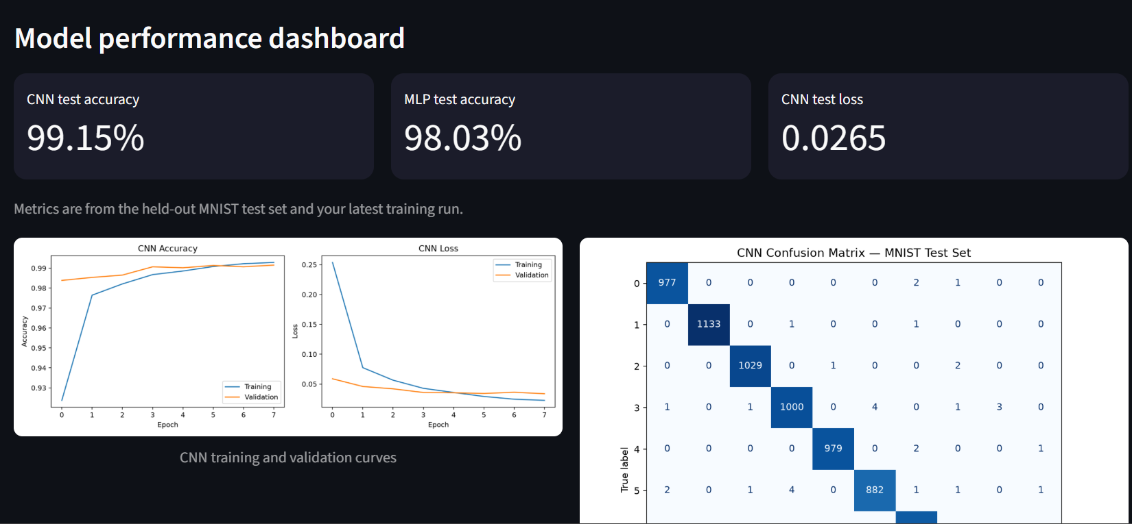
The CNN uses convolutional operations to learn image features, followed by classification layers. The MLP receives flattened pixel values and processes them through fully connected layers. Both approaches classify images into the ten MNIST digit categories.
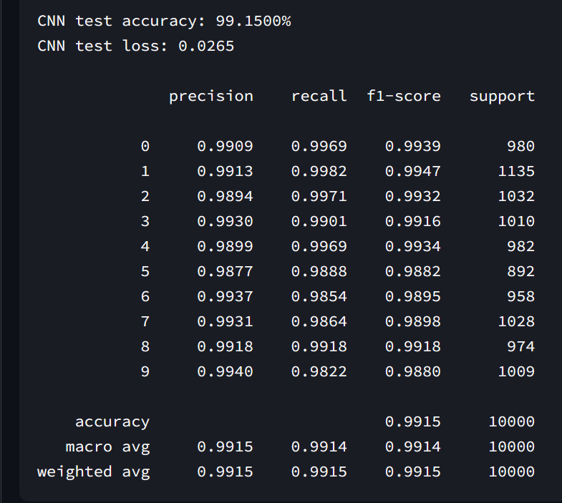

5.3 STREAMLIT APPLICATION
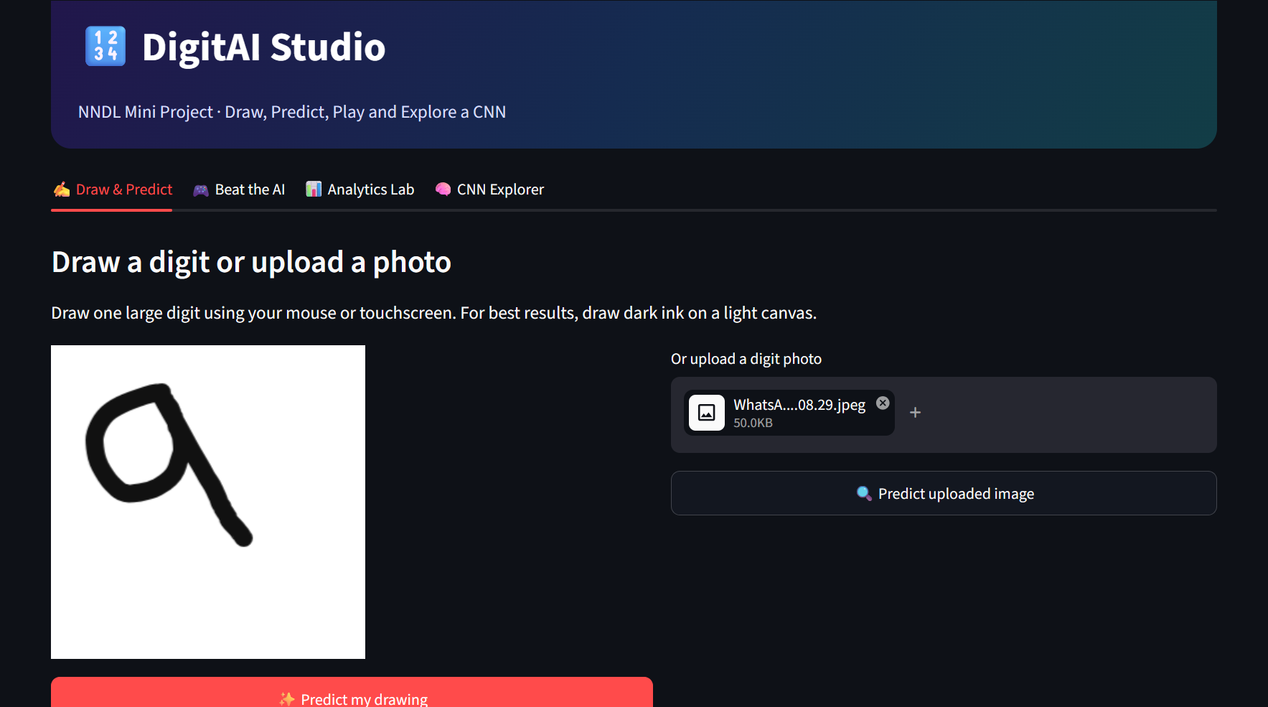
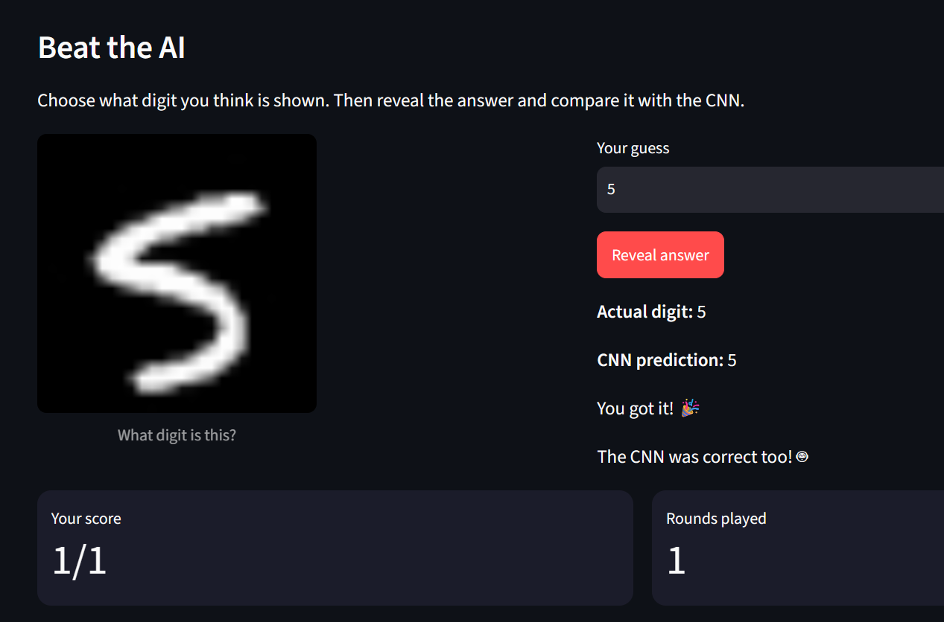
The Streamlit interface organizes the project's functionality into interactive sections. The application loads the trained model, preprocesses the input image, performs inference, and displays the predicted digit. The available features include Draw & Predict, Beat the AI, Analytics Lab, and CNN Explorer.

5.4 EXPERIMENTAL RESULTS
The CNN and MLP should be compared using values recorded during model evaluation. No accuracy or loss value should be inserted unless it comes from the actual run.
Metric | CNN result | MLP result
Training accuracy (Epoch 8) | 99.28% | 98.31%
Training loss (Epoch 8) | 0.0227 | 0.0505
Validation accuracy (Epoch 8) | 99.15% | 98.18%
Validation loss (Epoch 8) | 0.0338 | 0.0661
Test accuracy (reported by script) | 99.15% | 98.03%
Metric | CNN
Test accuracy | 99.15%
Test loss | 0.0265
Macro precision | 99.15%
Macro recall | 99.14%
Macro F1-score | 99.14%
Weighted F1-score | 99.15%
Test images | 10,000

5.5 DISCUSSION
The CNN preserves the spatial arrangement of pixels and learns local image patterns through convolutional filters. The MLP operates on a flattened representation of the image. CNNs are generally suitable for image classification, but the relative performance in this project must be established from the actual evaluation results.
Predictions can be affected by writing style, digit alignment, stroke thickness, and the similarity between user-drawn images and the training examples. Training curves and a confusion matrix can provide additional evidence about model learning and classification errors.

5.6 TESTING
- Test with clearly drawn examples from different digit classes.
- Try different writing styles for the same digit.
- Check predictions for visually similar digits.
- Verify that the trained model loads successfully.
- Navigate through all implemented application features.
- Check handling of empty or invalid inputs where applicable.

CHAPTER 6
CONCLUSION AND FUTURE SCOPE

6.1 CONCLUSION
DigitAI Studio demonstrates the application of Neural Networks and Deep Learning to handwritten digit recognition. Using the MNIST dataset, the project develops CNN and MLP approaches for classifying images into ten digit categories. The work covers image preprocessing, model construction, training, evaluation, and interactive inference.
The CNN learns spatial features through convolutional operations, while the MLP provides a comparison based on fully connected layers. The Streamlit application makes the project accessible through features such as Draw & Predict, Beat the AI, Analytics Lab, and CNN Explorer, as implemented in the system.
The project provides practical experience with Python, TensorFlow/Keras, image classification, model evaluation, and interactive application development. It also demonstrates the importance of consistent preprocessing and careful interpretation of predictions.

6.2 LIMITATIONS
- The system focuses on isolated digits rather than complete words or documents.
- Performance depends on input quality and compatibility with training data.
- User-drawn images may differ from MNIST images in alignment and stroke thickness.
- The reported model comparison depends on the actual experimental setup and evaluation results.
- The system is an educational demonstration, not a general-purpose document-recognition platform.

6.3 FUTURE SCOPE
- Improve preprocessing for user-drawn images, including centering and scaling.
- Evaluate additional CNN architectures and hyperparameter settings.
- Add a larger set of test examples and more detailed error analysis.
- Extend the system to recognize multiple digits or handwritten mathematical expressions.
- Explore deployment options that make the application easier to access.
- Improve interpretability with visualizations of learned feature maps, where supported.

REFERENCES
1. LeCun, Y., Bottou, L., Bengio, Y., and Haffner, P. (1998). “Gradient-Based Learning Applied to Document Recognition.” Proceedings of the IEEE, 86(11), 2278–2324.
2. Deng, L. (2012). “The MNIST Database of Handwritten Digit Images for Machine Learning Research.” IEEE Signal Processing Magazine, 29(6), 141–142.
3. TensorFlow. TensorFlow Documentation. https://www.tensorflow.org/
4. Keras. Keras Documentation. https://keras.io/
5. Streamlit. Streamlit Documentation. https://docs.streamlit.io/
6. Scikit-learn. Machine Learning in Python: Scikit-learn Documentation. https://scikit-learn.org/stable/
7. Python Software Foundation. Python Documentation. https://docs.python.org/3/

