MAIN COMPONENTS OF THE APP
Our app is made up of 7 key components:
- Users (Clients)
- Frontend Web App
- Load Balancer
- Backend API Servers
- Caching Layer
- Message Queue
- Database
- Real-Time Update System
We’ll explain each one and then how data flows between them.

System Components
The Adaptive Queue Optimizer App follows a layered and modular system architecture, where each component has a clear responsibility and interacts with other components in a controlled manner. This design ensures scalability, reliability, and ease of maintenance.

1️⃣ Users (Clients)
Who they are:
- Customers joining queues via QR codes
- Business admins monitoring queues
- Counter staff managing queue progression
Responsibilities:
- Interact with the application through a web browser
- Perform actions like joining queues, checking status, and updating queue flow
Users never directly interact with backend logic or the database.

2️⃣ Frontend Web Application
What it is:
- A browser-based interface built using HTML, CSS, and JavaScript
- Works on both mobile and desktop devices
Responsibilities:
- Displays queue status, wait times, and dashboards
- Collects user input and sends requests to backend APIs
- Listens for real-time updates and reflects changes instantly
Key Property:
- Stateless — no queue data is permanently stored on the client side

3️⃣ Load Balancer
What it is:
- A traffic management layer between frontend and backend servers
Responsibilities:
- Distributes incoming requests across multiple backend servers
- Detects unhealthy servers and reroutes traffic automatically
- Prevents any single server from becoming overloaded
This enables high availability and fault tolerance.

4️⃣ Backend API Servers
What they are:
- Multiple stateless backend servers running identical application logic
Core Responsibilities:
- Handle queue creation and user enrollment
- Calculate queue positions and estimated wait times
- Process admin and staff actions
- Communicate with cache, database, message queue, and real-time systems
Why Multiple Servers:
- Supports horizontal scaling
- Ensures system continuity even if one server fails

5️⃣ Caching Layer
What it is:
- An in-memory data store (e.g., Redis)
Responsibilities:
- Stores frequently accessed queue data
- Reduces repeated database reads
- Improves response time during high traffic
Behaviour:
- Backend checks cache first
- Falls back to database on cache miss
Cache improves performance but is not critical for correctness.

6️⃣ Message Queue (Background Processing)
What it is:
- An asynchronous task processing system
Used for:
- Sending notifications
- Logging analytics
- Storing queue history
- Performing non-critical background operations
Why it exists:
- Keeps backend API responses fast
- Isolates heavy or delayed tasks from core queue logic

7️⃣ Database (Persistent Storage)
What it is:
- Central, scalable database system (NoSQL / cloud-based)
Stores:
- Queue entries and positions
- Business and user data
- Timestamps and historical queue records
Key Role:
- Acts as the single source of truth
- Ensures data persistence even during server failures

8️⃣ Real-Time Update System
What it is:
- Event-driven communication layer (WebSockets / Pub-Sub)
Responsibilities:
- Pushes instant queue updates to users and dashboards
- Eliminates the need for constant manual refreshes
Fallback:
- Periodic polling if real-time connection fails
Improves user experience while minimizing server load.

🔁 Component Interaction Summary
- Users interact with the Frontend
- Frontend sends requests via Load Balancer
- Requests are processed by Backend Servers
- Backend reads/writes data using Cache and Database
- Real-Time System broadcasts queue updates
- Message Queue handles background tasks asynchronously
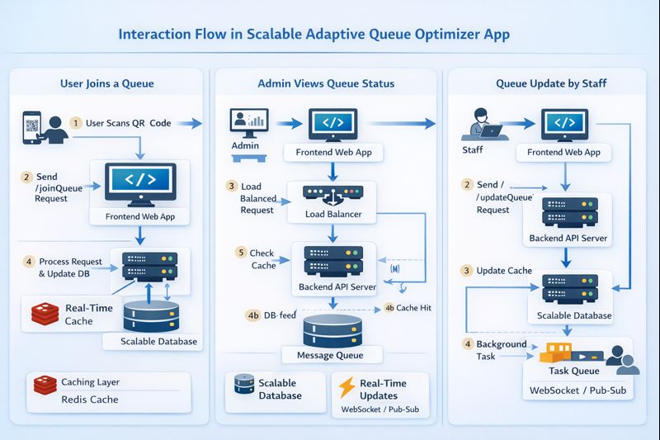

🔁 HOW COMPONENTS INTERACT (DATA FLOW)
Let’s walk through a real example.

🔄 Scenario: User Joins a Queue
- User scans QR code
- Frontend sends joinQueue request
- Load balancer routes request
- Backend server processes request
- Backend updates database
- Cache is updated
- Real-time system notifies dashboards

User → Frontend → Load Balancer → Backend
↓ ↓

Real-Time Cache + DB

🔄 Scenario: Admin Views Queue Status
- Admin opens dashboard
- Frontend requests queue data
- Backend checks cache
- Cache returns data instantly
- If cache miss → database used
- Data displayed on dashboard

🔄 Scenario: Queue Update by Staff
- Staff marks user as served
- Backend updates database
- Cache updated
- Real-time event pushed to users
- Message queue logs analytics

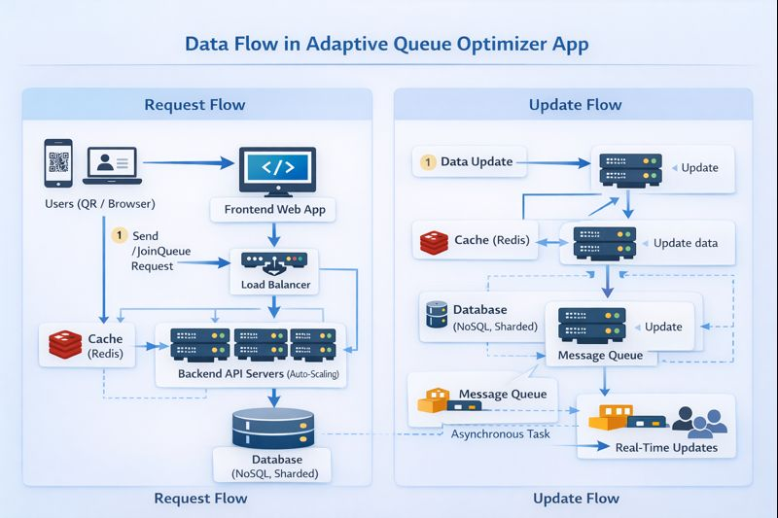

Think of this image as showing how information moves inside our app, from the moment a user clicks something to the moment everyone sees the updated queue status. It is divided into two parts:
- Request Flow (Left side) → when users send requests
- Update Flow (Right side) → when the system sends updates back

1. Request Flow (User → System)
This happens when a user joins a queue, checks their position, or an admin updates something.
Step-by-step:
- User (QR / Browser)
  - The user scans a QR or opens your website.
  - They click Join Queue, Check Status, etc.
- Frontend Web App
  - This is your UI (HTML/CSS/JS).
  - It collects the request and sends it to the backend.
- Load Balancer
  - Acts like a traffic police.
  - It decides which backend server should handle the request.
  - This prevents one server from getting overloaded.
- Backend API Servers (Auto-Scaling)
  - These servers do the main work:
    - Add user to queue
    - Calculate position
    - Estimate waiting time
  - If users increase, more servers are added automatically.
- Cache (Redis)
  - First checks here:
    - “Do I already have this queue data?”
  - If yes → returns instantly (very fast).
  - If no → goes to database.
- Database (NoSQL, Sharded)
  - Stores permanent queue data:
    - Users
    - Queue positions
    - History
  - “Sharded” means data is split across multiple databases so it doesn’t overload one.
- Response goes back
  - Backend → Frontend → User sees their queue status.
So:
User → Frontend → Load Balancer → Backend → Cache → Database → Backend → User

2. Update Flow (System → Everyone)
This happens when the queue changes and everyone must be informed in real-time.
Example:
A counter staff serves one customer → queue position changes.
Steps:
- Data Update
  - Admin or staff marks a person as “served”.
- Backend API Servers
  - Updates queue data.
- Cache (Redis) Update
  - Cache is refreshed so next requests get new data instantly.
- Database Update
  - Permanent storage updated.
- Message Queue
  - Backend sends a message:
“Queue has changed!”
- This prevents blocking the main server and handles heavy traffic smoothly.
- Asynchronous Tasks
  - Background workers process:
    - Notifications
    - Analytics
    - Logging
- Real-Time Updates (WebSocket / Pub-Sub)
  - Instantly pushes new queue position to:
    - Users
    - Admin dashboards
    - Staff screens
So:

Backend → Cache + Database → Message Queue → Real-Time Updates → Users/Admins

