What Our App Is (Summary)
Our project Adaptive Queue Optimizer is a web app that lets users join physical queues digitally using QR codes and get live wait-time updates, while businesses manage queues from a simple dashboard without cameras, extra hardware, or mobile apps.
As more users are added (like 100 → 1,000 → 10,000+ people), we think about how the system will handle that load without slowing or breaking. This is what “scalable” really means.

What “Scalability” Means for Our App
Scalability means the app continues to work well when more people use it at the same time — e.g., many users scanning QR codes and joining queues, businesses checking statuses, admin updating business dashboards. That’s done by designing our app to:
- Spread work across multiple servers instead of one
- Use efficient data storage and communication
- Not let any one part become a bottleneck
Here’s how our app can be designed to scale:

1. Designing the App Structure to Grow (Architecture)
A. Separation of Concerns
Split the app into independent parts:
- Web interface (front end)
- Backend API server
- Database
- Real-time notification service
Each part can be scaled separately. For example, if many users join queues at once, only the backend API part needs more capacity. This is a key idea in scalable systems.
B. Microservices (Optional but Powerful)
Instead of one big application, break it into small services:
- Queue service (handles adding users)
- Dashboard service (business view)
- Notification service (real-time updates)
Each service can run on its own server or container. When traffic grows, we can scale only the services that need it.

2. Manage Traffic with Load Balancing
If many users connect at the same time:
- Put a load balancer in front of the backend servers: it spreads requests so no single server gets overwhelmed.
- Also, software load balancers (cheaper, flexible) or cloud load balancers (auto-scaled) can be used.
This ensures users get responses quickly even under high load.

3. Auto-Scaling (Cloud or Servers)
Use cloud platforms like AWS / Firebase / Azure:
- The platform can add more server instances automatically when traffic spikes.
- When traffic drops, it scales down to save cost.
This makes our app both resilient and cost-efficient.
Example:
- If 1000 people join queues at lunchtime, our backend automatically gets more resources.
- After lunch, it scales back down.

4. Database That Grows with the users
As more people join queues:
- Our database must handle many read/write requests.
- We can use a scalable database like a NoSQL database (e.g., MongoDB or Firebase) which is easy to scale horizontally.
- Or use sharding/partitioning: split data into chunks handled by different servers so no one machine slows things down.

5. Real-Time Updates without Overload
Our app gives users live wait times:
- Instead of constantly polling the server, using WebSockets or Pub/Sub events — users get updates only when something changes.
- This drastically reduces unnecessary load.

6. Caching for Speed
When many users check the same queue info:
- Use cache (like Redis) to store frequently requested data in memory.
- This means the backend doesn’t hit the database every time — faster and more scalable.

7. Use Message Queues for Background Work
If some tasks take time (like sending notifications, logging activity):
- Use message queue systems (like RabbitMQ, Kafka) to process them in the background.
- This keeps the app responsive during heavy use.

Real-World Example (Simplified)
Imagine 10,000 users scan QR and join at 2pm:
- Load balancer spreads the traffic to 3 API servers.
- Database replicas serve queue data.
- Cached wait-time info reduces database hits.
- Real-time server pushes updates to users only when queue changes.
- Message queue handles notification delivery in background.
This makes the app fast and reliable even at peak times.

Summary: How Scalability Happens
Challenge | Scalability Solution
Many user requests | Load balancing + auto-scaling
Heavy database use | Sharding + NoSQL + caching
Real-time updates | WebSockets / event streams
Background tasks | Message queues
Cost efficiency | Cloud auto-scale & monitoring

Final Takeaway
Our Adaptive Queue Optimizer App becomes scalable by:
- Splitting responsibilities across services
- Using techniques that automatically handle more users
- Avoiding single points of overload
This makes the app reliable, fast, and able to support thousands (or more) simultaneous users without crashes or slowdowns — which is what scalability means in real tech stacks.

Step by Step Scalability plan:

- Current State of Our Project
Right now, our project logically has:
- Frontend (HTML/CSS/JS)
→ User scans QR, joins queue
→ Admin & staff dashboards
- Backend (single server logic)
→ Adds users to queue
→ Calculates wait time
→ Updates dashboard
- Database
→ Stores users, queues, timestamps
If many users join at once, one server + one database can become slow.

- Step-by-Step Scalability Plan

STEP 1: Convert Backend into a REST API
What changes?
- Our backend becomes an API server (example: /joinQueue, /getQueueStatus)
- Frontend only talks to backend using HTTP requests
Why this helps scalability?
- Any number of frontend users can now talk to backend
- Backend becomes independent → easier to scale
This is the foundation of scalability

STEP 2: Add Load Balancer (Traffic Distributor)
Problem
- 1 backend server = bottleneck
Solution
- Put a Load Balancer in front
What it does (simple)
Like a traffic police, it sends incoming users to different backend servers
Users
↓
Load Balancer
↓
Backend Server 1
Backend Server 2
Backend Server 3
Result
- 100 users → 1 server
- 5,000 users → 3–5 servers
- No server overload

STEP 3: Horizontal Scaling (Add More Servers)
Instead of making one server powerful:
- We can add more servers
- We don’t upgrade just one machine
This is called horizontal scaling.

STEP 4: Database Scaling (Very Important for Queues)
Queues are write-heavy (many users joining).
Option A: Use NoSQL Database
- MongoDB / Firebase / DynamoDB
- Handles high writes easily
Option B: Database Sharding
- Each business/location has its own data partition
- One busy shop doesn’t affect others
Example
Queue DB
├── Shop A queues
├── Shop B queues
└── Shop C queues
This prevents slowdown when many shops use the app simultaneously

STEP 5: Caching (Makes App FAST)
Problem
- Thousands of users checking the same queue status
Solution
- Use in-memory cache (Redis)
How it works
- Queue status is stored temporarily in memory
- Backend doesn’t hit database every time
Result
- Faster response
- Less load
- Happy users

STEP 6: Real-Time Updates Without Overload
Instead of users refreshing again and again:
WebSockets / Real-time listeners can be used
Flow
- Backend sends update only when queue changes
- Users instantly see updated wait time
Why this scales
- Reduces unnecessary requests
- Efficient real-time communication

🔹 STEP 7: Background Jobs (Advanced but Impressive)
Some tasks don’t need instant response:
- Notifications
- Analytics logging
- Queue history storage
Use Message Queue
- Backend sends task → message queue
- Worker processes it later
Result
- App stays fast even during peak load
STEP 8: Auto-Scaling on Cloud
Deploy on cloud (AWS / GCP / Firebase):
- Traffic ↑ → servers auto-increase
- Traffic ↓ → servers auto-reduce
This means:
- App never crashes during peak time
- Cost stays low when usage is low

- SIMPLE SYSTEM ARCHITECTURE DIAGRAM

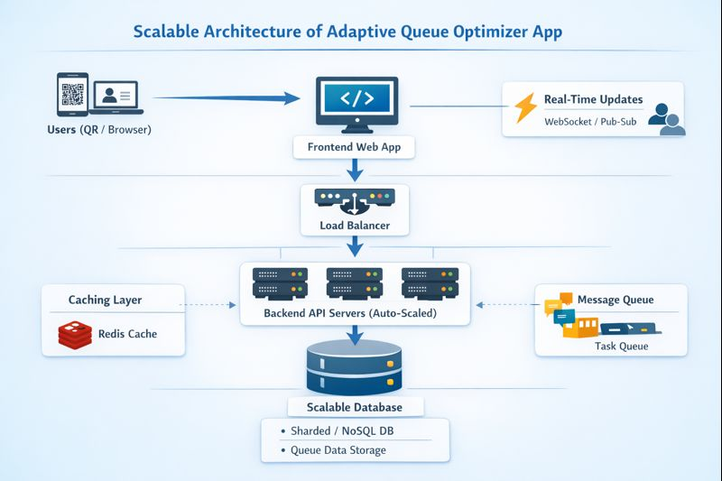

- How It Handles MORE USERS (Real Scenario)
Scenario: 10,000 users at lunch time
- Users scan QR and hit frontend
- Load balancer splits traffic
- Multiple backend servers handle requests
- Cache serves most queue reads
- Database handles only essential writes
- Real-time updates push changes efficiently
- Background workers process analytics
No crash, no delay, smooth experience

