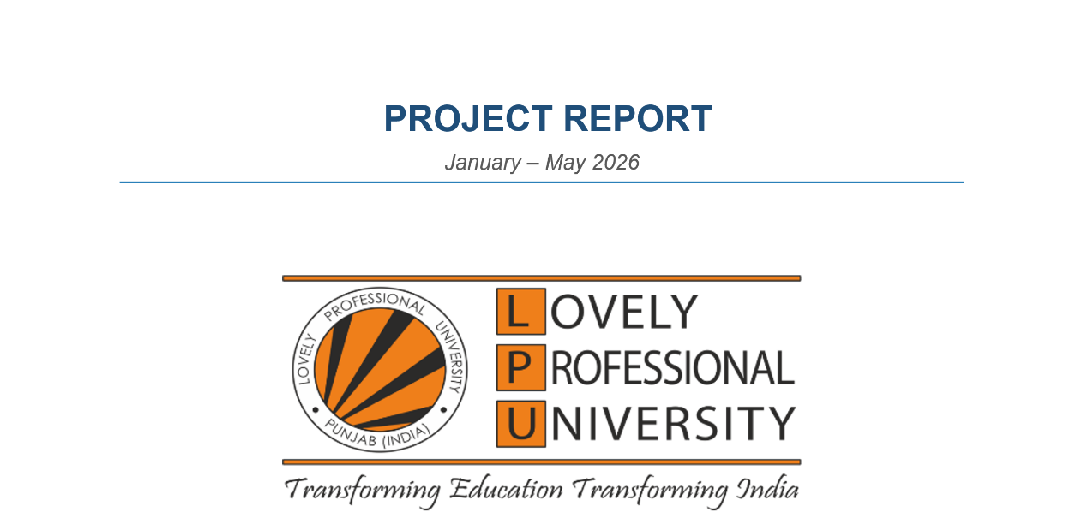

Financial Literacy Chatbot for Investment Awareness

Course Code: INT428

Submitted by

Name of Student | Registration Number
Isha | 12412796
Shagun Batham | 12407654

Under the Guidance of

Name of Faculty Mentor with Designation: Tarun Singh (Assistant Professor) (34442)

School of Computer Science and Engineering
Lovely Professional University, Phagwara

DECLARATION

We hereby declare that the project work entitled

"Financial Literacy Chatbot for Investment Awareness"

is an authentic record of our own work carried out as requirements of Project for the award of B.Tech Computer Science and Engineering from Lovely Professional University, Phagwara, under the guidance of (Name of Faculty Mentor) during January–May 2026. All information furnished in this report is based on our own intensive work and is genuine.

Student | Registration No.
Isha | 12412796
Shagun Batham | 12407654

CERTIFICATE

This is to certify that the declaration statement made by this group of students is correct to the best of my knowledge and belief. They have completed this Project under my guidance and supervision. The present work is the result of their original investigation, effort and study. No part of the work has ever been submitted for any other degree at any University. The Project is fit for submission and partial fulfillment of the conditions for the award of B.Tech Computer Science and Engineering from Lovely Professional University, Phagwara.

(Tarun Singh)
Name of the Supervisor

(Assistant Professor)
Designation of the Supervisor

School of Computer Science and Engineering
Lovely Professional University
Phagwara, Punjab.

Date: 04/05/2026

ACKNOWLEDGEMENT

We would like to express our sincere gratitude to our project guide and faculty members for their continuous support, valuable guidance, and encouragement throughout the development of this project titled "Financial Literacy Chatbot for Investment Awareness." Their insights and suggestions greatly helped in shaping the design, implementation, and evaluation of the system successfully.

We are also thankful to our institution, Lovely Professional University, for providing the necessary resources, infrastructure, and academic environment that enabled the successful completion of this work.

We extend our appreciation to our classmates and peers for their cooperation, constructive feedback, and helpful discussions during the development of the project, particularly in refining the RAG retrieval pipeline, the knowledge base ingestion strategy, and the streaming chat interface.

We would also like to acknowledge the use of various online resources, official documentation, and study materials — including the Ollama, ChromaDB, Flask, and nomic-embed-text communities — that assisted in understanding the underlying concepts and implementing the system effectively.

Lastly, we are grateful to everyone who directly or indirectly contributed to the successful completion of this project.

1. INTRODUCTION
The Financial Literacy Chatbot for Investment Awareness is a Python-based conversational web application that helps users learn about personal finance, investing, budgeting, and tax planning through natural language dialogue. The system combines a Retrieval-Augmented Generation (RAG) pipeline with a locally deployed large language model to deliver context-grounded, private, and streaming responses directly in the browser.

The project addresses a practical gap in accessible financial education. Most individuals lack affordable access to financial advisors and rely on fragmented online content that may be outdated or conflicting. The chatbot provides an always-available, locally hosted assistant that answers questions conversationally, grounds its replies in a curated financial knowledge base, and streams responses in real time without sending any user data to external servers.

The system is not intended to replace certified financial professionals. Its purpose is to improve financial awareness and help users make more informed decisions. Two core scripts power the system: ingest.py, which builds and maintains the ChromaDB vector knowledge base from CSV documents, and app.py, which serves the Flask-based chat interface with SSE streaming and RAG retrieval.

1.1 Objectives of the Project
- To build a knowledge ingestion pipeline that reads financial CSV documents, chunks them, embeds each chunk using nomic-embed-text, and stores them in a persistent ChromaDB collection.
- To implement idempotent ingestion using SHA-256 hashing so that re-running ingest.py never duplicates existing chunks.
- To develop a Flask-based chat backend with a RAG retrieval function that queries ChromaDB for the top-3 most semantically relevant chunks before each response.
- To integrate the Phi-3 language model via Ollama for fully local, privacy-preserving LLM inference.
- To stream model responses token by token to the browser using Server-Sent Events (SSE), providing a real-time typing experience.
- To maintain a rolling conversation history of up to five prior exchanges to support coherent multi-turn dialogue.
- To deliver an intuitive single-page web interface with dark/light mode, suggestion chips, a typing indicator, and a conversation reset control.

1.2 Technology Used
Table 1: Technologies Used in the Project
Technology | Purpose
Python 3.10+ | Primary programming language for both ingest.py and app.py
Flask | Backend web framework serving the chat API and static frontend
Flask-CORS | Cross-origin request handling between frontend and Flask server
Ollama | Local model runner for nomic-embed-text embeddings and Phi-3 inference
Phi-3 (phi3:latest) | Locally hosted large language model for response generation
nomic-embed-text | Embedding model for converting text to semantic vectors
ChromaDB | Persistent vector database for storing and querying document embeddings
Server-Sent Events (SSE) | Token-by-token streaming of model output from server to browser
HTML / CSS / JavaScript | Responsive single-page chat interface with dark mode and chips
Marked.js | Client-side Markdown rendering for assistant responses
hashlib (SHA-256) | Chunk deduplication during knowledge base ingestion
csv / pathlib | CSV document loading and file-system traversal in ingest.py

2. PROFILE OF THE PROBLEM, RATIONALE AND SCOPE
Financial literacy remains critically low across most demographics. Students, early-career professionals, and general users regularly encounter concepts such as index funds, compound interest, tax-advantaged retirement accounts, and portfolio rebalancing without adequate guidance on how these concepts apply to their own situations. Online search surfaces fragmented and sometimes contradictory content, while traditional financial advisors are too expensive or inaccessible for the majority of users.

The problem deepens in the context of investment awareness, where incomplete or misunderstood information can directly result in poor financial decisions and lasting monetary harm. Users need a reliable, interactive, and always-available assistant that explains concepts clearly, adapts to follow-up questions, and does not expose sensitive financial queries to cloud services.

2.1 Problem Statement
General users need a private and conversational tool that improves their understanding of financial concepts and investment strategies. Existing solutions either require internet connectivity that exposes query content to third parties, produce answers without grounding them in a verified knowledge base, or provide static content that cannot adapt to follow-up questions. This project develops an offline-capable, RAG-enhanced chatbot that grounds every response in a curated financial knowledge base while using a locally deployed language model for natural conversation.

2.2 Rationale of the Study
- The rationale is to make quality financial education accessible at zero cost and without privacy trade-offs, by running all components locally on the user's own hardware.
- The RAG pipeline grounds responses in curated financial CSV documents, reducing the risk of hallucination compared to a prompt-only approach.
- Idempotent chunk ingestion via SHA-256 hashing ensures that the knowledge base can be updated incrementally without data duplication.
- Streaming SSE responses improve perceived responsiveness and give users immediate feedback as the model generates its answer.
- The study applies and demonstrates concepts in NLP, vector databases, embedding models, RESTful API design, and modern web development.

2.3 Scope of the Study
- Includes ingestion of financial knowledge from CSV files with arbitrary column structures into a ChromaDB vector collection.
- Includes conversational responses to questions about investing, budgeting, taxation, and personal finance.
- Includes real-time token streaming from the Flask backend to the browser via SSE.
- Includes rolling conversation history of up to five prior exchanges for multi-turn dialogue.
- Does NOT include professional certified financial advice, real-time market data feeds, user authentication, or persistent multi-user session storage.

3. EXISTING SYSTEM
Existing tools for financial guidance and education can be grouped into static educational websites, rule-based chatbots, cloud-connected AI assistants, and commercial robo-advisors. Each category solves part of the problem but also introduces significant limitations for users who need private, conversational, and grounded financial education.

3.1 Introduction
Static educational websites such as Investopedia and Khan Academy provide well-written content but require users to browse and read independently, offering no conversational adaptation. Rule-based chatbots follow scripted decision trees and cannot handle nuanced or multi-turn financial queries. Cloud-connected AI assistants can answer financial questions but transmit user queries to external servers, raising privacy concerns. Commercial robo-advisors automate portfolio management but are focused on trading rather than conceptual financial education.

3.2 Existing Software
- General-purpose cloud AI assistants: Can answer financial questions but require internet connectivity and send query content to external providers.
- Investopedia and Khan Academy: Provide accurate static content but offer no conversational interaction or personalized follow-up.
- Robo-advisors (Betterment, Wealthfront): Manage investments automatically but do not explain financial concepts interactively to users.
- Bank virtual assistants: Handle account-related queries but lack depth for investment education and general financial literacy.

3.3 Data Flow of Present System
In a typical existing process, a user types a financial question into a web interface, the query is transmitted to a cloud server or rule-based engine, a generic response is generated without access to a curated local knowledge base, and the result is returned without retaining any conversational context for follow-up.

User → Query Submission → Cloud / Rule-based Engine → Generic Response → No Conversational Context

3.4 What is New in the Proposed System
- The proposed system runs entirely on local hardware; user queries never leave the device.
- A two-script architecture separates knowledge base management (ingest.py) from the chat service (app.py), making each independently maintainable.
- Incremental ingestion with SHA-256 deduplication means new CSV documents can be added to the data/ directory and re-ingested without reprocessing existing chunks.
- The RAG pipeline retrieves the top-3 semantically relevant document chunks before each response, grounding answers in the curated financial knowledge base.
- Conversation history of up to five exchanges is included in every prompt, enabling coherent multi-turn dialogue.
- Token streaming via SSE provides a real-time, responsive experience without waiting for full response generation.

4. PROBLEM ANALYSIS
Problem analysis identifies the product definition, feasibility, and the plan for development. The main challenge is to design a system that retrieves accurate financial knowledge, maintains coherent conversation, and runs entirely on consumer-grade hardware without any cloud dependency.

4.1 Product Definition
The Financial Literacy Chatbot is an interactive two-component software system. The first component, ingest.py, reads CSV files from the data/ directory, chunks each row into overlapping 300-word segments, embeds each chunk using nomic-embed-text, and stores new chunks in a ChromaDB collection using SHA-256 hashes as unique identifiers. The second component, app.py, serves a Flask web application where users ask financial questions and receive streaming, context-grounded responses via the Phi-3 model. Primary users are students, young professionals, and general users seeking accessible financial education.

4.2 Feasibility Analysis
Table 2: Feasibility Analysis
Feasibility Type | Assessment
Technical | Flask, Ollama, ChromaDB, nomic-embed-text, and Phi-3 are all open-source and fully documented. The entire stack runs on commodity hardware.
Operational | The web interface uses natural language input, making it accessible to non-technical users without any training.
Economic | All software components are open-source and free of charge. The only cost is the local hardware used for model inference.
Schedule | The two-script architecture allows ingestion and chat components to be developed and tested independently across defined phases.

4.3 Project Plan
Table 3: Project Plan
Phase | Activity
Phase 1 | Requirement analysis, technology selection, and local environment setup (Ollama, ChromaDB, Flask)
Phase 2 | ingest.py development: CSV loading, chunking, embedding, and ChromaDB storage with deduplication
Phase 3 | app.py development: RAG retrieval, prompt construction, and conversation history management
Phase 4 | SSE streaming integration: ollama.chat() stream loop and Flask SSE response
Phase 5 | Frontend development: HTML/CSS/JS interface with dark mode, suggestion chips, and typing indicator
Phase 6 | Testing, performance tuning, documentation, and report preparation

5. SOFTWARE REQUIREMENT ANALYSIS
Software Requirement Analysis defines the expected behaviors, constraints, and quality attributes of the system. Requirements were chosen to balance response accuracy, data privacy, real-time usability, and maintainability in a fully local deployment environment.

5.1 Introduction
- The system must load financial CSV documents from a data/ directory, chunk them, embed them, and store deduplicated chunks in ChromaDB.
- The system must accept natural language financial questions and return context-grounded, streamed responses.
- The system must maintain a rolling conversation history of up to five exchanges and include it in each prompt.
- The system should degrade gracefully when the ChromaDB collection is empty, falling back to model-only responses.

5.2 General Description
- The application consists of two independent scripts: ingest.py for knowledge base management and app.py for the chat service.
- Users interact with the system through a browser-based single-page interface served by Flask.
- All LLM inference and embedding is performed locally via Ollama; no external API calls are made.
- Conversation history is stored in-memory per server process and is not persisted between server restarts.
- Ingested chunk hashes are stored as ChromaDB metadata to enable idempotent re-ingestion.

5.3 Specific Requirements
Table 4: Specific Requirements
Requirement ID | Description | Priority
FR1 | ingest.py shall load all CSV files from the data/ directory and format each row as structured text. | High
FR2 | ingest.py shall split each row text into 300-word chunks with 75-word overlap. | High
FR3 | ingest.py shall embed each chunk using nomic-embed-text and store it in ChromaDB with its SHA-256 hash. | High
FR4 | ingest.py shall skip chunks whose hash already exists in the collection (idempotent ingestion). | High
FR5 | app.py shall embed each user query and retrieve the top-3 relevant chunks from ChromaDB. | High
FR6 | app.py shall construct a prompt incorporating conversation history and retrieved context. | High
FR7 | app.py shall stream Phi-3 responses token by token to the browser via SSE. | High
FR8 | app.py shall maintain and trim conversation history to the last 5 exchanges. | High
FR9 | The system shall support a /reset endpoint to clear conversation history. | Medium
FR10 | The frontend shall display suggestion chips, dark/light mode toggle, and a typing indicator. | Low
NFR1 | The system shall handle an empty ChromaDB collection without crashing. | High
NFR2 | Identical queries shall always retrieve the same set of document chunks. | High
NFR3 | The system shall respond within acceptable latency on consumer-grade hardware. | Medium

6. DESIGN
The system design follows a two-script, layered architecture. ingest.py handles all knowledge base construction offline, while app.py handles all runtime query serving. This separation keeps each component independently testable and maintainable.

6.1 System Design
Table 5: System Architecture
Component | Script | Responsibility
CSV Loader | ingest.py – load_all_csvs() | Reads all CSV files from data/, formats each row as labelled key-value text with source annotation
Text Chunker | ingest.py – chunk_text() | Splits row text into 300-word overlapping chunks (75-word overlap) to fit embedding context limits
Chunk Preparer | ingest.py – prepare_chunks() | Generates SHA-256 hash for each chunk as a unique identifier for deduplication
Index Builder | ingest.py – build_index() | Embeds new chunks in batches of 32, checks existing hashes, and upserts to ChromaDB
Vector Store | ChromaDB (rag_chatbot) | Persistent storage of chunk embeddings, texts, and hash metadata
Query Embedder | app.py – embed_query() | Embeds the user's question using nomic-embed-text for semantic retrieval
Retriever | app.py – retrieve() | Queries ChromaDB for the top-3 most relevant chunks using the query embedding
Prompt Builder | app.py – build_prompt() | Assembles final prompt from conversation history, retrieved context, and user question
Inference & Streamer | app.py – /chat endpoint | Calls ollama.chat() in stream mode and yields each token as an SSE event
Frontend | templates/index.html + static/ | Browser chat interface: SSE listener, Markdown rendering, dark mode, suggestion chips

6.2 Design Notations
- External entities: User (browser), Ollama server (local), ChromaDB (local persistent store), CSV files in data/.
- Processes: CSV loading, text chunking, hash deduplication, batch embedding, vector storage, query embedding, chunk retrieval, prompt construction, LLM inference, SSE streaming.
- Data flow (ingestion): CSV files → load_all_csvs() → chunk_text() → SHA-256 hash → build_index() → Ollama embeddings → ChromaDB.
- Data flow (chat): User message → embed_query() → ChromaDB.query() → context chunks → build_prompt() → ollama.chat() stream → SSE tokens → browser.
- Data store: ChromaDB rag_chatbot collection (persistent) and in-memory conversation_history list (session).

6.3 Detailed Design
- load_all_csvs() uses csv.DictReader to iterate each CSV. Columns named 'text' are included as-is; columns named 'question' and 'answer' are prefixed with 'Q:' and 'A:' respectively; all other columns are included as 'key: value' pairs. Each row is prefixed with its source filename.
- chunk_text() splits text by whitespace into words and builds chunks of CHUNK_SIZE (300) words, advancing by CHUNK_SIZE minus CHUNK_OVERLAP (75) words at each step to create overlapping segments.
- build_index() fetches all existing metadata from ChromaDB, extracts stored hashes, filters out already-indexed chunks, and batches new chunks into groups of BATCH_SIZE (32) for embedding via ollama.embeddings().
- embed_query() calls ollama.embeddings() with the nomic-embed-text model and the user query string, returning the embedding vector.
- retrieve() calls collection.query() with the query embedding and n_results=TOP_K (3), returning the matched document texts.
- build_prompt() formats the last MAX_HISTORY (5) exchanges as 'User: / Assistant:' dialogue, appends the retrieved context chunks separated by '---', and appends the current user question.
- The /chat SSE generator calls ollama.chat() with streaming=True, yields each token as an SSE 'token' event, appends the completed reply to conversation_history, trims history to MAX_HISTORY, and finally yields an SSE 'done' event.

6.4 Flowchart
Ingestion Flow:
Start → Scan data/ for CSV files → Load and format each row → Chunk each row text → Hash each chunk → Check ChromaDB for existing hashes → Embed new chunks in batches → Store in ChromaDB → End

Chat Flow:
Start → Receive user message → [Empty? → Return 400] → Embed query → [ChromaDB empty? → Skip retrieval] → Retrieve top-3 chunks → Build prompt with history and context → Stream Phi-3 tokens via SSE → Append to history → Trim history → Yield done event → End

6.5 Pseudo Code
ingest.py:
- For each CSV file in data/: open with DictReader; for each row build a labelled text string prefixed with source filename.
- For each row text: split into words; slide a 300-word window with 75-word overlap to produce chunks.
- For each chunk: compute SHA-256 hash as unique ID.
- Connect to ChromaDB; fetch existing metadata hashes; filter new chunks.
- For each batch of 32 new chunks: call ollama.embeddings() for each text; call collection.add() with IDs, embeddings, documents, and metadata.

app.py:
- Receive POST /chat with user_message; return 400 if empty.
- Call embed_query(user_message); query ChromaDB for top-3 chunks if collection is non-empty.
- Call build_prompt(conversation_history[-5:], context_chunks, user_message).
- Open ollama.chat() stream with Phi-3; for each token yield SSE 'token' event.
- After stream ends: append exchange to conversation_history; trim to 5 entries; yield SSE 'done' event.

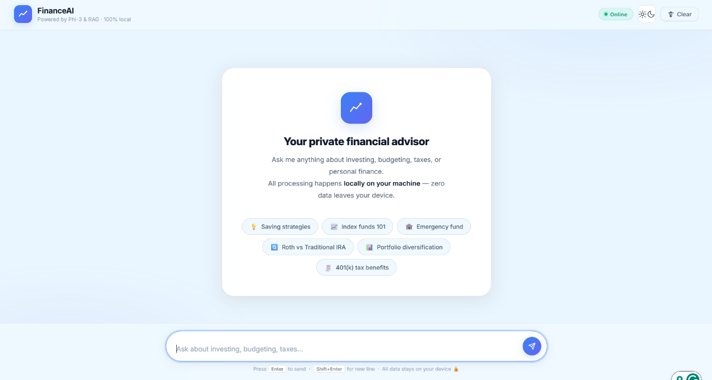

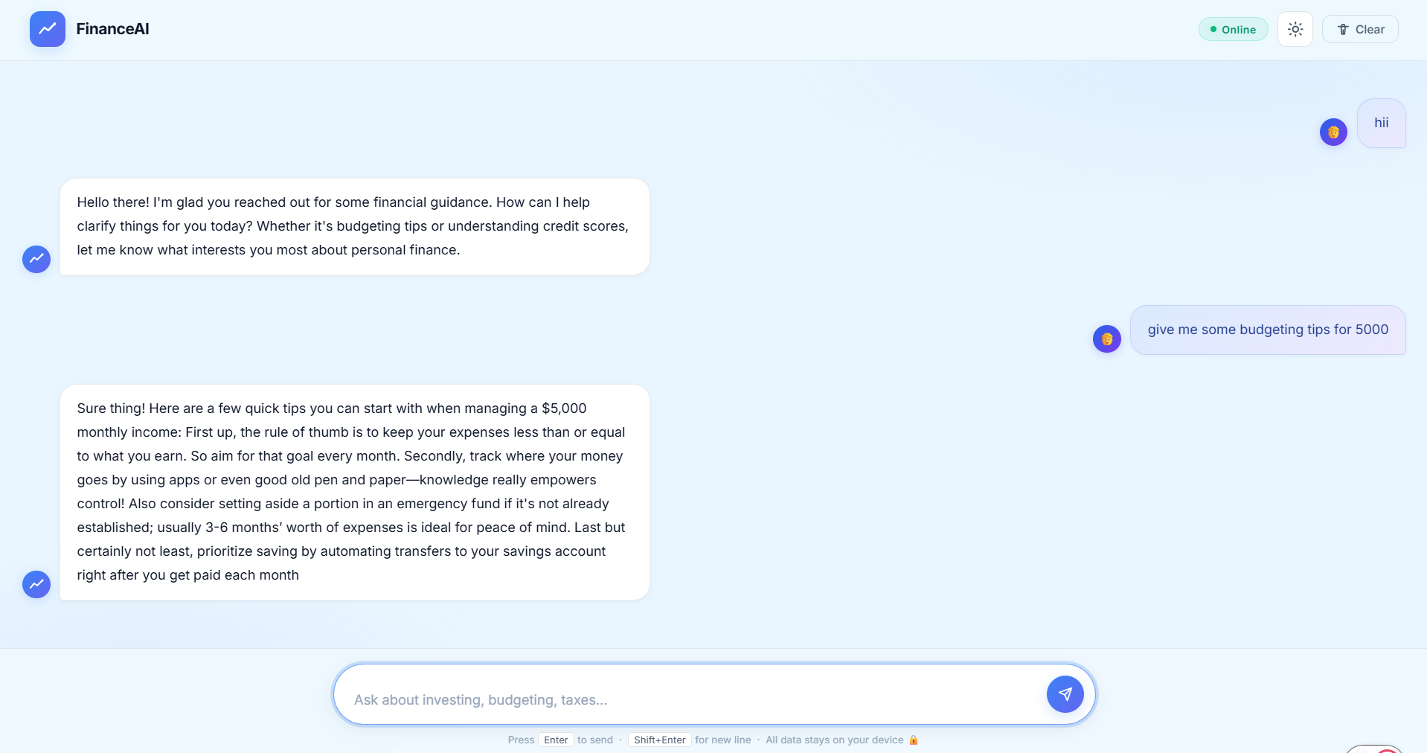

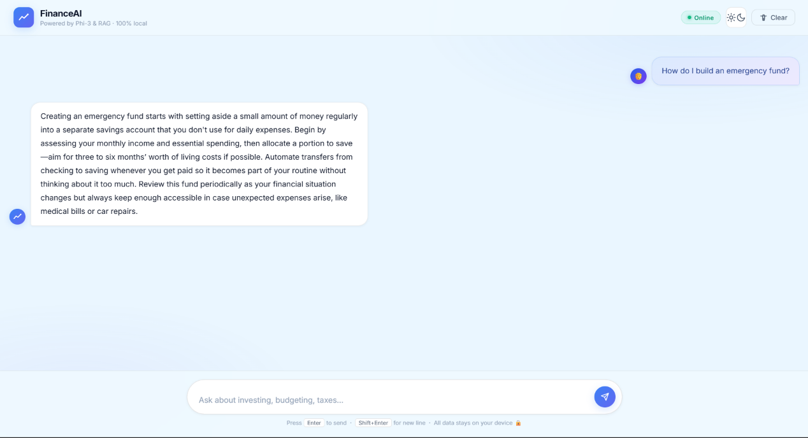

7. TESTING
Testing was performed to validate the ingestion pipeline, RAG retrieval, prompt construction, SSE streaming, and error handling behavior of both ingest.py and app.py. Both functional correctness and system-level stability were evaluated.

7.1 Functional Testing
- ingest.py was tested with a set of sample financial CSV files covering question-answer, plain-text, and mixed-column formats to verify correct row parsing and source annotation.
- Re-running ingest.py on the same data directory was tested to confirm that no duplicate chunks were added to ChromaDB.
- Adding a new CSV file to data/ and re-running ingest.py was tested to confirm that only new chunks were indexed.
- The /chat endpoint was tested with representative financial questions to verify that relevant context chunks were retrieved and coherent responses were streamed.
- The /reset endpoint was tested to confirm that conversation_history is cleared and the welcome state is restored in the frontend.

7.2 Structural Testing
- load_all_csvs() was tested with an empty data/ directory to confirm that an empty list is returned without error.
- chunk_text() was tested with texts shorter than CHUNK_SIZE to confirm a single chunk is returned correctly.
- build_index() was tested with all chunks already present in ChromaDB to confirm the 'No new chunks' path executes without modification.
- retrieve() was tested with an empty ChromaDB collection to confirm graceful return of an empty list.
- build_prompt() was tested with empty history and empty context to confirm a valid minimal prompt is produced.

7.3 Levels of Testing
- Unit testing: individual functions — load_all_csvs, chunk_text, prepare_chunks, embed_query, retrieve, build_prompt — tested in isolation with controlled inputs.
- Integration testing: the full ingestion pipeline (load → chunk → hash → embed → store) and the full chat pipeline (embed → retrieve → prompt → stream) tested end-to-end.
- System testing: the complete web application tested via browser with representative financial queries covering investing, budgeting, and retirement topics.
- Regression testing: ingestion and retrieval tests re-run after changes to CHUNK_SIZE, CHUNK_OVERLAP, TOP_K, and MAX_HISTORY to verify consistent behavior.

7.4 Test Summary
Table 6: Test Summary
Test Area | Test Case | Expected Outcome
CSV Loading | load_all_csvs with Q&A columns | Rows formatted as 'Q: ...' and 'A: ...' with source prefix
CSV Loading | load_all_csvs with empty data/ | Returns empty list without error
Chunking | chunk_text on text shorter than 300 words | Returns exactly one chunk containing the full text
Deduplication | build_index re-run on same data | Zero new chunks added; collection count unchanged
Retrieval | retrieve with empty ChromaDB collection | Returns empty list without raising an exception
Prompt | build_prompt with empty history and context | Returns valid prompt with only user question
Streaming | POST /chat with a valid financial question | SSE stream emits token events followed by a done event
Reset | POST /reset | Returns HTTP 200; conversation_history is empty
Error | POST /chat with empty message body | Returns HTTP 400 with error JSON

8. IMPLEMENTATION
Implementation was completed as a two-script Python project with a static HTML/CSS/JS frontend. The ingestion script and the chat server are intentionally decoupled so that the knowledge base can be rebuilt or extended without restarting the application server.

8.1 Implementation of the Project
- ingest.py implements load_all_csvs(), chunk_text(), prepare_chunks(), and build_index(). It is run once initially and re-run whenever new CSV documents are added to the data/ directory.
- load_all_csvs() uses pathlib.Path.glob('*.csv') to discover files and csv.DictReader to parse them. Question/answer columns receive Q:/A: prefixes; all other columns use 'key: value' format; a '[SOURCE: filename]' header is prepended to each row.
- chunk_text() produces overlapping word-level chunks using a sliding window with CHUNK_SIZE=300 and CHUNK_OVERLAP=75, ensuring that sentence context is not lost at chunk boundaries.
- build_index() uses chromadb.PersistentClient to connect to db/chroma_db, fetches existing hashes from collection metadata, and only embeds and stores chunks not already present. Embeddings are requested in batches of BATCH_SIZE=32 via ollama.embeddings().
- app.py implements get_collection(), embed_query(), retrieve(), format_history(), build_prompt(), and the Flask routes / /chat, and /reset.
- The /chat route builds the RAG prompt synchronously before opening the SSE stream. The stream generator calls ollama.chat() with stream=True, yields each token as a formatted SSE event, and appends the completed response to conversation_history after the stream closes.
- The frontend index.html listens to the SSE stream with the EventSource API, appends token text progressively to the current message bubble, and calls marked.parse() on the final accumulated text to render Markdown.

8.2 Conversion Plan
- The project can be containerised using Docker, with separate services for the Flask app and Ollama, and ChromaDB mounted as a volume.
- The Flask development server should be replaced with a production WSGI server such as Gunicorn with Gevent workers to support concurrent SSE connections.
- The in-memory conversation_history should be replaced with a session-keyed store such as Redis to support multiple simultaneous users.
- ingest.py can be scheduled as a cron job or triggered via a webhook to re-index the knowledge base whenever new CSV documents are added.
- The data/ directory content should be version-controlled separately from application code to allow independent knowledge base updates.

8.3 Post-Implementation and Software Maintenance
- Add new financial CSV documents to data/ and re-run ingest.py to expand the knowledge base without any application code changes.
- Monitor Ollama releases for updated Phi-3 or nomic-embed-text model versions and re-evaluate inference quality after upgrades.
- Review and tune CHUNK_SIZE, CHUNK_OVERLAP, TOP_K, and MAX_HISTORY constants as the knowledge base grows.
- Add structured logging in ingest.py for embedding failures and in app.py for retrieval empty results and SSE stream errors.
- Conduct regression testing of the ingestion deduplication logic after any changes to the hashing or metadata storage approach.

9. PROJECT LEGACY
Project legacy records the current state of the system, remaining concerns, and key learning outcomes. The two-script architecture establishes a solid and extensible foundation for a richer financial education and advisory platform.

9.1 Current Status of the Project
- ingest.py is fully operational and successfully ingests CSV-based financial documents into ChromaDB with idempotent deduplication.
- app.py serves the Flask chat application with RAG retrieval, Phi-3 streaming inference, and rolling conversation history.
- The frontend interface supports dark/light mode, suggestion chips for common financial topics, a typing indicator, and conversation reset.
- The system has been tested with representative queries covering index funds, budgeting strategies, emergency funds, IRA account types, and portfolio diversification.

9.2 Remaining Areas of Concern
- Response latency depends on local hardware; systems without a GPU may experience noticeable token generation delay with Phi-3.
- The knowledge base is static between ingest.py runs; it must be manually updated as financial regulations, tax rules, or best practices change.
- Overlapping chunks may cause the same source sentence to appear in multiple retrieved context segments, adding minor redundancy to prompts.
- The in-memory conversation_history is not persisted across server restarts, so sessions are lost if the Flask process is restarted.
- Phi-3 may occasionally respond to questions outside the financial domain despite the system prompt's domain restriction; additional guardrails may be needed.

9.3 Technical and Managerial Lessons Learnt
- Separating knowledge ingestion (ingest.py) from query serving (app.py) makes each component independently testable and allows the knowledge base to be updated without touching the application server.
- SHA-256 hashing for chunk deduplication is a simple and reliable strategy for idempotent ingestion that adds negligible overhead.
- Overlapping chunking with a 25% overlap (75 of 300 words) significantly reduces the risk of relevant sentences being split across chunk boundaries.
- SSE streaming requires the Flask server to run with threaded=True and requires the nginx X-Accel-Buffering header to be disabled when deployed behind a proxy.
- Tuning num_predict, num_ctx, temperature, top_p, and top_k in the ollama.chat() call has a significant combined effect on both response quality and generation latency.
- Clear separation of concerns and consistent logging conventions in ingest.py make it much easier to diagnose ingestion failures during knowledge base expansion.

10. USER MANUAL
This user manual explains how to install, configure, and use the Financial Literacy Chatbot for Investment Awareness application.

10.1 Installation
- Install Python 3.10 or later from https://python.org
- Install Ollama from https://ollama.com and start the local model server using: ollama serve
- Pull the required models: ollama pull phi3:latest and ollama pull nomic-embed-text
- Install Python dependencies: pip install flask flask-cors chromadb ollama
- Create the data/ directory in the project root and place financial CSV files inside it.

10.2 Building the Knowledge Base
- Ensure Ollama is running and the nomic-embed-text model has been pulled.
- Run the ingestion script from the project root: python ingest.py
- The script will log the number of CSV files found, total chunks generated, and new chunks indexed. Wait until the script exits successfully.
- To add more documents later, place new CSV files in data/ and re-run python ingest.py. Existing chunks will not be duplicated.

10.3 Running the Application
- Ensure Ollama is running in the background.
- Start the Flask server: python app.py
- Open a browser and navigate to http://127.0.0.1:5000
- Type a financial question in the input box or click a suggestion chip and press Enter or the Send button.
- To clear the conversation, click the Clear button in the header.

10.4 Interface Components
Table 7: Interface Components
Component | Description
Chat Input | Type your financial question and press Enter to send. Shift+Enter inserts a new line.
Send Button | Submits the current message to the chat endpoint.
Suggestion Chips | Pre-defined prompts for common topics (saving strategies, index funds, emergency fund, Roth vs Traditional IRA, portfolio diversification, 401(k) tax benefits). Click to auto-fill and send.
Clear Button | Calls /reset to clear conversation history and resets the chat window to the welcome card.
Dark Mode Toggle | Switches the interface between light and dark themes. Preference is applied immediately.
Online Pill | Indicates that the Flask server and Ollama model runner are accessible and ready.
Typing Indicator | Animated dots shown while the model is generating a response.

11. SOURCE CODE AND SYSTEM SNAPSHOTS
The source code is organised into two Python scripts and a static frontend. The key files and their roles are listed below.

11.1 Source Code Structure
Table 8: Source Code Structure
File / Module | Role
ingest.py | Knowledge base builder: CSV loading, text chunking, SHA-256 deduplication, batch embedding, and ChromaDB storage
app.py | Flask chat server: RAG pipeline (embed, retrieve, build_prompt), SSE streaming endpoint, conversation history, reset endpoint
templates/index.html | Single-page chat interface: HTML structure, suggestion chips, typing indicator, dark/light mode toggle, SSE EventSource client
static/css/style.css | Interface styles: CSS variables for light/dark themes, animations for typing indicator and pulse dot, responsive layout
static/js/app.js | Client logic: SSE stream handling, token accumulation, Markdown rendering via Marked.js, UI state management
data/ | Directory containing financial knowledge CSV files consumed by ingest.py
db/chroma_db/ | ChromaDB persistent storage directory for the rag_chatbot vector collection

11.2 Key Configuration Constants
Table 9: Configuration Constants
Constant | Script | Value | Purpose
DATA_DIR | ingest.py | data | Directory scanned for CSV knowledge base files
CHROMA_PATH | both | db/chroma_db | Path to ChromaDB persistent storage
COLLECTION_NAME | both | rag_chatbot | Name of the ChromaDB vector collection
EMBED_MODEL | both | nomic-embed-text | Ollama embedding model
CHUNK_SIZE | ingest.py | 300 | Maximum words per text chunk
CHUNK_OVERLAP | ingest.py | 75 | Overlap words between consecutive chunks
BATCH_SIZE | ingest.py | 32 | Chunks embedded per ollama.embeddings() batch
LLM_MODEL | app.py | phi3:latest | Ollama language model for response generation
TOP_K | app.py | 3 | Number of ChromaDB chunks retrieved per query
MAX_HISTORY | app.py | 5 | Maximum prior exchanges kept in conversation memory

11.3 System Snapshots
(Insert screenshots of: the welcome card with suggestion chips; a sample question-response exchange with streamed Markdown output; the dark mode view; and the ingest.py terminal log showing CSV files found, chunks generated, and new chunks indexed.)

GitHub Link - https://github.com/Shagun26Batham/FinanceAi

12. BIBLIOGRAPHY

Ollama Documentation: https://ollama.com/docs
ChromaDB Documentation: https://docs.trychroma.com/
Flask Documentation: https://flask.palletsprojects.com/
Flask-CORS Documentation: https://flask-cors.readthedocs.io/
nomic-embed-text Model: https://ollama.com/library/nomic-embed-text
Phi-3 Model Card: https://ollama.com/library/phi3
Marked.js Documentation: https://marked.js.org/
Python csv Module Documentation: https://docs.python.org/3/library/csv.html
Python hashlib Documentation: https://docs.python.org/3/library/hashlib.html
Python Documentation: https://docs.python.org/3/
Lewis, P. et al. (2020). Retrieval-Augmented Generation for Knowledge-Intensive NLP Tasks. arXiv:2005.11401. https://arxiv.org/abs/2005.11401
Server-Sent Events Specification: https://html.spec.whatwg.org/multipage/server-sent-events.html
Project source files and local documentation from the Financial Literacy Chatbot repository.

