Title: Smart Pill Dispenser

**Shagun Yadav(A2305322007)  
Amity University, Uttar Pradesh**

**Bachelor of Technology (Information Technology)**

Abstract

The Smart Pill Dispenser is an IoT-based healthcare solution designed to automate and monitor medicine intake. It utilizes an ESP8266 microcontroller, an MG995 servo motor, and a user-friendly web interface to dispense pills at scheduled times. Users can set and manage their medication schedule remotely via a smartphone or PC, ensuring timely and accurate dosage even in their absence. The system supports time-based control, reduces the risk of missed or incorrect doses, and maintains dispensing logs for tracking and accountability. This project enhances personal healthcare by promoting medication adherence, reducing manual intervention, and providing peace of mind to users and caregivers alike. It represents a step toward smarter, connected healthcare at home through reliable and efficient automation.

Proposed Technique

To ensure a reliable, user-friendly, and automated medication management experience, the **Smart Pill Dispenser** integrates the following technologies and techniques:

* **Pill Dispensing Schedule Module**: A time-based scheduling system allows users to define specific times and days for medication intake. This schedule can be set and updated through a web interface, accessible from both smartphones and computers, ensuring flexibility and ease of use.
* **MG995 Servo Motor Control**: A high-torque MG995 servo motor is used to rotate and release pills from the dispenser with precision. The system ensures accurate dosage during each dispensing session, reducing the risk of under- or over-medication.
* **Wi-Fi Connectivity Module**: Powered by the ESP8266 microcontroller, the device connects to a local Wi-Fi network, enabling real-time remote access. Users can manage schedules, initiate manual dispensing, and monitor system status through a responsive and intuitive dashboard.
* **Notification & Logging System**: The system sends alerts or reminders to the user (or caregiver) whenever a dose is dispensed or missed. It also maintains a secure log of all pill dispensing events, helping monitor adherence to prescribed regimens.
* **Power and Safety Management**: The dispenser is powered via a stable 5V supply with optional battery backup for uninterrupted operation. Safety checks and fallback logic are implemented to prevent motor jamming, double dispensing, or hardware failure, ensuring reliable and safe medication delivery.

.

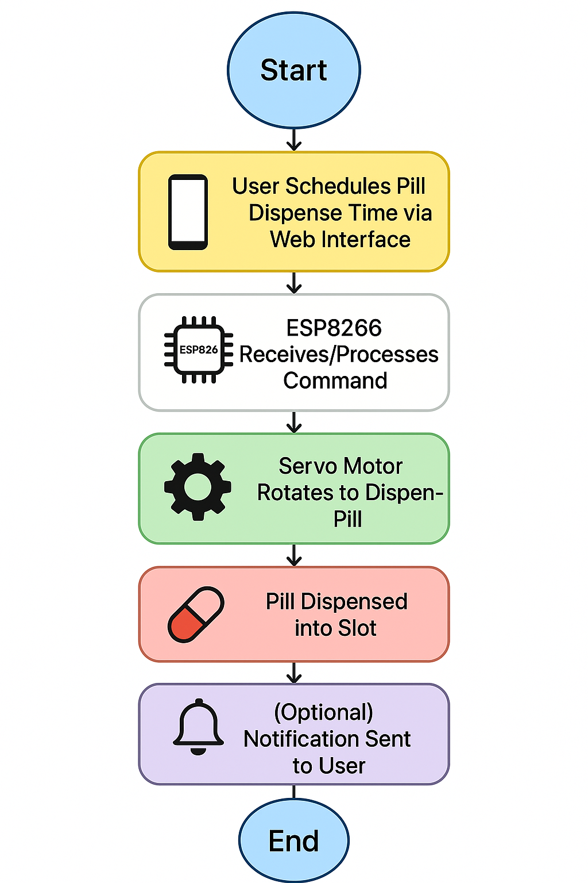

Experimental Results

**• Efficiency: The system automates scheduled pill dispensing with minimal human involvement, ensuring accurate and timely medication delivery according to user-defined schedules.**

**• User Convenience: The web-based interface allows seamless control and configuration of medication times via smartphones or PCs, improving accessibility and reducing dependency on manual tracking.**

**• Performance: The ESP8266 microcontroller executes optimized code to manage the servo motor’s rotation with precision, ensuring accurate dosage release without errors or mechanical failures during testing.**

**•Scalability: The system design supports easy integration of additional features such as multiple pill compartments, patient-specific schedules, or external modules like real-time clocks (RTC), cloud connectivity, and mobile app support.**

**• Additional Features: Real-time notifications for each pill dispensed, logs of dispensing history, and alerts for missed doses or errors enhance monitoring and offer better insights for users or caregivers, contributing to improved medication adherence and patient safety.**

Conclusions

The Smart Pill Dispenser efficiently automates and simplifies medication management through IoT technology, ensuring accurate and timely pill dispensing even in the user’s absence. Utilizing components like the ESP8266 microcontroller, MG995 servo motor, and a web-based interface, the system provides remote accessibility, scheduling convenience, and precise dose control. It enhances patient care by minimizing human error, supporting adherence to medication routines, and offering real-time monitoring. Future enhancements could include mobile app integration, biometric authentication for secure access, and AI-based analytics for personalized medication insights and improved health outcomes.

Acknowledgement

This work was supported in part by the Grants from **Information Technology Department at Amity University Uttar Pradesh**