

Practicle File
Of
Programming In C
Submitted By: Submitted to
Shagun gurung Dr. Piyush bagla
590025458
Bsc cs
1 sem
Batch 1
2025-26

/*Experiment 1: Installation, Environment setup and starting with C language
1. Write a C program to print "Hello World"*/

#include <stdio.h>
int main()
{
printf("Name - Shagun gurung\nSAP ID - 590025458\nCourse - Bsc CS\nBatch-B1");
printf("\n----------------------------------------------\n");
printf("Hello World");

return 0;
}

Output:

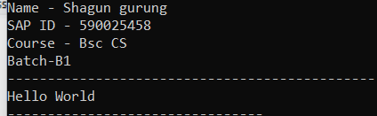
/*Experiment 1: Installation, Environment Setup and starting with C language
2. Write a C Program to print the address in multiple lines (new line).*/
#include <stdio.h>
int main()
{
printf("Name - Shagun\nSAP ID - 590025458\nCourse-BscComputerScience\nBatch-B1");
printf("\n---------------------------------------------------------\n");
printf("\n---------------------------------------------------------\n");
printf("Name:Shagun\n");
printf("House no:161 \n");
printf("Street:krishna colony\n");
printf("City:dehradun\n");
printf("Pincode:248007 \n");

return 0;
}

Output:

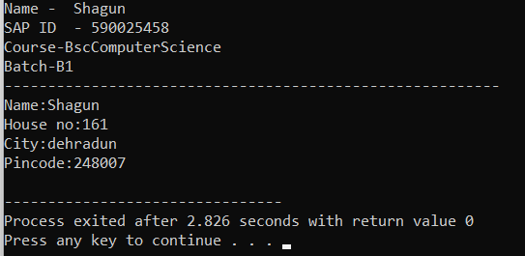
/Experiment 1: Installation, Environment Setup and starting with C language
3.Write a C program to add two numbers and take a number from the user.*/
#include <stdio.h>
int main()
{
int n1,n2,n3;
printf("Name - Shagun\nSAP ID - 590025458\nCourse-BscComputerScience\nBatch-B1");
printf("\n---------------------------------------------------------\n");
printf("enter the frst number.");
scanf("%d",&n1);
printf("enter the second number.\n");
scanf("%d",&n2);
n3=n1+n2;
printf("Sum=%d\n",n3);
return 0;
}
Output

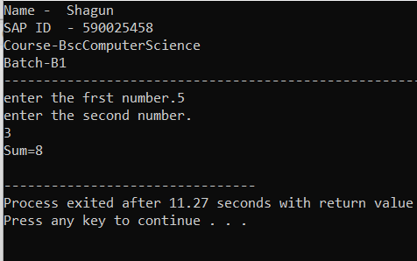
/*Experiment 1: Installation, Environment Setup and starting with C language
4.Write a C program to perform four arithmetic operations on two variables*/
#include <stdio.h>
int main()
{
int a,b;
int sum,dif,prod;
float div;
printf("Name - Shagun\nSAP ID - 590025458\nCourse-BscComputerScience\nBatch-B1");
printf("\n---------------------------------------------------------\n");
printf("enter the frst number.");
scanf("%d",&a);
printf("enter the second number.");
scanf("%d",&b);
sum = a+b;
div = a-b;
prod = a*b;
div = (float)a/b; //typecasting to get decimal value
printf("Addition = %d\n",sum);
printf("Substraction =%d\n",dif);
printf("Multiplication = %d\n", prod)
printf("Division = %.2f\n", div);
return 0;
}
Output

